STAV
2006
CHEMISTRY
Unit 3 Exam

Section A – Multiple Choice

Question 1
The amount, in mol, of sulfate ions in 200 mL of 0.0100 mol L⁻¹ Fe₂(SO₄)₃ is
- 0.00200
- 0.00600
- 0.0600
- 6.00

Question 2
The volume, in mL, of 0.500 mol L⁻¹ hydrochloric acid needed to titrate completely 25.0 mL of 0.350 mol L⁻¹ barium hydroxide solution is
- 8.75 mL
- 17.5 mL
- 25.0 mL
- 35.0 mL

Question 3
Copper metal can be oxidised by nitric acid according to the following half-equations
Cu (s) → Cu²⁺ (aq) + 2 e–
NO₃– (aq) + 4 H⁺ (aq) + 3 e– → NO (g) + 2 H₂O (l)
The number of moles of nitrate ions reduced by one mole of copper is closest to
- 0.33
- 0.67
- 1.5
- 2.0

Question 4
A student is asked to accurately prepare an aqueous solution of 0.500 M CuSO₄.
In addition to an accurate balance the students would require a
- measuring cylinder
- pipette
- burette
- volumetric flask

Question 5
A chemist working for a mining company found that a mineral sample contained 67% zinc.
A possible chemical formula for the mineral sample is
- ZnO
- Zn₂S
- ZnS
- FeZnS

Question 6
Hardness in water is caused by the presence of small amounts of metal ions that readily form insoluble compounds containing Mg²⁺ and Ca²⁺ ions. An analytical laboratory wishing to accurately determine the concentration of a metal ion in a sample of hard water would use
- high pressure liquid chromatography
- UV-visible spectroscopy
- atomic absorption spectrometry
- gravimetric analysis

Question 7
The procedure likely to be involved in the gravimetric analysis of iron in a sample of steel is
- Titration of Fe²⁺ ions in acid solution with a standard solution of KMnO₄ (aq).
- Measurement of the mass of Fe₂O₃ residue obtained by the dehydration of a precipitate of Fe(OH)₃ (s).
- Determination of the colour intensity of a solution of Fe(SCN)²⁺ (aq)
- Separation of Fe²⁺ ions from Fe³⁺ ions using chromatography with an acid as the mobile phase.

Question 8
Students in a VCE Chemistry class were given the task of using chromatography to investigate the food dyes present in a popular brand of sweets. The distances measured by the students on the chromatogram are shown in the table.

 | Distance (mm)
Solvent front | 88.8
Food Colour A | 78.0
Food Colour B | 34.0

The R_{f} value obtained by the students for food colour B is
- 0.38
- 0.44
- 0.88
- 2.61

Question 9
In an episode of a cartoon series, a character concocted an alcoholic drink called a ‘Flaming Humour’. The secret ingredient in the drink was identified by an industrial chemist using gas chromatography. The secret ingredient was probably
- a metal
- organic and non-volatile
- organic and volatile
- coloured

Question 10
Which of the following set of conditions would produce the greatest rate of reaction for a chemical reaction in the gas phase?
 | Catalyst | Temperature | Pressure
A. | present | high | low
B. | absent | low | high
C. | present | high | high
D. | absent | low | low

Questions 11 and 12 refer to the following information.
A 100 mL sample of an aqueous solution of a weak monoprotic acid has a concentration of 0.10 mol L⁻¹ and a pH of 2.0.

Question 11
The concentration of the hydronium ion in the solution of the weak acid is
- 0.010 mol L⁻¹
- 0.10 mol L⁻¹
- 1.0 mol L⁻¹
- 10 mol L⁻¹

Question 12
The volume of 0.20 mol L⁻¹ KOH needed to neutralise the weak acid is
- 100 mL
- 50 mL
- 10 mL
- 5.0 mL

Question 13
A 1.0 mol L⁻¹ aqueous solution of H₂C₂O₄ was prepared at 25°C. The equation for the hydrolysis reaction is:
H₂C₂O₄ (aq) + H₂O (l)  H₃O⁺ (aq) + HC₂O₄– (aq) K_{a} (298 K) = 6.4 × 10⁻⁵ M
Which of the following species is present in the lowest concentration?
- H₂C₂O₄ (aq)
- H₃O⁺ (aq)
- HC₂O₄– (aq)
- H₂O (l)

Question 14
The order of increasing boiling points (lowest to highest) would be
- ethane, chloroethane, ethanol, ethanoic acid
- chloroethane, ethane, ethanoic acid, ethanol
- ethane, ethanoic acid, chloroethane, ethanol
- chloroethane, ethanol, ethane, ethanoic acid

Questions 15 and 16 refer to the following information.
Sulfuric acid, H₂SO₄, is produced industrially by the Contact Process. The main reaction involves the following equilibrium
2 SO₂ (g) + O₂ (g)  2 SO₃ (g)

Question 15
The graph shows the equilibrium yield of SO₃ (g) produced at various temperatures:
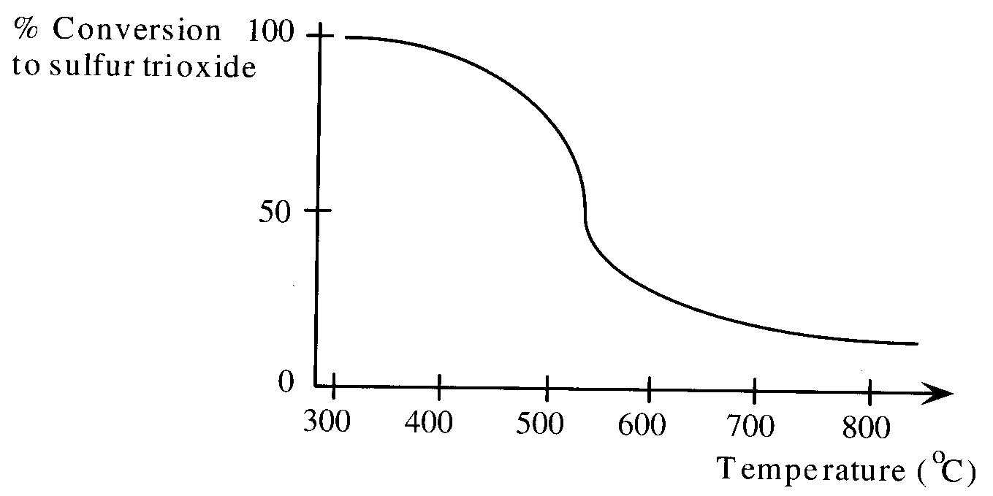
Complete conversion to SO₃ (g) occurs at about 300°C. However, industrial plants producing sulfuric acid typically carry out this conversion at about 450°C.
The most likely explanation for this is
- the amount of SO₃ obtained is dependent upon the rate of reaction
- the conversion of SO₂ to SO₃ is endothermic
- a suitable catalyst for the conversion reaction is unavailable
- the product, SO₃ becomes liquid at temperatures lower than 350°C

Question 16
A chemist investigating this equilibrium in the laboratory has a 2.0 L vessel at equilibrium at 200°C. The vessel is found to contain 0.020 mol of SO₂ (g), 0.010 mol of O₂ (g) and 0.040 mol of SO₃ (g).
The equilibrium constant for this reaction under these conditions is
- 1.25 × 10⁻³ M
- 2.50 × 10⁻³ M
- 400 M⁻¹
- 800 M⁻¹
Question 17
Part of a polymer chain is shown below.
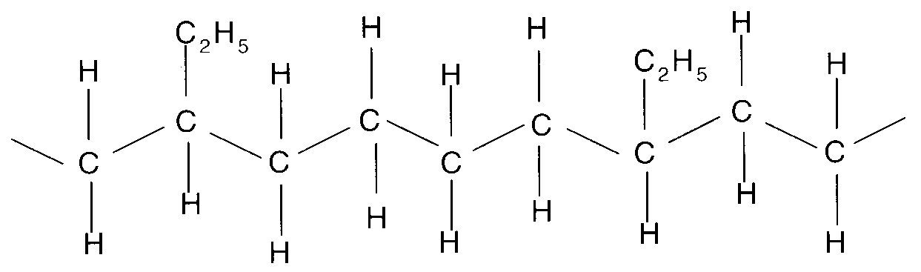
The pair of alkenes used as monomers to produce this polymer chain was
- ethene and propene
- ethene and but-1-ene
- propene and but-1-ene
- ethene and but-2-ene

Question 18
Part of a polyester chain is shown below.
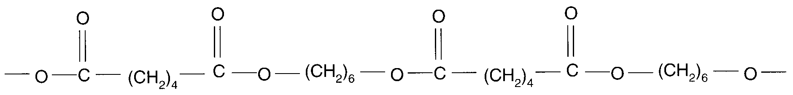
Which compound when added to the reactants during polymerisation, would be most likely to result in shorter polymer chains?
A. | 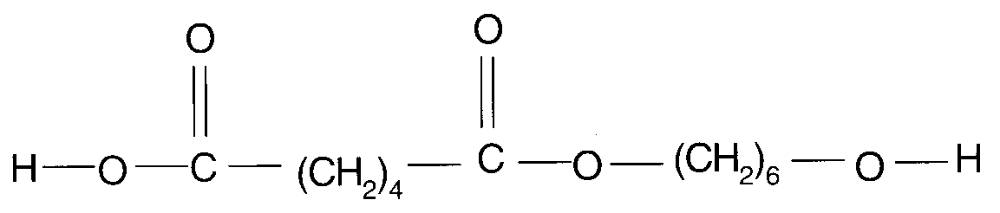 | C. | 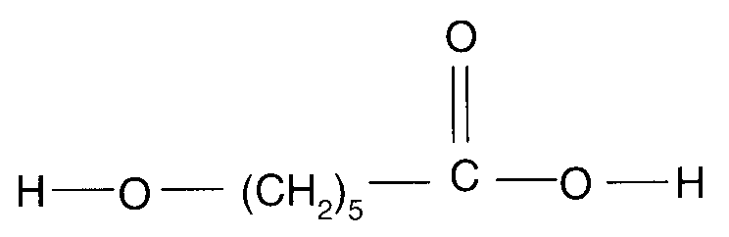
B. | H–O–(CH₂)₆–O–H | D. | CH₃–OH

Question 19
In which of the following reactions is sulfuric acid, H₂SO₄, acting as an oxidant?
- H₂SO₄ (aq) + CuO (s) → CuSO₄ (aq) + H₂O (l)
- 2 H₂SO₄ (aq) + Cu (s) → CuSO₄ (aq) + SO₂ (g) + H₂O (l)
- H₂SO₄ (aq) + CaCO₃ (s) → CaSO₄ (aq) + CO₂ (g) + H₂O (l)
- H₂SO₄ (aq) + 2 NaCl (s) → 2 HCl (g) + Na₂SO₄ (aq)

Question 20
The rates of many chemical reactions double for a ten degree rise in temperature.
An increase in which of the following factors may contribute to this rate increase.
- The number of collisions occurring in a given time
- The energy of each collision
- The activation energy
- I only
- II only
- III only
- Both I and II

Question 21
The following semi-structural formula represents an ester.
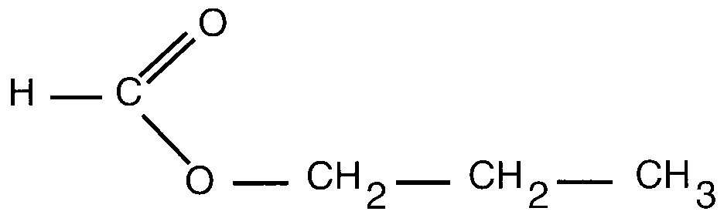
The two organic compounds that could be used to produce this ester are
- methanoic acid and propan-1-ol
- ethanoic acid and propan-2-ol
- propanoic acid and methanol
- propanoic acid and ethanol

Question 22
When but-2-ene reacts with bromine, the formula of the product is
- CH₃CHBrCHBrCH₃
- CH₃CHBrCH₂CH₂Br
- CH₃CBr₂CH₂CH₃
- CH₂BrCHBrCH₂CH₃

Section B – Short Answer Questions

Question 1
Hydrogen iodide will decompose to produce hydrogen and purple iodine vapour according to the equation

2 HI (g) |  | H₂ (g) | + | I₂ (g)
colourless |  | colourless |  | purple

- Write the expression for the equilibrium constant, K, for the reaction.

- The forward reaction is an exothermic process. Complete the table below when the changes (i) to (iii) are made to the system.

 | Change to the system | Direction of reaction  (forward, backward, neither) | Change to the intensity of the purple colour  (increased, decreased,  remains the same) | Change to rate of forward reaction  (increased, decreased,  remains the same)
(i) | Temperature is decreased
(ii) | Volume is decreased
(iii) | Hydrogen gas is added  (at constant volume) |  |  | (No answer required here)

- A sample of hydrogen iodide was placed in a sealed flask and allowed to reach equilibrium. Show the changes in the concentration of hydrogen iodide against time on the axes given below.

t(int) indicates the time when the hydrogen iodide was placed in the sealed flask.
t(eq) indicates the time when the system reached equilibrium.
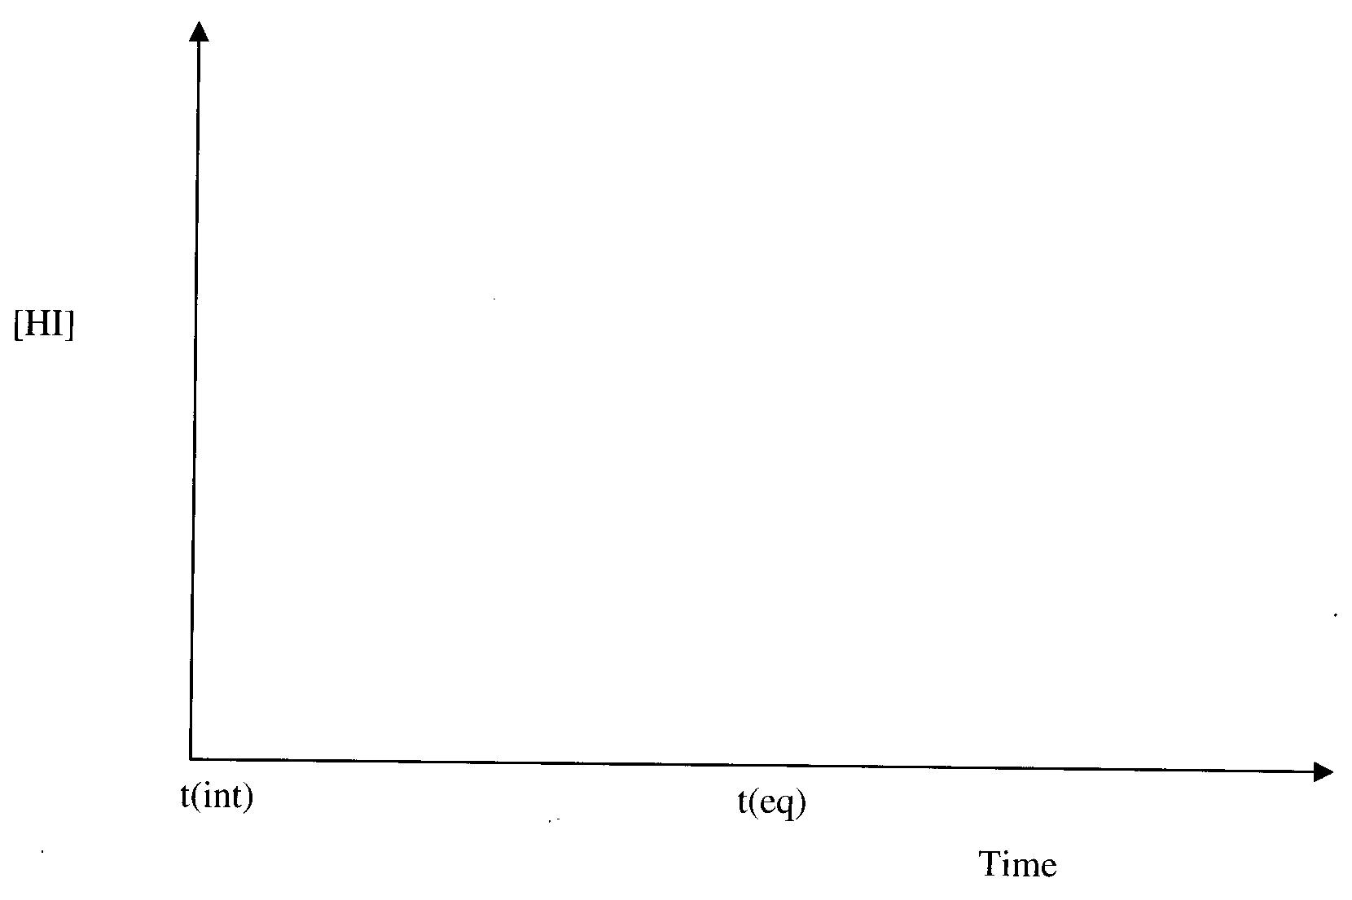
1 + 8 + 2 = 11 marks
Suggested time: 12 minutes

Question 2
Natural gas consisting of the alkanes containing one to four carbon atoms can undergo thermal cracking in a cracker.
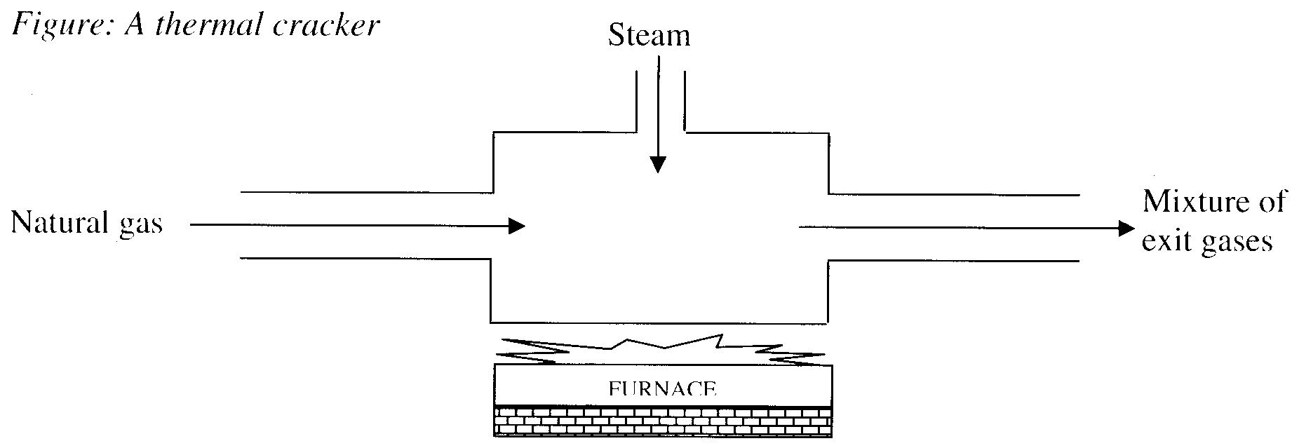
- Why is the steam added into the cracker?
_________________________________________________________________________________________
_________________________________________________________________________________________
- (i) Name and write the semi-structural chemical formula for three possible alkenes that could be formed in the cracker.
______________________________________________________________________________________
______________________________________________________________________________________
______________________________________________________________________________________
(ii) Write the chemical formula and name a polymer formed from an alkene containing four carbon atoms.

- Crude oil can also be used as a reactant for the cracking process. However, catalytic cracking is generally used with the fractions obtained from crude oil.
(i) Identify a catalyst used. _____________________________________________________________
(ii) Write a balanced chemical equation for the cracking of decan to produce pentene.
______________________________________________________________________________________
1 + [3 + 2] + [1 + 1] = 8 marks)
Suggested time: 9 minutes

Question 3
- Numerical values for the self-ionisation constant of water, K_{w}, at two temperatures are shown in the table.

Temperature (°C) | K_{w}
25.0 | 1.00 × 10⁻¹⁴
50.0 | 5.48 × 10⁻¹⁴

Considering the equation for the self ionisation of water
H₂O (l) → H⁺ (aq) + OH– (aq)
(i) State the sign for ΔH ____________________
(ii) and; give a reason for your answer.
______________________________________________________________________________________
(iii) Calculate the pH of water at 50.0°C.

(iv) Is the water at 50°C neutral? Explain your response.
______________________________________________________________________________________
______________________________________________________________________________________
- The hydrogensulfate ion behaves as a weak acid in aqueous solutions.
The concentration of the hydrogensulfate ion in an aqueous solution with a pH of 1.18 is 0.437 mol L⁻¹ at 25°C.
(i) Write an equation to illustrate the ionisation of the hydrogensulfate ion in aqueous solution.
______________________________________________________________________________________
(ii) Calculate the value of the acid constant, K_{a}, for the hydrogensulfate ion.

[1 + 1 + 2 + 1] + [1 + 2] = 8 marks)
Suggested time: 9 minutes

Question 4
The iron in blood serum can be determined by forming a purple complex with a chemical called ferrozine and determining the absorbance using UV-visible-spectrometry. Standard solutions of the purple complex were prepared and absorbance measurements taken using a UV-visible spectrophotometer at a wavelength of 562 nm.

Concentration of iron in μg L⁻¹ | Absorbance
40.0 | 0.200
60.0 | 0.300
80.0 | 0.400
120.0 | 0.600
160.0 | 0.800

Note: 1 μg = 1 × 10⁻⁶ g

- On the axes provided construct a calibration curve.
Choose an appropriate scale for each axis.
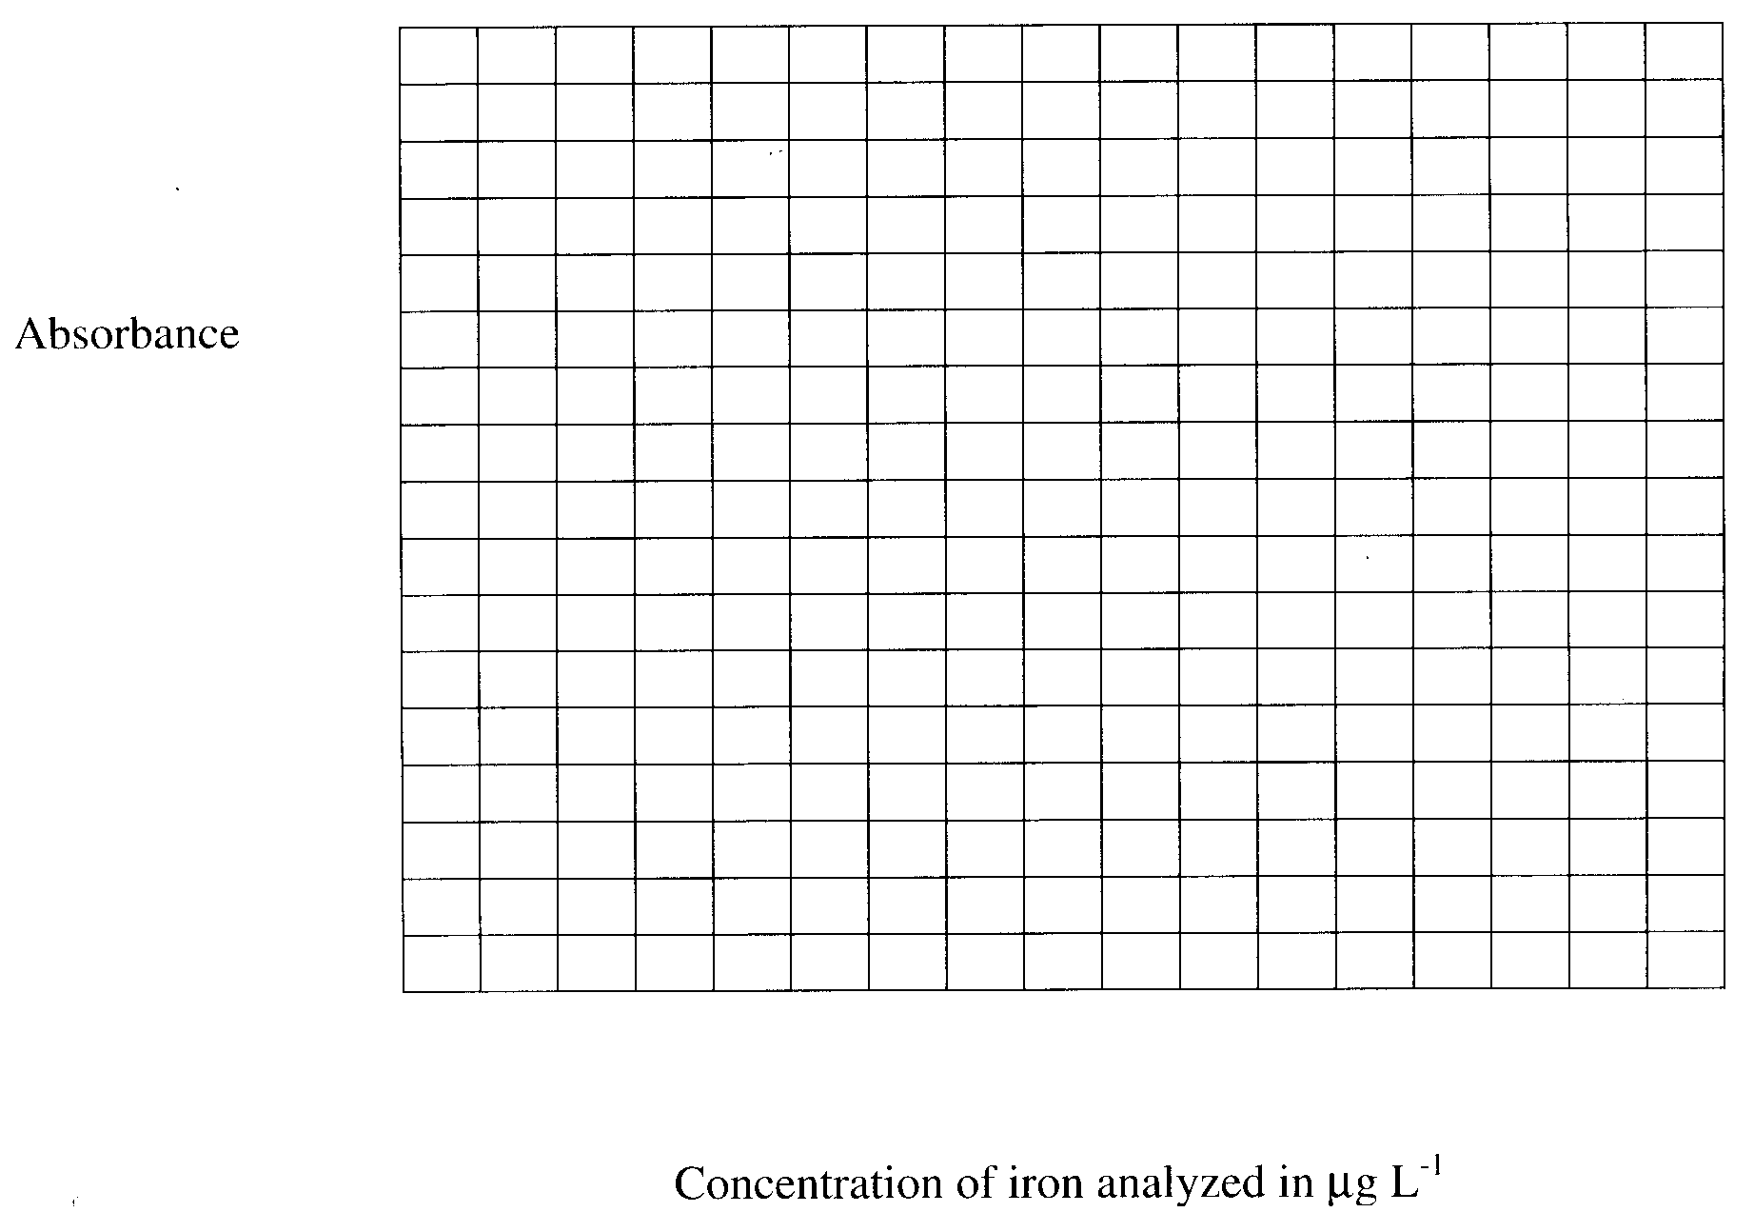

A 10.0 mL sample of blood serum was analysed using the UV-visible spectrophotometer. The procedure involved forming the purple complex with the serum and dissolving the mixture in 90.0 mL of a suitable solvent. A 10.0 mL sample of this mixture was placed in a sample cell and analysed. The spectrum represented below was obtained.
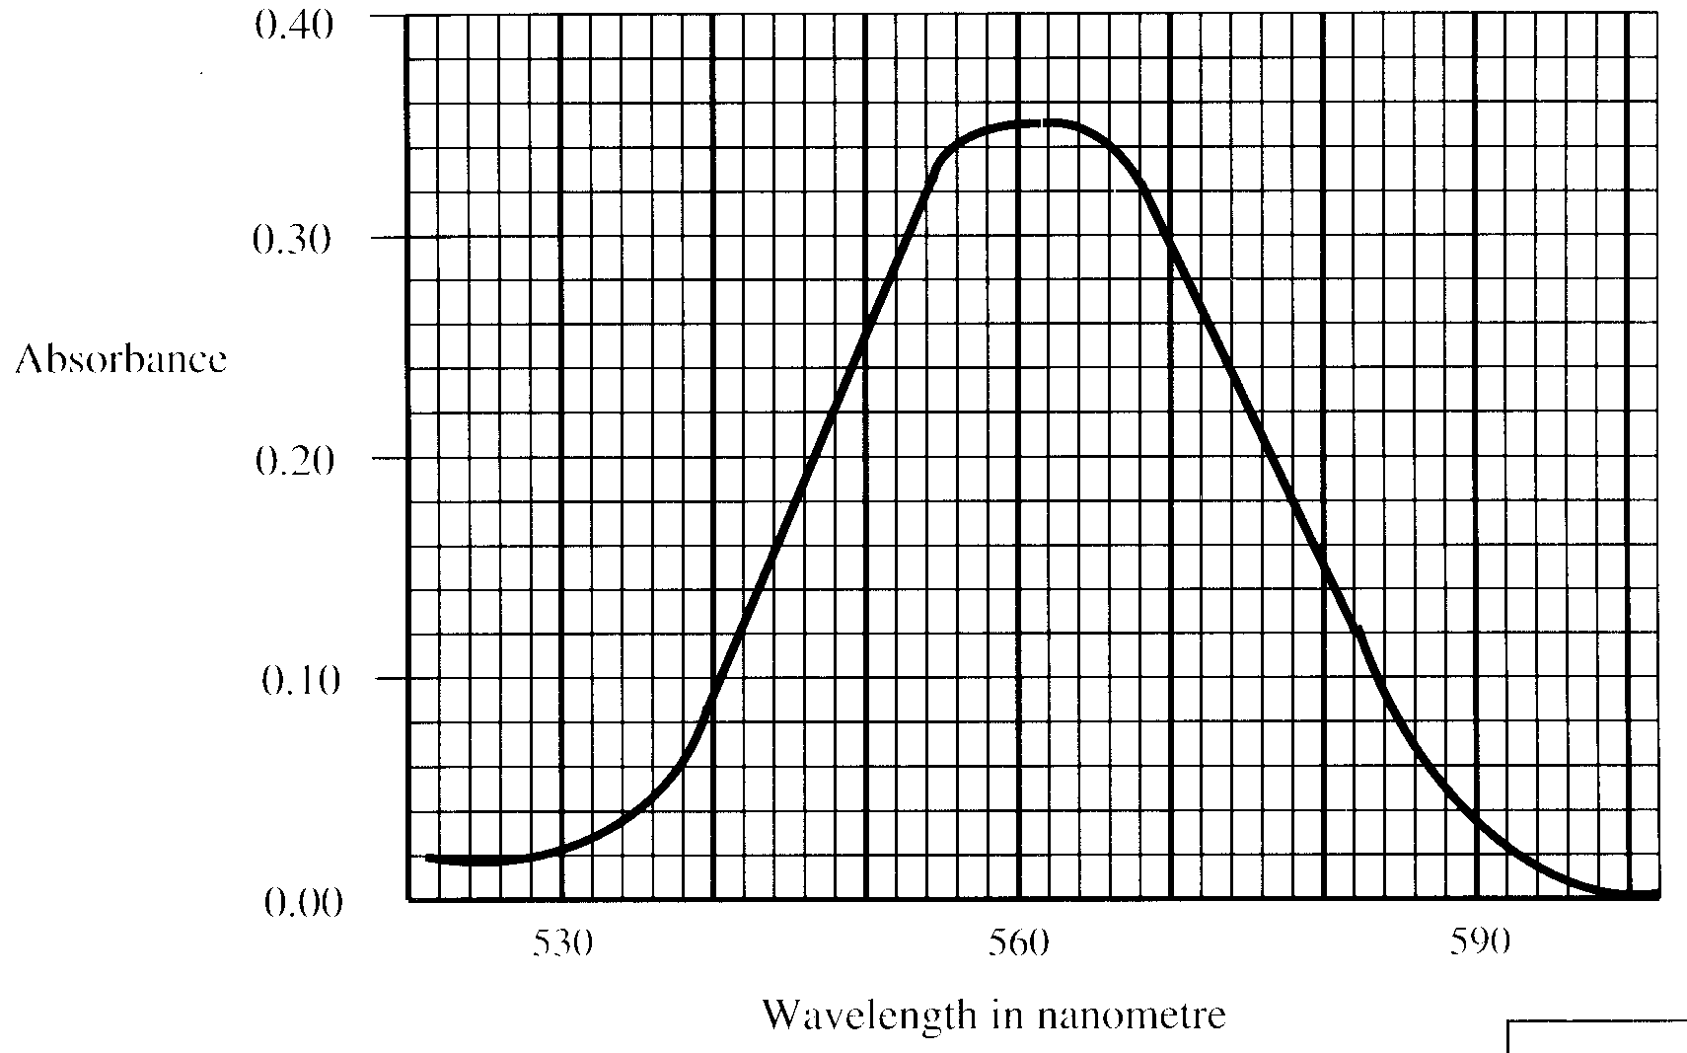
- Use the calibration curve and the spectrum to calculate the concentration, in μg L⁻¹, of iron in the original sample of blood serum.

Concentration of iron, μg L⁻¹, in the original sample of blood serum is:

- The range of concentration of iron in normal adult human blood is 9.0 to 27.0 μmol L⁻¹.
[μmol L⁻¹ is equal to 10⁻⁶ mol L⁻¹]
Does the analysed blood serum fall into the normal range for blood?
Show calculations supporting your response.

- Why was the wavelength of 562 nm used in this analysis?
_________________________________________________________________________________________
_________________________________________________________________________________________
2 + 3 + 2 + 1 = 8 marks
Suggested time: 9 minutes

Question 5
A student attempted to determine the amount of sodium chloride in a brand of chicken stock powder. The label on the bottle states the sodium content at 17050 mg per 100 g.

- Calculate the amount of sodium, in mol, in 3.0 g of the chicken stock, assuming the label is accurate.

- The student dissolves 3.0 g of stock in distilled water and makes up the solution to 250 mL in a volumetric flask. A 20.00 mL sample is taken and excess silver nitrate solution is added to precipitated all the chloride ions as silver chloride.
Using the information provided, calculate the mass of silver chloride that the students would expect to precipitate.

- Name the kind of analysis performed in this determination.
_________________________________________________________________________________________
- Given that the precipitate collected was completely dry, suggest why the experimental value of silver chloride might be higher than the value expected by the student.
_________________________________________________________________________________________
_________________________________________________________________________________________
_________________________________________________________________________________________
- The silver chloride precipitate is light sensitive and could decompose on standing. If some gaseous produce is produced, how would this affect your result? Explain.
_________________________________________________________________________________________
_________________________________________________________________________________________
_________________________________________________________________________________________
2 + 3 + 1 + 1 + 1 = 8 marks)
Suggested time: 9 minutes

Question 6
- Draw the structural formula for propan-2-ol.

- Using systematic nomenclature, name the compounds represented by the following formulas.
(i) CH₃CH₂CH₂CH₂CH₂CHOHCH₂CH₂CH₃ _______________________________________________
(ii) CH₃CH₂CH₂CHClCH₃ _______________________________________________
(iii) CH₃CH₂COOH _______________________________________________
- In the diagram the steps I, II and III represent industrial processes.
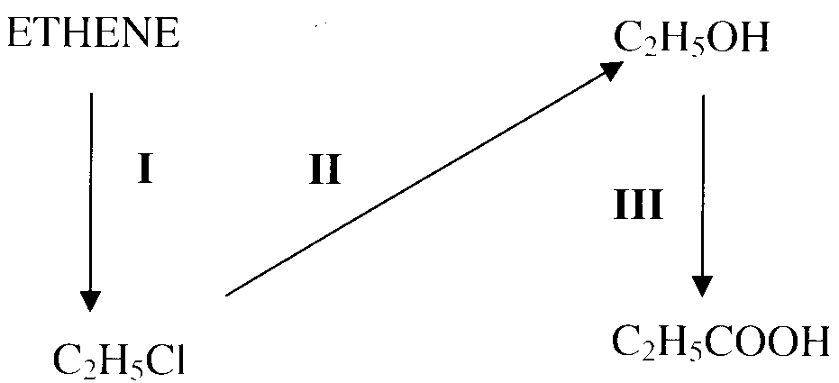
(i) Name the type of reaction indicated by process I __________________________________
(ii) Write the formula for the other reactant used in process I __________________________________
(iii) Name the type of reaction indicated by process II __________________________________
(iv) Write the formula for the other reactant used in process II __________________________________
(v) Name the type of reaction indicated by process III __________________________________
(vi) Write the formula for the two other reactants required for in process III
(A) __________________________________ (B) __________________________________
1 + 3 + 6 = 10 marks)
Suggested time: 11 minutes

Question 7
For people who suffer from bronchitis, even low concentrations of ozone, O₃, irritate the lining of the throat and can cause headaches. NO₂ (g) from car exhausts reacts with oxygen as follows
O₂ (g) + NO₂ (g)  NO (g) + O₃ (g)
Car exhaust fumes also contain volatile organic compounds (VOC).
These combine with NO gas.

- Explain how a rise in VOC concentration will change the ozone concentration.
_________________________________________________________________________________________
_________________________________________________________________________________________
_________________________________________________________________________________________
_________________________________________________________________________________________
- In an experiment to measure the concentration of O₃ in Melbourne’s air, 1.0 × 10⁵ L of air was bubbled through a colourless solution of potassium iodide. Ozone reacts with potassium iodide solution releasing iodine as shown in the following equation,
2 KI (aq) + O₃ (g) + H₂O (l) → I₂ (aq) + O₂ (g) + 2 KOH (aq)
The iodine formed was titrated with 0.010 mol L⁻¹ sodium thiosulfate solution, Na₂S₂O₃ (aq), using starch indicator according to:
I₂ (aq) + 2 S₂O₃²⁻ (aq) → 2 I⁻ (aq) + S₄O₆²⁻ (aq)
The results of three titrations are shown in the Table below.

Experiment | Volume of thiosulfate (mL)
1 | 22.90
2 | 22.40
3 | 22.50

(i) Why was the volume of sodium thiosulfate to be used in the calculation taken to be 22.45 mL although this is not he average of the three titres?
______________________________________________________________________________________
______________________________________________________________________________________
______________________________________________________________________________________
(ii) Taking the volume of sodium thiosulfate solution to be 22.45 mL, calculate the number of ozone molecules in one litre of air.
______________________________________________________________________________________
______________________________________________________________________________________
______________________________________________________________________________________
______________________________________________________________________________________
______________________________________________________________________________________
______________________________________________________________________________________
______________________________________________________________________________________
______________________________________________________________________________________
1 + [1 + 4] = 6 marks)
Suggested time: 7 minutes

END OF QUESTION AND ANSWER BOOKLET

