STAV 2006 | CHEMISTRY | Unit 4 | Trial Examination Solutions

Section A Multiple Choice Questions

- A
- B
- B
- D
- C
- C
- C
- D
- D
- B
- A
- C
- C
- A
- B
- B
- B
- A
- A
- C

Guidelines for Section A solutions
1 A significant advantage of fuel cells over combustion of fuels is that they convert chemical energy directly to electrical energy.
Answer: A

2 ΔH (= –3120 kJ mol^{–1}) for the given equation indicates that 2 mol of gaseous ethane releases 3120 kJ of heat energy. Therefore 1 mol will release 3120 ÷ 2 = 1560 kJ. As the question refers to the formation of ethane the energy will be absorbed rather than released.
Answer: B

3 When a reduced volume of water is used the change in temperature, ΔT, will be greater for the same energy input, E. This will mean that the calculated calibration factor, CF, will be lower. (Note: CF = E ÷ ΔT) Hence the correct CF will be higher than the value used to calculate ΔH for the reaction. In turn, the calculated energy released by the reaction, E_{R}, between magnesium and HCl (aq) will be low (E_{R} = CF × ΔT_{R}). That is, ΔH should be higher than calculated. (Note: ΔH is directly proportionally to E_{R})
Answer: B

4 n(metal) = n(electron) ÷ charge on the cation
(For example: M^{x+} + x e– → M and, hence, n(M) = n(e–) ÷ x)
n(e–) = It ÷ F; where I is the current in amp and t is the time in seconds that the current is flowing. Therefore the amount of a metal discharged is dependent on all three factors (current, time and change on the metal ion).
Answer: D

5 |  | Fuel | Heat of Combustion  (kJ g^{–1}) | Molar mass of fuel  (g mol^{–1}) | Energy  (kJ mol^{–1})
 | A. | methanol | 22.7 | 32 | 22.7 × 32 = 726
 | B. | ethanol | 29.6 | 46.0 | 29.6 × 46 = 1362
 | C. | propan-1-ol | 33.6 | 60.0 | 33.6 × 60 = 2016
 | D. | octane | 47.8 | 114.0 | 47.8 × 114 = 5449
Answer: C

6 Beryllium is in Group II and is most likely to form the Be²⁺ ion. In addition, fluorine in compounds has an oxidation number of –1. hence, x + 4(–1) = –2 and x = +2.
Answer: C

7 |  |  | Mole relationship | Mass of element formed in grams
 | A. | Al | n(Al) = ⅓ n(e–) | mass = n(Al) × M(Al) = ⅓ × 27 = 9
 | B. | Na | n(Na) = n(e–) | mass = n(Na) × M(Na) = 1 × 23 = 23
 | C. | Cl₂ | n(Cl₂) = ½ n(e–) | mass = n(Cl₂) × M(Cl₂) = ½ × 71 = 35.5
 | D. | O₂ | n(O₂) = ¼ n(e–) | mass = n(O₂) × M(O₂) = ¼ × 32 = 8
Answer: C

8 n(e–) = Q / F; where Q is the charge in coulomb and F is Faraday’s constant
Q = I t and E = energy input (in joules) = V I t. Therefore Q = E / V
n(e–) = 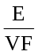 = 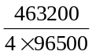 = 1.2 mol
n(Ti) = 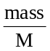 = 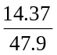 = 0.3 mol
Ti^{x+} + x e– = Ti
x = 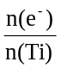 = 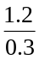 = 4
Hence Ti⁴⁺ and O^{2–} give the chemical formula TiO₂.
Answer: D

9 The site of reduction is the cathode. Cations migrate towards the cathode. Both Fe²⁺ and Cu²⁺ migrate towards the copper cathode although only copper(II) ions are discharged. Note, although the porous pot acts as a barrier to the mixing of solutions it must allow slow diffusion of ions in order to complete the electric circuit.
Answer: D
10 Glucose molecules react endothermically to produce cellulose and water.
Answer: B

7 | A. | hydrogen bonding between component parts in the peptide links.  This is H-bonding between components of the amide group. Secondary structure.
 | B. | hydrogen bonding between component parts in the side chains of the peptide chain.  This contributes to tertiary structure.
 | C. | covalent bonding between atoms in the peptide chain.  This contributes directly to the primary structure.
 | D. | dispersion forces between adjacent sections of the peptide chain.  This may contribute to tertiary structure.
Answer: A

12 Proline (C₅H₉O₂N) will react via condensation reactions losing water molecules while forming peptide links resulting in the formation of polypeptides. As water contains a (much) higher percentage of oxygen than the proline molecule the mass of oxygen present in the polymer is less than in separate proline monomers. Therefore the percent of oxygen in the polypeptide will be lower.
Answer: C

13 The chief role of fat soluble antioxidants is to prevent the oxidation of carbon-carbon double bonds in unsaturated fats by reacting with oxidants such as oxygen from the atmosphere.
Answer: C

14 The formation of glycogen from glucose involves the formation of glycosidic links or ether bonds. These have the structure –C–O–C–. Alternative B is the amide group found in proteins and alternative C is the ester group found in triglycerides.
Answer: A

15 Absorption spectra are produced when the electrons in vaporised atoms interact with photons (from white light) and are excited to higher energy orbitals. The photons are absent from the light that forms the spectrum.
Answer: B

16 The nuclear reaction is: 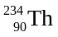 → 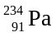 + 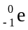. The relevant atomic numbers are found by using the Periodic Table on the Data Sheet.
Answer: B

17 | A. | electronegativity of the elements | Electronegativity is not defined for Group VII elements and these elements do not attract electrons of other elements (strongly). Therefore this trend is not true for neon.
 | B. | ionisation energy of the elements | Correct response.
 | C. | atomic radius of the elements | Reverse trend due to increasing core charge.
 | D. | metallic nature of the properties of the elements | Reverse trend as metals are predominantly on the left hand side of the Periodic Table.
Answer: B

18 Transition elements typically have variable electrovalencies and can form more than one cation. Manganese, as described in alternative A displays this property. Having variable electrovalencies is not typical of the main group elements. The other three properties referred to in alternatives B, C and D are more typical of main group elements.
Answer: A

Questions 19 and 20
One approach to these equations is to identify the elements I, II, III and IV using the Periodic Table and the number of electrons indicated by the electronic configuration.
I 1s²2s²2p⁴ 8 electrons ⇒ oxygen
II 1s²2s²2p⁶3s¹ 11 electrons ⇒ sodium
III 1s²2s²2p⁶3s²3p⁶4s¹ 19 electrons ⇒ potassium
IV 1s²2s²2p⁶3s²3p⁶3d¹⁰4s² 30 electrons ⇒ zinc

19 Only element I is likely to gain electrons. It will gain two electrons to obtain the stable electron configuration 1s²2s²2p⁶.
Answer: A

20 The other three elements (sodium, potassium and zinc) are all likely to lose electrons to form cations. Reductants lose electrons in redox reactions.
Answer: C

Section B Short Answer

Question 1 (Total 8 marks)
- When conjugate redox pairs are both in aqueous solution an inert electrode is required to complete the construction of the half cell. Platinum acts as an unreactive electrode. Iron would be too reactive reducing Fe³⁺ to Fe²⁺. In addition, iron is the conjugate reductant to Fe²⁺. | 2 marks
- Water is a stronger oxidant than Na⁺ ions. Therefore, if sodium is to be produced, water must not be present in the electrolytic cell. | 2 marks
- Iodine has a smaller atomic weight (relative atomic mass) due to its most abundant isotope having fewer neutrons (74) than the most abundant isotope of tellurium (78 neutrons). Original versions of the periodic table arranged elements in order of increasing atomic weight. The Modern Periodic Table lists elements in order of increasing atomic number. | 2 marks
- Zinc forms Zn²⁺ cations with the 3d subshell filled with electrons. Therefore electrons are unable to transfer to unoccupied 3 d orbitals and absorb wavelengths in the visible frequency range. All visible wavelengths are reflected or transmitted producing colourless zinc compounds. | 2 marks

Question 2 (Total 4 marks)
- Advantage: Can obtain a higher percentage of the available energy / Less energy produced is wasted by additional processes (used in producing ethanol) | 1 mark
Disadvantage: Expensive to transport to where it is to be used / Cannot replace liquid fuels (petrol) in some uses such as the internal combustion engine. | 1 mark
- Advantage: Liquid fuel has more uses (eg motor vehicles) / Will create less pollution at site of use as it burns more cleanly. | 1 mark
Disadvantage: Less energy is available from ethanol than from biomass materials / Expensive infrastructure required to convert biomass to ethanol. | 1 mark

Question 3 (Total 9 marks)
- C₂H₅OH (l) or (g) + 3 O₂ (g) → 2 CO₂ (g) + 3 H₂O (g)  1 mark for balanced equation and 1 mark for correct subscripts | 2 marks
- i. 334 J of energy required per 1.0 g (according to hikers)
334 kJ of energy required per 1.0 kg | 1 mark
Molar mass of ethanol is 46.0 g mol^{–1}  Therefore 46 g of ethanol releases 1364 kJ  1 g of ethanol releases 1364 ÷ 46.0 = 29.7 kJ  Mass of ethanol required = 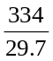 = 11.246 = 11 g of ‘methylated spirits’  1 mark for correct significant digits and 1 mark for numerical answer | 2 marks
ii. V = 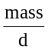 = 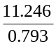 = 14.1813 = 14 mL | 1 mark
- Not all of the heat energy would be transferred to the ice.
or  Once melted, water would require further heat to be made warm enough for use (either for drinking or cooking purposes). | 1 mark
- i. C₂H₅OH (l) + 3 H₂O (l) → 2 CO₂ + 12 H⁺ (aq) + 12 e– | 1 mark
ii. O₂ (g) + 4 H⁺ (aq) + 4 e– → 2 H₂O (l)  (Note: H₂O will be liquid at the temperatures at which a fuel cell operates.) | 1 mark

Question 4 (Total 5 marks)
- E = m C ΔT  Therefore ΔT = 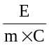 = 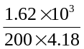 = 1.94°C |  | 1 mark
Therefore T_{final} = T_{initial} + ΔT = 25.00 + 1.94 = 26.94°C |  | 1 mark
- n(KOH) = 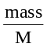 = 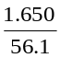 = 0.02941 mol |  | 1 mark
Therefore 0.02941 mol releases 1.62 kJ of heat energy
1 mol releases 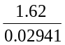 kJ (55.1 kJ)
Alternatively (using mass ratios)
1.650 g releases 1.62 kJ of heat energy  and 1 mol has a mass of: 56.1 g releases X kJ of heat energy | 1 mark for correct molar mass
Therefore 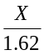 = 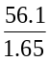 X = 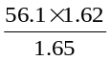 = 55.1 kJ  Hence, using either method: ΔH = –55.1 kJ mol^{–1}  1 mol for the negative sign and 1 mark for the numerical value |  | 2 marks

Question 5 (Total 6 marks)
 | 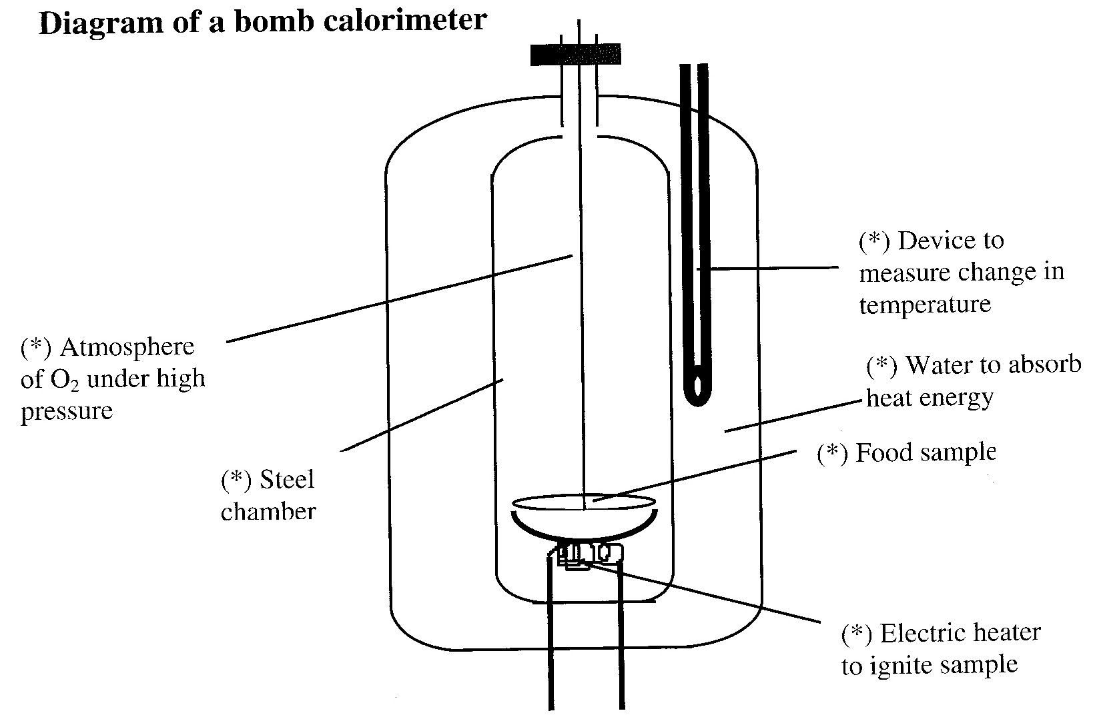  Award three marks for the diagram: key points are shown (*). | 3 marks
- E = m C ΔT = 484 × 5.52 = 2671.68 J |  | 1 mark
Therefore Energy content per gram = 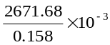 = 16.909  Energy content = 16.9 kJ g^{–1} |  | 1 mark
- Cereal is a mixture and its molar mass cannot be determined (and hence the mass of a sample of cereal cannot be converted into moles). |  | 1 mark

Question 6 (Total 5 marks)
 | 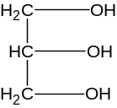 | and | glycerol
1 mark for structure and 1 mark for the name |  |  |  |  | 2 marks
- CH₃(CH₂)₁₆COOH |  |  |  |  | 1 mark
- i. the saturated fatty acid corresponding to eighteen carbon atoms, as indicated in the structure in part (b), has four more hydrogen atoms than linoleic acid. For each pair of hydrogen atoms less there is one C–C double bond. So linoleic acid has two carbon-carbon double bonds. |  |  |  |  | 1 mark
ii. Alignment of fatty acid molecules is much closer in saturated fatty acids such as stearic acid resulting in stronger bonding between molecules. The stronger the bonding the greater the heat energy required to break the bonding. |  |  |  |  | 1 mark

Question 7 (Total 9 marks)
 | Protein |  |  | A | B | C | D |  | E | F | G | H
 | Fat |  |  | A | B | C | D |  | E | F | G | H
 | Carbohydrate |  |  | A | B | C | D |  | E | F | G | H
 | 1 mark for each type of compound |  |  |  |  |  |  |  |  |  |  |  |  | 3 marks
 | Waste product |  |  | A | B | C | D |  | E | F | G | H |  | 1 mark
- i. |  | 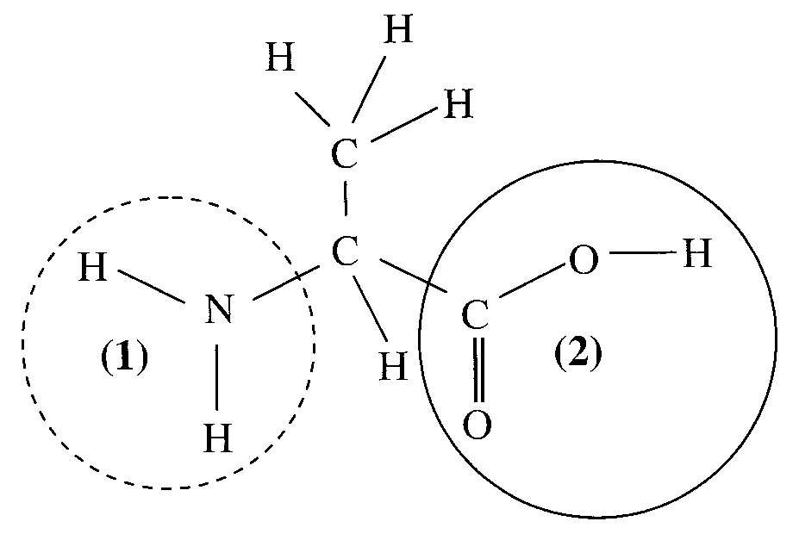
1 mark for overall structure and 1 mark for each functional group circled |  |  |  |  |  |  |  |  |  |  |  |  |  | 3 marks
ii. Functional group: (1) amino (or amine)  Functional group: (2) carboxyl (do not accept carboxylic acid)  No mark awarded if functional groups are not labelled (1) and (2) on diagram  1 mark for both correct |  |  |  |  |  |  |  |  |  |  |  |  |  | 1 mark
iii. |  |  | At pH 11 alanine will act as an acid donating a proton. |  |  |  |  | 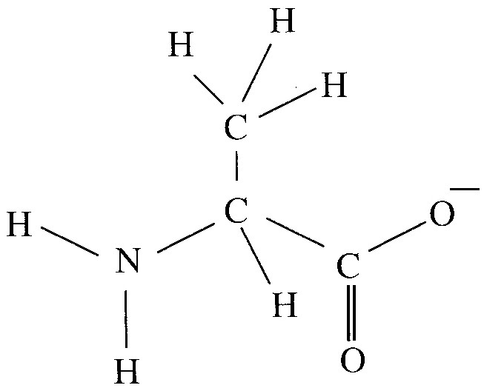 |  |  |  |  |  | 1 mark

Question 8 (Total 8 marks)
- A_{r} = 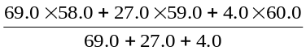 = 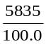 = 58.4 (3 significant digits) (Do not accept 58.7) | 2 marks
- i. 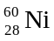 | 1 mark
ii. 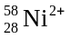 | 1 mark
iii. Force experienced by the charged particles as they enter a magnetic field causes the ions to deflect from their pathway. | 1 mark
- i. 1s²2s²2p⁶3s²3p⁶3d⁸4s² | 1 mark
ii. 1s²2s²2p⁶3s²3p³ (Z = 15: phosphorus) | 1 mark
iii. Phosphorus is a non-metal while nickel is a metal. Non-metals tend to have higher electronegativities than metals. Therefore phosphorus has the higher electronegativity – the greater electron attracting power. (Other explanations are acceptable) | 1 mark

Question 9 (Total 7 marks)
- Vanadium (Spelling must be correct) | 1 mark
- i. VO₂⁺ | 1 mark
ii. VO₂⁺ has an oxidation state (number) of +5 | 1 mark
(VO²⁺: oxidation number is +4; V³⁺: oxidation number is +3; and V²⁺: oxidation number is +2)
iii. Highest oxidation state is +5. In this state all five electrons in its 3d and 4s subshells are used in bonding. There are no more electrons available for bonding and therefore vanadium cannot have an oxidation state greater than five. | 1 mark
- 1s²2s²2p⁶3s²3p⁶3d² | 1 mark
- VO₂⁺
To oxidise iodide ion to iodine in aqueous solution you require an oxidant species with a higher E⁰ value than +0.54 V. Only VO₂⁺ (with an E⁰ value of +1.02 V) has an E⁰ value that is high enough. | 1 mark

