IARTV
2000
CHEMISTRY
Unit 3 Exam

Section A – Multiple Choice

Question 1
What volume of 0.02 M Ba(OH)₂ is required to neutralise 100 mL of 0.10 M HCl
- 200 mL
- 100 mL
- 50 mL
- 25 mL

Question 2
Anhydrous sodium carbonate is used as a primary standard in titration procedures. A sample of sodium carbonate left in the atmosphere for several hours, however, cannot be used to make a primary standard solution because
- it reacts with carbon dioxide and forms another substance
- absorption of atmospheric water changes the molecular mass of the anhydrous sodium carbonate
- the sample is no longer dry and will not dissociate in solution
- the degree of hydration of sodium carbonate is unknown

Question 3
The concentration of an unknown solution of hydrochloric acid was determined by titration. 25.00 mL aliquots of a standard 0.0250 M sodium carbonate solution were pipetted into conical flasks and were titrated against the unknown hydrochloric acid solution using methyl orange as an indicator.
In performing the experiment, a student made some errors that may have affected the final results. Which of the following procedures would have caused the final calculation of the concentration of the acid to be lower than the actual value?
- The conical flask had a final rinse with distilled water.
- The burette had a final rinse with distilled water.
- The pipette had a final rinse with distilled water.
- When measuring the volume of sodium carbonate solution the meniscus was below the line on the pipette.

Question 4
In which of the following compounds does carbon have the lowest oxidation number?
- CH₃OH
- CO
- C₂H₂
- CF₄

Question 5
The following reaction involves nitric acid
4 Zn (s) + 10 HNO₃ (aq) → 4 Zn(NO₃)₂ (aq) + N₂O (g) + 5 H₂ (l)
In this equation nitric acid is acting as
- an acid
- a dehydrating agent
- a reductant
- an oxidant

Question 6
According to the label on a bottle of White-up bleach, it contains 4.8% (w/v) active ingredient (sodium hypochlorite).
The mass of active ingredient in 25 mL of White-up is approximately
- 5.2 g
- 192 mg
- 1.9 µg
- 1.2 g

Question 7
The R_{f} value for a particular food colouring is 0.78. If the solvent travelled 6.00 cm, how far from the origin would the food colour travel during paper chromatography?
- 0.13 cm
- 4.7 cm
- 7.7 cm
- 7.8 cm

Question 8
Which of the following instruments would be suitable for identifying the components of a mixture of the alcohols ethanol and butanol?
- A gas chromatograph and an atomic absorption spectrometer.
- A gas chromatograph and a high-performance liquid chromatograph.
- A high-performance liquid chromatograph and an atomic absorption spectrometer.
- An ultra-violet visible spectrophotometer and an atomic absorption spectrometer.

Question 9
Gas emissions from a paint factory were analysed by gas chromatograph. In one particular test, four substances, W, X, Y and Z were shown to be present in the emissions.
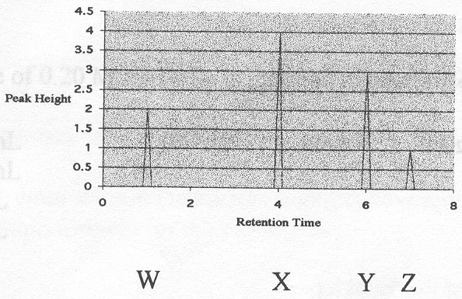
From the above chromatogram obtained for this test it can be concluded that
- W has a higher boiling point than X, Y or Z.
- X has the highest molecular mass of these four substances.
- Y was absorbed less strongly onto the stationary phase than Z.
- Z was the first to leave the column

Question 10
Increasing the concentration of a reactant
- usually increases the reaction rate
- usually decreases the reaction rate
- has no effect on the reaction rate
- only increases the reaction rate if a catalyst is present

Question 11
Increasing the temperature of a reaction
- usually increases the reaction rate
- usually decreases the reaction rate
- has no effect on the reaction rate
- only increases the reaction rate if a catalyst is present

Question 12
At 1000°C, COF₂ decomposes according to the equation
2 COF₂ (g)  CO₂ (g) + CF₄ (g) K = 4.0
At the same temperature, the equilibrium constant for the equation ½ CF₄ (g) + ½ CO₂ (g)  COF₂ (g) is approximately
- –4.0
- 0.25
- 0.50
- 2.0

Question 13
An acid-base indicator, methylphthalein, can be represented by the following
blue anion (aq) + H⁺ (aq)  yellow molecule (aq) K = 10⁴ M^{–1}
The concentrations of the blue anion and the yellow molecule are equal at pH
- 0.25
- 4
- 7
- 10

Question 14
The pH of human blood is normally maintained at a level between 7.35 and 7.45. The following equilibria assist in controlling blood pH levels.
CO₂ (g) + H₂O (l)  H₂CO₃ (aq)  H⁺ (aq) + HCO₃– (aq)
When a person hyperventilates, caused by breathing too rapidly, the level of dissolved carbon dioxide in the blood decreases. This will
- cause blood pH to rise
- reduce the volume of water in the blood
- cause blood pH to fall
- not affect the pH of the blood because the concentration of H⁺ ions always equals the concentration of HCO₃– ions

Question 15
C₄H₇OH has a number of possible isomers. The total number of possible isomers of the straight chain molecule is
- 4
- 5
- 6
- 7

Question 16
In order to monitor the Contact Process at a sulfuric acid plant, gas samples are taken at hourly intervals over a period of six hours. The graph below shows the percentage of sulfur trioxide in samples taken from the converter after the first pass over the catalyst bed.
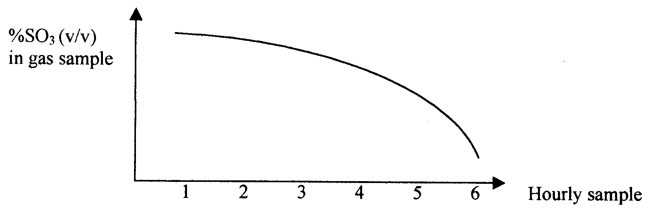
One possible explanation for these results over the time period studied is that
- the gas pressure in the converter increased
- the catalyst was being poisoned
- the reaction had reached equilibrium
- the temperature of the converter was decreasing

Question 17
While monitoring the reaction in the converter at another sulfuric acid plant, chemists discovered that although the temperature remained constant there was a leakage of gases from the vessel. The effect of escaping gases on the equilibrium would be to
- decrease the equilibrium constant
- increase the equilibrium constant
- shift the equilibrium to the produce side of the chemical equation
- increase the proportion of sulfur dioxide in the mixture

Question 18
The production of unsaturated hydrocarbons involves the cracking of alkanes. Which of the following statements is incorrect?
- Cracking is an exothermic reaction.
- The catalyst lowers the temperature required by lowering the energy of the products.
- The extent of the reaction is favoured by higher temperatures and lower pressures.
- The products have a lower relative molecular mass
Question 19
In order to see if polymers could be improved, research chemists synthesised polyvinyl fluoride. The monomer needed to produce this polymer is
- CF₂=CF₂
- –CHF–CH₂–CHF–CH₂–
- CH₂F–CH₂F
- CH₂=CHF

Question 20
A certain hydrocarbon was burnt in excess oxygen to produce equi-molar amounts of steam and carbon dioxide. 5.60 g of the compound was found to occupy 2.24 L at STP. The hydrocarbon was found to decolourise bromine solution. The semi-structural formula of the compound must have been
A. | CH₂CH₂ | B. | CH₃CH₂CH₃ | C. | CH₃CHCHCH₃ | D. | 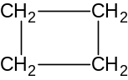

Section B – Short Answer Questions

Question 1 (10minutes, 8marks)
Maxi-Sweet tablets contain the artificial sweetener saccharin, C₇H₅NO₃S. During production, regular analysis of the tablets is carried out to ensure the quality of the product. The saccharin content per tablet is determined by gravimetric analysis. The S is oxidised to SO₄^{2–} ions, which are then precipitated using excess barium chloride, BaCl₂ solution.

- Write an ionic equation for the precipitation of the sulfate ions.
________________________________________________________________________________________________

During the analysis, 10 Maxi-Sweet tablets were crushed and the S oxidised to SO₄^{2–} ions. This solution was then filtered and excess barium chloride solution was added to the filtrate. The precipitate formed was filtered out, washed, dried and weighed.

- Why was the table solution filtered prior to the addition of barium chloride?
________________________________________________________________________________________________
________________________________________________________________________________________________
- It was found that 1.568 g of barium sulfate precipitate was formed. Calculate the mass of saccharin present in the sample.
________________________________________________________________________________________________
________________________________________________________________________________________________
________________________________________________________________________________________________
________________________________________________________________________________________________
________________________________________________________________________________________________
________________________________________________________________________________________________
- Determine the mass of saccharin per tablet.
________________________________________________________________________________________________
________________________________________________________________________________________________
- If the average mass of a Maxi-Sweet tablet is 205 mg, calculate the percentage of saccharin per tablet.
________________________________________________________________________________________________
________________________________________________________________________________________________
- What simple test could be performed to ensure that all sulfate ions were precipitated during the analysis?
________________________________________________________________________________________________
________________________________________________________________________________________________
- What steps should have been taken to ensure that the precipitate contained no moisture?
________________________________________________________________________________________________
________________________________________________________________________________________________
(1 + 1 + 2+ 1 + 1 + 1 + 1 = 8 marks)

Question 2 (3 minutes, 2 marks)
When chlorine gas is bubbled through water, it reacts to form a mixture of hydrochloric acid, HCl (aq) and hypochlorous acid, HOCl (aq). This is shown by the following equation
Cl₂ (g) + H₂O (l) → HOCl (aq) + H⁺ (aq) + Cl– (aq)

- Write the half equation for the oxidation of chlorine gas.
________________________________________________________________________________________________
- Write the half equation for the reduction of chlorine gas.
________________________________________________________________________________________________
(1 + 1 = 2 marks)

Question 3 (10 minutes, 8 marks)
Two sunscreen products, Zincbloc and Rayscreen were tested for the amounts of zinc that each contained, using an Atomic Absorption Spectrometer. The zinc content measured in gram per gram, g/g, of these particular sunscreens determines how effective they are in blocking out the sun’s rays. The instrument was first calibrated using standard solutions. The results are shown in the following table.

Standard | Concentration of Zn²⁺ (mg/L) | Absorbance
Standard 1 | 0.50 | 0.309
Standard 2 | 0.80 | 0.417
Standard 3 | 1.20 | 0.671
Standard 4 | 1.50 | 0.789

- Sketch a calibration curve of the absorbance against concentration of zinc (g/L) using the grid below.

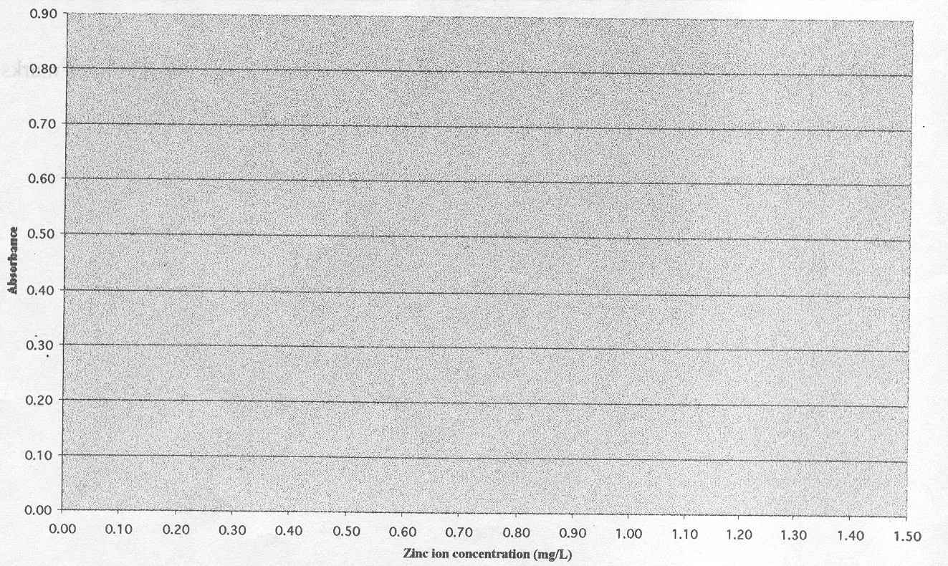

5.00 gram samples of each sunscreen were then treated to extract their zinc content and diluted to 1.00 L. Both solutions were then further diluted by a factor of 100.

These solutions were then analysed and the following absorbances recorded.

 | Concentration of Zn²⁺ (mg/L) | Absorbance
Sample 1 Zincbloc |  | 0.407
Sample 2 Rayscreen |  | 0.715

- Using the calibration graph, complete the table above with the concentrations of the zinc ion in the diluted samples.
- Calculate the mass in gram of zinc in each 5.00 g sample.
Zincbloc ________________________________________________________________________________________
________________________________________________________________________________________________
Rayscreen _______________________________________________________________________________________
________________________________________________________________________________________________
- Calculate the percentage mass of zinc present in the two samples of sunscreen and comment on which is the more effective sunscreen.
________________________________________________________________________________________________
________________________________________________________________________________________________
________________________________________________________________________________________________
________________________________________________________________________________________________
________________________________________________________________________________________________
- Why were the two samples further diluted after extraction of the zinc?
________________________________________________________________________________________________
________________________________________________________________________________________________
- Why was a zinc cathode lamp used in this AAS analysis?
________________________________________________________________________________________________
________________________________________________________________________________________________
________________________________________________________________________________________________
(2 + 1 + 1 + 2 + 1 + 1 = 8 marks)

Question 4 (12 minutes, 9 marks)
Lawn Sand is made of coarse granules of sand containing ammonium sulfate, (NH₄)₂SO₄, shich fertilises the lawn and iron(II) sulfate, FeSO₄, which kills off moss. To analyse the ammonium sulfate content of the Lawn Sand, a chemistry student followed the procedure outlined below.

A sample of Lawn Sand was weighed accurately and then boiled with 50.0 mL of 0.125 M NaOH. Water was added to maintaine the volume in the flask. The excess NaOH was titrated with 0.114 M H₂SO₄. The studetn’s results are shown in the table below:

Mass of Lawn Sand | Initial burette reading | Final burette reading | Titre
2.46 g | 3.45 mL | 17.20 mL | 13.75 mL

- Write a full equation for the neutralisation of the excess sodium hydroxide with the sulfuric acid.
________________________________________________________________________________________________
- Calculate the amount (in mol) of sulfuric acid needed to neutralise the excess sodium hydroxide in the flask.
________________________________________________________________________________________________
________________________________________________________________________________________________
- Determine the amount (in mol) of sodium hydroxide remaining in the flask after reaction with the Lawn Sand.
________________________________________________________________________________________________
________________________________________________________________________________________________
- Calculate the amount (in mol) of the sodium hydroxide that reacted with the ammonium sulfate in the Lawn Sand.
________________________________________________________________________________________________
________________________________________________________________________________________________
________________________________________________________________________________________________
________________________________________________________________________________________________
- Write a full equation for the neutralisation of ammonium sulfate with sodium hydroxide.
________________________________________________________________________________________________
- Calculate the amount (in mol) of ammonium sulfate in the sample of Lawn Sand.
________________________________________________________________________________________________
________________________________________________________________________________________________
- Calculate the percentage by mass of ammonium sulfate in the Lawn Sand.
________________________________________________________________________________________________
________________________________________________________________________________________________
________________________________________________________________________________________________
________________________________________________________________________________________________
(1 + 1 + 1 + 2 + 1 + 1 + 2 = 9 marks)

Question 5 (15 minutes, 12 marks)
Nitrosyl chloride , NOCl, can be produced from the following reaction
2 NO (g) + Cl₂ (g)  2 NOCl (g) ΔH = –120 kJ mol^{–1}

- Describe three different ways in which the equilibrium yield of NOCl might be increased. In each case state the effect of the strategy on the equilibrium constant, K.
Method 1
________________________________________________________________________________________________
________________________________________________________________________________________________
Effect on K ______________________________________________________________________________________
Method 2
________________________________________________________________________________________________
________________________________________________________________________________________________
Effect on K ______________________________________________________________________________________
Method 3
________________________________________________________________________________________________
________________________________________________________________________________________________
Effect on K ______________________________________________________________________________________

The graph below shows concentrations of the three gases plotted against time.
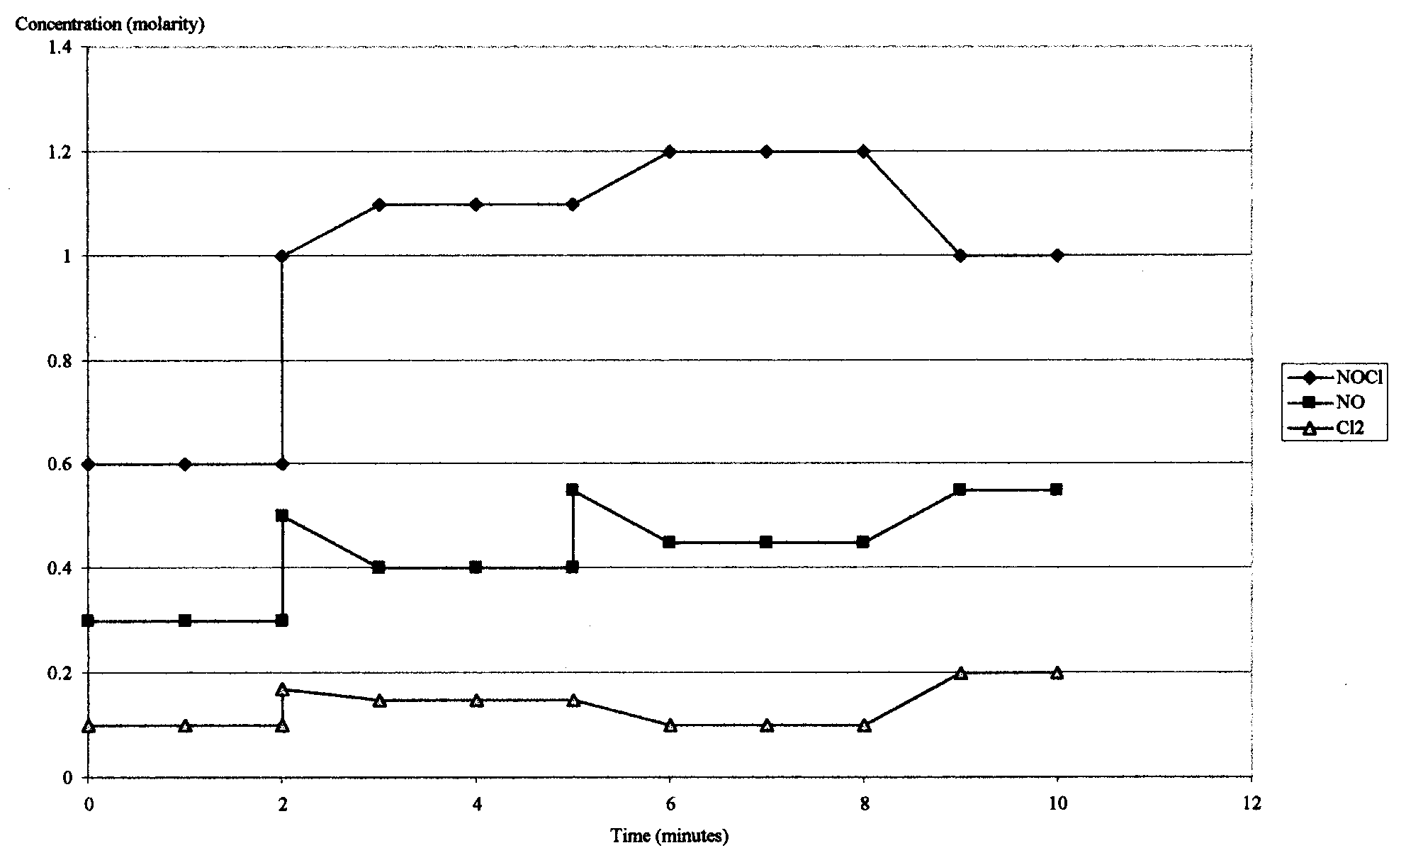

- What event happened to cause the change an dhow did the system respond at the following times?
2 minutes
________________________________________________________________________________________________
________________________________________________________________________________________________
5 minutes
________________________________________________________________________________________________
________________________________________________________________________________________________
8 minutes
________________________________________________________________________________________________
________________________________________________________________________________________________
- Write an expression for the equilibrium constant of this system.

- Calculate the equilibrium constant at the 4 minute mark.
________________________________________________________________________________________________
________________________________________________________________________________________________
________________________________________________________________________________________________
________________________________________________________________________________________________
(3 + 6 + 1 + 2 = 12 marks)

Question 6 (6 minutes, 5 marks)
Consider the following molecules

- Br₂ | - CH₃CH₂OH | - CH₂CH₂ | - CH₃CO₂H
- C₄H₁₀ | - C₅C₁₁Cl | - H₂O | - CH₃OH
- HCl | - HOCH₂CH₂OH | - CH₃CH₂NH₂ | - CO₂

- Which molecules are possible reactant in addition reactions

- Which molecules are in the same homologous series?

- Which molecule could act as a monomer in a condensation polymerisation reaction?

- Which molecules are produced when alkanes are burnt in excess oxygen?

- Which molecules are products when chloroethane reacts with ammonia?

(1 + 1 + 1 + 1 + 1 = 5 marks)

Question 7 (8 minutes, 6 marks)
Consider the following chemical reactions.
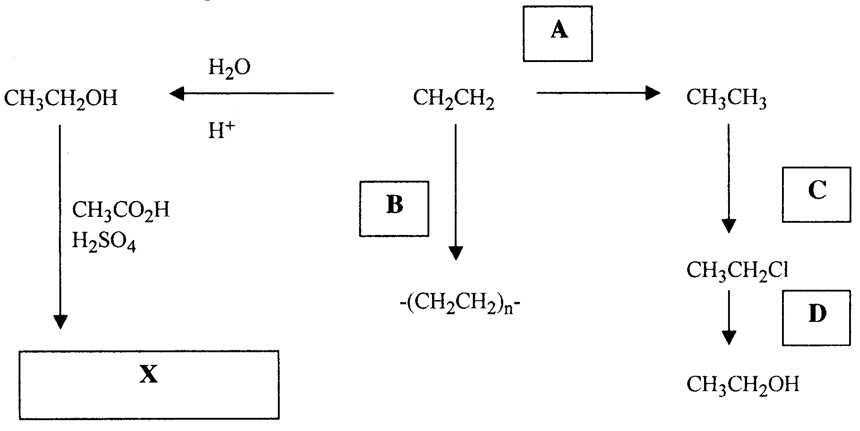

- Name the type of reaction that occurred at
A _______________________
B _______________________
C _______________________
D _______________________
- Draw the structural formula for the product X.

- Name the product X.
________________________________________________________________________________________________
(4 + 1 + 1 = 6 marks)

