IARTV 2000 | CHEMISTRY | Unit 4 | Trial Examination Solutions

Section A Multiple Choice Questions (1 mark per question)

- D
- A
- C
- A
- A
- D
- C
- D
- B
- D
- B
- B
- D
- D
- A
- A
- C
- C
- B
- B

In Q5 students should recognise that the large emf of the magnesium and copper half-cells will drive the electrons in the left to right direction causing nickel to be oxidised and zinc to be reduced by electrolysis.

Section B Short Answer

Question 1 (9 marks)
a. | CH₄ (g) + 2 O₂ (g) → CO₂ (g) + 2 H₂O (g) ΔH = –890 kJ mol^{–1} |  | 1 mark
b. | ΔH(methane) = 9.50 × 10^{–3} × 890 = 8.455 kJ |  | 1 mark
 | CF = 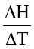  = 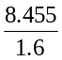  = 5.28 kJ °C^{–1} = 5.28 × 10³ J °C^{–1} |  | 1 mark
c. | (i) | E = V I t  = 6.01 × 5.00 × 3.00 × 60  = 5.41 × 10³ J | 1 mark
 | (ii) | E = CF × ΔT | 1 mark
 |  | ΔT = 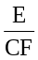 = 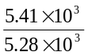 = 1.02°C | 1 mark
 | The temperature should rise to 23.8 + 1.0 = 24.8 °C |  | 1 mark
d. | Disadvantages:  - more CO₂ produced (twice that of methane)  - combustion of coal is less efficient, partly due to the fact coal is wet  - power has to be produced at the site of the coal mine, whereas CH₄ can be piped to a more convenient location  - particulate matter produced  - oxides of sulphur and nitrogen produces, which cause acid rain and other environmental and health problems  - site damage |  | Any one  1 mark
 | Advantages:  - coal is cheap  - large reserves |  | Any one  1 mark

Question 2 (13 marks)
a. | Negative | 1 mark
b. | Cathode | 1 mark
c. | [Cu(NH₃)₄]²⁺ (aq) + 2 e– → Cu (s) + 4 NH₃ (aq) but accept Cu²⁺ (aq) + 2 e– → Cu (s) | 1 mark
d. | Q = I t = 3.50 × 10.00 × 60 = 2.10 × 10³ C | 1 mark
e. | n(e–) = 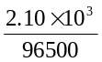 | 1 mark
 | n(Cu) = 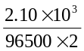 = 0.01088 mol | 1 mark
 | m(Cu) = 0.01088 × 63.5 = 0.691 g | 1 mark
f. | n(Cu) = n(Cu(NH₃)₄(H₂O)₂SO₄) = 0.01088 mol | 1 mark
 | Relative formula mass calculated from the experiment = = 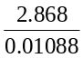 = 263.6 | 1 mark
 | Relative formula mass calculated from A_{r} = 63.5 + ( 4 × 17.0) + (2 × 18.0) + 32.1 + (4 × 16.0) = 263.6  This is the same as that arrived at by experiment. | 1 mark
g. | 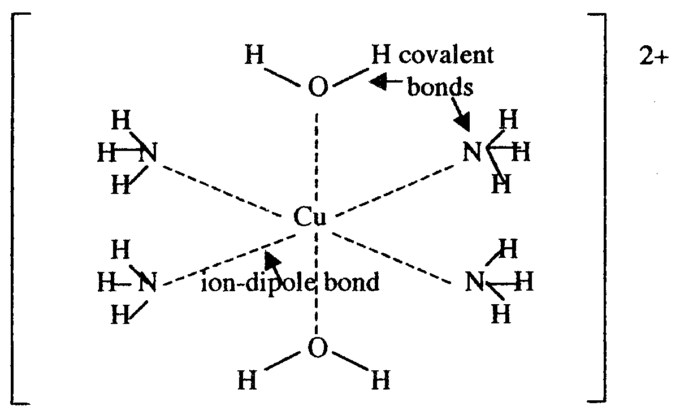  structure = 1 mark, bonds = 2 marks | 3 marks

Question 3 (5 marks)
a. | (i) and (ii) Two of the following (half mark each)  - lighter  - non-polluting  - continuous supply of energy (cell doesn’t go flat)  - more efficient |  |  |  | 1 mark
b. | (i) | oxygen |  |  | 1 mark
 | (ii) | anode: | H₂ (g) → 2 H⁺ (aq) + 2 e–
 |  | cathode: | O₂ (g) + 4 H⁺ (aq) + 4 e– → 2 H₂O (l) | half mark for each equation | 1 mark
 | (iii) | 2 H₂ (g) + O₂ (g) → 2 H₂O (l0 |  |  | 1 mark
c. | One of:  - electrodes must be porous to gases  - electrodes must catalyse the reaction  - electrodes must be non-reactive |  |  |  | 1 mark

Question 4 (4 marks)
a. | Carbohydrates |  |  |  |  | 1 mark
b. | C₁₂H₂₂O₁₁ (aq) + 12 O₂ (g) → 12 CO₂ (g) + 11 H₂O (l or g) |  |  |  |  | 1 mark
c. | 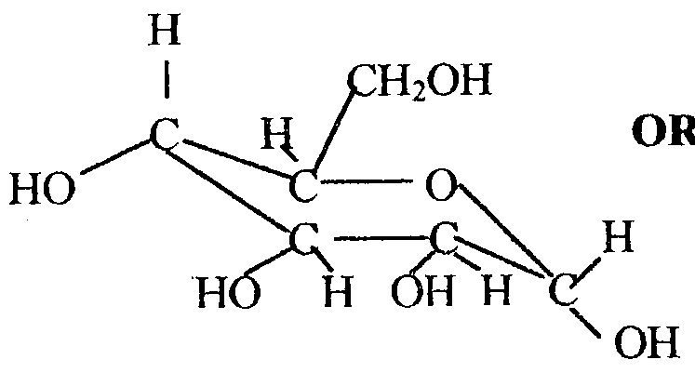 |  | or |  | 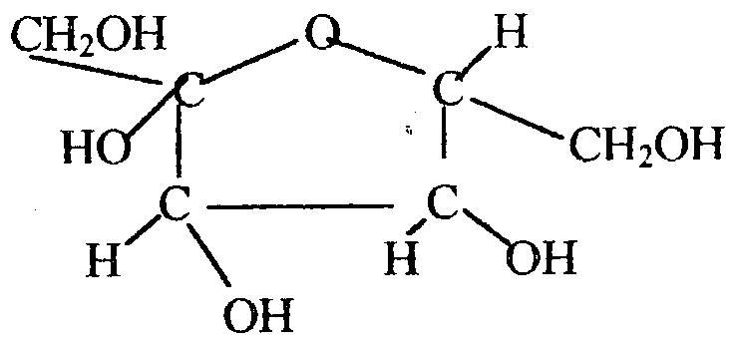 | 1 mark
d. | –OH | Hydroxy |  | half mark each for correctly circling and naming |  | 1 mark

Question 5 (8 marks
a. | Nitrogen fixation or reduction |  |  | 1 mark
b. | Some plants such as legumes have nodules where nitrogen-fixing bacteria convert nitrogen into a soluble form. |  |  | 1 mark
c. | To make amino acids or proteins |  |  | 1 mark
d. | Any α-amino acid.  half mark for recognising that it is an amino acid, half mark for correct structural formula |  |  | 1 mark
e. | N₂ (g) + O₂ (g) → 2 NO (g) |  |  | 1 mark
f. | Products of digestion | Elements present | Names of waste products
f. | glucose | C, H, O | carbon dioxide; water
f. | glycine | C, H, O, N | carbon dioxide; water; urea
f. | glycerol | C, H, O | carbon dioxide; water
 | half mark for each fully correct box |  |  | 3 marks

Question 6 (11 marks
a. | (i) | No, because a relative atomic mass between 20.2 and 23.0 would mean that the element would have to have an atomic number below 23 and all these elements have been discovered. | 1 mark
 | (ii) | It must be an isotope of an existing element, possibly a heavy isotope of neon or a light isotope of sodium. | 1 mark
b. | Neutrons are present in almost equal numbers as the protons I the lighter elements. Rutherford could not explain the observation because he did not know of the existence of neutrons. |  | 1 mark
c. | The relative atomic mass is the weighted mean of the naturally occurring isotopes (in this case copper-63 and copper-65) on a scale in which carbon12 has a value of 12 units exactly. The proportion of copper-63 atoms is greater than the proportion of copper-65 atoms in naturally occurring copper. |  | 1 mark
d. | As successive protons are added to the nucleus of atoms of elements across a period, the net positive charge of the nucleus plus the inner electrons (sometimes referred to as the core charge) increases. This pulls the outer shell electrons more strongly towards the nuclear and the atomic radius decreases. Sodium with a core charge of +1 is therefore larger than chlorine with a core charge of +7, even though they have the same number of occupied electron shells. |  | 1 mark
e. | (i) | Na₂O (s) + H₂SO₄ (aq) → Na₂SO₄ (aq) + H₂O (l) | 1 mark
 | (ii) | SO₃ (g) + 2 NaOH (aq) → Na₂SO₄ (aq) + H₂O (l) | 1 mark
f. | (i) | 1s² 2s² 2p⁶ 3s² 3p⁶ 3d⁵ 4s¹ | 1 mark
 | (ii) | 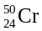 + 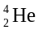 → 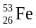 + 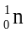 | 1 mark
 | (iii) | a neutron | 1 mark
 | (iv) | green because KCr₂O also has chromium in the +3 oxidation state.  half mark for colour and half mark for explanation | 1 mark

