NEAP 2000 | Unit 3 Chemistry | Trial Examination Solutions

Section A – Multiple choice questions

- D
- B
- C
- A
- C
- D
- B
- C
- A
- D
- A
- B
- B
- C
- D
- D
- C
- A
- A
- B

Section B – Short Answer Questions

Question 1
a. | A species capable of donating one proton. |  |  | 1 mark
b. | i. | n(NaOH) = c × V = 0.100 × 9.55 × 10^{–3} = 9.55 × 10^{–4} mol |  | 1 mark
 | ii. | n(compound)_{in 20.00 mL} = n(NaOH) = 9.55 × 10^{–4} mol |  | 1 mark
 |  | n(compound)_{in 250.0 mL} = 9.55 × 10^{–4} × 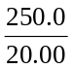 = 0.0119 mol |  | 1 mark
 | iii. | M(compound) = 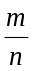 = 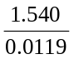 = 129 g mol^{–1} |  | 1 mark
c. | i. | Empirical formula mss = (12.0 + 1.0 + 16.0 + 35.5 = 64.5  Molecular formula mass = 129  ∴ MF = EF × 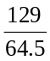 = C₂H₂O₂Cl₂ |  | 1 mark
 | ii. | 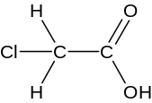  (Structure must show a monoprotic acid) |  | 1 mark
d. | i. | Any two of:  - known formula  - must not deteriorate on standing  - high molar mass to minimise weighing errors  - soluble in chosen solvent  - must be pure and react fully according to a known equation | ½ + ½ marks
 | ii. | Sodium hydroxide (solid) absorbs water from the air. Sodium hydroxide (solution) reacts with carbon dioxide |  | 1 mark
 |  | 2 NaOH (aq) + CO₂ (g) → Na₂CO₃ (aq) + H₂O (l) |  | 1 mark
 |  | Total 10 marks

Question 2
a. | i. | 4 NH₃ (g) + 5 O₂ (g) → 4 NO (g) + 6 H₂O (g) |  |  |  |  |  | 1 mark
 | ii. | Rate of reaction is too slow. |  |  |  |  |  | 1 mark
b. | ii. | K = 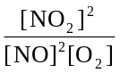 M^{–1} |  |  |  |  |  | 1 mark
 | ii. |  |  | 2 NO | O₂ | 2 NO₂ |  | 1 mark
 | ii. |  | c_{i} | 0.010 | 0.020 | 0 |  | 1 mark
 | ii. |  | change | –0.0060 | –0.0030 | +0.0060 |  | 1 mark
 | ii. |  | c_{e} | 0.0040 | 0.017 | 0.0060 |  | 1 mark
 |  | [NO] = 0.0040 M [O₂] = 0.017 M [NO₂] = 0.0060 M |  |  |  |  |  | 2 marks
 | iii. | K = 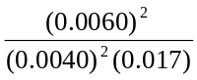 = 1.3 × 10² M^{–1} |  |  |  |  |  | 1 mark
c. | 68% w/w ⇒ 68 g of HNO₃ in 100 g of solution  V = 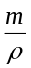 ⇒ 68 g of HNO₃ in 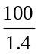 mL of solution  ⇒ 68 × 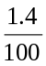 × 100 g of HNO₃ in 1000 mL of solution  n = 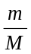 ⇒ 68 × × 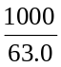 mol of HNO₃ in 1000 mL of solution  ⇒ 15 mol L^{–1} |  |  |  |  |  |  | 1 mark
Total 8 marks

Question 3
a. | i. | n(CH₄) = = 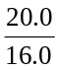 = 1.25 mol | ½ mark
 |  | n(H₂) = 3 × n(CH₄) = 3 × 1.25 = 3.75 mol | ½ mark
 |  | m(H₂) = n × M = 3.75 × 2 = 7.50 g | ½ mark
 | ii. | The reaction has reached equilibrium. | ½ mark
 |  | ie. the rate of formation of products equals the rate of reaction of products,  so mass of hydrogen remains constant, but less than the 7.50 g calculated.  The extent of reaction is not 100%. | 1 mark
b. | Graph I |  | ½ mark
 | The catalyst will increase the rate of reaction, but will not alter the equilibrium yield of hydrogen. |  | 1 mark
c. | Graph II |  | ½ mark
 | The reaction is endothermic. Raising the temperature will increase the equilibrium yield of H₂ (in addition to increasing the reaction rate). |  | 1 mark
Total 6 marks

Question 4
a. | Any two of:
 |  |  | 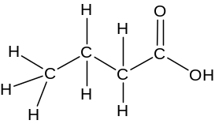 |  | 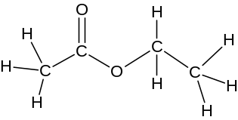 |  | (1 + 1)× 2 marks
 |  |  | butanoic acid |  | ethyl ethanoate
 |  |  | 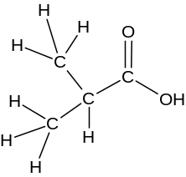 |  | 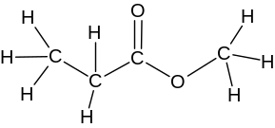
 |  |  | 2-methyl propanoic acid |  | methyl propanoate
b. | i. | X H₂O (l) / H⁺ (aq) |  |  |  |  |  | ½ mark
 |  | Y Cr₂O₇^{2–} (aq) / H⁺ (aq) or MnO₄– (aq) / H⁺ (aq) or other suitable oxidant |  |  |  |  |  | ½ mark
 | ii. | X addition, hydrolysis |  |  |  |  |  | ½ mark
 |  | Y oxidation |  |  |  |  |  | ½ mark
 | iii. | CH₃COOH (aq) + CH₃CH₂OH (aq) 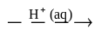 CH₃OOCH₂CH₃ (aq) + H₂O (l) |  |  |  |  |  | 1 mark
Total 7 marks

Question 5
a. | i. | 197 + 460 = 657 kJ mol^{–1} | 1 mark
 | ii. | = –98.5 kJ mol^{–1} | 1 mark
 | iii. | K’ = = = 2.51 × 10^{–3} M | 1 mark
b. | i. | SO₃ (g) + H₂SO₄ (l) → H₂S₂O₇ (aq) | 1 mark
 | ii. | The reaction is highly exothermic and generates a mist of acid droplets. | 1 mark
 | iii. | Absorption into H₂SO₄ to produce oleum  SO₃ (g) + H₂SO₄ (l) → H₂S₂O₇ (l) | 1 mark
 |  | Dilution to produce H₂SO₄  H₂S₂O₇ (l) + H₂O (l) → 2 H₂SO₄ (l) | 1 mark
c. | i. | CuO (s) + H₂SO₄ (aq) → CuSO₄ (aq) + H₂O (l) | 1 mark
 | ii. | CH₃CH₂OH (l) 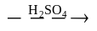 CH₂CH₂ + H₂O (g) | 1 mark
Total 9 marks

