NEAP
2000
CHEMISTRY
Unit 3 Exam

Section A – Multiple Choice

Question 1
Which of the following is a form of quantitative analysis?
- Identifying the presence of steroids in a urine sample using UV-visible spectroscopy.
- Detecting traces of methanol in petrol samples using gas-liquid chromatography.
- Separating the pigments in a plant leaf extract using thin-layer chromatography.
- Analysing the alcohol content of a home-brewed beer using titration with acidified dichromate solution.

Questions 2 and 3 refer to the following information

A Vegemite sample contains 7.6% by mass salt (NaCl). A 2.73 g sample of Vegemite was dissolved in water, excess silver nitrate (AgNO₃) solution added, and the silver chloride (AgCl) precipitate obtained was dried.

M(NaCl) = 58.5 g mol⁻¹ M(Ag NO₃) = 143.4 g mol⁻¹

Question 2
The expected mass of silver chloride obtained is
- 0.0846 g
- 0.509 g
- 0.621 g
- 6.69 g

Question 3
The actual mass of silver chloride obtained was greater than the value calculated in Question 2. Which of the following would not account for the larger than expected mass of precipitate?
- The Vegemite also contained some iodide ions which precipitated as silver iodide.
- The precipitate was not completely dry when weighed.
- The Vegemite sample was incorrectly weighed and had a true mass of 2.61 g.
- The precipitate was not washed with water prior to drying.

Question 4
Which of the following molecules would be likely to undergo condensation polymerisation?
- HOCH₂COOH
- CHClCHBr
- CH₃CN
- CH₃CH(OH)CH₃

Question 5
A sugary substance isolated from milk was treated with hydrochloric acid. The resulting solution was analysed using thin-layer chromatography (TLC). Several known sugars were also placed on the TLC plate for reference. The chromatogram obtained is shown below.
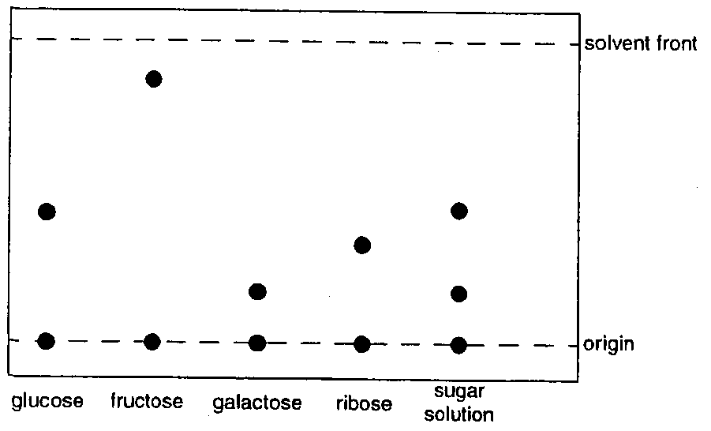
The chromatogram indicates that acid treatment of the milk sugar breaks it down into
- glucose only
- ribose and galactose
- glucose and galactose
- glucose, ribose and galactose
Question 6
Magnesium reacts with water to slowly form hydrogen gas and magnesium hydroxide. The reaction may be represented by the equation:
Mg (s) + 2 H₂O (l) → Mg(OH)₂ (aq) + H₂ (g)
During this reaction, water is acting as
- an acid
- a base
- a reductant
- an oxidant

Question 7
The Contact process for sulfuric acid production uses a V₂O₅ catalyst to increase the rate of the reaction
2 SO₂ (g) + O₂ (g)  2 SO₃ (g)
The V₂O₅ catalyst is used in pellet form. Which of the following best explains why pellets are used in preference to sheets of V₂O₅?

Pellets increase the reaction rate more than sheets because pellets have
- greater surface area leading to a greater decrease in the activation energy for the reaction.
- greater surface area leading to a greater number of successful collisions between reactant molecules.
- less surface area leading to a greater decrease in the activation energy for the reaction.
- less surface area leading to a greater number of successful collisions between reactant molecules.

Question 8
A 1.00 mL sample of hydrochloric acid which has a pH of 2 is diluted to 100 mL with water. The pH of the solution is now
- 2
- 3
- 4
- 7

Question 9
A “Composition of Foods” table lists the iron content of tomato sauce as 0.2 mg of Fe in 1.0 tablespoon (equivalent to 22 g) of sauce. Atomic absorption spectroscopy was used to verify this value, using the calibration curve shown below.
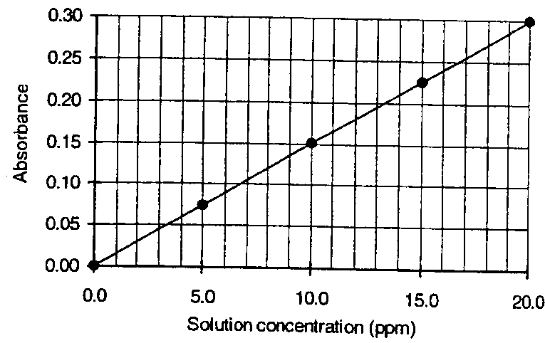
A sauce sample was diluted from 5.0 mL to 10.0 mL and the absorbance of the diluted sample measured in the spectrometer. The expected absorbance of the diluted sample is approximately
- 0.07
- 0.14
- 0.20
- 0.27

Question 10
Which of the following reactions involves neither oxidation nor reduction?
- Fe (s) + Cu²⁺ (aq) → Fe²⁺ (aq) + Cu (s)
- NH₄NO₂ (s) → N₂ (g) + 2 H₂O (g)
- Cl₂ (g) + H₂O (l) → HCl (aq) + HOCl (aq)
- Zn(OH)₂ (s) + 2 H⁺ (aq) → Zn²⁺ (aq) + 2 H₂O (l)

Question 11
During the thermal cracking of saturated hydrocarbons
- the pressure of the reaction mixture increases as the products form
- some larger unsaturated hydrocarbons are produced
- the total enthalpy of the products is less than that of the reactants
- heat is evolved due to the exothermic nature of the reaction

Question 12
Gas-liquid chromatography (GLC) may be used to separate mixtures of hydrocarbons. The common names and boiling points of four hydrocarbons are listed below:

Name | Boiling Point (°C)
allene | -35
1,3-butadiene | -4
isoprene | 34
hexene | 64

When a mixture containing these four hydrocarbons was passed through a GLC instrument, the following chromatogram was obtained:
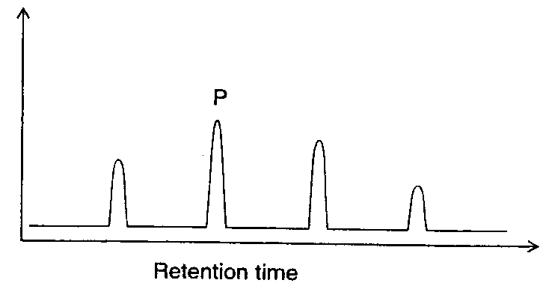
The peak labelled P is most likely to be
- allene
- 1,3-butadiene
- isoprene
- hexene

Question 13
The acidity constant, K_{a}, of a weak acid, HZ, is 4.0 × 10⁻⁷. The pH of a 0.5 M solution of HA is closest to
- 3.20
- 3.35
- 6.40
- 6.70

Question 14
Copper(II) nitrate decomposes on heating, according to the equation
2 Cu(NO₃)₂ (s) 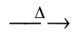 2 CuO (s) + 4 NO₂ (g) + O₂ (g)
When 50.0 g of copper(II) nitrate is heated, the volume of gas produced at STP is
- 5.97 L
- 11.9 L
- 14.9 L
- 29.9 L

Question 15
Consider the following system at equilibrium:
Fe³⁺ (aq) + SCN⁻ (aq)  Fe(SCN)²⁺ (aq) ΔH < 0
Fe(SCN)²⁺ has a distinctive red colour. Which one of the following changes would lead to an increase in the red colour?
- Addition of water to increase solution volume
- Temperature increase
- Addition of OH⁻, which reacts according to the equation Fe³⁺ (aq) + 3 OH⁻ (aq)  Fe(OH)₃ (s)
- None of the above

Question 16
Which of the following contains the greatest number of atoms?
- 12.1 g of solid silver oxide (Ag₂O)
- 2.10 L of sulfur dioxide gas (SO₂) at 101.3 kPa and 25°C
- 20.0 mL of 0.10 M iron(III) nitrate (Fe(NO₃)₃) solution
- 2.36 × 10²⁵ molecules of oxygen gas (O₂)

Question 17
Before crude oil is separated into fractions and subsequently used to produce ethene by thermal cracking, it undergoes a desulfurisation process. Desulfurisation is necessary because the sulfur would
- poison the catalyst used during the thermal cracking process
- react with the ethene and hence reduce the yield of ethene
- form toxic gases when the fractions were burnt in air
- alter the boiling point of the hydrocarbon fractions and therefore interfere with the fractional distillation process

Question 18
20.0 mL of 0.200 M copper(II) nitrate (Cu(NO₃)₂) reacts with 25.0 mL of 0.150 M sodium hydroxide (NaOH) according to the equation:
Cu(NO₃)₂ (aq) + 2 NaOH (aq)  Cu(OH)₂ (s) + 2 NaNO₃ (aq)
The maximum mass of copper(II) hydroxide (Cu(OH)₂) that can be precipitated from the reaction is
- 0.183 g
- 0.366 g
- 0.390 g
- 0.731 g

Question 19
A substance X reacts to produce two products Y and Z according to the equation:
2 X (g)  2 Y (g) + Z (g)
The energy profile for this reaction is shown in the diagram below.
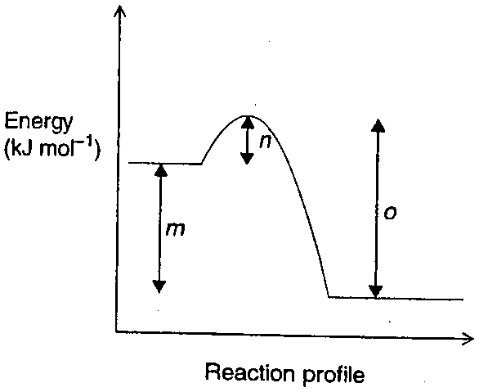
Which of the following statements concerning this reaction and graph is incorrect?
- m represents the energy absorbed when 2 mol of X reacts to produce 2 mol of Y and 1 mol of Z
- n represents the energy required to break the bonds within molecules of X
- (o – n) represents the enthalpy change for the reaction
- o represents the energy released when bonds form in Y and Z

Question 20
During a colorimetric procedure to determine the iron(III) (Fe³⁺) content of cement using the red thiocyanate complex ion Fe(SCN)²⁺, which of the following steps would be required?
- Addition of a coloured indicator to detect the endpoint
- Preparation of a number of solutions of Fe(SCN)²⁺ of accurately known concentration
- Addition of excess sodium hydroxide solution to produce a coloured precipitate of Fe(OH)₃
- Determination of the retention time of a standard solution containing Fe(SCN)²⁺

Section B – Short Answer Questions

Question 1
Analysis of an organic compound shows that it has the empirical formula CHOCl. Further tests indicate that the compound is a monoprotic acid.

A 1.540 g sample of this compound was dissolved and the volume made up to 250.0 mL in a volumetric flask. 20.00 mL aliquots of the solution were titrated with a recently standardized 0.100 M sodium hydroxide solution using an appropriate indicator. A titre of 9.55 mL was required to reach the endpoint.

- What is meant by the term monoprotic acid?
________________________________________________________________________________________________
________________________________________________________________________________________________
1 mark
- Calculate the
  - amount (in mol) of sodium hydroxide used.
___________________________________________________________________________________________
___________________________________________________________________________________________
  - amount (in mol) of the organic compound in the 1.540 g sample.
___________________________________________________________________________________________
___________________________________________________________________________________________
___________________________________________________________________________________________
  - molar mass of the organic compound.
___________________________________________________________________________________________
___________________________________________________________________________________________
4 marks
- (i) Determine the molecular formula of the organic compound.
___________________________________________________________________________________________
___________________________________________________________________________________________
(ii) molar mass of the organic compound.

2 marks
- Sodium hydroxide cannot be prepared as a primary standard, hence the sodium hydroxide solution used in the titration was recently standardised by titration with a standard solution of oxalic acid.
  - State two properties a substance must have in order to be used as a primary standard.
___________________________________________________________________________________________
___________________________________________________________________________________________
  - With the aid of an equation, explain why sodium hydroxide is not a primary standard.
___________________________________________________________________________________________
___________________________________________________________________________________________
___________________________________________________________________________________________
3 marks
Total 10 marks
(suggested time: 15 minutes)
Question 2
Consider the diagram below which shows the reactions of some simple organic compounds.

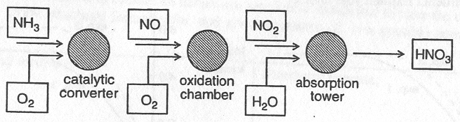

- (i) In the catalytic converter, gaseous ammonia reacts with oxygen to produce gaseous nitrogen monoxide (NO) and steam. Write a balanced equation for this reaction.
___________________________________________________________________________________________
(ii) The reaction to produce NO occurring in the converter is exothermic and would therefore give the greatest yield of NO at low temperatures. Suggest why low temperatures are not used.
___________________________________________________________________________________________
2 marks
- The reaction in the oxidation chamber may be represented by the equation:
2 NO (g) + O₂ (g)  2 NO₂ (g) ΔH = -114 kJ mol⁻¹
NO and O₂ are added to the reaction chamber and allowed to come to equilibrium at a temperature of T°C. The initial concentration of NO is 0.01 M and the initial concentration of O₂ is 0.020 M.
60% of the NO is consumed when equilibrium is reached.
- Write an expression for the equilibrium constant, K, for the reaction which produces NO₂.

- Calculate the equilibrium concentrations of NO, O₂ and NO₂.
___________________________________________________________________________________________
___________________________________________________________________________________________
___________________________________________________________________________________________
___________________________________________________________________________________________
___________________________________________________________________________________________
___________________________________________________________________________________________
- Hence calculate the value of the equilibrium constant, K, at T°C.

4 marks
- The nitric acid produced during this industrial process has a concentration of 68% w/w, and a density of 1.4 g mL⁻¹. calculate the molarity (mol L⁻¹) of the nitric acid produced.
________________________________________________________________________________________________
________________________________________________________________________________________________
________________________________________________________________________________________________
________________________________________________________________________________________________
2 marks
Total 8 marks
(suggested time: 12 minutes)

Question 3
Hydrogen may be prepared industrially by reacting methane and steam, according to the equation
CH₄ (g) + H₂O (g)  3 H₂ (g) + CO (g) ΔH = -114 kJ mol⁻¹
This reaction was investigated by measuring the mass of hydrogen formed at a temperature of 800°C. 20.0 g of methane was reacted with excess steam, and the mass of hydrogen formed was recorded at 10 minute intervals. The results are shown in the graph below.
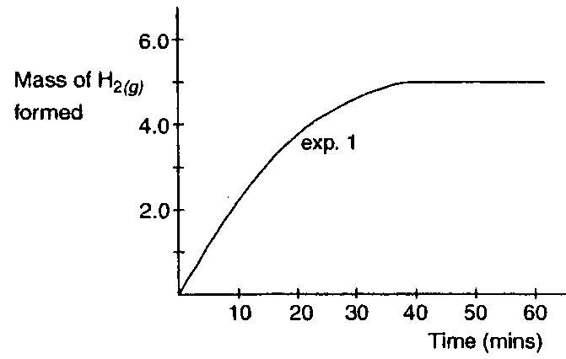

- (i) Calculate the mass of hydrogen expected when 20.0 g of methane reacts with excess steam according to the equation shown.
___________________________________________________________________________________________
___________________________________________________________________________________________
___________________________________________________________________________________________
(ii) Explain why the mass of hydrogen formed after 60 minutes is less than the value calculated in (i).
___________________________________________________________________________________________
___________________________________________________________________________________________
___________________________________________________________________________________________
3 marks
- The experiment was repeated under the same conditions, but a nickel catalyst was added to the reaction mixture.
Which of the graphs below (I or II) shows the expected results of this second experiment? Explain your choice.
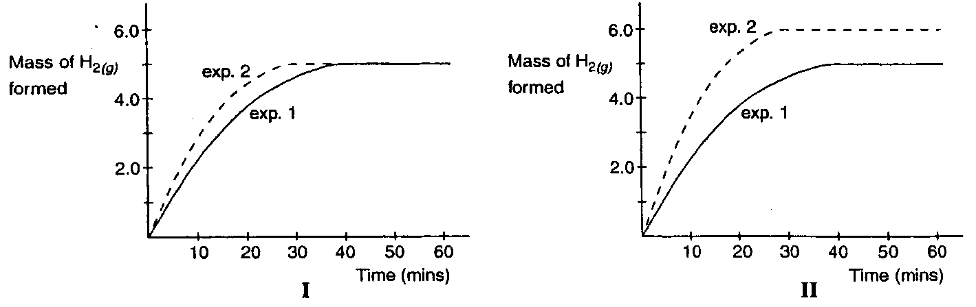
________________________________________________________________________________________________
________________________________________________________________________________________________
________________________________________________________________________________________________
1½ marks
- A third experiment was conducted. 20.0 g of methane was reacted with excess steam at a temperature of 1200 C. No catalyst was added.
Which of the graphs below (I or II) shows the expected results of this third experiment? Explain your choice.
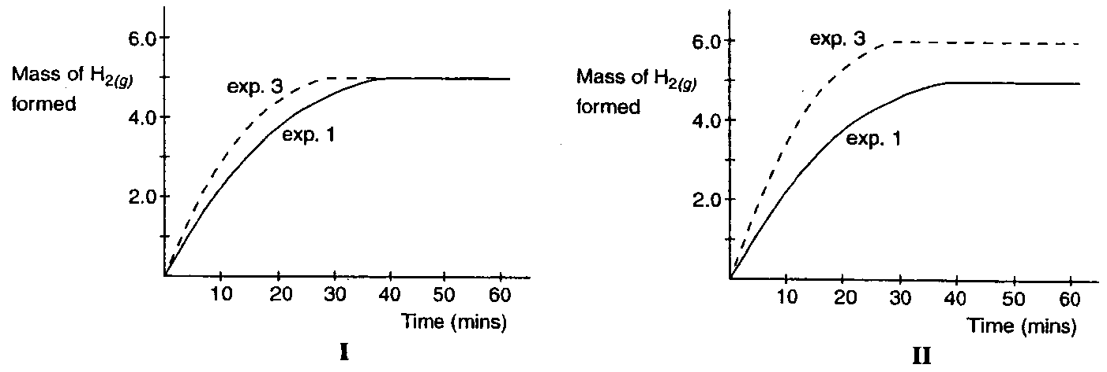
________________________________________________________________________________________________
________________________________________________________________________________________________
________________________________________________________________________________________________
1½ marks
Total 6 marks
(suggested time: 9 minutes)

Question 4
- Compound X is known to contain no carbon-carbon double bonds and to have the molecular formula C₄H₈O₂. Draw structural formulas for, and give the names of, two possible compounds which X could be.

Structural formula: | Structural formula:
Name: | Name:
4 marks
- The flowchart below outlines a sequence of reactions involved in the production of ethyl ethanoate. The questions which follow refer to this flowchart.

ethene |  | ethanol |  | ethanoic acid |  | ethyl ethanoate
ethene | X | ethanol | Y | ethanoic acid | Z | ethyl ethanoate

  - Give the chemical formulas for reagents and catalysts needed to complete the reactions labelled:
X ________________________________________________________________________________________
Y ________________________________________________________________________________________
  - Give a name for the type of reactions labelled:
X ________________________________________________________________________________________
Y ________________________________________________________________________________________
  - Write a balanced chemical equation fort he reaction labelled Z.
___________________________________________________________________________________________
3 marks
Total 7 marks
(suggested time: 10 minutes)

Question 5
The formation of sulfur trioxide gas from sulfur dioxide gas, shown in the equation below, is an impotant step in the Contact Process for sulfuric acid production.
2 SO₂ (g) + O₂ (g)  2 SO₃ (g) ΔH = -197 kJ mol⁻¹
The activation energy for this reaction is 460 kJ mol⁻¹.
The value of the equilibrium constant, K, at 500°C is 398 M⁻¹.

- Determine
  - the activation energy for the reaction 2 SO₃ (g)  2 SO₂ (g) + O₂ (g)
___________________________________________________________________________________________
  - ΔH for the reaction SO₂ (g) + ½ O₂ (g)  2 SO₃ (g)
___________________________________________________________________________________________
  - The value of the equilibrium constant at 500°C for the reaction
___________________________________________________________________________________________
3 marks
- (i) Sulfur trioxide may be reacted directly with water to produce sulfuric acid.
Write a balanced equation for this reaction.
___________________________________________________________________________________________
(ii) Explain why this direct reaction is not used in industry to produce sulfuric acid.
___________________________________________________________________________________________
___________________________________________________________________________________________
(iii) With the aid of equations, explain how the industrial production of sulfuric acid from sulfur trioxide is carried out.
___________________________________________________________________________________________
___________________________________________________________________________________________
___________________________________________________________________________________________
4 marks
- Sulfuric acid has the ability to ract in several different ways. Write balanced equations to show the action of sulfuric acid
  - in an acid-base reaction with copper(II) oxide powder.
___________________________________________________________________________________________
  - in the conversion of ethanol to ethene.
___________________________________________________________________________________________
2 marks
Total 9 marks
(suggested time: 14 minutes)

END OF QUESTION AND ANSWER BOOKLET

