NEAP 2000 | CHEMISTRY | Unit 4 | Trial Examination Solutions

Section A Multiple Choice Questions

- A
- B
- D
- A
- C
- B
- C
- B
- A
- D
- B
- B
- C
- D
- A
- C
- D
- A
- C
- D

Section B Short Answer

Question 1
a. | (i) | n(HCl) = c × V = 0.250 × 50.0 × 10^{–3} = 0.0125 mol  n(NaOH) = c × V = 0.250 × 50.0 × 10^{–3} = 0.0125 mol |  |  |  | 1 mark
 | (ii) | From the equation, 1 mol HCl reacting releases 55.6 kJ  ∴ 0.0125 mol HCl reacting releases x kJ  ∴ x = 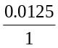 × 55.6 = 0.695 kJ |  |  |  | 2 marks
 | (iii) | CF = 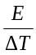 = 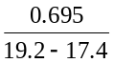 = 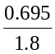 = 0.386 |  |  |  | 2 marks
b. | (i) | Error made during the procedure | Effect of the error on the value calculated for the calibration factor |  |  | 3 marks
b. | (i) | Error made during the procedure | higher value | lower value | no effect | 3 marks
b. | (i) | 1. 0.250 M nitric acid (HNO₃) was used in  place of hydrochloric acid. |  |  |  | 3 marks
b. | (i) | 2. The solutions used were labelled  0.250 M, but were actually 0.300 M. |  |  |  | 3 marks
b. | (i) | 3. The top was not placed on the  calorimeter during the reaction. |  |  |  | 3 marks
 | (ii) | The greater number of mole of reactants (0.0150 mol) would generate more heat and hence a larger increase in temperature. This would give a lower calculated value for the calibration factor (calibration factor = ). |  |  |  | 1 mark
Total 9 marks

Question 2
a. | (i) | 7(1.00783) + 7(1.00866) + 7(0.005486) = 14.15 |  | 1 mark
 | (ii) | Mass is converted to energy when the 14 nucleons fuse to form a stable nucleus. |  | 1 mark
b. | RAM = Σ (RIM × abundance fraction)  = (14.003 × 0.99633) + (15.001 × 0.003670)  = 14.01 |  |  | 2 marks
c. | 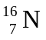 → 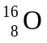 + 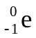 |  |  | 1 mark
d. | (i) | I | 
 |  | II | 
 |  | III |  | 1 mark
 | (ii) | Addition of fertiliser, eg NH₄NO₃. |  | 1 mark
Total 7 marks

Question 3
a. | (i) | It cannot be manufactured by the human body and must therefore be included in the diet. |  |  | 1 mark
 | (ii) | For example:  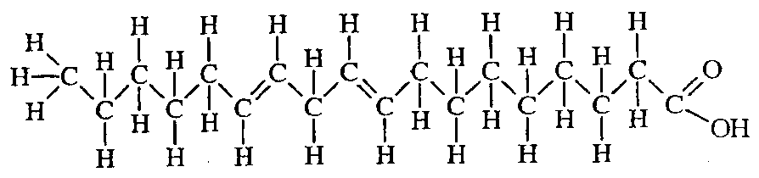  (18 carbon chain, –COOH group at end, two double bonds) |  |  | 1 mark
 | (iii) | Polyunsaturated – it contains more than one C=C double bond. |  |  | 1 mark
b. | (i) | Stearic acid.  Stearic acid is a saturated fatty acid. Its straight chain structure allows molecules to pack closely together to form “relatively strong” dispersion forces between molecules. This produces a higher boiling point than for linoleic acid, where the double bonds produce “bent” molecules which do not pack closely together. |  |  | 2 marks
 | (ii) | Linoleic acid | C₁₈H₃₂O₂ (s) + 25 O₂ (g) → 18 CO₂ (g) + 16 H₂O (l)
 |  | Stearic acid | C₁₈H₃₆O₂ (s) + 26 O₂ (g) → 18 CO₂ (g) + 18 H₂O (l)
 |  | More oxygen is needed to completely oxidise stearic acid. |  |  | 2 marks
c. | (i) | A
 | (ii) | C
 | (iii) | G
 | (iv) | F |  | 4 × ½ = 2 marks
Total 9 marks

Question 4
a. | Fe²⁺ (aq) → Fe³⁺ (aq) + e–  H₂O₂ (aq) + 2 H⁺ (aq) + 2 e– → 2 H₂O (l)  H₂O₂ (aq) + 2 Fe²⁺ (aq) + 2 H⁺ (aq) → 2 H₂O (l) + 2 Fe³⁺ (aq) | 2 marks
b. | Fe³⁺ (aq) + 3 OH– (aq) → Fe(OH)₃ (s) | 1 mark
c. | For example: FeCl₄–  (a complex ion of Fe³⁺ and Cl–) | 1 mark
d. | Variable oxidation states (Fe²⁺ and Fe³⁺).  The energy of the 4s and 3d orbitals is similar. Electrons may be lost from either orbital to produce the two different ions.  or  Formation of complex ions (Fe(H₂O)₆²⁺, FeCl₄–).  Ion-dipole bonds form between the metal ion and a suitable ligand. Transition metal ions are relatively small with large charges, allowing complex ion formation.  or  Formation of coloured compounds.  Energy differences between the partially filled 3d orbitals are similar to the energy of photons in white light. This allows for the absorption of light as electrons move between the orbitals. | 2 marks
Total 6 marks

Question 5
a. | (i) | Sn²⁺ (aq) + 2 e– → Sn (s) | 1 mark
 | (ii) | 2 Br– (aq) → Br₂ (aq) + 2 e– | 1 mark
b. | (i) | Q = I t = 2.64 × (4 × 60 + 20) = 686.4 = 686 C | 1 mark
 | (ii) | 1 electron carries 1.60 × 10^{–19} C  ∴ n electrons carry 686.4 C  ∴ n = 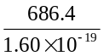 = 4.29 × 10²¹ electrons | 1 mark
 | (iii) | n(Sn) = 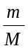 = 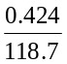 = 3.57 × 10^{–3} mol | 1 mark
 | (iv) | n(e–) = 2 × n(Sn) = 2 × 3.57 × 10^{–3} = 7.14 × 10^{–3} mol | 1 mark
 | (v) | 4.29 × 10²¹ electrons = 7.14 × 10^{–3} mol  N_{A} electrons = 1.00 mol  ∴ N_{A} = 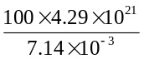 = 6.01 × 10²³ | 2 marks
c. | H₂O is a stronger oxidant than Mg²⁺, thus the cathode reaction would be the reduction of water to produce hydrogen and hydroxide ions, not the deposition of magnesium metal. |  | 1 mark
Total 9 marks

