STAV 2000 | Unit 3 Chemistry | Trial Examination Solutions

Section A – Multiple choice questions

- B
- C
- C
- A
- C
- B
- D
- D
- B
- B
- D
- D
- D
- A
- C
- A
- D
- C

Section B – Short Answer Questions

Question 1
- butane C₄H₁₀ (1 mark)
2 C₄H₁₀ (g) + 13 O₂ (g) → 8 CO₂ (g) + 10 H₂O (l) (1 mark)
 | 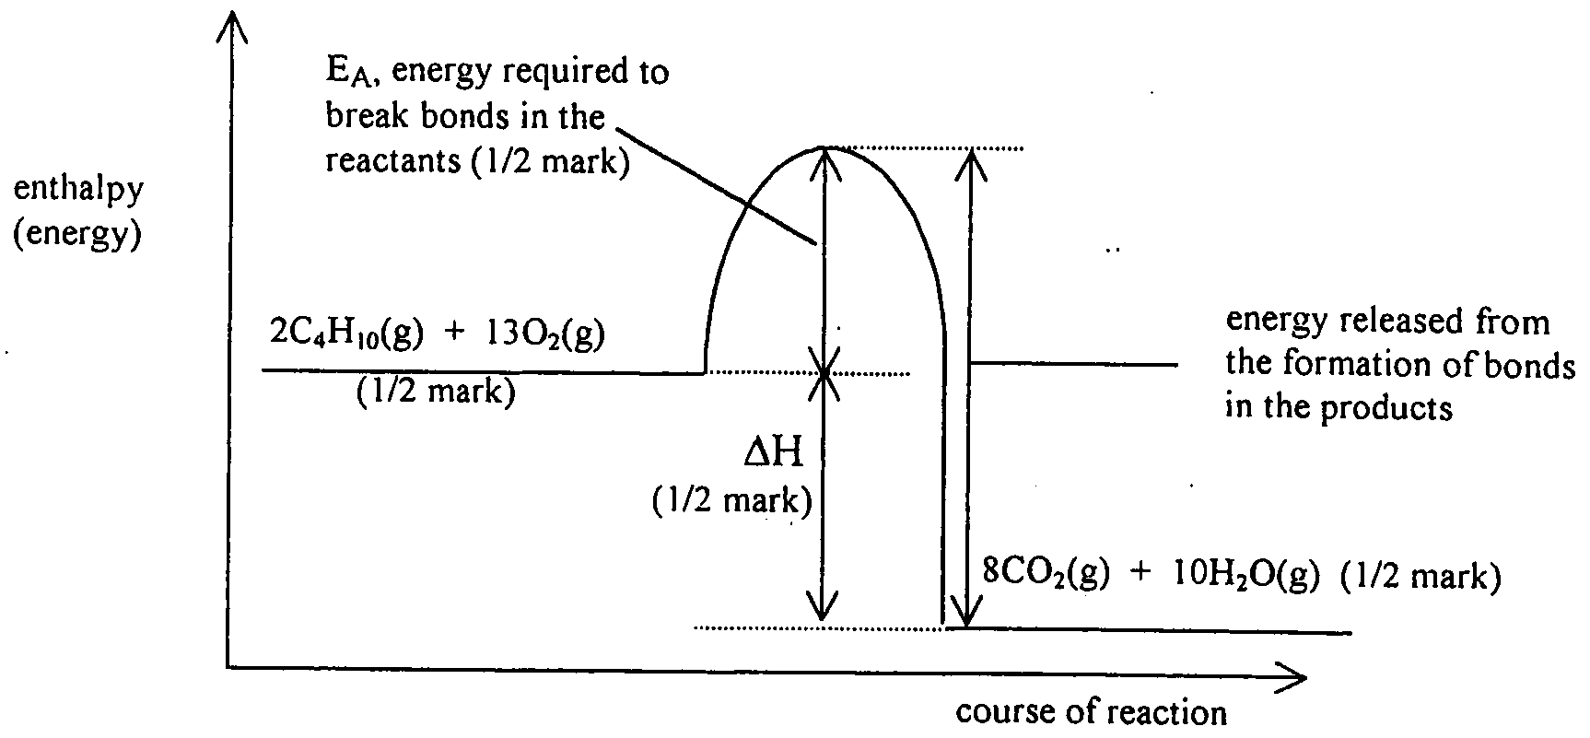 | (1 mark for the diagram)
- a source of ignition (1 mark)

Question 2
- M(Na₂C₂O₄) = (2 × 23.0) + (2 × 12.0) + 4 × 16.0) = 134.0 g mol^{–1} (1 mark)
N(Na₂C₂O₄) = 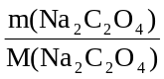= 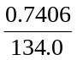 = 0.005527 mol (1 mark)
- (i) n(KMnO₄) = c(KMnO₄) × V(KMnO₄) = 0.1005 × 0.02080 = 0.0020904 mol. (1 mark)
n(Na₂C₂O₄) = n(C₂O₄^{2–}) = × n(KMnO₄) = 0.005226 mol
n(Na₂C₂O₄) in excess = 0.005226 mol (1 mark)
(ii) n(MnO₂) = n(C₂O₄^{2–}) reacted (1 mark)
n(C₂O₄^{2–}) reacted = n(C₂O₄^{2–}) total – n(C₂O₄^{2–}) excess
= 0.005527 – 0.005226 = 0.000301 mol
hence, n(MnO₂) = 0.000301 mol (1 mark)
(iii) n(Mn) = n(MnO₂) = 0.000301 mol (1 mark)
m(Mn) = n(Mn) × M(Mn) = 0.000301 × 54.9 = 0.0165 g (1 mark)
(iv) percentage Mn = 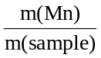 × 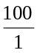 = 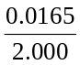 × = 0.825% (m/m) (1 mark)

Question 3
- (i) the extent to which a sample will move depends upon its relative attraction for the mobile and stationary phases (1 mark) therefore, changing the mobile phase will change the attraction of components such as ascorbic acid for the stationary phase and therefore change their rate of movement. (1 mark)
(ii) sample Y, as this has the same R_{f} value as the ascrobic acid sample (1 mark)
- (i) the spots on this chromatogram would be further up the chromatogram than those of the first student’s chromatogram (1 mark)
alternative: depending on how much longer the chromatogram had been running, all the spots could have reached the top
(ii) This student could not use the chromatogram to identify ascorbic acid. (1 mark) This is because the exact position of the solvent front is not known (1 mark) preventing accurate R_{f} values being calculated. (1 mark)

Question 4
- (i) S₂O₈^{2–} (aq) + 2 e– → 2 SO₄^{2–} (aq)
(ii) 2 I– (aq) → I₂ (aq) + 2 e–
(1 mark for each half-equation; 1 mark for the correct order)
- (i) concentration of reactants (1 mark)
temperature (1 mark)
use of a catalyst (1 mark)
(ii) An increase in the concentration will result in an increase in the rate. (1 mark) This can be explained using the collision theory. This theory states that particles must collide with sufficient energy in order to react. The greater the number of particles in a given volume the greater the likelihood of these particles colliding. (1 mark)
An increase in temperature will result in an increase in the rate. (1 mark) The faster the particles, the greater the likelihood of collisions. In addition, the particles will have more kinetic energy and therefore are more likely to have sufficient energy to react (to overcome the activation energy required to break bonds so that the particles can react). (1 mark)
A catalyst increases the rate of reaction. (1 mark) A catalyst lowers the activation energy by providing an alternative reaction pathway. This results in more collisions between particles successfully forming products. (1 mark)
- (i) the formation of I₂ (aq) (1 mark)
(ii) I initial fast rate of forward reaction due to high(er) concentrations of reactants (1 mark)
II lower rate of reaction (line has smaller gradient due to lower concentration of reactants (1 mark)
III reaction has reacted equilibrium, hence colour intensity is constant. (1 mark)

Question 5
- (i) C₂H₄ (1 mark)
 | (ii) |  | 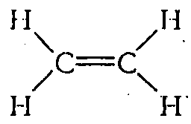 | (1 mark)
 |  | 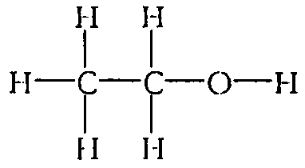 |  |  |  | (1 mark)
- (i) chloroethane (1 mark)
(ii) ethanol (1 mark)
(iii) ethanoic acid (1 mark)
(iv) ethyl ethanoate (1 mark)
- carboxyl (1 mark)
- (i) addition (1 mark)
(ii) addition polymerisation (1 mark)
(iii) substitution (1 mark)
(iv) esterification (1 mark)

Question 6
- (i) S(l) + O₂ (g) → SO₂ (g) (1 mark)
(ii) 2 SO₂ (g) + O₂ (g)  2 SO₃ (g) (1 mark)
- (i) conversion to SO₂ is an equilibrium reaction (1 mark)
(ii) the reaction is exothermic (1 mark)
at higher temperatures the conversion to SO₃ is lower, this is typical of an exothermic reaction (1 mark)

