STAV
2000
CHEMISTRY
Unit 3 Exam

Section A – Multiple Choice

Question 1
The percentage, by mass, of hydrogen in a sample of pure ethanol is
- 3.4%
- 13%
- 67%
- 87%

Question 2
An aerosol spray-can must have a pressure greater than the atmospheric pressure to function properly. In a quality control test on a “Smelwel” brand of deodorant, an aerosol spray-can was found to have an inside pressure of 1.04 atmosphere at 18.0°C.
With the air pressure of 1.00 atmosphere, the minimum temperature required for the spray-can to function properly is
- 18°C
- 11°C
- 7°C
- 0°C

Question 3
In gas chromatography, an unknown component may be identified by measuring the
- distance moved by the component through the stationary phase
- width of the component’s peak on the chromatogram
- time taken for the component to pass through the instrument
- height of the component’s peak on the chromatogram

The next three questions refer to the following

The fertiliser, sulfate of ammonia, (NH₄)₂SO₄, is manufactured by reacting sulfuric acid with ammonia.

Question 4
In this process the sulfuric acid acts as an
- acid only
- acid and an oxidant
- acid and a reductant
- oxidant only

Question 5
The oxidation number of the sulfate atom in (NH₄)₂SO₄ is
- +2
- +4
- +6
- –2

Question 6
The mass of sulfate of ammonia that can be obtained from 1.00 tonne of sulfuric acid and 0.500 tonne of ammonia is
- 0.70 tonne
- 1.35 tonne
- 1.50 tonne
- 3.80 tonne

Question 7
A student takes 100 mL of a solution of strong acid, which has a pH of 4, then dilutes it by adding 900 mL of water. The hydroxide ion concentration of the new solution would be
- 10^{–5} mol L^{–1}
- 10^{–6} mol L^{–1}
- 10^{–8} mol L^{–1}
- 10^{–9} mol L^{–1}

Question 8
In atomic absorption spectroscopy, AAS, which one of the following is incorrect?
- A solvent blank is used as a reference.
- The sample is sprayed into the flame.
- The ions in the flame are converted into atoms.
- The instrument is used to measure amounts of organic compounds.

Question 9
In the production of ammonia, gaseous nitrogen is reacted with gaseous hydrogen in the presence of a catalyst. The reaction can be represented as
N₂ (g) + 3 H₂ (g)  2 NH₃ (g) ΔH - –92 kJ mol^{–1}
The system is allowed to attain equilibrium at SLC.
With the temperature constant, the system is connected to an evacuated container of equal volume to the first. Compared to the mass of ammonia in the original system, the mass of ammonia in the new system
- will increase
- will decrease
- will remain unchanged
- cannot be determined from the data given

Question 10
The numerical value of K_{a} for HCN is 6.2 × 10^{–10} M. The pH of a 0.010 mol ^{–1} solution of HCN is
- 2.0
- 5.6
- 7.0
- 9.2

Question 11
A student measures the pH of a 0.10 M solution of ammonium chloride, NH₄Cl, and found it to be 5.3 The hydronium ion, H₃O⁺, concentration of this solution is
- 0.79 mol L^{–1}
- 4.0 mol L^{–1}
- 2.0 × 10^{–5} mol L^{–1}
- 5.0 × 10^{–6} mol L^{–1}

Question 12
The graph below shows how the concentration of reactants and products change over time for the reaction:
CH₃COOC₂H₅ (aq) + H₂O (l)  CH₃ COOH (aq) + C₂H₅OH (aq)
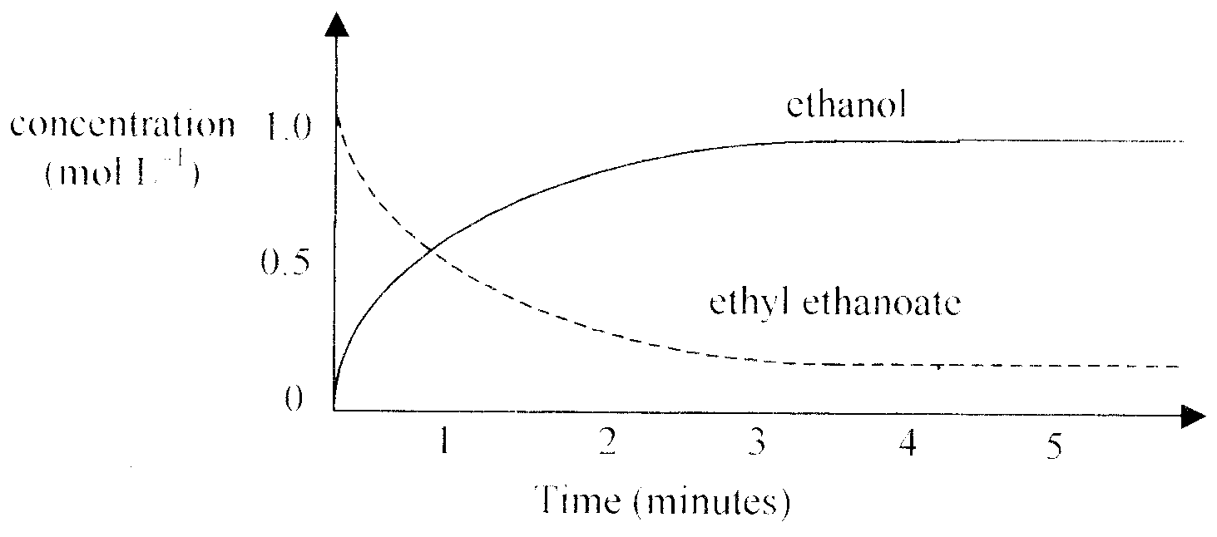
From this graph we can determine that the
- forward reaction stopped after 4 minutes
- system reached equilibrium after 1 minute
- equilibrium constant for the reaction is equal to 1.0 mol ^{–1}
- reaction did not go to completion

Question 13
The first three members of the alcohol series are, in order
- butanol, ethanol, methanol
- ethanol, methanol, propanol
- methanol, ethanol, butanol
- methanol, ethanol, propanol

Question 14
Which of the following pairs of substances are not structural isomers?
- 1-chlorobutane and 1-chloropropane
- ethyl ethanoate and methyl propanoate
- methyl propane and butane
- propan-1-ol and propan-2-ol

Question 15
A particular monochloroalkane contains seven carbon atoms per molecule. Its molecular formula will be
- C₇H₁₃Cl
- C₇H₁₄Cl
- C₇H₁₅Cl
- C₇H₁₆Cl

Question 16
The polymer poly(butylene terephthalate), PBT, is used to make the external mirror housings of some vehicles. This polymer provides excellent protection to the mirror glass whilst driving off-road. The structure of PBT is
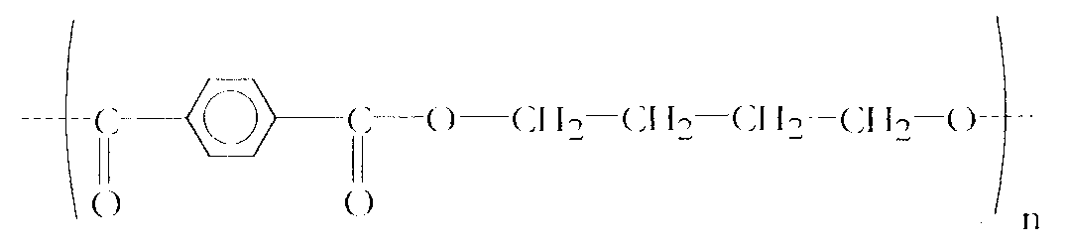
The monomers used to make PBT are
A. | 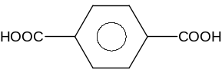 | and | HOCH₂CH₂CH₂CH₂OH
B. | 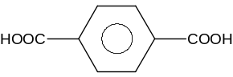 | and | HOOOCCH₂CH₂CH₂CH₂COOH
C. | 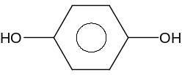 | and | HOCH₂CH₂CH₂CH₂OH
D. | 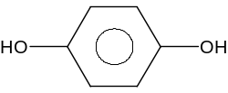 | and | HOOHCCH₂CH₂CH₂CH₂COOH

Question 17
Which alternative contains the compounds that could be used to make the ester represented by CH₃CH₂COOCH₃?
- ethanoic acid and methanol
- propanoic acid and ethanol
- methanoic acid and ethanol
- propanoic acid and methanol

Question 18
Sulfuric acid can act as an oxidant. In a redox reaction between dilute sulfuric acid and magnesium, one of the products would be
- sulfur dioxide
- water
- hydrogen
- magnesium sulfide

Section B – Short Answer Questions

Question 1
Butane is often used as a fuel for camping stoves.

- Write a balanced chemical equation for the complete combustion of butane.
__________________________________________________________________________________________________
- Sketch and fully label an energy profile diagram for this reaction.

- What provides the activation energy for this reaction?
__________________________________________________________________________________________________
__________________________________________________________________________________________________
2 + 3 + 1 = 6 marks
Suggested time: 7 minutes

Question 2
Ores can be analysed to determine their manganese content by adding an excess of pure sodium oxalate, Na₂C₂O₄, and heating with concentrated sulfuric acid. The following reaction occurs:
MnO₂ (s) + C₂O₄^{2–} (aq) + H⁺ (aq) → Mn²⁺ (aq) + 2 CO₂ (g) + 2 H₂O (l)
A mass of 0.7406 g of sodium oxalate was added to a 2.000 g ore sample.

- Calculate the amount, in mole, of sodium oxalate added to the ore sample.

- The excess oxalate is titrated with standard KMnO₄ in acid solution.
This reaction is represented by the equation:
5 C₂O₄^{2–} (aq) + 2 MnO₄– (aq) + 16 H⁺ (aq) → 2 Mn²⁺ (aq) + 10 CO₂ (g) + 8 H₂O (l)
The excess sodium oxalate required 20.80 mL of 0.1005 KMnO₄.
(i) Calculate the excess amount, in mol, of sodium oxalate added to the ore.

(ii) Determine the amount, in mol, of MnO₂ in the ore sample.

(iii) Determine the mass of manganese in the ore sample.

(iv) What is the percentage of manganese, by mass, in the ore sample?

2 + 7 = 9 marks
Suggested time: 11 minutes

Question 3
Ascorbic acid is an antioxidant used in many foods to prevent the breakdown of the food by atmospheric oxygen. In an experiment, a VCE student was analysing a food sample for the presence of ascorbic acid using paper chromatography. The chromatogram the students obtained showed a number of spots.
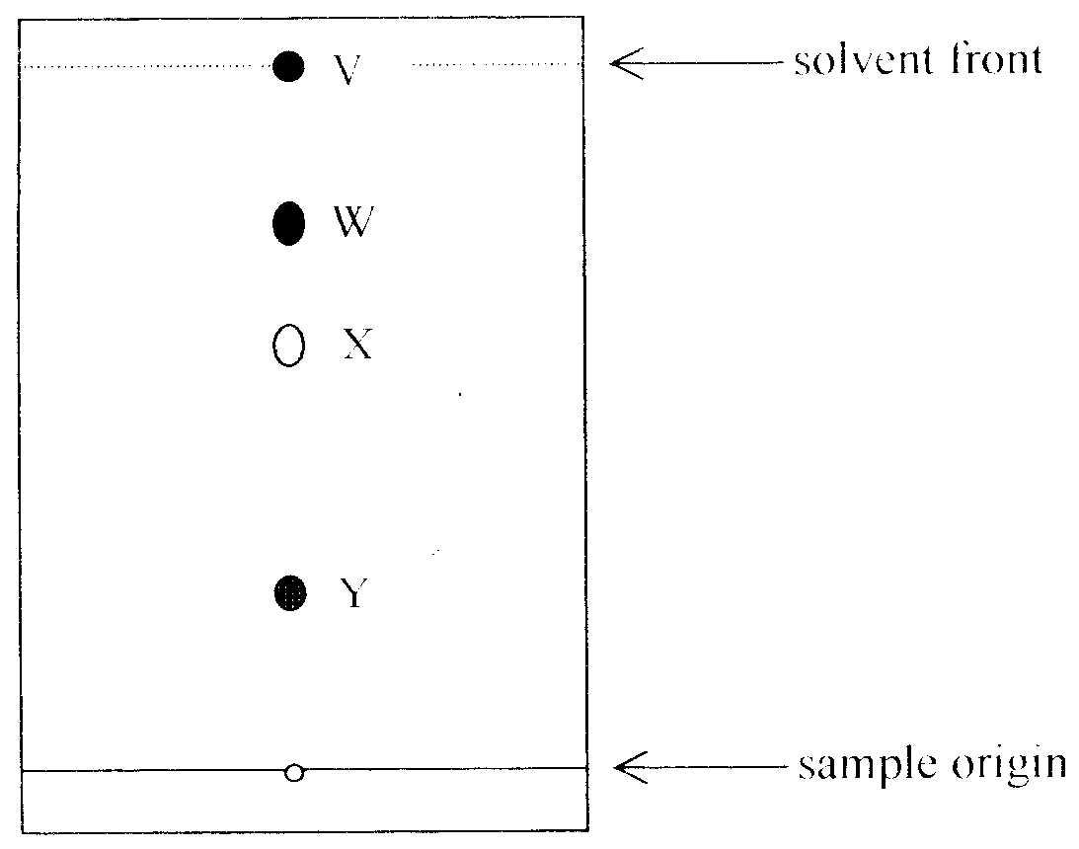
- In another chromatogram run in the same mobile phase, ascorbic acid was found to have an R_{f} of 0.250.
(i) Why is it important that the same mobile phase was used in both chromatograms?
_______________________________________________________________________________________________
_______________________________________________________________________________________________
_______________________________________________________________________________________________
_______________________________________________________________________________________________
(ii) Identify which sample spot is most likely to be ascorbic acid. Justify your selection.
_______________________________________________________________________________________________
_______________________________________________________________________________________________
_______________________________________________________________________________________________
_______________________________________________________________________________________________
- Another student performed the same experiment. This student left the chromatogram while it was running and when the student returned the solvent front had already reached the top of the chromatogram.
(i) How would the chromatogram of this student compare with the chromatogram of the first student?
_______________________________________________________________________________________________
_______________________________________________________________________________________________
_______________________________________________________________________________________________
(ii) Could this student use their chromatogram to identify the presence of ascorbic acid in the food sample? Explain your answer.
_______________________________________________________________________________________________
_______________________________________________________________________________________________
_______________________________________________________________________________________________
_______________________________________________________________________________________________
3 + 4 = 7 marks
Suggested time: 9 minutes

Question 4
This question concerns the way in which you would investigate the kinetics of the redox reaction represented by the equation:
S₂O₈^{2–} (aq) + 2 I– (aq)  2 SO₄^{2–} (aq) + I₂ (aq)
The solution changes from colourless to yellow as the reaction proceeds. This reaction occurs at a faster rate in acid solution.

- Write the half-equation for the
(i) reduction process
_______________________________________________________________________________________________
(ii) oxidation process
_______________________________________________________________________________________________
- (i) Identify three different factors that could affect the rate of this reaction.
_______________________________________________________________________________________________
_______________________________________________________________________________________________
_______________________________________________________________________________________________
(ii) Describe how you would expect the reaction rate to be affected by each of these factors and explain your predictions at the ionic/molecular level.
_______________________________________________________________________________________________
_______________________________________________________________________________________________
_______________________________________________________________________________________________
_______________________________________________________________________________________________
_______________________________________________________________________________________________
_______________________________________________________________________________________________
_______________________________________________________________________________________________
_______________________________________________________________________________________________
_______________________________________________________________________________________________
- (i) What causes the final solution to be yellow?
_______________________________________________________________________________________________
_______________________________________________________________________________________________
(ii) The graph of colour intensity against time for the reaction is shown below.
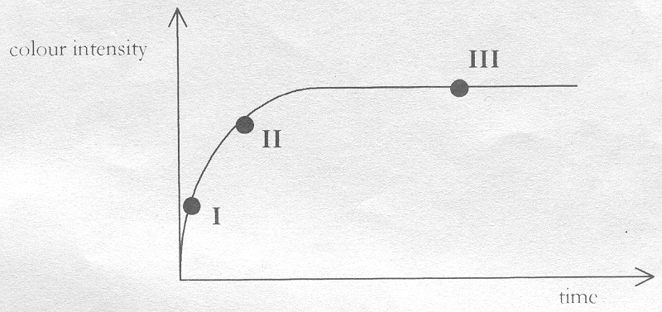
Account for the shape of the graph at each of points I, II and III.
_______________________________________________________________________________________________
_______________________________________________________________________________________________
_______________________________________________________________________________________________
_______________________________________________________________________________________________
_______________________________________________________________________________________________
_______________________________________________________________________________________________
_______________________________________________________________________________________________
_______________________________________________________________________________________________
_______________________________________________________________________________________________
3 + 9 + 4 = 16 marks
Suggested time: 20 minutes

Question 5
The hydrocarbon A undergoes a series of reactions to produce compounds B, C, D, E, and F. Other reactants involved in the reactions are indicated by W and X.
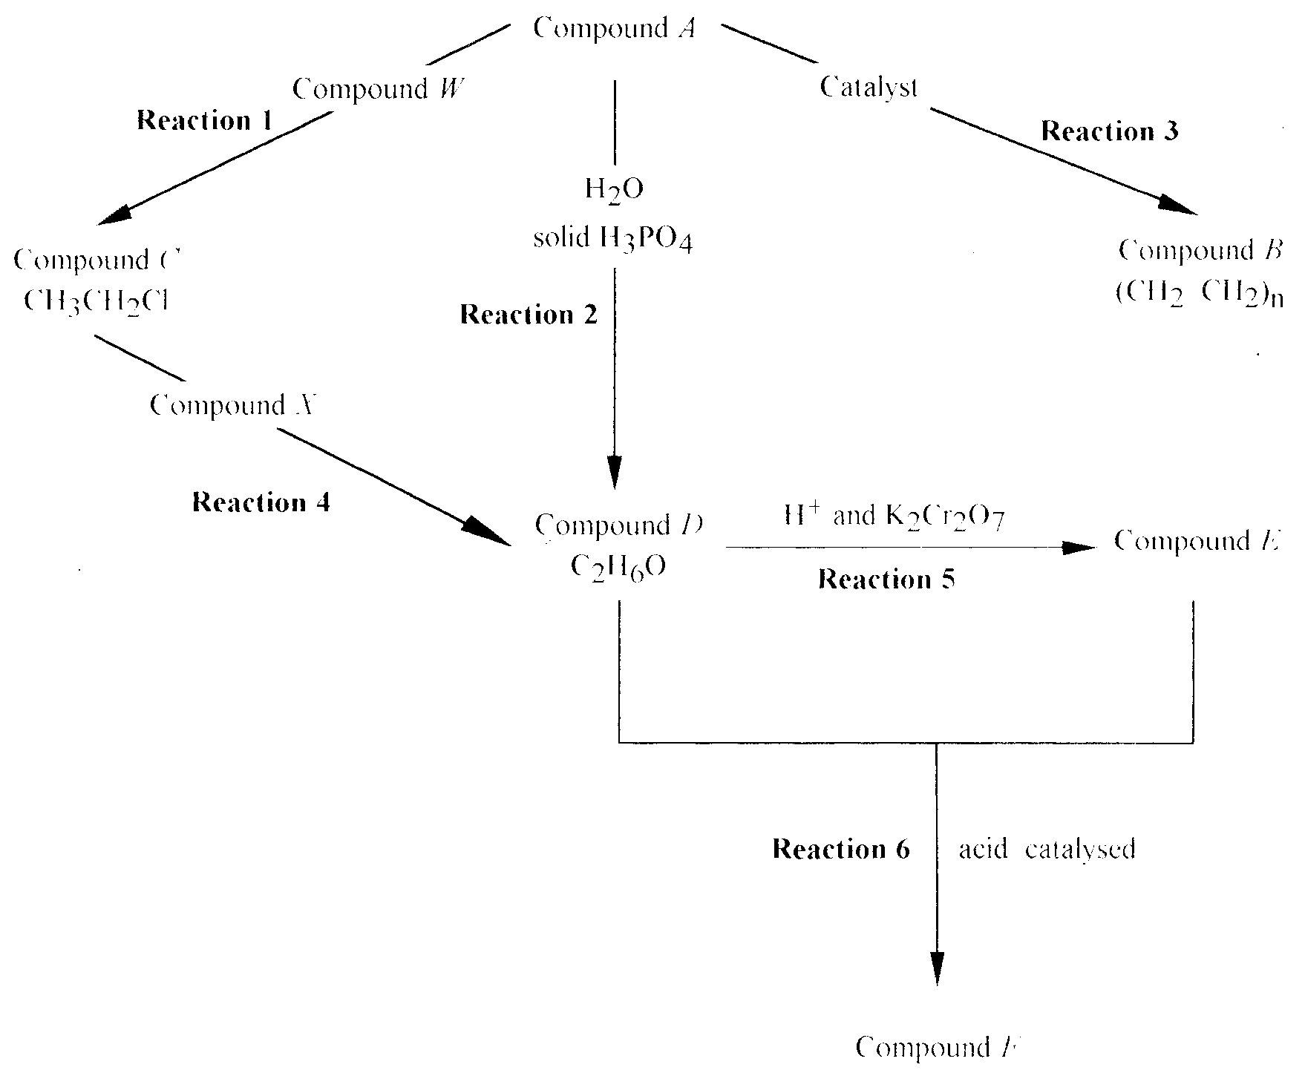

- Compound A has an empirical formula CH₂ and molar mass o28 g mol^{–1}.
(i) What is the molecular formula for Compound A? _______________________________________________________
- Give the structural formula for compound D.

- Write the systematic name for
(i) Compound C ________________________________________________________________________________
(ii) Compound D ________________________________________________________________________________
(iii) Compound E ________________________________________________________________________________
(iv) Compound F ________________________________________________________________________________
- Name the functional group in compound E. ___________________________________________________________
- Name the type of reaction involved in
(i) Reaction 1 ________________________________________________________________________________
(ii) Reaction 3 ________________________________________________________________________________
(iii) Reaction 4 ________________________________________________________________________________
(iv) Reaction 6 ________________________________________________________________________________
2 + 1 + 4 + 1 + 4 = 12 marks
Suggested time: 15 minutes

Question 6
Sulfuric acid is usually manufactured by the Contact Process. It is an important industrial chemical, playing a role in the production of many other chemicals.

- During the Contact Process sulfur is oxidised in two steps.
Write balanced chemical equations for the relevant reactions.
(i) _______________________________________________________________________________________________
(ii) _______________________________________________________________________________________________
- The graph represents the formation of sulfur trioxide with a catalyst at constant pressure.
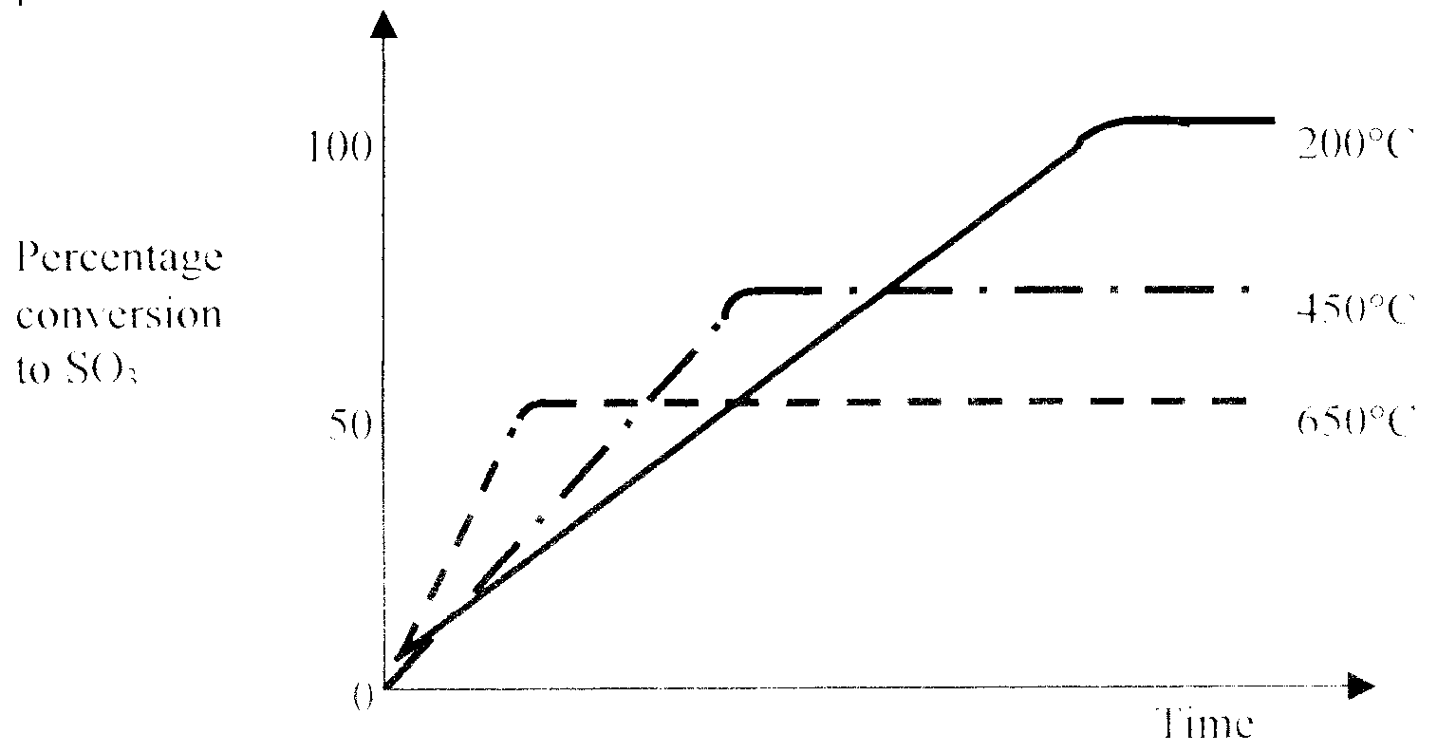
(i) At each temperature the percent conversion to sulfur trioxide reaches a constant. Explain this observation.
_______________________________________________________________________________________________
_______________________________________________________________________________________________
(ii) With reference to the graph, explain whether the conversion to sulfur trioxide is an exothermic or endothermic reaction.
_______________________________________________________________________________________________
_______________________________________________________________________________________________
2 + 3 = 5 marks
Suggested time: 6 minutes

