STAV 2000 | CHEMISTRY | Unit 4 | Trial Examination Solutions

Section A Multiple Choice Questions

- B
- A
- D
- B
- C
- B
- B
- A
- D
- C
- D
- D
- C
- C
- C
- A
- D
- C
- C
- B

Section B Short Answer

Question 1
a. | (i) | Pb(s) + SO₄^{2–} (aq)  PbSO₄ (s) + 2 e– | 1 mark
 | (ii) | PbO₂ (s) + SO₄^{2–} (aq) + 4 H⁺ (aq) + 2 e–  PbSO₄ (s) + 2 H₂O (l) | 1 mark
b. | H⁺ ions are consumed in the discharge reaction (1 mark)  so pH will increase as the battery is used. (1 mark) |  | 2 marks

Question 2
a. | C₂H₅OH (l) + 3 O₂ (g)  2 CO₂ (g) + 3 H₂O (g) | 1 mark
b. | heat released = 4.180 × 49.80 × (75.60 – 16.60) = 12 281.676 J (1 mark) = 12.282 kJ  n(ethanol) = 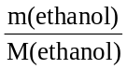 = 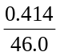 = 0.0090 mol (1 mark)  ΔH = 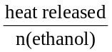 = 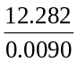 = 1365 kJ mol^{–1} (1 mark) | 3 marks
c. | ethanol = 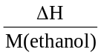 = 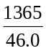 = 29.7 kJ g⁻¹ (1 mark)  propanol = 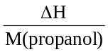 = 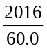 = 33.6 kJ g⁻¹ (1 mark) | 2 marks
d. | Ethanol is more easily produced from renewable sources than is propanol; or the processes for producing ethanol on a large scale are already well known, and are in use; or ethanol is less toxic than propanol.  One of the above or any other suitable alternative for 1mark | 1 mark

Question 3
a. | 1 mark for correct circle on diagram.  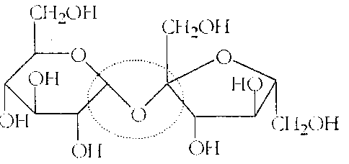 |  | 1 mark
b. | (i) | monosaccharides | 1 mark
 | (ii) | C₆H₁₂O₆ | 1 mark
 | (iii) | Enzymes (1 mark) and water (1 mark) | 2 marks
 | (iv) | hydrolysis | 1 mark
 | (v) | To provide energy through the process of aerobic respiration. | 1 mark

Question 4
a. | anode |  | 2 H₂O (l)  O₂ (g) + 4 H⁺ (aq) + 4 e– | 1 mark
 | cathode |  | 2 H₂O (l) 2 e–  H₂ (g) + 2 OH– (aq) | 1 mark
b. | (i) | Chlorine may be produced by the use of non-standard conditions, in this case the use of a saturated (approx. 5 M) sodium chloride solution (1 mark) so that Cl– ions are preferentially oxidised at the anode. (1 mark) |  | 2 marks
 | (ii) | 2 Cl– (aq)  Cl₂ (g) + 2 e– |  | 1 mark
c. | Semi-permeable membrane allows Na⁺ (aq) ions to pass from the anode chamber to the cathode chamber but does not allow Cl– (aq) or OH– (aq) to move from one chamber to the other (1 mark) enabling a purer solution of sodium hydroxide to be collected. This prevents the products at the two electrodes from mixing and reacting (1 mark) while allowing for efficient movement of electrolyte between the two electrodes to complete the circuit. (1 mark) |  |  | 3 marks
d. | (i) | n(e) = 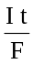 = 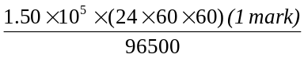 = 134 301 mol (1 mark)  n(Cl₂) = 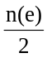 = 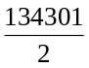 = 67 150.5 mol (1 mark)  V(Cl₂) = n(Cl₂) × V_{m} = 67 150.5 × 24.5 = 1.6 × 10⁶ L (1 mark) |  | 4 marks
 | (ii) | Side reactions may have occurred, which consumed electrons but did not produce chlorine; or small amounts of chlorine remain dissolved in solution. |  | 1 mark

Question 5
a. | 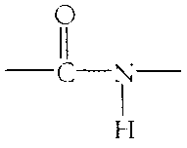 |  | 1 mark
b. | (i) | alanine (1 mark) and glycine (1 mark) | 2 marks
 | (ii) | hydrolysis | 1 mark
c. | 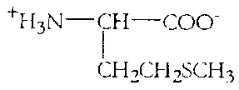 |  | 1 mark

Question 6
a. | 1s² 2s² 2p⁶ 3s² 3p⁶ 3d⁵ 4s¹ or 1s² 2s² 2p⁶ 3s² 3p⁶ 3d⁴ 4s² |  | 1 mark
b. | (i) | Cr(OH)₂ | 1 mark
 |  | Na₂Cr₂O₇ | 1 mark
 | (ii) | 1s² 2s² 2p⁶ 3s² 3p⁶ 3d⁴ | 1 mark
c. | (i) | H₂O (1 mark) and Cl– (1 mark) | 2 marks
 | (ii) | Polar molecules such as H₂O, CO and NH₃ and anions such as fluoride, F–, chloride, Cl–, and cyanide, CN– able to form interactions with transition metal ions | 1 mark
 | (iii) | 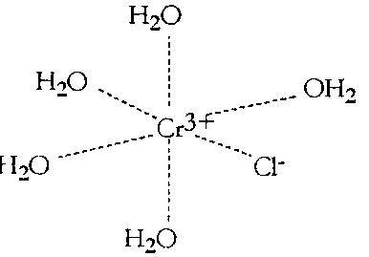 | 1 mark
 | (iv) | Transition element ions are smaller than their main group counterparts due to a greater nuclear charge and generally carry a higher amount of charge. In aqueous solution therefore they are able to more strongly attract a definite number of water molecules to form complex ions. | 1 mark

Question 7
a. | The high temperatures are required to overcome the forces of repulsion between nuclei (1 mark) allowing them to com close enough for nuclear binding forces to operate. (1 mark) | 2 marks
b. | total mass of helium nuclei = 3 × 4.0015 = 12.0045 g (1 mark)  mass loss in forming carbon nucleus = 12.0045 – 11.9965 = 0.0080 g (1 mark) | 2 marks
c. | The mass lost is converted into energy. | 1 mark

