STAV
2000
UNIT 4 CHEMISTRY

SECTION A – Multiple-choice questions

Question 1
A sample of 9.00 g of glucose is combusted with excess oxygen in a bomb calorimeter according to the equation:
C₆H₁₂O₆ (s) + 6 O₂ (g)  6 H₂O (g) + 6 CO₂ (g)
The initial temperature of the gaseous mixture was 290 K and the final temperature was 3000 K/
The change in heat energy for the process was determined to be 141 kJ.
The enthalpy change, ΔH for the reaction represented by the equation is
- +2.82 × 10³ kJ mol^{–1}
- –2.82 × 10³ kJ mol^{–1}
- +2.82 × 10⁴ kJ mol^{–1}
- –2.82 × 10⁴ kJ mol^{–1}

Question 2
Water and the iron(II) ion are both able to act as either an oxidant or a reductant during a chemical reaction. Select the equation representing a reaction that would be expected to proceed substantially to the right spontaneously.
- Fe (s) + 2 Fe³⁺ (aq)  3 Fe²⁺ (aq)
- 2 H₂O (l)  O₂ (g) + 2 H₂ (g)
- 2 H₂O (l) + 2 Fe²⁺ (aq)  O₂ (g) + 4 H⁺ (aq) + 2 Fe (s)
- 2 H₂O (l) + 4 Fe³⁺ (aq)  O₂ (g) + 4 H⁺ (aq) + 4 Fe²⁺ (aq)

Question 3
In a fuel cell, the
- fuel is oxidised at the cathode
- reductant is oxidised at the cathode
- fuel is reduced at the cathode
- oxidant is reduced at the cathode

Question 4
Which one of the following half-cells would give the largest cell potential when paired with the Ni²⁺ (aq) / Ni (s) half-cell under standard conditions?
- Fe³⁺ (aq) / Fe²⁺ (aq)
- Ag⁺ (aq) / Ag (s)
- Cu²⁺ (aq) / Cu (s)
- Co²⁺ (aq) / Co (s)

Question 5
Which of the following is a product formed at the cathode in the electrolysis of a 1.0 M aqueous solution of sodium sulfate, Na₂SO₄, using inert electrodes?
- sodium metal
- hydrogen ions
- hydrogen gas
- oxygen gas

Question 6
Nickel-cadmium, NiCad, batteries are commonly used as rechargeable batteries. Each cell generates a potential of 1.30 V. The overall cell reaction for discharging can be written as:
Ni₂O₃ (s) + 3 H₂O (l) + Cd (s)  Cd(OH)₂ (s) + 2 Ni(OH)₂ (s)
In recharging the cell it would be necessary to apply a potential of
- more than 1.30 V across the cell with the Cd electrode connected to the positive terminal of the power source
- more than 1.30 V across the cell with the Cd electrode connected to the negative terminal of the power source
- 1.30 V across the cell with the Cd electrode connected to the positive terminal of the power source
- 1.30 V across the cell with the Cd electrode connected to the negative terminal of the power source

Question 7
The processes occurring in a coal-fired power station in a Latrobe Valley power station are shown in the following flowchart:

Coal is burnt | I | Steam is generated | II | Steam turns turbines | III | Turbines turn the generator | IV | Electricity is produced

The process which involves the transformation of heat energy to mechanical energy is
- I
- II
- III
- IV

Question 8
In the nitrogen cycle, oxidising bacteria convert
- NH₃ into NO₃–
- N₂ into NH₃
- NO₃– into N₂
- NO₃– into NH₄⁺

Question 9
Which one of the following represents an α-amino acid species in 0.1 M sodium hydroxide solution?
- ⁺NH₃CH₂CH₂COOH
- ⁺NH₃CH₂COOH
- NH₂CH₂CH₂COO–
- NH₂CH₂COO–

Question 10
The carbohydrates found in plants are
- sucrose and glycogen
- cellulose and glycogen
- starch and cellulose
- starch and glycogen

Question 11
Which one of the following only includes molecules that are typical waste products of human cellular chemical processes?
- C₆H₁₂O₆, (NH₂)₂CO, H₂O
- NH₃, NH₂CH₂COOH, NH₂CH(CH₃)COOH
- CO₂, NH₃NO₃, C₆H₁₂O₆
- (NH₂)₂CO, H₂O, CO₂
Question 12
An example of a saturated fatty acid is
- CH₃COOH
- C₆H₁₂O₆
- C₁₆H₃₁COOH
- C₁₆H₃₃COOH

Question 13
One mole of each of the following fuels was combusted. Which one would contribute the most carbon dioxide to the atmosphere?
- methanol, CH₃OH
- methane, CH₄
- octane, C₈H₁₈
- toluene, C₆H₅CH₃

Question 14
Marie and Pierre Curie discovered the element radium in 1898. The radium isotope with the longest half-life undergoes alpha decay. This process can be represented by
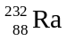  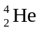 + X
The particle, X, represents
- 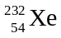
- 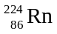
- 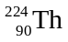

Question 15
All except one of the electronic configurations below represent atoms in their ground states. Which is the exception?
- 1s² 2s² 2p⁶
- 1s² 2s² 2p⁶ 3s¹
- 1s² 2s² 2p⁶ 3s² 3p⁶ 3d¹
- 1s² 2s² 2p⁶ 3s² 3p⁶ 4s¹

Question 16
The first ionisation energy is the minimum energy required to
- remove an electron from an atom in the gaseous state to form a positive ion
- promote an electron to a higher energy level within an atom
- add an electron to an atom in the gaseous state to form a negative ion
- form a more positively charged ion from a cation

Question 17
Which one of the following substances is most likely to produce a highly coloured solution?
- AgNO₃
- ZnSO₄
- Cu(OH)₂
- Ni(NO₃)₂

Question 18
Which one of the following lists only basic oxides?
- Na₂O, MgO, Al₂O₃
- Na₂O, MgO, SO₂
- Na₂O, K₂O, CaO
- Al₂O₃, SO₂, SO₃

Question 19
Atomic radius
- decreases across a period, right to left, and increases down a group
- decreases across a period, right to left, and decreases down a group
- increases across a period, right to left, and increases down a group
- increases across a period, right to left, and decreases down a group

Question 20
The neutron was discovered by
- Aston
- Chadwick
- Rutherford
- Thompson

SECTION B – Short-answer questions

Question 1
The lead-acid accumulator is used in cars as the source of the electrical energy needed to start the engine. The reaction occurring in the cell during discharge can be written as:
Pb (s) + PbO₂ (s) + 4 H⁺ (aq) + 2 SO₄^{2–} (aq)  2 PbSO₄ (s) + 2 H₂O (l)

- Write the half-equations for the reactions occurring during discharge at the
(i) anode _____________________________________________________________________________
(ii) cathode _____________________________________________________________________________
- Explain how pH can be used to indicate the state of charge of the battery over a period of time.
_______________________________________________________________________________________
_______________________________________________________________________________________
_______________________________________________________________________________________
_______________________________________________________________________________________
2 + 2 = 4 marks
Suggested time = 5 minutes

Question 2
A student wishes to determine the heat of combustion of ethanol, using the apparatus shown below.
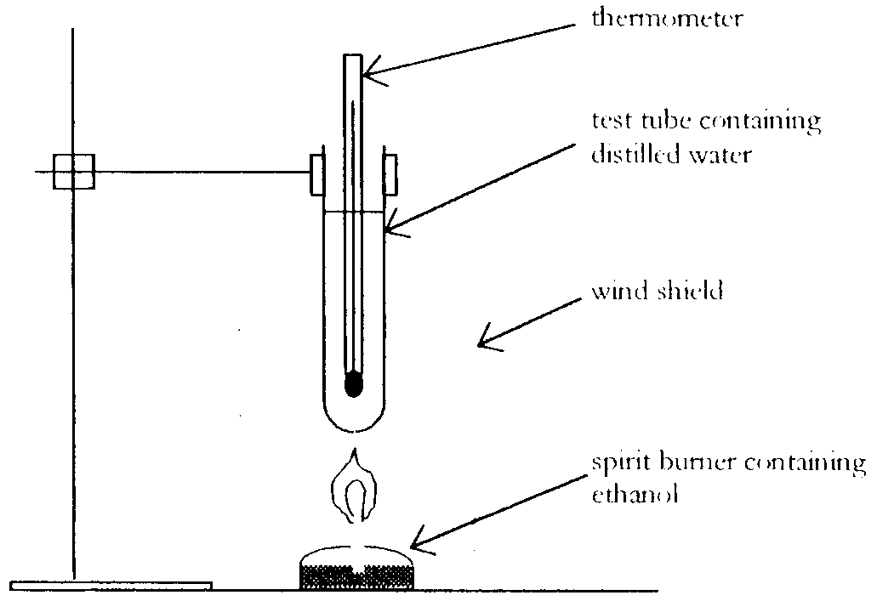
The following data was collected by the student:
Mass of test tube = 33.121 g
Mass of ethanol burnt = 0.414 g
Mass of water heated = 49.80 g
Initial temperature of water = 16.60°C
Final temperature of water = 75.60°C

4.180 J of energy are required to raise the temperature of 1.00 g of water by 1.00°C.

- Write a balanced chemical equation for the complete combustion of ethanol.
_______________________________________________________________________________________
- Calculate the heat of combustion for 1 mole of ethanol.

- The heat of combustion of propanol, C₃H₇OH, is 2016 kJ mol^{–1}. Use calculations to show which of ethanol or propanol is the better fuel on a per gram basis.

- What factor would give ethanol an advantage over propanol as a fuel?
_______________________________________________________________________________________
_______________________________________________________________________________________
_______________________________________________________________________________________
_______________________________________________________________________________________
1 + 3 + 2 + 1 = 7 marks
Suggested time: 9 minutes

Question 3
A representation of the biochemical molecule sucrose is shown below.
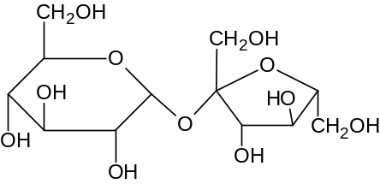

- On the diagram of sucrose, circle the glycosidic (ether) link.
- In a living organism, the sucrose molecule is broken down into two smaller molecules.
(i) What is the general name given to the two molecules formed?
____________________________________________________________________________________
(ii) Both the product molecules have the same molecular formula. What is this molecular formula?
____________________________________________________________________________________
(iii) What chemical substance(s) must be present for sucrose to be broken down in a living organism?
____________________________________________________________________________________
(iv) The break down of sucrose occurs during digestion. State the name f the type of chemical reaction that occurs during this biochemical process.
____________________________________________________________________________________
(v) State the main biochemical role of the products of the digestion of sucrose in humans.
____________________________________________________________________________________
1 + 6 = 7 marks
Suggested time: 9 minutes

Question 4
Industrially, chlorine is produced by the electrolysis of brine, a solution of sodium chloride. A simplified diagram of the electrolytic cell used is shown below.
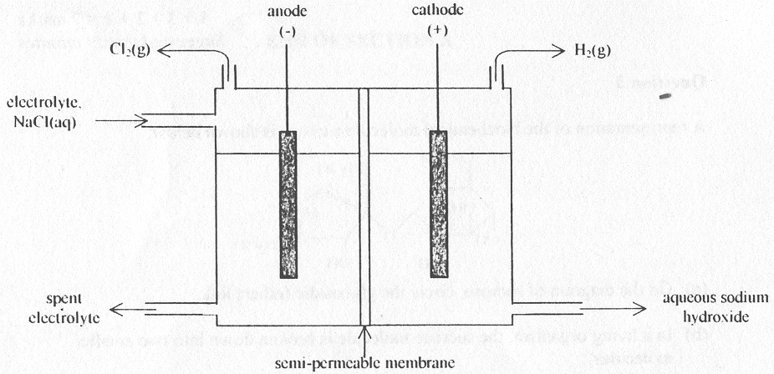

- Write the half-equations for the reactions expected, under standard conditions, at the
anode _____________________________________________________________________________
cathode _____________________________________________________________________________
- (i) Explain why chlorine is produced in the industrial electrolytic cell shown.
____________________________________________________________________________________
____________________________________________________________________________________
____________________________________________________________________________________
____________________________________________________________________________________
(ii) Write a half-equation for the production of chlorine.
____________________________________________________________________________________
- What is the function of the semi-permeable membrane in the operation of this electrolytic cell?
_______________________________________________________________________________________
_______________________________________________________________________________________
_______________________________________________________________________________________
_______________________________________________________________________________________
_______________________________________________________________________________________
_______________________________________________________________________________________
- (i) Calculate the volume of chlorine gas, measured at SLC, produced by one electrolytic cell in 24 hours if the current flowing through the cell is 1.50 × 10⁵ A.

(ii) Explain why the actual volume produced is likely to be less than the volume calculated in part d.(ii).
____________________________________________________________________________________
____________________________________________________________________________________
____________________________________________________________________________________
2 + 3 + 3 + 5 = 13 marks
Suggested time: 17 minutes

Question 5
A segment of a protein molecule is shown below.
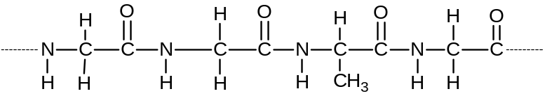
- Draw a peptide link.

- The action of enzymes on the protein molecule produces amino acids.
(i) Name the amino acids formed from this section of the protein molecule.
____________________________________________________________________________________
____________________________________________________________________________________
____________________________________________________________________________________
____________________________________________________________________________________
(ii) Write an ionic equation for the reaction producing solid cobalt.
____________________________________________________________________________________
____________________________________________________________________________________
____________________________________________________________________________________
- Explain why the ionic compounds of many transition elements are coloured.
_______________________________________________________________________________________
_______________________________________________________________________________________
_______________________________________________________________________________________
_______________________________________________________________________________________
_______________________________________________________________________________________
_______________________________________________________________________________________
1 + 2 + 2 = 5 marks
Suggested time: 6 minutes

Question 6
- Write the ground state electronic configuration of an atom of chromium.
_______________________________________________________________________________________
- Chromium is able to form compounds such as Cr(OH)₂ and Na₂Cr₂O₇.
(i) Identify the oxidation number of chromium in each of these compounds.
Cr(OH)₂ ___________________________________________________________________________
Na₂Cr₂O₇ ___________________________________________________________________________
(ii) Write the electronic configuration for chromium in Cr(OH)₂.
____________________________________________________________________________________
- Chromium is able to form complex ions, such as [Cr(H₂O)₅Cl]²⁺ in aqueous solution.
(i) Identify the ligand(s) in this complex ion.
____________________________________________________________________________________
(ii) Explain what is meant by the term ‘ligand’.
____________________________________________________________________________________
____________________________________________________________________________________
____________________________________________________________________________________
(iii) Sketch the shape of this ion.

(iv) Explain why transition elements, such as chromium, are more likely to form complex ions than main group elements.
____________________________________________________________________________________
____________________________________________________________________________________
____________________________________________________________________________________
____________________________________________________________________________________
1 + 3 + 5 = 9 marks
Suggested time: 12 minutes
Question 7
It has been experimentally determined that Red Giant stars have mean temperatures of around 2 × 10⁸ K. In such stars, helium nuclei combine to form carbon nuclei, as shown by the equation:
3  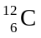

- Explain why such high temperatures are required to initiate this nuclear reaction.
_______________________________________________________________________________________
_______________________________________________________________________________________
_______________________________________________________________________________________
_______________________________________________________________________________________
- Given that the relative masses of and nuclei are 11.9965 and 4.0015 respectively, calculate the total mass loss during the formation of one mole of nuclei.

- Explain the ‘fate’ of the mass lost in the formation of carbon nuclei in Red Giant stars.
_______________________________________________________________________________________
_______________________________________________________________________________________
_______________________________________________________________________________________
2 + 2 + 1 = 5 marks
Suggested time: 6 minutes

