IARTV 2001 | CHEMISTRY | Unit 4 | Trial Examination Solutions

Section A Multiple Choice Questions (1 mark per question)

- C
- A
- C
- C
- B
- B
- D
- B
- C
- D
- B
- D
- A
- A
- C
- A
- A
- C
- D
- A

Section B Short Answer

Question 1 (9 marks)
a. | (i) | E = V I t = 6.06 × 7.50 × 2.50 × 60 = 6820 J |  | 1 mark
 | (ii) | CF = 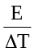 = 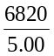 = 1360 J °C^{–1} |  | 1 mark
b. | For 1 g chips, energy = 18.0 kJ = 18 000 J  For 0.600 g chips, energy = 18 000 × 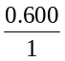 = 10 800 J  ΔT = 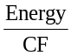  = 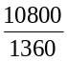  = 7.92°C |  | A consequential mark should be allowed. | 2 marks
c. | For 0.600 g chips, energy = CF × ΔT = 1140 × 10.50 = 11 970 J  For 1 g chips, energy = 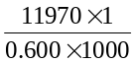 = 20.0 kJ g^{–1} |  |  | 1 mark
d. | The Crispthins may have had a higher fat content, since this contributes more energy per gram than their carbohydrate content. |  |  | 1 mark
e. | The body would not absorb 180 kJ energy because the body’s metabolic processes are different and produce different products from those obtained by direct combustion of foods in pure oxygen. |  |  | 1 mark
 | In addition, not all the food may be absorbed since some may pass out undigested. |  |  | 1 mark
f. | If some of the mass of the sample were water then the measured mass would contain less fat and carbohydrate than expected and therefore less energy would be released per gram during combustion. |  |  | 1 mark

Question 2 (4 marks)
a. | (i) | Cu (s) → Cu²⁺ (aq) + 2 e– | 1 mark
 | (ii) | Cu²⁺ (aq) + 2 e– → Cu (s) | 1 mark
b. | Q = I t = 405 × 5.00 × 60 = 121 500 C  n(e–) = = 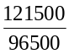 = 1.26 mol |  | 1 mark
 | n(Cu) = 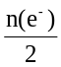 = 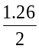 = 0.630 mol  m(Cu) = 0.630 × 63.6 = 40.0 g |  | 1 mark

Question 3 (9 marks)
a. | Zn (s) + Ag₂O (s) → ZnO (s) + 2 Ag (s) |  | 1 mark
b. | Silver oxide |  | 1 mark
c. | Mass of Ag₂O consumed = 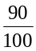 × 5.45 g = 4.91 g  M(Ag₂O) = 2 × 107.9 + 16.0 = 231.8 g mol^{–1}  n(Ag₂O) = 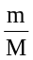 = 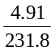 = 2.12 × 10^{–2} mol |  | 1 mark
 | n(e–) = 2 × n(Ag₂O) = 2 × 2.12 × 10^{–2} = 4.23 × 10^{–2} mol  Q = n(e–) × F = 4.232 × 10^{–2} × 96 500 = 4080 C |  | 1 mark
 | t = = 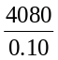 = 40 800 s = 11 h |  | 1 mark
d. | n(Ag₂O) = n(Zn) = 2.12 × 10^{–2} mol |  | 1 mark
 | m(Zn) – n(Zn) × M = 2.12 × 10^{–2} × 65.4 = 1.4 g | A consequential mark should be allowed. | 1 mark
e. | A primary cell cannot be recharged whereas a secondary cell can be recharged. In a secondary cell the products formed during discharge remain in contact with the electrodes and can be regenerated as reactants. |  | 2 marks

Question 4 (6 marks)
 |  | Glycine  sample |  | Glucose  sample |  | Monounsaturated  fatty acid
Lassiagne Test for the presence of nitrogen |  |  |  |  |  | 
Solubility in water |  |  |  |  |  | 
Bromine test |  |  |  |  |  | 
Limewater test on the combustion products |  |  |  |  |  | 
Test for a reducing sugar with Fehling’s solution |  |  |  |  |  | 
Test for the presence of a hydroxyl group |  |  |  |  |  |  | 6 marks

Question 5 (9 marks
a. | C, H, O, N | 1 mark
b. | CO₂, H₂O | 1 mark
c. | –C–O–C– | 1 mark
d. | C₆H₁₂O₆ | 1 mark
e. | C₂H₅NO₂, C₃H₇NO₂ | 1 mark
f. | NH₄⁺, N₂, NO₃–, C₃H₇NO₂, C₂H₅NO₂, CH₄C₂O | 1 mark
g. | CH₄N₂O | 1 mark
h. | CH₃(CH₂)₇CH=CH(CH₂)₇COOH  or CH₃CH₂CH₂CH₂CH₂CH₂CH₂CH₂CH=CHCH₂CH₂CH₂CH₂CH₂CH₂ CH₂COOH  One mark for correct functional group and total number of carbon atoms,  one mark for putting in a double bond somewhere in the chain. | 2 marks

Question 6 (11 marks
a. | Species |  | Charge | Electron configuration  (ground state) | Name of species | Symbol of species
a. | A |  | +1 | 1s² 2s² 2p⁶ | Sodium ion | Na⁺
a. | B |  | –1 | 1s² 2s² 2p⁶ | Fluoride ion | F–
a. | C |  | –2 | 1s² 2s² 2p⁶ 3s² 3p⁶ | Sulfide ion | S^{2–}
a. | D |  | +2 | 1s² 2s² 2p⁶ 3s² 3p⁶ | Strontium ion | Sr²⁺
 | Half mark each |  |  |  |  |  | 5 marks
b. | 1s² 2s² 2p⁶ 3s² 3p⁵ 4s¹ or similar |  |  |  |  |  | 1 mark
c. | (i) | Ga₂O₃ (s) + 2 OH– (aq) + 3 H₂O (l) → 2 Ga(OH)₄– (aq) |  |  |  |  | 1 mark
 | (ii) | Ga₂O₃ (s) + 6 H⁺ (aq) → 2 Ga³⁺ (aq) + 3 H₂O |  |  |  |  | 1 mark
d. | (i) | +2 |  |  |  |  | 1 mark
 | (ii) | 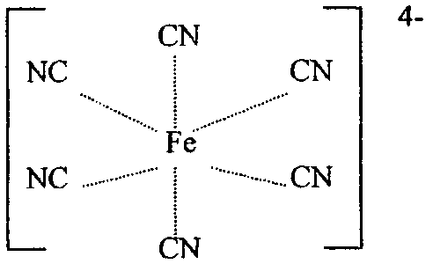  Note: The correct representation of a complex ion is to show the overall charge not the individual charges on the constituent ions. In this case allow charges to be shown but expect orientation of the –CN ion to be correct. |  |  |  |  | 1 mark
 | (iii) | The iron atom has a configuration ending in 3d⁶ 4s². For the Fe²⁺ ion the configuration ends in 3d⁶ with a loss of the 4s electrons. A slightly more stable configuration is achieved by the formation of the Fe³⁺ ion with a configuration of 3d⁵ since there is a tiny increase of stability when the d-subshell is exactly half full. |  |  |  |  | 1 mark

Question 7 (6 marks)
a. | (i) | 4 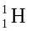 → 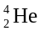 + 2 | 1 mark
 | (ii) | Huge temperatures are required and once the reaction has started it is uncontrollable. There is no container available to contain the reaction. | 1 mark
b. | Two single protons plus two single neutrons have the greater mass because during fusion some mass is lost and converted to energy according to the equation, E = mc². |  | 2 marks
c. | The discovery of neutrons by Chadwick explained the structure of the helium nucleus. |  | 1 mark
 | The neutron carries the same mass as the proton but no charge and in the helium nucleus there are two neutrons and two protons. |  | 1 mark

