NEAP 2001 | Unit 3 Chemistry | Trial Examination Solutions

Section A – Multiple choice questions

- B
- B
- A
- C
- D
- D
- A
- B
- C
- D
- C
- A
- B
- B
- C
- C
- A
- D
- D
- A

Section B – Short Answer Questions

Question 1
a. | Not necessarily correct because the solution of HX may be more concentrated than that of HY. | 1 mark
 | The concentration of the acids must be the same in order to compare their relative strengths based on the pH of the solution. | 1 mark
b. | The higher the concentration of HCl, the greater the number of collisions between acid molecules and the copper oxide particles. | 1 mark
 | With more collisions (at a given temperature), the rate of reaction will increase. | 1 mark
Total 4 marks

Question 2
a. | A. | 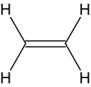 | E. | 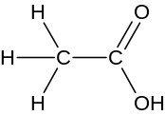 | C. | 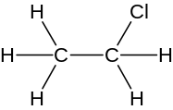 | F. | 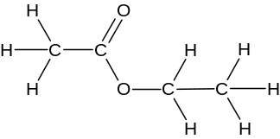 | 4 × 1 = 4 marks
b. | i. | chlorination or substitution |  |  |  |  |  |  |  | 1 mark
 | ii. | esterification or condensation |  |  |  |  |  |  |  | 1 mark
c. | H₂O and H₃PO₄ (as a catalyst) |  |  |  |  |  |  |  |  | 1 mark
Total 7 marks

Question 3
a. | i. |  | H₂ |  |  | I₂ |  | 2 HI |  |  |  |  |  |  |  | 1 mark
a. |  | n_{i} | 0.737 |  |  | 0.984 |  | 0 |  |  |  |  |  |  |  | 1 mark
a. |  | change | –0.351 |  |  | –0.351 |  | +0.702 |  |  |  |  |  |  |  | 1 mark
a. |  | n_{e} | 0.386 |  |  | 0.633 |  | 0.702 |  |  |  |  |  |  |  | 1 mark
a. |  | c_{e} = 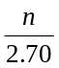 | 0.143 M |  |  | 0.234 M |  | 0.260 M |  |  |  |  |  |  |  | 1 mark
 | ii. | K = 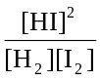 |  |  |  |  |  |  |  |  |  |  |  |  |  | 1 mark
 | ii. | ∴ K = 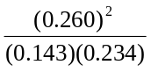 = 2.02 |  |  |  |  |  |  |  |  |  |  |  |  |  | 1 mark
b. | K = 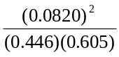 = 0.0249 |  |  |  |  |  |  |  |  |  |  |  |  |  |  | 1 mark
 | Reaction is exothermic. (K has decreased with increase in temperature) |  |  |  |  |  |  |  |  |  |  |  |  |  |  | 1 mark
c. | change |  |  |  | increase in [HI] |  | decrease in [HI] |  |  |  |  | no change in [HI] |  | 2 × 1 =2 marks
c. | i. The volume of the reaction vessel is increased |  |  |  |  |  | 
c. | ii. Nitrogen gas is added at constant volume |  |  |  |  |  |  |  |  |  |  | 
d. | Any two of:  increased temperature  increased pressure  addition of a catalyst  increased concentration of H₂or I₂ |  |  |  |  |  |  |  |  | 2 × 1 = 2 marks
Total 10 marks

Question 4
a. | i. | Dehydrating agent (to remove water vapour) |  | 1 mark
 | ii. | V₂O₅ catalyses the reaction 2 SO₂ (g) + O₂ (g)  2 SO₃ (g) |  | 1 mark
 | iii. | SO₃ (g) + H₂O (l) → H₂SO₄ (aq) |  | 1 mark
b. | For example: In industry  - molten sulfur is burnt in air, not solid sulfur  - SO₃ is not directly reacted with H₂O. Instead SO₃ is reacted with H₂SO₄ to produce oleum which is then diluted to produce H₂SO₄.
 | - the gas mixture is passed over V₂O₅ several times, not once as in the laboratory synthesis |  | 2 × 1 = 2 marks
 |  |  | Total 5 marks

Question 5
a. | Cl– (aq) + Ag⁺ (aq) → AgCl (s) |  | 1 mark
b. | % salt by mass = 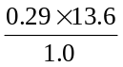 = 3.9% |  | 1 mark
c. | Gravimetric analysis of the AgCl precipitate  or  Analysis of the sodium content using atomic absorption spectroscopy |  | 1 mark
d. | i. | n(AgNO₃) = c × V = 0.050 × 10^{–3} × V | 1 mark
 | ii. | n(NaCl) = n(AgNO₃) = 0.050 × 10^{–3} × V | 1 mark
 | iii. | m(NaCl) = n × M = 0.050 × 58.5 × 10^{–3} × V = 2.9 × 10^{–3} × V | 1 mark
 | iv. | % salt = 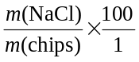 = 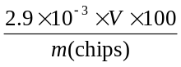 = 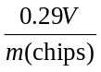 | 1 mark
Total 7 marks

Question 6
a. | 2 Cr³⁺ (aq) + 7 H₂O (l) → Cr₂O₇^{2–} (aq() + 14 H⁺ (aq) + 6 e– |  | 1 mark
b. | i. | 0.14 mol L^{–1} | 1 mark
 | ii. | n(Cr₂O₇^{2–}) = c × V = 0.14 × 0.200 = 0.028 mol  n(Cr) = 2 × n(Cr₂O₇^{2–}) = 2 × 0.028 = 0.056  m(Cr) = n × M = 0.056 × 52.0 = 2.9 g | 2 marks
 | iii. | % = 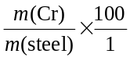 = 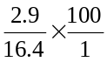 = 18% | 1 mark
c. | The chosen wavelength must be absorbed strongly by the chromium.  The chosen wavelength must not be absorbed by other metals in the steel sample. |  | 1 mark  1 mark
Total 7 marks

