NEAP
2001
CHEMISTRY
Unit 3 Exam

Section A – Multiple Choice

Question 1
Borax is a light, colourless, crystalline substance of chemical formula Na₂B₄O₇.10H₂O. It is used as a disinfectant, a soap additive and a water softener. The oxidation number of boron in borax is
- +2
- +3
- +4
- +6

Question 2
The graph below shows the potential energy diagram for a chemical reaction.
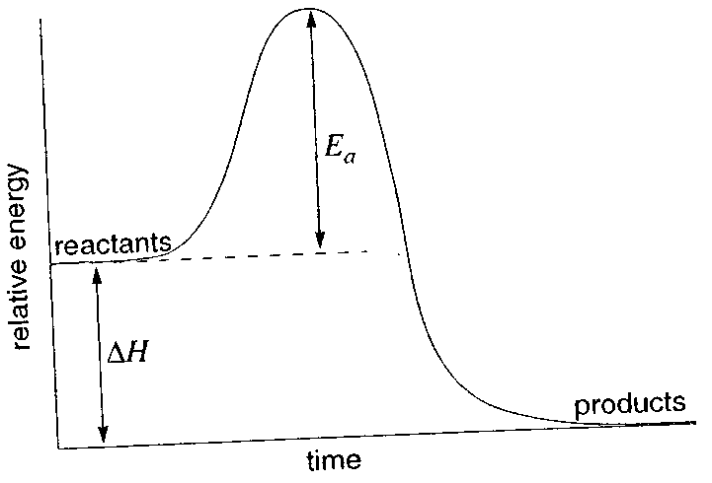
If a catalyst was added to the system,
- both ΔH and E_{a} would decrease
- ΔH would remain constant but E_{a} would decrease
- ΔH would decrease and E_{a} would remain constant
- both ΔH and E_{a} would remain constant

Question 3
If 150 mL of 0.40 M hydrochloric acid is mixed with 50.0 mL of 0.80 M sodium hydroxide, the pH of the resulting solution will be closest to
- 1.0
- 1.3
- 12.7
- 13.0

Question 4
During a practical class a student spilled some concentrated sulfuric acid on exposed skin. The student should immediately
- pour sodium hydroxide over the spill to neutralise the acid
- wrap the affected area in a bandage and seek medical attention
- wash the area with large quantities of cold water
- add sodium carbonate powder to the spill to neutralise the acid

Question 5
Police in Victoria are now able to test blood samples from drivers suspected of ingesting drugs, such as marijuana. The active ingredient of marijuana is THC, of chemical formula C₂₁H₂₉O₂. The most suitable analytical technique to test the level of THC in blood would be
- atomic absorption spectroscopy
- acid-base titration
- thin layer chromatography
- high performance liquid chromatography

Question 6
Hydrogen gas and iodine gas can be reacted together in a closed container to produce hydrogen iodide gas:
H₂ (g) + I₂ (g)  2 HI (g)
The graph shows the percentage concentration of H₂, I₂ and HI found in the container over a period of 40 minutes.
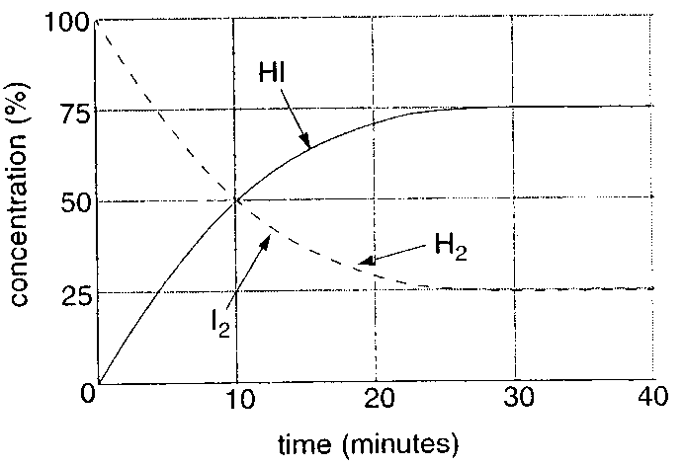
From the information provided, it would be incorrect to conclude that
- The student rinsed the pipette with water instead of the primary standard sodium carbonate solution.
- The student filled the pipette with sodium carbonate solution so that the top of the meniscus was level with the calibration mark.
- The conical flask used in the titration was rinsed with water.
- The student overshot the endpoint of the titration.

Question 7
Octane may undergo thermal cracking to produce ethene and one other product. The other product is
- hexane
- hexene
- heptane
- heptene

Question 8
Large quantities of ammonia are produced every year by the reaction of nitrogen gas with hydrogen gas according to the equation:
N₂ (g) + 3 H₂ (g)  2 NH₃ (g) ΔH = –92 kJ mol^{–1}
To achieve the greatest yield of product, the conditions employed would theoretically be
- high pressure and high temperatures
- high pressure and low temperatures
- low pressure and high temperatures
- low pressure and low temperatures

Question 9
Pyruvic acid is produced by the enzyme-catalysed reaction of glucose within the body. Analysis of this compound establishes its percentage composition as 40.91% carbon, 4.545% hydrogen and 54.55% oxygen. The empirical formula of pyruvic acid is
- CHO
- C₂H₃O₂
- C₃H₄O₃
- CH₂O

Question 10
Two compounds which have the same molecular formula but different structural formulas are
- hexanol and pentanoic acid
- ethyl ethanoate and propionic acid
- dichloroetahne and chlorobutene
- 2-chlorobutane and 2-methyl-2-chlroropropane

Question 11
Methanoic acid (HCOOH), a weak monoprotic acid, has an acidity constant, K_{a}, of 1.6 × 10^{–4}. The pH of a 0.10 M solution of methanoic acid would be closest to
- 1.5
- 2.0
- 2.4
- 5.0

Question 12
Water undergoes self-ionisation according to the endothermic equation shown below:
2 H₂O (l)  H₃O⁺ (aq) + OH– (aq)
The ionisation constant for pure water, K_{w}, at 25°C has a value of 10^{–14}.

Based on the information provided, the value of K_{w} at temperatures less than 25°C would be expected
- less than 10^{–14}
- equal to 10^{–14}
- greater than 10^{–14}
- greater than or less than 10^{–14} depending upon the exact water temperature

Questions 13 to 16 refer to the following information

A commonly used primary standard in analytical chemistry is potassium hydrogen phthalate (KC₈H₅O₄), a monoprotic acid of molar mass 204.1 g mol^{–1}.

A student uses potassium hydrogen phthalate to determine the percentage by mass of ammonia present in a newly released “U-Bute” cleaning solution.

24.6 g of “U-Bute” solution is measured into a 200.0 mL standard flask and deionised water is added to make up 200.0 mL of solution. A 25.0 mL aliquot of this solution is placed into a conical flask. Three drops of methyl red indicator are then added to the solution and it is titrated against 1.00 M potassium hydrogen phthalate solution until a permanent yellow-orange colour change is noted. A titre of 9.23 mL is required to reach the endpoint.

The relevant equation for this acid-base reaction is
C₈H₅O₄– (aq) + NH₃ (aq) → C₈H₄O₄^{2–} (aq) + NH₄⁺ (aq)

Question 13
Which of the following properties is not required for KC₈H₅O₄ to be classified as a primary standard?
KC₈H₅O₄
- solutions are stable in the atmosphere
- forms a colourless solution
- is highly soluble in water
- has a relatively high molar mass

Question 14
The mass of potassium hydrogen phthalate needed to prepare 250.0 mL of a 1.00 M solution is approximately
- 41 g
- 51 g
- 102 g
- 204 g

Question 15
The amount (in mol) of ammonia present in the 24.6 g sample is
- 1.15 × 10^{–3}
- 9.23 × 10^{–3}
- 7.38 × 10^{–2}
- 1.85

Question 16
The percentage by mass of ammonia present in the “U-Bute” solution is approximately
- 0.64%
- 3.16%
- 5.10%
- 7.52%
Question 17
Premium grade unleaded petrol can contain as many as 300 different components. A small quantity of petrol is injected into a gas-liquid chromatograph to produce a chromatogram similar to that shown.
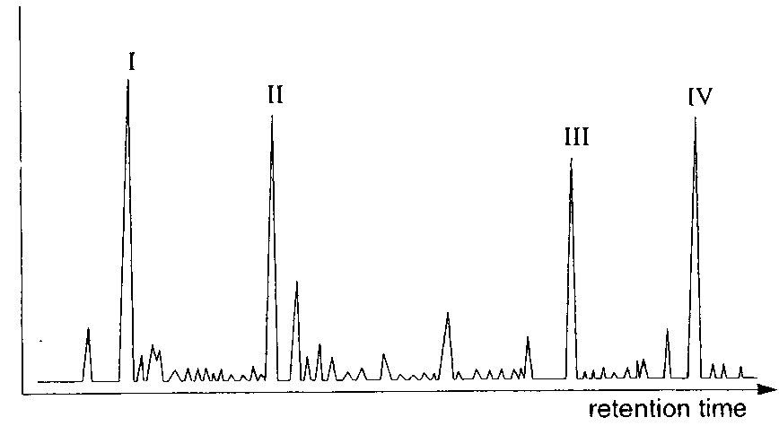
Four major constituents of petrol are hexane, butane, octane and 2-methyl butane. Peak III could represent
- hexane
- butane
- octane
- 2-methyl butane

Question 18
The number of structural isomers of C₄H₉OH is
- 1
- 2
- 3
- 4

Question 19
Cracking of hydrocarbons to produce ethene is carried out at a temperature of approximately 900°C because
- the ethene would form as a liquid if the reaction was carried out at room temperature
- this temperature increases the reaction rate but decreases the yield of ethene
- this temperature increases the yield of ethene but decreases the reaction rate
- this temperature increases the reaction rate and increases the yield of ethene

Question 20
Sulfuric acid is a strong oxidant, in addition to displaying other important chemical properties. Which of the following equations shows sulfuric acid acting as an oxidant?
- 3 Mg (s) + 4 H₂SO₄ (aq) → 3 MgSO₄ (aq) + 4 H₂O (l) + S (s)
- 2 NH₃ (aq) + H₂SO₄ (aq) → (NH₄)₂SO₄ (aq)
- H₂SO₄ (aq) + NaNO₃ (aq) → HNO₃ (g) + NaHSO₄ (s)
- 3 H₂SO₄ (aq) + Fe₂O₃ (s) → Fe₂(SO₄)₃ (aq) + 3 H₂O (l)

Section B – Short Answer Questions

Question 1
- A solution of an acid, HX, has a pH of 4.1, while a solution of another acid, HY, has a pH of 5.0. A student concludes that HX must be a stronger acid than HY. Is the student’s conclusion correct? Explain your response.
________________________________________________________________________________________________
________________________________________________________________________________________________
________________________________________________________________________________________________
________________________________________________________________________________________________
2 marks
- In terms of collision theory, explain why the rate of reaction of copper(II) oxide (CuO) with 0.20 M hydrochloric acid (HCl) at 35°C is greater than the rate of reaction of CuO with 0.15 M HCl at 35°C.
________________________________________________________________________________________________
________________________________________________________________________________________________
________________________________________________________________________________________________
________________________________________________________________________________________________
2 marks
Total 4 marks

Question 2
Consider the diagram below which shows the reactions of some simple organic compounds.

Compound B  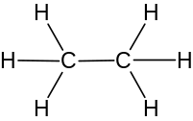 | Cl₂ (g)  UV light | Compound C
H₂ (g) / catalyst |  | KOH (aq)
Compound A | ? | Compound D  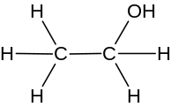
 |  | strong oxidant
Compound F | H₂SO₄ (aq) | Compound E

- Draw structural formulas for the compounds labelled A, C, E and F. (Place the drawings in the boxes shown on the diagram.
4 marks
- Give a name for the type of reaction involved in the conversion of compounds
i. B to C.
____________________________________________________________________________________________
ii. D and E to form F.
____________________________________________________________________________________________
2 marks
- State the formula for any chemicals required to carry out the direct conversion of compound A to compound D.
________________________________________________________________________________________________
1 mark
Total 7 marks

Question 3
- A student wished to determine the equilibrium constant for the reaction shown by the equation:
H₂ (g) + I₂ (g)  2 HI (g)
At the start of the reaction, 0.737 mol of hydrogen and 0.984 mol of iodine were introduced into a 2.70 L reaction vessel. When equilibrium was established at 470°C, the concentration of hydrogen iodide was determined to be 0.260 M.
i. Calculate the concentration of the gases H₂ and I₂ at equilibrium.
____________________________________________________________________________________________
____________________________________________________________________________________________
____________________________________________________________________________________________
____________________________________________________________________________________________
ii. Determine the equilibrium constant for the reaction at this temperature.

4 marks
- The experiment was repeated at a temperature of 600°C and equilibrium concentrations of H₂, I₂ and HI were determined as 0.446 M, 0.605 M and 0.0820 M respectively. Calculate the new equilibrium constant, and so determine whether the reaction is exothermic or endothermic.

Reaction is ___________________________________
2 marks
- Predict the effect (increase, decrease, no change) on the equilibrium concentration of hydrogen iodide ({HI}) of the changes shown below. Indicate your responses by placing ticks in the appropriate spaces in the table.

change | increase in [HI] | decrease in [HI] | no change in [HI]
i. The volume of the reaction vessel is increased
ii. Nitrogen gas is added at constant volume.

2 marks
- State two ways in which the rate of the reaction to produce HI could be increased.
________________________________________________________________________________________________
________________________________________________________________________________________________
2 marks
Total 10 marks

Question 4
The following diagram illustrates the production of sulfuric acid in the laboratory.
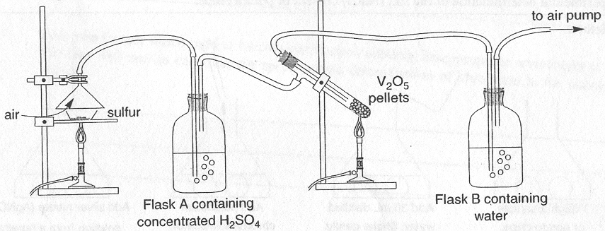
Sulfur is heated in a crucible. Air and gases produced from the burning of sulfur are drawn through the system using an air pump.

- i. State the likely function of the concentrated H₂SO₄ in Flask A.
____________________________________________________________________________________________
ii. With the aid of a balanced equation, state the function of the V₂O₅ pellets.
____________________________________________________________________________________________
____________________________________________________________________________________________
iii. Write a balanced equation for the reaction occurring in Flask B.
____________________________________________________________________________________________
3 marks
- Explain two differences between this laboratory synthesis and the industrial production of sulfuric acid using the Contact Process.
________________________________________________________________________________________________
________________________________________________________________________________________________
________________________________________________________________________________________________
________________________________________________________________________________________________
2 marks
Total 5 marks

Question 5
An examination paper for a Science competition presented the following information concerning the experimental determination of the salt (NaCl) content of potato chips.
Method:
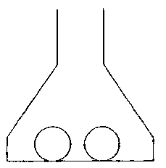 | 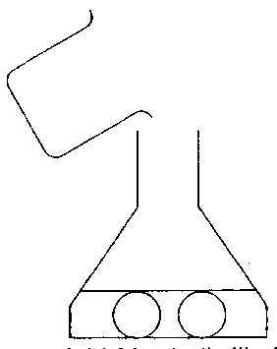 | 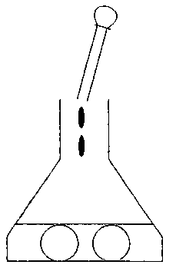 | 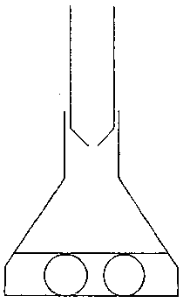
Weigh a sample  of potato chips | Add 30 mL distilled  water. Shake gently. | Add potassium  chromate indicator | Add silver nitrate  (AgNO₃ ) solution from  a burette until a red colour  (the endpoint) is detected
Results:
Mass of potato chips: 1.0 g
Volume of AgNO₃ solution added: 13.6 mL
Concentration of AgNO₃ used: 0.050 M
Formula for calculation:
% salt by mass = 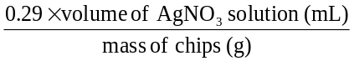
Reaction occurring:
NaCl (aq) + AgNO₃ (aq) → NaNO₃ (aq) + AgCl (s)
The potassium chromate indicator changes colour when the chloride ion has been removed from solution.
- Write a balanced ionic equation for the reaction occurring during the determination of salt content.
________________________________________________________________________________________________
1 mark
- Using the data provided, determine the percentage salt (by mass) in the potato chips.
________________________________________________________________________________________________
________________________________________________________________________________________________
1 mark
- Name the alternative experimental method by which the salt content of the potato chips may be determined
________________________________________________________________________________________________
________________________________________________________________________________________________
1 mark
- A curious student was “puzzled” as to how the figure 0.29 given in the formula for calculation was obtained. Complete the following steps to solve the “puzzle”.
i. Write an expression in terms of V, the volume of AgNO₃ solution (mL), for the amount of silver nitrate (in mol) reacting during the experiment.
____________________________________________________________________________________________
ii. Write an expression for the amount of sodium chloride (in mol) reacting during the experiment.
____________________________________________________________________________________________
iii. Write an expression for the mass of sodium chloride (in g) reacting during the experiment.
____________________________________________________________________________________________
____________________________________________________________________________________________
iv. Hence show how the figure of 0.29 given in the formula for calculation was obtained.
____________________________________________________________________________________________
____________________________________________________________________________________________
4 marks
Total 7 marks
Question 6
Stainless steels have a high resistance to corrosion due to the presence of chromium, present in proportions of 10 to 26% by mass. A metallurgist wishes to accurately determine the percentage of chromium in a particular sample of stainless steel. The steel is first dissolved in acid, which converts the chromium to Cr³⁺ ions. The Cr³⁺ ions are then oxidised further to orange dichromat ions Cr₂O₇^{2–}. The concentration of the dichromate ions can then be determined using UV-visible spectroscopy

- Write a partial redox equation for the oxidation of Cr³⁺ ions to Cr₂O₇^{2–} ions.
________________________________________________________________________________________________
1 mark
- A set of standard solutions of potassium chromate were made up and the absorbances of samples of these solutions were measured by passing light of a wavelength of 440 nm through the samples. A graph of dichromate ion concentration versus absorbance is shown below.
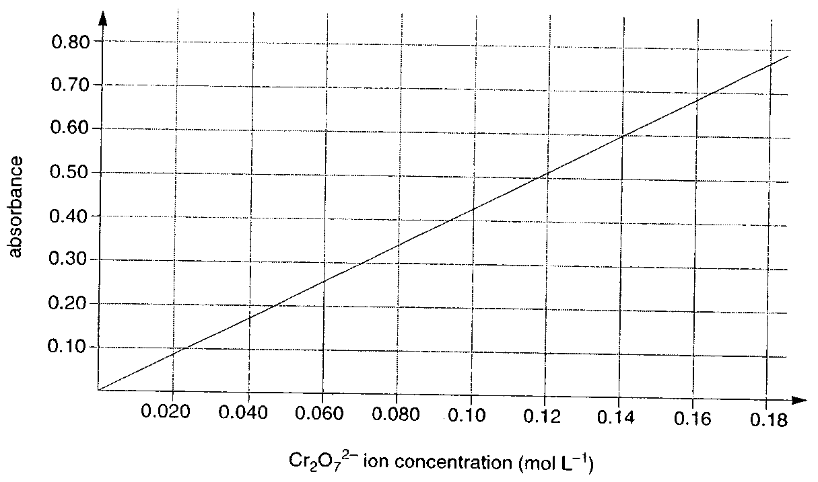
The metallurgies dissolved 16.4 g of the stainless steel sample in acid and the Cr³⁺ was oxidised to Cr₂O₇^{2–}. The solution was then made up to 200 mL. The absorbance reading of the solution was recorded as 0.60.
i. What was the concentration of dichromate ions in the solution of dissolved stainless steel?
____________________________________________________________________________________________
ii. Determine the mass of chromium metal in the sample of steel.
____________________________________________________________________________________________
____________________________________________________________________________________________
____________________________________________________________________________________________
iii. Calculate the percentage by mass of chromium in the sample of steel.
____________________________________________________________________________________________
4 marks
- State two factors which need to be considered when selecting an appropriate wavelength of light (in this case 440 nm) to carry out the spectroscopic determination of chromium in the stainless steel sample.
________________________________________________________________________________________________
________________________________________________________________________________________________
________________________________________________________________________________________________
2 marks
Total 7 marks

END OF QUESTION AND ANSWER BOOKLET

