NEAP
2001
UNIT 4 CHEMISTRY

SECTION A – Multiple-choice questions

Question 1
Which of the following combinations of reactants would be expected to show a significant extent of reaction?
- H₂S (g) and Fe(NO₃)₂ (aq)
- Pb(NO₃)₂ (aq) and Cl₂ (g)
- AgNO₃ (aq) and SnCl₂ (aq)
- SnCl₄ (aq) and Mg(NO₃)₂ (aq)

Question 2
Raffinose is a trisaccharide with molecular formula C₁₈H₃₂O₁₆ and is an important constituent of beans and other legumes. It is made up of the monosaccharides glucose, fructose, and galactose. The energy content of raffinose is not available to the human body. Instead, raffinose is broken down to produce gases such as methane and hydrogen by intestinal bacteria.
The most likely reason that raffinose is not available as a source of energy for humans is that
- humans are unable to hydrolyse polysaccharides to monosaccharides
- the covalent bonding within raffinose molecules is too strong to be broken down by the gastric juices of the stomach
- the rate of hydrolysis of raffinose to its component monosaccharides is too slow for it to be completed while the food is within the body
- humans do not possess the appropriate enzymes to catalyse the hydrolysis of this particular trisaccharide

Question 3
The electronic configuration of an atom of cobalt changes from 1s²2s²2p⁶3s²3p⁶3d⁶4s²4p¹ to 1s²2s²2p⁶3s²3p⁶3d⁶4s¹4p¹5s¹. In the process the atom of cobalt has become
- less stable as its electrons gained energy
- more stable as its electrons gained energy
- less stable as its electrons lost energy
- more stable as its electrons lost energy

Question 4
The fatty acid, linolenic acid, is found primarily in brain tissue while another fatty acid, oleic acid, is found in a wide rang eof animal and plant tissues. In comparison to linolenic acid, C₁₈H₃₀O₂, oleic acid, C₈H₃₄O₂, has
- a greater degree of unsaturation and a higher melting point
- a greater degree of unsaturation and a lower melting point
- a lesser degree of unsaturation and a higher melting point
- a lesser degree of unsaturation and a lower melting point

Question 5
The calibration factor of a calorimeter and its contents was determined to be 580 J °C^{–1}. When 0.020 mol of calcium chloride (CaCl₂) was completely dissolved in the calorimeter the temperature decreased by 2.6°C.
The molar heat of the solution of CaCl₂ is
- +1.5 kJ mol^{–1}
- –1.5 kJ mol^{–1}
- +75 kJ mol^{–1}
- –75 kJ mol^{–1}

Question 6
Atmospheric nitrogen is generally not biologically available to plants and so must be ‘fixed’.
Which of the following process would not result in nitrogen fixation?
- high temperature incinerators
- lightning strikes
- the Haber Process for the production of ammonia
- the deamination of amino acids to produce urea

Question 7
Lecithin is the name given to a class of compounds widely used as food additives. The structure of a typical lecithin is shown below.
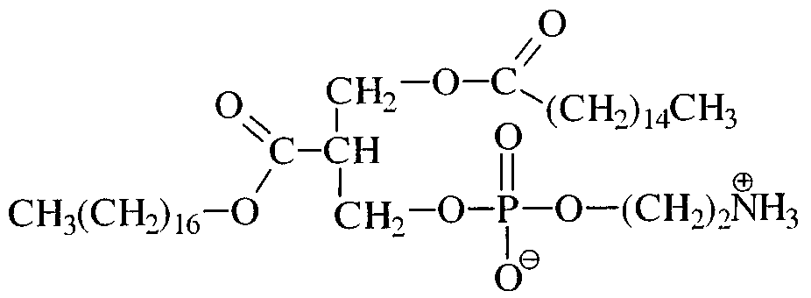
Based on its structure, it is likely that the main role of lecithin as a food additive is to
- stop the food from being oxidised and becoming rancid
- prevent the oil-based components of the food from separating from the water-based components
- improve the colour and appearance of foods to which it is added
- absorb water and so maintain the correct moisture balance in the food

Question 8
Which of the following shows the sequence of energy conversions occurring in a coal-fired power station?
- thermal → chemical → mechanical → electrical
- chemical → mechanical → thermal → electrical
- chemical → electrical
- chemical → thermal → mechanical → electrical

Question 9
Which of the following shows the polysaccharides usually used as energy storage molecules in plants and animals?
 | Plants | Animals
A. | starch and cellulose | glycogen
B. | starch | glycogen
C. | glycogen | starch
D. | starch and cellulose | glycogen and starch

Question 10
Which of the following sketch graphs is the most accurate representation of the trend in electronegativities of the elements of Period 3 across the Periodic Table from sodium to chlorine?
A. | 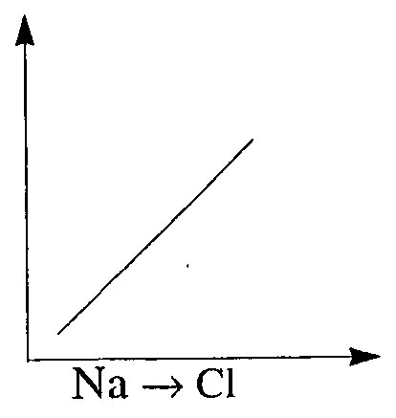 | B. |  | C. | 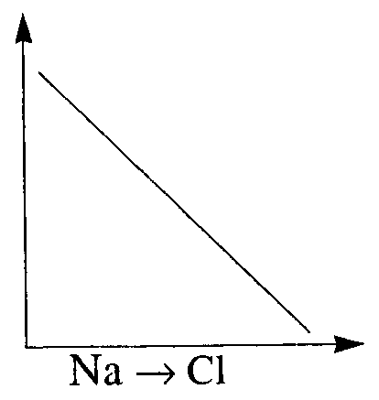 | D. | 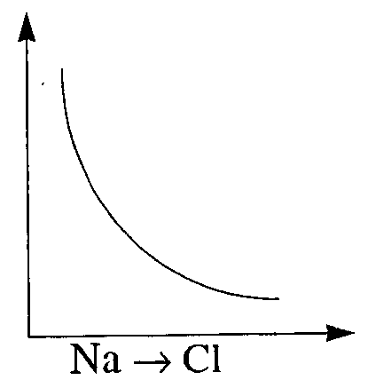

Question 11
Which of the following lists shows processes which involve only hydrolysis reactions?
- polypeptides to amino acids; monosaccharides to polysaccharides; fats to fatty acids and glycerol
- amino acids to polypeptides; polysaccharides to disaccharides; fatty acids to glycerol and fats
- polypeptides to amino acids; disaccharides to monosaccharides; fats to fatty acids and glycerol
- amino acids to polypeptides; polysaccharides to monosaccharides; fatty acids and glycerol to fats

Question 12
The political leaders of many of the largest economies of the world have recently been discussing the Kyoto Protocol to limit global warming. A major contributor to this phenomenon is the increasing quantity of carbon dioxide in the Earth’s atmosphere.
Which of the following process would have the least effect on the overall quantity of carbon dioxide in the atmosphere?
- the combustion of fossil fuels such as coal and petroleum
- the destruction of rainforests in South America to allow for cattle grazing
- an increase in the level of the world’s oceans
- an increase in the rate of denitrification

Question 13
Which of the following elements is a metal found in Period 4 of the Periodic Table?
- 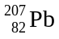
- 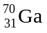
- 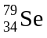
- 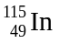

Question 14
During a practical class a student constructed a number of half-cells. Each half-cell contained a metal electrode and a solution containing the metal ion. Half-cells were connected, as shown below. The direction of electron flow and cell voltage for each cell was recorded. All solutions used were 1 M.
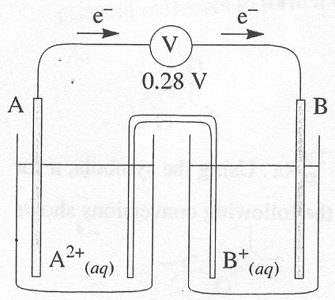 | 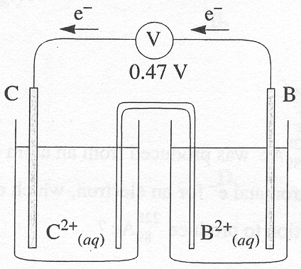 | 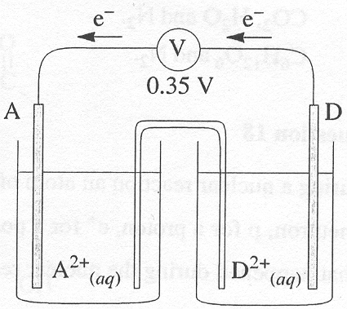
Based on these observations the student could conclude that the strongest oxidant was
- A²⁺
- B²⁺
- C²⁺
- D²⁺

Question 15
Enzymes are often referred to as ‘biological catalysts’. Compared to industrial catalysts, such as platinum and vanadium (V) oxide, enzymes are generally
- far more efficient in speeding up reactions
- able to catalyse a wider range of reactions
- able to operate over a wider range of conditions of temperature and pressure
- altered during reaction and so are unable to be used more than once
Question 16
Copper (I) salts tend to be unstable, and decompose into copper metal and the copper (II) salt according to the equation:
Cu₂SO₄ (aq) → Cu (s) + CuSO₄ (aq)
During this reaction the Cu⁺ (aq) ion
- is simultaneously oxidised to Cu (s) and reduced to Cu²⁺ (aq)
- is simultaneously oxidised to Cu²⁺ (aq) and reduced to Cu (s)
- is oxidised to Cu²⁺ (aq) while a sulphur atom is reduced
- is neither oxidised nor reduced

Question 17
In order to manufacture proteins, plants require sources of carbon, hydrogen, oxygen and nitrogen. Most plants obtain these requirements by the uptake of
- CO₂, H₂O and NH₄⁺ ions
- C₆H₁₂O₆ and NH₄⁺ ions
- CO₂, H₂O and N₂
- C₆H₁₂O₆ and N₂

Question 18
During a nuclear reaction an atom of 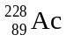 was produced from an atom of 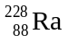. Using the symbols, n for a neutron, p for a proton, e⁺ for a positron and e– for an electron, which of the following conversions shows what happened during the nuclear reaction to produce ?
- p → n + e⁺
- p → n + e–
- n → p + e⁺
- n → p + e–

Question 19
Three electrolysis cells were constructed, each using a pair of graphite electrodes. Each cell contained sodium chloride as the electrolyte, but the state or concentration of the sodium chloride differed, as shown in the diagrams below.
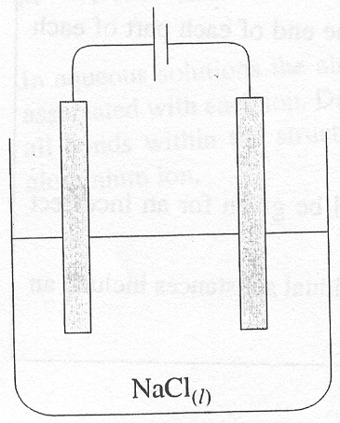 | 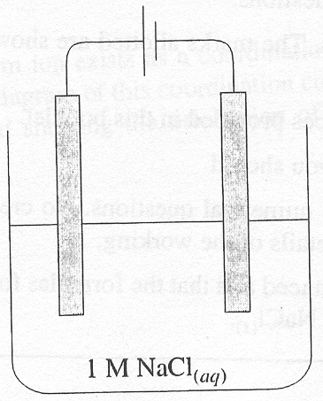 | 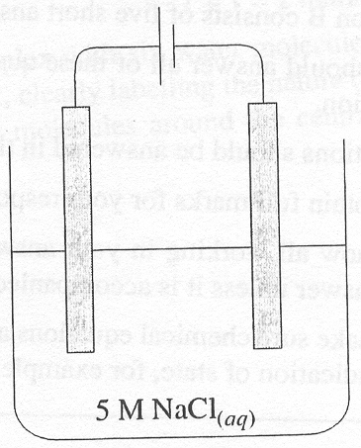
Cell I | Cell II | Cell III
For which cells would you expect to see the same chemical or chemicals initially produced at the anode when the electrolysis was performed?
- I and II
- I and III
- II and III
- I, II and III

Question 20
Which of the following shows the type of linkage which forms when three fatty acid molecules react with a glycerol molecule to form a triglyceride?
A. | 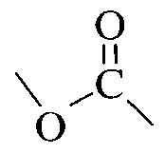 | B. | 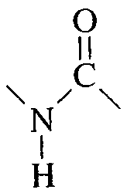 | C. | 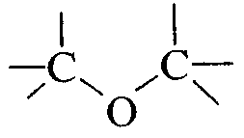 | D. | 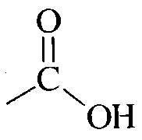

SECTION B – Short-answer questions

Question 1
Large quantities of aluminium are produced every year by the electrolytic reduction of alumina, Al₂O₃. When alloyed with elements such as manganese or copper, aluminium can be produced with similar strength and hardness to steel, with the advantage of being a metal of lower density.

- Aluminium is produced using the Hall-Heroult cell, a simplified diagram of which is shown below.
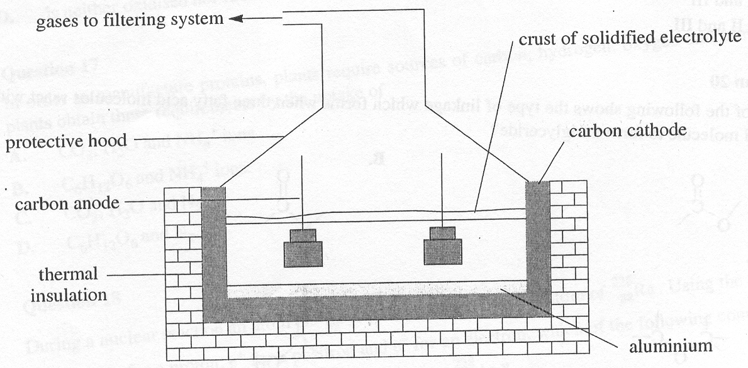
(i) Write half-equations for the reactions occurring at the cathode and anode.
Cathode: ___________________________________________________________________________
Anode: ___________________________________________________________________________
(ii) In the industrial production of aluminium, very large currents (in excess of 140 000 A) are employed at a potential difference of approximately 5 V. State one reason why such very high currents are used in these cells.
____________________________________________________________________________________
____________________________________________________________________________________
2 + 1 = 3 marks
- Aluminium oxide, Al₂O₃, is an amphoteric oxide. Write relevant equations to show how this substance can function as
(i) an acid _____________________________________________________________________________
(ii) a base _____________________________________________________________________________
1 + 1 = 2 marks
- In aqueous solutions the aluminium ion exists as a coordination complex with six water molecules associated with each ion. Draw a diagram of this coordination complex, clearly labelling the nature of all bonds within the structure and showing the orientation of water molecules around the central aluminium ion.

2 marks
- Aluminium and copper are both shiny metals and good conductors of heat and electricity, though each exhibits quite different properties as a ersult of their different locations on the Periodic Table.
(i) Write the ground state electronic configuration of each metal.
Aluminium: ________________________________________________________________________
Copper: ________________________________________________________________________
(ii) State one property that a transition metal, such as copper exhibits, that is not characteristic of a main group metal such as aluminium.
____________________________________________________________________________________
____________________________________________________________________________________
2 + 1 = 3 marks
Total 10 marks

Question 2
The reaction of the two α-amino acids glycine and phenylalanine generates the dipeptide shown below.
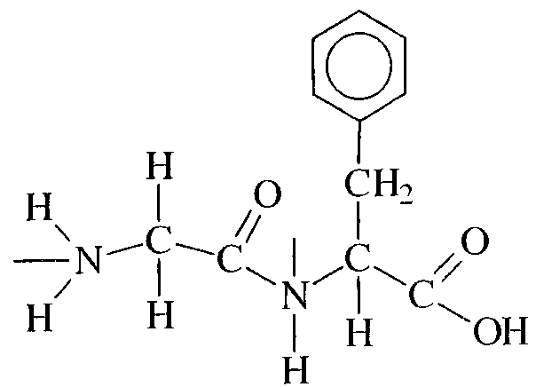
- Clearly indicate the peptide link in the structure above by circling it.
1 mark
- Draw the structural formulas glycine and phenylalanine.

2 marks
- Draw the structural formula of glycine as it would occur in acidic solutions.

1 mark
- When 50 or more amino acids join together they form a protein. Define the term ‘primary structure’ as it applies to proteins.
_______________________________________________________________________________________
_______________________________________________________________________________________
1 mark
- The structure of a protein is important to its correct biochemical functioning. Any change which destroys this functioning is called denaturation.
(i) State one factor which may cause a protein to undergo denaturation.
____________________________________________________________________________________
(ii) Give an example of a situation where the denaturation of a protein is
desirable: ________________________________________________________________________
undesirable: ________________________________________________________________________
1 + 2 = 3 marks
Total 8 marks

Question 3
A student conducted an experiment to investigate the combustion of propanol (CH₃CH₂CH₂OH). Liquid propanol was placed in a spirit burner, the wick lit and the heat released used to heat a beaker of water. The apparatus used and results obtained are shown below.

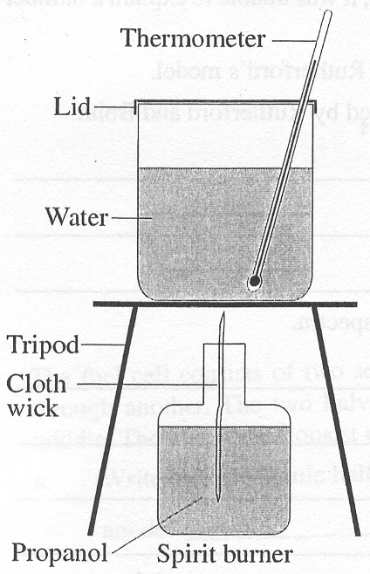 | Precautions: | A shield was placed around the apparatus to help prevent heat loss.
 | Results: | Mass of propanol burned = 1.20 g  Mass of water heated = 150 g  Rise in temperature of water = 54.7°C
 | Observations: | It was difficult to start the propanol burning.
 | Data: | Specific heat capacity of water = 4.18 J g^{–1} °C^{–1}  Heat of combustion of propanol = 2016 kJ mol^{–1}
 | Equation: | C₃H₈O (l) + O₂ (g) → 3 CO₂ (g) + 4 H₂O

- Calculate the energy used in heating the beaker of water.
_______________________________________________________________________________________
_______________________________________________________________________________________
_______________________________________________________________________________________
2 marks
- Calculate the energy released by the burning propanol.
_______________________________________________________________________________________
_______________________________________________________________________________________
_______________________________________________________________________________________
2 marks
- Calculate the percentage of the energy from the burning propanol which was actually used to heat the water.
_______________________________________________________________________________________
_______________________________________________________________________________________
1 mark
- When the experiment was repeated using methanol (CH₃OH) it was found that it was much easier to start the methanol burning than the propanol. Explain this observation.
_______________________________________________________________________________________
_______________________________________________________________________________________
1 mark
Total 6 marks

Question 4
- On the basis of his famous ‘gold leaf’ experiment, Ernest Rutherford proposed a model of the atom in which a tiny but massive nucleus was surrounded by orbiting electrons. While Rutherford’s model was a significant improvement on J. J. Thomson’s ‘plum pudding’ model, it was unable to explain a n umber of important phenomena, such as emission spectra.
The Danish physicist Neils Bohr proposed a number of revisions to Rutherford’s model.
(i) State one fundamental difference between the models proposed by Rutherford and Bohr.
____________________________________________________________________________________
____________________________________________________________________________________
____________________________________________________________________________________
(ii) Explain how Bohr’s model was able to account for emission spectra.
____________________________________________________________________________________
____________________________________________________________________________________
____________________________________________________________________________________
____________________________________________________________________________________
____________________________________________________________________________________
1 + 2 = 3 marks
- With the invention of the mass spectrometer in 1919 by Francis Aston, the relative masses of atoms could be accurately determined. It was found that a helium atom was four times as heavy as a hydrogen atom. This puzzled scientists who expected a helium atom to be twice as heavy as a hydrogen atom.
(i) Why was the helium atom expected to be twice as heavy as the hydrogen atom?
____________________________________________________________________________________
____________________________________________________________________________________
(ii) How do we explain the observation that the helium atom is four times as heavy as the hydrogen atom?
____________________________________________________________________________________
____________________________________________________________________________________
1 + 1 = 2 marks
- Naturally occurring gallium consists of two isotopes. 60.5% of atoms are ⁶⁹Ga, which has a relative isotopic mass of 69.0. Given that the relative atomic mass of gallium is 69.7, calculate the relative isotopic mass of the ⁷¹Ga isotope.
_______________________________________________________________________________________
_______________________________________________________________________________________
_______________________________________________________________________________________
_______________________________________________________________________________________
2 marks
Total 7 marks

Question 5
The German car makers BMW are well advanced in the development of a car that can be run using hydrogen gas as its principal fuel, rather than petrol. The company has spent in excess of US$5 billion on developing a hydrogen/oxygen fuel cell. The diagram below is a simplified version of such a cell.
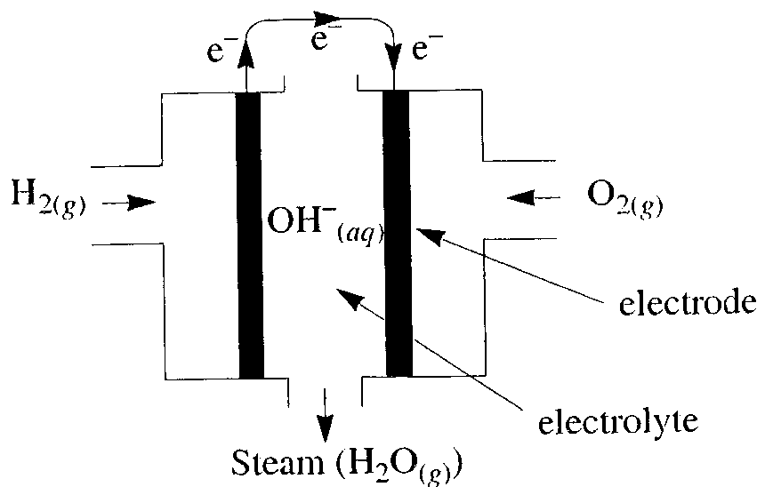
The fuel cell consists of two sections: hydrogen gas is pumped through one half cylinder and oxygen gas through another. The two halves are joined and an alkaline electrolyte such as KOH passes through the middle. The electrodes consist of a porous nickel alloy mesh.

- Write balanced ionic half-equations for the reactions occurring at the anode and cathode.
anode: _______________________________________________________________________________
cathode: _______________________________________________________________________________
2 marks
- (i) State two roles of the nickel electrodes.
____________________________________________________________________________________
____________________________________________________________________________________
(ii) Given that the cost of building a car engine to run on hydrogen gas rather than petrol is very high, state two significant advantages such cells have over traditional petrol combustion engines.
____________________________________________________________________________________
____________________________________________________________________________________
____________________________________________________________________________________
____________________________________________________________________________________
2 + 2 = 4 marks
- A particular hydrogen/oxygen fuel cell generated a current of 6.55 A for 1.00 hour. Calculate the volume of hydrogen gas consumed at a pressure of 5000 kPa and a temperature of 250°c over this period of time.
Describe the role of each.
_______________________________________________________________________________________
_______________________________________________________________________________________
_______________________________________________________________________________________
_______________________________________________________________________________________
3 marks
Total 9 marks

