STAV 2001 | Unit 3 Chemistry | Trial Examination Solutions

Section A – Multiple choice questions

- D
- C
- B
- D
- B
- B
- C
- A
- D
- A
- C
- C
- A
- A
- B
- C
- B
- D

Section B – Short Answer Questions

Question 1
- NH₄⁺ (aq) + H₂O (l)  NH₃ (aq) + H₃O⁺ (aq) (1 mark)
(NH₃ (g) is also acceptable)
- (i) [H₃O⁺] = 10^{–pH} = 10^{–4.80} = 1.58 × 10^{–5} M (1 mark)
(ii) K_{a} = 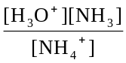 (1 mark)
[H₃O⁺] = [NH₃] = 1.58 × 10^{–5} M (1 mark)
K_{a} = 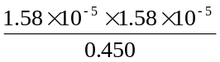 = 5.55 × 10^{–10} M (1 mark)
5.58 × 10^{–10} M is the answer if no rounding off is done during calculations.
(iii) Any one of the following for 1 mark
  - there is no effective change in [H₂O]
  - NH₄⁺ is a weak enough acid to be able to use this relationship
  - initial [NH₄⁺] = equilibrium [NH₄⁺]
  - self-ionisation of water does not significantly affect [H₃O⁺]
- (i) B (1 mark)
(ii) This equilibrium is endothermic in the forward direction, so cooling it will move it in favour of the reactants. (1 mark) This will reduce both [OH–] and [H₃O⁺]. (1 mark) Reducing [H₃O⁺] will cause an increase in pH. (1 mark)

Question 2
- 5 minutes (1 mark)
- The volume of the reaction vessel was decreased, increasing the concentration of all the gases. (1 mark)
- (i) Each concentration should continue at the same level prior to 20 minutes. (1 mark)
(ii) There will be no change in the equilibrium yield of ammonia on the addition of the catalyst. (1 mark) A catalyst only enables equilibrium to be reached more rapidly, it does not alter the position of the equilibrium. (1 mark)

Question 3
- (i) n(C) = 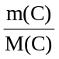= 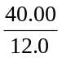 = 3.33 mol
n(H) = 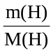= 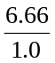 = 6.66 mol
n(O) = 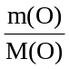= 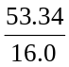 = 3.33 mol (1 mark for mole calculations)
n(C) : n(H) : n(O) = 1 : 2 : 1
empirical formula is CH₂O (1 mark)
(ii) M(sugar) = 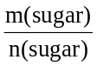 = 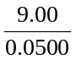 = 180 g mol^{–1} (1 mark)
integer = 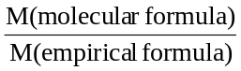 = 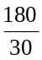 = 6 1 mark)
molecular formula is C₆H₁₂O₆ (1 mark)
- (i) One of the following for 1 mark
- the complex reflects red light and absorbs blue or
- the complex is likely to have maximum absorbance at this wavelength
(ii) | 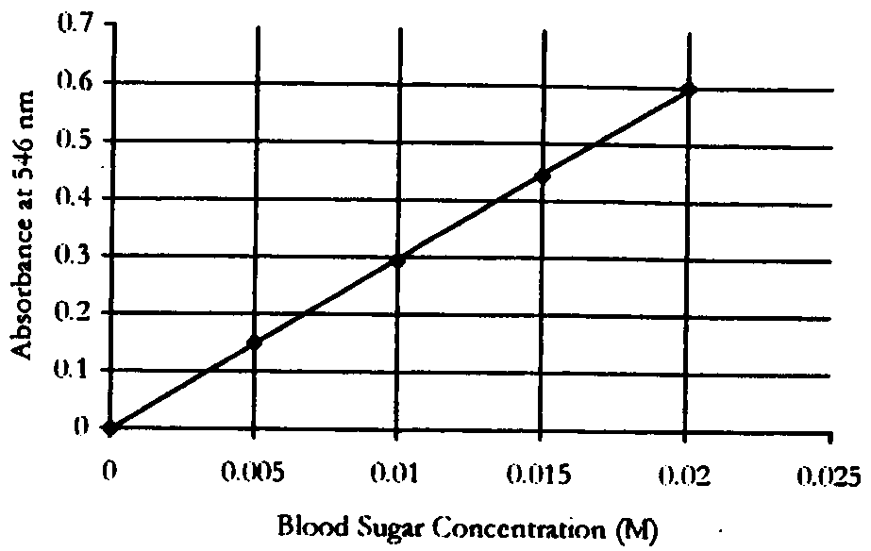 | (1 mark for axes correctly oriented)  (1 mark for data plotted correctly)
(iii) 0.013 M (1 mark) allow ±0.001 M

Question 4
- 3 Mg (s) + N₂ (g) → Mg₃N₂ (s) (1 mark)
- from the equation; 3 mol Mg reacts with 1 mol N₂
therefore
3 × 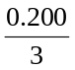 mol of Mg reacts with 1 × mol of N₂
so, 0.200 mol of Mg reacts with 0.0667 mol of N₂ (1 mark)
hence, there is an excess of N₂ as there is 2.00 mol available
so the limiting reagent is Mg (1 mark)
- m(Mg₃N₂) = ⅓ × n(Mg) = ⅓ × 0.200 = 0.06667 mol (1 mark
m(Mg₃N₂) = n(Mg₃N₂) × M(Mg₃N₂) = 0.06667 × 100.9 = 6.73 g (1 mark)

Question 5
- Any two of (molecules drawn flat for convenience)
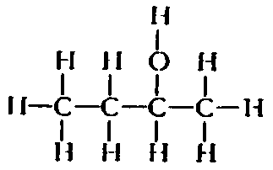 | 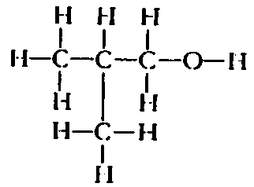 | 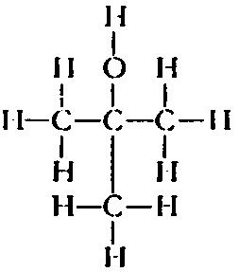
butan-2-ol | methylpropan-1-ol | methylpropan-2-ol
(1 mark each for correct structures of isomers; 1 mark each for correct names of the isomers drawn)
- A C₂H₆O (1 mark)
B C₂H₄O₂ (1 mark)
C C₂H₅Cl (1 mark)
D –(CH₂–CH₂)_{n}– (1 mark)
(A more informative way of representing these molecular formulas is in the form of a semi-structural formula)
A ethanol, C₂H₅OH
B ethanoic acid, CH₃COOH
C chloroethane, CH₃CH₂Cl
D polyethene, –(CH₂–CH₂)_{n}–

Question 6
 | 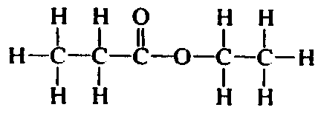 |  |  | (1 mark)
 | Structural formula | Name of the functional group | Name of each molecule
 | 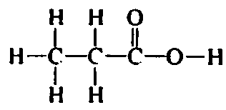  (1 mark) | 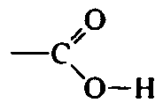  carboxyl (1 mark) | propanoic acid (1 mark)
 | 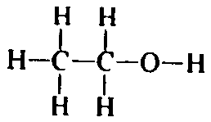  (1 mark) | –O–H  alcohol/ hydroxyl (1 mark) | ethanol (1 mark)

Question 7
- (i) n(total NaOH) = c(NaOH) × V(NaOH) = 0.342 × 50.0 × 10^{–3} = 0.0171 mol
(ii) n(excess NaOH) = 2 × n(H₂SO₄) (1 mark)
n(excess NaOH) = 2 × c(H₂SO₄) × V(H₂SO₄)
= 2 × 0.107 × 20.76 × 10^{–3} = 0.00444 mol (1 mark)
(iii) n(NaOH reacted with lawn feed) = n(total NaOH) – n(excess NaOH)
n(NaOH reacted with lawn feed = 0.01266 mol (1 mark)
n((NH₄)₂)SO₄) = ½ × n(NaOH) = ½ × 0.01266 = 0.00633 mol (1 mark)
m((NH₄)₂SO₄) = n((NH₄)₂SO₄) × M((NH₄)₂SO₄)
= 0.00663 × 132.1 = 0.8362 g (1 mark)
percentage = 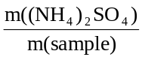 × 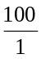 = 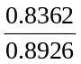 × = 93.7% (1 mark)
- Any two of the following (1 mark each)
- incomplete transference of solid material during various stages of the procedure
- some of the original sulfate ion not dissolving into the solution
- incomplete precipitation of barium sulfate

