STAV
2001
CHEMISTRY
Unit 3 Exam

Section A – Multiple Choice

Question 1
The most suitable instrumental technique for separating the various components in a sample of diesel fuel would be
- atomic absorption spectroscopy
- UV-visible spectroscopy
- high pressure liquid chromatography
- gas liquid chromatography

Question 2
A substance would not be suitable for use as a primary standard if it
- was inexpensive and readily available
- was obtainable in a pure state
- reacts with moisture and gases in the atmosphere
- had a relatively high molar mass

Question 3
In the Ostwald Process for the production of nitric acid, the overall reaction in the final stage is represented by
3 NO₂ (g) + H₂O (l) → 2 HNO₃ (aq) + NO (g)
The oxidation number of nitrogen in the produce HNO₃, compared to the reactant NO₂, has
- decreased by 1
- increased by 1
- increased by 3
- remained unchanged

Question 4
Baking powder is used to assist cake mixture to rise. It contains sodium hydrogen carbonate, NaHCO₃, and trace amounts of ‘flowing agents’ such as silicon dioxide. In the analysis of a brand of baking powder a 1.50 gram sample was reacted with excess acid. The gas released by the reaction is collected at SLC.
Which one of the listed gas syringes would have sufficient capacity to collect he carbon dioxide released?
- 5 mL gas syringe
- 10 mL gas syringe
- 100 mL gas syringe
- 500 mL gas syringe

Question 5
A pipette labelled ’20.00 mL’ could be expected to deliver a volume within
- ± 0.2 mL
- ± 0.02 mL
- ± 0.002 mL
- ± 0.0002 mL

Question 6
To determine the percentage of iron in a given mass of steel by the technique of gravimetric analysis, it would be necessary to
- use an indicator to determine the endpoint
- first prepare a solution which contains the iron component of the steel
- select a solvent for use as the mobile phase in which the iron will dissolve
- prepare a number of standard solutions of known iron concentration

Question 7
The reaction between dilute hydrochloric acid and magnesium is an exothermic reaction that produces hydrogen. Which one of the following factors would decrease the rate of hydrogen production?
- Heating the reaction mixture
- Using more concentrated acid
- Cooling the mixture
- Adding a catalyst

Question 8
The normal pH of human blood must be maintained between 7.38 – 7.43. The following equation indicates a buffering system which operates in the blood:
CO₂ (aq) + H₂O (l)  H₂CO₃ (aq)  H⁺ (aq) + HCO₃– (aq)
People with lung disorders often fail to remove carbon dioxide efficiently. What would be the effect of higher concentrations of carbon dioxide in the blood?
- The blood pH falls
- The blood pH rises
- Water levels in the blood increase
- The blood pH remains the same

Question 9
The expression for the equilibrium constant, K for the reaction: N₂O₄ (g)  2 NO₂ (g) would be
- K = 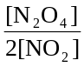
- K = 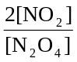
- K = 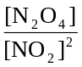
- K = 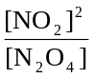

Question 10
What would happen to the value of K in the reaction described in Question 9, if the pressure of the N₂O₄ is doubled, at constant temperature?
- K would not change
- K would be halved
- K would be doubled
- K would increase by a factor of 4

Question 11
An example of a weakly acidic solution formed by a strong acid is
- 0.001 M CH₃COOH
- 1.0 M CH₃COOH
- 0.001 M HNO₃
- 1.0 M HNO₃

Question 12
A pH meter was used to monitor the progress of an acid-base titration. 50 mL of 0.100 M NaOH (aq) was added in 1 mL aliquots to 50 mL of an acid. The pH of the acid-base mixture was measured after each 1 mL aliquot was added. The results are shown on the graph.
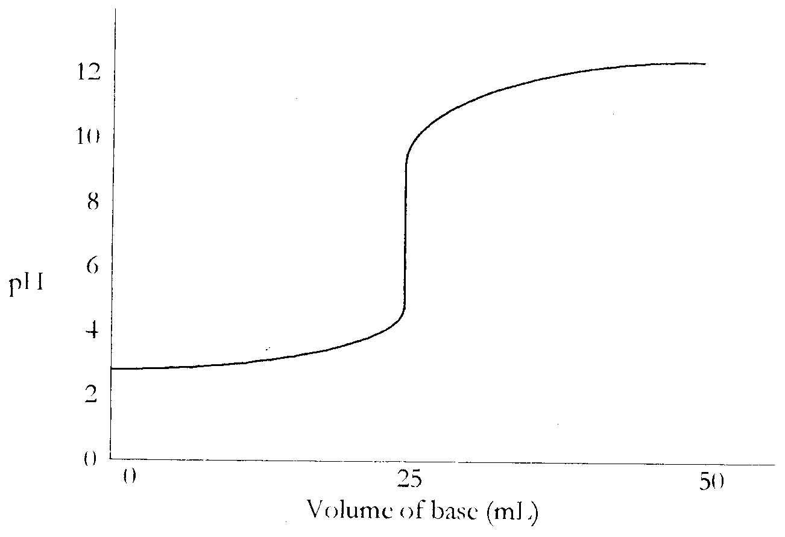
Using the information above, it is reasonable to conclude that the acid was
- nitric acid
- hydrochloric acid
- ethanoic acid
- sulfuric acid

Question 13
Hydrocarbons undergoing incomplete combustion produce mostly
- water and carbon monoxide
- water and carbon dioxide
- water and carbon
- carbon dioxide and oxygen

Question 14
During the production of sulfuric acid the following reaction is involved:
2 SO₂ (g) + O₂ (g)  2 SO₃ (g) ΔH = -197 kJ mol^{–1}
Which statement is incorrect for this equilibrium system?
- Using a catalyst would decrease the heat of reaction.
- Increasing the temperature would produce less of the product.
- Adding more sulfur dioxide would produce more of the product.
- Increasing the pressure while the temperature remained constant would produce more of the product.

Question 15
The reaction between ethanol and hydrogen chloride is an example of
- an addition reaction
- a substitution reaction
- a polymerisation reaction
- a hydrogenation reaction

Question 16
In Australia, the major use for sulfuric acid is
- as an alkali
- as a catalyst
- in the manufacture of fertiliser
- in the manufacture of plastics

Question 17
In the final stage of sulfuric acid manufacture, sulfur trioxide is absorbed in a concentrated solution of sulfuric acid, producing oleum, rather than being added directly to water. The reason for this is that
- the reaction between sulfur trioxide and water is endothermic and requires heat
- the reaction between sulfur trioxide and water is exothermic, producing an acid mist that is costly to condense
- sulfur trioxide does not react with water alone
- oleum is a more valuable chemical than is sulfuric acid

Question 18
The catalyst most commonly used to convert sulfur dioxide to sulfur trioxide is
- Fe
- SiO₂
- Al₂O₃
- V₂O₅

Section B – Short Answer Questions

Question 1
Ammonium sulfate, (NH₄)₂SO₄, is widely used by gardeners as a fertiliser. Care has to be taken with its use because ammonium ions, NH₄⁺, are weakly acidic.

- Write a balanced chemical equation for the reaction of ammonium ions with water.
__________________________________________________________________________________________________
- The pH of a 0.450 M solution of ammonium ions is determined to be 4.80.
(i) Calculate the concentration of hydronium ions, H₃O⁺, in this solution.
_______________________________________________________________________________________________
_______________________________________________________________________________________________
(ii) Calculate the acid dissociation constant, K_{a}, for the reaction of ammonium ions with water.
_______________________________________________________________________________________________
_______________________________________________________________________________________________
_______________________________________________________________________________________________
_______________________________________________________________________________________________
_______________________________________________________________________________________________
(ii) Give an assumption that is made in calculating the K_{a} value for NH₄⁺.
_______________________________________________________________________________________________
_______________________________________________________________________________________________
_______________________________________________________________________________________________
_______________________________________________________________________________________________
_______________________________________________________________________________________________
- The self-ionisation of water may be represented by the equation
H₂O (l) + H₂O (l)  H₃O⁺ (aq) + OH– (aq) ΔH = +57 kJ mol^{–1}
At 25°c, the pH of water is 7.0
(i) At 15°C, the pH of water will be
A. 7.0 exactly
B. greater than 7.0
C. less than 7.0
Write the letter that represents your answer in the box.
(ii) Explain your answer to c. part (i).
_______________________________________________________________________________________________
_______________________________________________________________________________________________
_______________________________________________________________________________________________
_______________________________________________________________________________________________
_______________________________________________________________________________________________
1 + 5 + 4 = 105 marks
Suggested time: 13 minutes

Question 2
Ammonia is manufactured by the direct reaction of nitrogen and hydrogen.
N₂ (g) + 3 H₂ (g)  2 NH₃ (g)
Nitrogen and hydrogen are added to a 100 L reaction vessel. The graph below shows the change in the concentrations of nitrogen, hydrogen and ammonia over a 20 minute period in the reaction vessel.
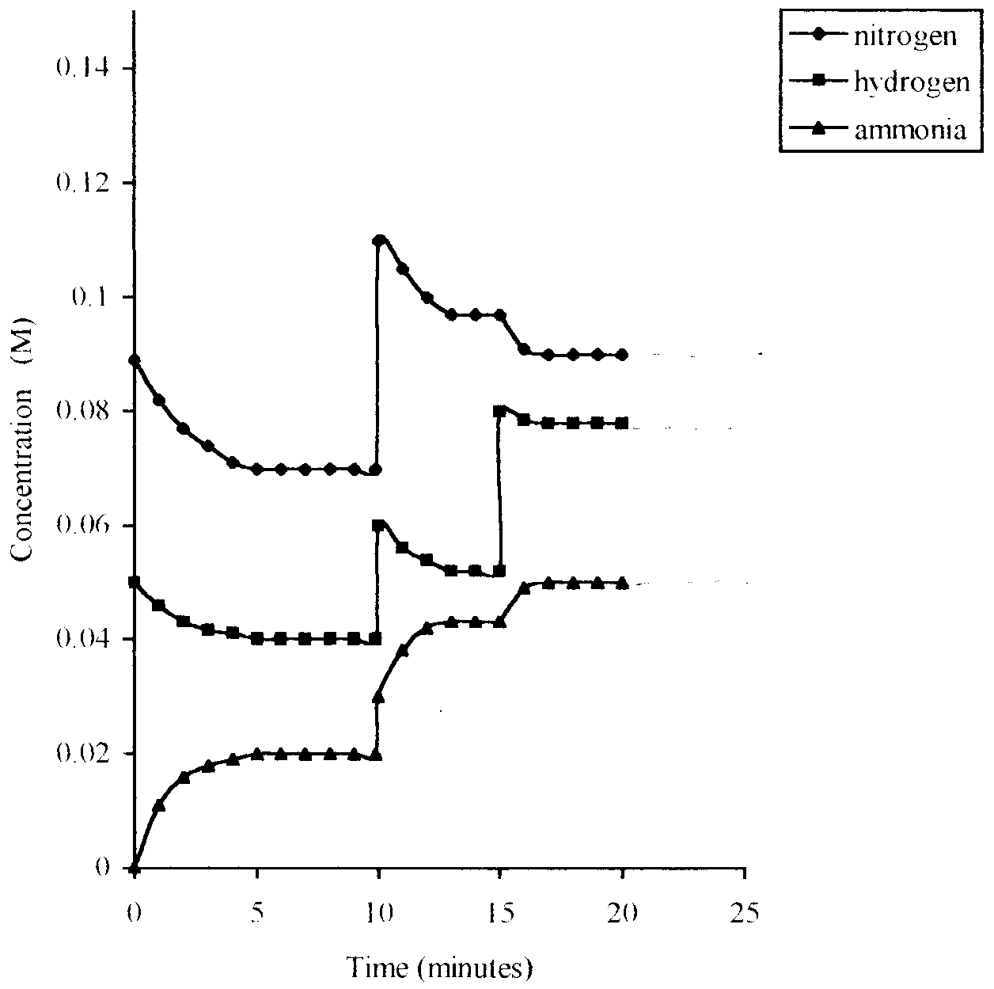

- At what time was equilibrium first achieved in the reaction vessel?
__________________________________________________________________________________________________
- What change was made to the system at the 10 minute mark?
__________________________________________________________________________________________________
- (i) Sketch on the graph the effect on the concentration of each gas when a catalyst is added to the reaction vessel at the 20 minute mark.
(ii) What would be the effect on the equilibrium yield of ammonia in the reaction vessel on adding a catalyst at the 20 minute mark? Explain your answer.
_______________________________________________________________________________________________
_______________________________________________________________________________________________
_______________________________________________________________________________________________
_______________________________________________________________________________________________
1 + 1 + 3 = 5 marks
Suggested time: 6 minutes

Question 3
- Analysis of a sugar found in the blood shows it to consist of 40.00% carbon, 6.66% hydrogen and 53.34% oxygen, by mass.
(i) Use this information to determine an empirical formula for this sugar.
_______________________________________________________________________________________________
_______________________________________________________________________________________________
_______________________________________________________________________________________________
_______________________________________________________________________________________________
(ii) Given that 0.0500 mol of this sugar has a mass of 9.00 g, determine a molecular formula for the sugar.
_______________________________________________________________________________________________
_______________________________________________________________________________________________
_______________________________________________________________________________________________
_______________________________________________________________________________________________
- People who suffer from diabetes need to have their blood sugar levels monitored closely. One way of quantitatively analysing blood sugar is to use simple calorimetry, taking advantage of the fact that blood sugar readily forms a red complex that absorbs at a wavelength of 546 nm.
(i) The wavelength 546 nm is toward the blue end of the spectrum yet the complex is red in colour. Explain why this wavelength is used.
_______________________________________________________________________________________________
_______________________________________________________________________________________________
_______________________________________________________________________________________________
_______________________________________________________________________________________________
_______________________________________________________________________________________________
(ii) Before quantitative analysis of a patient’s blood can take place, a calibration graph must be obtained. Use the data provided in the table to plot a calibration graph on the grid provided.

Blood sugar concentration (M) | Absorbance
0.00 | 0.00
0.005 | 0.15
0.010 | 0.30
0.015 | 0.45
0.020 | 0.60

(iii) Use the calibration graph to determine the blood sugar concentration of a diabetes patient whose blood sample had an absorbance of 0.375.
_______________________________________________________________________________________________
5 + 4 = 9 marks
Suggested time: 12 minutes

Question 4
Magnesium metal reacts on heating with nitrogen gas and forms magnesium nitride, Mg₃N₂. In one such experiment 0.200 mol of magnesium was reacted with 2.00 mol of nitrogen gas.

- Write a balanced chemical equation for the described reaction.
__________________________________________________________________________________________________
- Which reactant is the limiting reagent? Show the working that you used to determine the limiting reagent.
__________________________________________________________________________________________________
__________________________________________________________________________________________________
__________________________________________________________________________________________________
__________________________________________________________________________________________________
__________________________________________________________________________________________________
__________________________________________________________________________________________________
__________________________________________________________________________________________________
__________________________________________________________________________________________________
- What mass of magnesium nitride, Mg₃N₂, would be produced by this reaction?
__________________________________________________________________________________________________
__________________________________________________________________________________________________
__________________________________________________________________________________________________
__________________________________________________________________________________________________
__________________________________________________________________________________________________
__________________________________________________________________________________________________
1 + 2 + 2 = 5 marks
Suggested time: 6 minutes

Question 5
An alcohol has the following structural formula
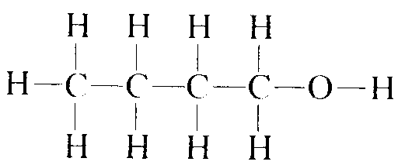

- Draw, and name, two other structural isomers of alcohols with this molecular formula.

- Ethene is an important industrial chemical, being involved in the synthesis of a number of other widely used chemicals. The following reaction scheme shows some of the more important reactions involving ethene.
In boxes A, B, C and D write the molecular formula of the substance formed, and in box E the name of the process occurring.
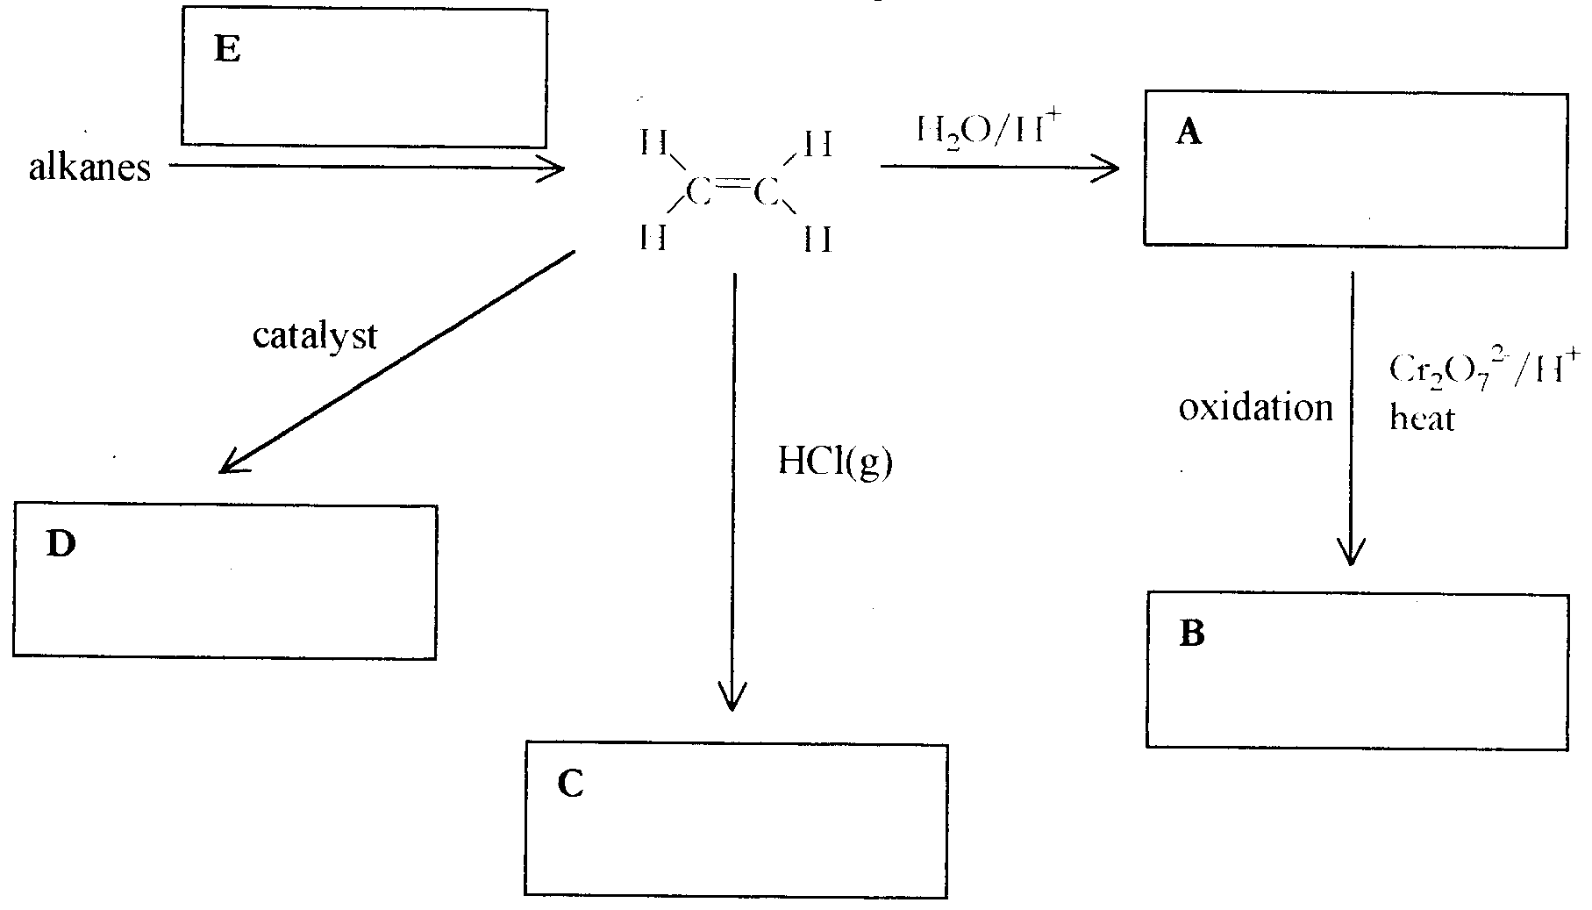
4 + 5 = 9 marks
Suggested time: 11 minutes

Question 6
Esters are a class of organic chemicals that have a wide range of uses as a result of their distinctive smell.

- An example of an ester is C₂H₅COOC₂H₅. Draw the structural formula for this ester.

- Complete the following table, giving the structural formula, name of the functional group and the name of each molecule used to make this particular ester.

Structural formula | Name of Functional Group | Name of Each Molecule

1 + 6 = 7 marks
Suggested time: 8 minutes

Question 7
The content of ammonium sulfate in lawn food can be determined using either volumetric analysis or gravimetric analysis.

A brand of lawn food called ‘Fedwel’ is known to contain a mixture of ammonium sulfate and sand.

Two students using volumetric analysis took a 0.8926 g sample of lawn feed. After boiling with 50.0 mL of 0.342 M NaOH fro 10 minutes, the excess base was titrated with 0.107 M H₂SO₄. An average concordant titre of 20.76 mL was obtained.

The relevant equations are
(NH₄)₂SO₄ (aq) + 2NaOH (aq) → Na₂SO₄ (aq) + 2 NH₃ (g) + 2 H₂O (l)
H₂SO₄ (aq) + 2NaOH (aq) → Na₂SO₄ (aq) + 2 H₂O (l)

- Determine the amount, in mol, of sodium hydroxide
(i) in the original 50.0 mL of solution added to the lawn feed.
_______________________________________________________________________________________________
_______________________________________________________________________________________________
_______________________________________________________________________________________________
(ii) in excess after the lawn feed/base mixture had been boiled for 10 minutes.
_______________________________________________________________________________________________
_______________________________________________________________________________________________
_______________________________________________________________________________________________
(iii) Hence, calculate the percentage, by mass, of ammonium sulfate in the lawn feed.
_______________________________________________________________________________________________
_______________________________________________________________________________________________
_______________________________________________________________________________________________
_______________________________________________________________________________________________
_______________________________________________________________________________________________
_______________________________________________________________________________________________
_______________________________________________________________________________________________
_______________________________________________________________________________________________
_______________________________________________________________________________________________
_______________________________________________________________________________________________
- Another pair of students used the technique of gravimetric analysis. They precipitated the sulfate ion using barium nitrate. They obtained a percentage, by mass of 89.0%, which was lower than that determined by volumetric analysis. With reference to the gravimetric procedure, list two experimental errors that might lead to this result.
__________________________________________________________________________________________________
__________________________________________________________________________________________________
__________________________________________________________________________________________________
__________________________________________________________________________________________________
__________________________________________________________________________________________________
__________________________________________________________________________________________________
7 + 2 = 9 marks
Suggested time: 12 minutes

END OF QUESTION AND ANSWER BOOK

