STAV
2001
UNIT 4 CHEMISTRY

SECTION A – Multiple-choice questions

Question 1
The boiling of water may be represented by the following thermochemical equation:
H₂O (l)  H₂O (g) ΔH = +44.0 kJ mol^{–1}
The activation energy for this reaction is 52.0 kJ mol^{–1}.
The activation energy for the reaction:
H₂O (g)  H₂O (l) ΔH = –44.0 kJ mol^{–1}
is
- –8.00 kJ mol^{–1}
- +8.00 kJ mol^{–1}
- –96.0 kJ mol^{–1}
- +96.0 kJ mol^{–1}

Question 2
Solutions of hydrochloric acid and sodium hydroxide react according to the equation:
HCl (aq) + NaOH (aq)  NaCl (aq) + H₂O (g) ΔH = –57.2 kJ mol^{–1}
When 50.0 mL of 0.100 M HCl is added to 20.0 mL of 0.500 M NaOH the energy released would be
- 286 J
- 572 J
- 2.86 kJ
- 5.72 kJ

Question 3
A galvanic cell is constructed by linking a standard hydrogen half-cell to a half-cell consisting of a graphite electrode dipping into 1.0 M aqueous solutions of iron (III) nitrate and iron (II) nitrate. In this galvanic cell
- oxidation occurs at the graphite electrode
- reduction occurs at the electrode in the hydrogen half-cell
- the pH of the solution in the standard hydrogen half-cell is decreasing
- the pH of the solution in the standard hydrogen half-cell is increasing

Questions 4 and 5 refer to the following information

The half equations below represent the reduction reactions of three substances A³⁺, B²⁺, and C₂.
A³⁺ (aq) + e– |  | A²⁺ (aq)
B²⁺ (aq) + 2 e– |  | B (s)
C₂ (aq) + 2 e– |  | 2 C– (aq)

Pairs of the six species, A³⁺ (aq), A²⁺ (aq), B²⁺ (aq), B (aq), C₂ (aq), and C– (aq), were mixed in test tubes and if any observable reaction occurred the results were noted. Some of these results are given in the table.

 |  | Reductant
Oxidant |  | A²⁺ (aq) | B (s) | C– (aq)
Oxidant | A³⁺ (aq) | – | # | * |  | * an observable reaction occurs
Oxidant | B²⁺ (aq) | * | – | I |  | # no observable reaction occurs
Oxidant | C₂ (aq) | II | – | – |  | – not tested

Question 4
The order of strength of the oxidants, from weakest to strongest is
- C₂ < B²⁺ < A³⁺
- B²⁺ < C₂ < A³⁺
- B²⁺ < A³⁺ < C₂
- C₂ < A³⁺ < B²⁺
Question 5
In which of the combinations I and II would it be expected that an observable reaction would occur?
- I and II only
- I only
- II only
- Neither I nor II

Question 6
The electrode with a positive polarity during the discharging process of a secondary cell will become, during the recharging process, the
- positive anode
- negative anode
- positive cathode
- negative cathode

Question 7
Mercury oxide-zinc batteries are used in many low power applications, such as watches and calculators. The cell reaction is:
HgO (s) + Zn (s) + H₂O (l)  Hg (l) + Zn(OH)₂ (s)
The half-cell reaction at the positive electrode of the battery is
- HgO (s) + H₂O (l) + 2 e–  Hg (l) + 2 OH– (aq)
- Hg (l) + 2 OH– (aq)  HgO (s) + H₂O (l) + 2 e–
- Zn(OH)₂ (s) + 2 e–  Zn (s) + 2 OH– (aq)
- Zn (s) + 2 OH– (aq)  Zn(OH)₂ (s) + 2 e–

Question 8
An aqueous solution containing a mixture of 0.1 M Ca(NO₃)₂, 0.1 M Cu(NO₃)₂ and 0.1 M AgNO₃ is electrolysed using graphite electrodes. After all the possible reactants have been consumed, the outermost coating on the cathode will be
- silver followed by copper
- calcium, copper then silver
- silver, copper then calcium
- copper followed by silver

Question 9
Many naturally occurring carbohydrates are condensation polymers of glucose, C₆H₁₂O₆. When three of these molecules undergo a condensation reaction the product has the molecular formula
- C₁₈H₃₆O₁₈
- C₁₈H₁₈O₉
- C₁₈H₃₂O₁₆
- C₁₈H₃₀O₁₅

Question 10
The concentration of nitrate ions present in soil can be decreased by the
- action of lightning
- action of denitrifying bacteria
- action of nitrifying bacteria in legumes
- death and decay of plants and animals

Question 11
When polyunsaturated vegetable oils are hydrogenated the product(s) will be
- glycerol and fatty acids
- glycerol and water
- carbon dioxide and water
- solid fats

Question 12
During digestion the enzymes present in the small intestine are mostly involved in
- addition reactions
- condensation reactions
- hydrolysis reactions
- combustion reactions

Question 13
Identify the molecule that can form proteins via condensation reactions.
- NH₂CHCH₃COOH
- C₁₆H₃₃COOH
- (NH₂)₂CO
- NH₄OH

Question 14
The chemical formula of an alcohol formed by the hydrolysis of triglycerides is
- CH₃COOH
- CH₂OHCHOHCH₂OH
- CH₃CH₂OH
- NH₄OH

Question 15
Aluminium is normally manufactured by passing an electric current through a molten mixture of Al₂O₃ and Na₃AlF₆, using carbon electrodes. The gas discharged to the atmosphere in the largest amount during the process is
- F₂
- O₂
- HF
- CO₂

Question 16
Which one of the following represents the electronic configuration of an atom of 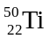 in an excited state?
- 1s² 2s² 2p⁶ 3s² 3p⁶ 3d²
- 1s² 2s² 2p⁶ 3s² 3p⁶ 3d⁵
- 1s² 2s² 2p⁶ 3s² 3p⁶ 4s² 4p²
- 1s² 2s² 2p⁶ 3s² 3p⁶ 3d² 4s²

Questions 17 and 18 refer to the following information

In the production of nuclear energy, ²³⁵U is bombarded with neutrons, initiating the following reaction sequence:
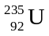 + 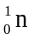  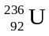  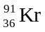 + 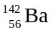 + 3 X + energy

Question 17
The particles represented by X in this reaction are
- helium nuclei
- electrons
- protons
- neutrons

Question 18
In this nuclear reaction
- ¹⁴²Ba is produced by nuclear fusion
- ¹⁴²Ba is produced by nuclear fission
- the energy released is equivalent to the nuclear binding energy of ²³⁵U
- the energy released is equivalent to the nuclear binding energy of ¹⁴²Ba

Question 19
Which of the following species is not able to act as a ligand?
- ammonia
- ammonium ion
- chloride ion
- carbon monoxide

Question 20
An element, E, forms the following compounds E₂O₅ and Na₃EO₄. In the periodic table, element E would appear in the same group as
- carbon
- fluorine
- nitrogen
- oxygen

SECTION B – Short-answer questions

Question 1
Methanol, CH₃OH, has been suggested as an alternative fuel to petrol (octane, C₈H₁₈) in cars. The enthalpy (heat) of combustion for methanol is 727 kJ mol^{–1} and that of octane is 5450 kJ mol^{–1}.

- Write balanced chemical equations to represent the complete combustion of each of these fuels.
_______________________________________________________________________________________
_______________________________________________________________________________________
- Determine the enthalpy (heat) of combustion for each fuel, expressed as kJ g^{–1}.

- (i) If the fuel tank of an average car takes 60 kg of fuel, which fuel potentially would allow the car to travel further? Justify your answer.
____________________________________________________________________________________
____________________________________________________________________________________
____________________________________________________________________________________
____________________________________________________________________________________
(ii) State one assumption that you made in answer part (i).
____________________________________________________________________________________
____________________________________________________________________________________
____________________________________________________________________________________
2 + 2 + 3 = 7 marks
Suggested time = 9 minutes

Question 2
It has been suggested that in the future some homes could obtain their electricity from an acidic electrolyte fuel cell which consumes methane and oxygen. The methane would be supplied by the decomposition of organic material produced in the home. A possible arrangement is shown below.
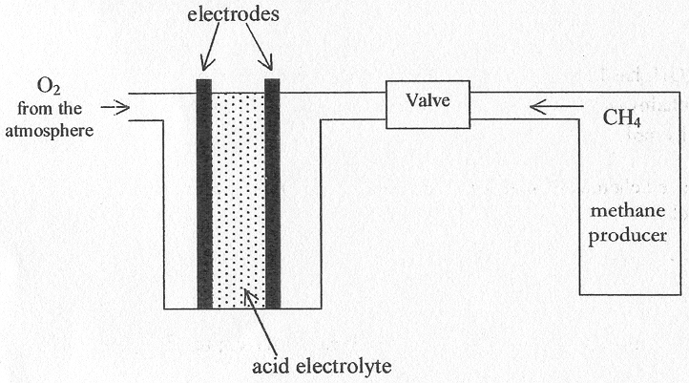
The overall equation for such a fuel cell is
CH₄ (g) + 2 O₂ (g)  CO₂ (g) + 2 H₂O (l)

- What compound is oxidised in the reaction? Explain your answer.
_______________________________________________________________________________________
_______________________________________________________________________________________
- Write a partial ionic equation for the oxidation reaction.
_______________________________________________________________________________________
_______________________________________________________________________________________
- Suppose the current drawn by a household connected to this fuel cell averages 5.00 A. What volume of methane, measured at SLC, is consumed by the cell each day if 70% of the energy produced by the cell is converted into electricity?

- Give one major difference between the operation of a fuel cell and the operation of a galvanic cell such as a simple dry cell battery.
_______________________________________________________________________________________
_______________________________________________________________________________________
_______________________________________________________________________________________
_______________________________________________________________________________________
2 + 1 + 5 + 1 = 9 marks
Suggested time: 11 minutes

Question 3
Soybean oil contains stearic acid, oleic acid and eleostearic acid.

Stearic acid
CH₃(CH₂)₁₆COOH
Oleic acid
CH₃(CH₂)₇CH=CH(CH₂)₇COOH

Eleostearic acid
CH₃(CH₂)₇CH=CHCH=CHCH=CH(CH₂)₃COOH

- These three fatty acids combine with glycerol to form triglycerides.
State which one or more of the fatty acids would be expected to form a saturated triglyceride. Explain your selection(s).
_______________________________________________________________________________________
_______________________________________________________________________________________
_______________________________________________________________________________________
- Explain why soybean oil is a liquid rather than a solid.
_______________________________________________________________________________________
_______________________________________________________________________________________
_______________________________________________________________________________________
_______________________________________________________________________________________
- These three fatty acids all contain 18 carbon atoms. Suggest an experimental method, which could be performed in a school laboratory, to distinguish between oleic acid and eleostearic acid.
_______________________________________________________________________________________
_______________________________________________________________________________________
_______________________________________________________________________________________
_______________________________________________________________________________________
_______________________________________________________________________________________
1 + 2 + 2 = 5 marks
Suggested time: 6 minutes

Question 4
In an experiment to determine the value of the Avogadro constant, N_{A}, a Chemistry student carries out an electrolysis using the equipment shown in the diagram.
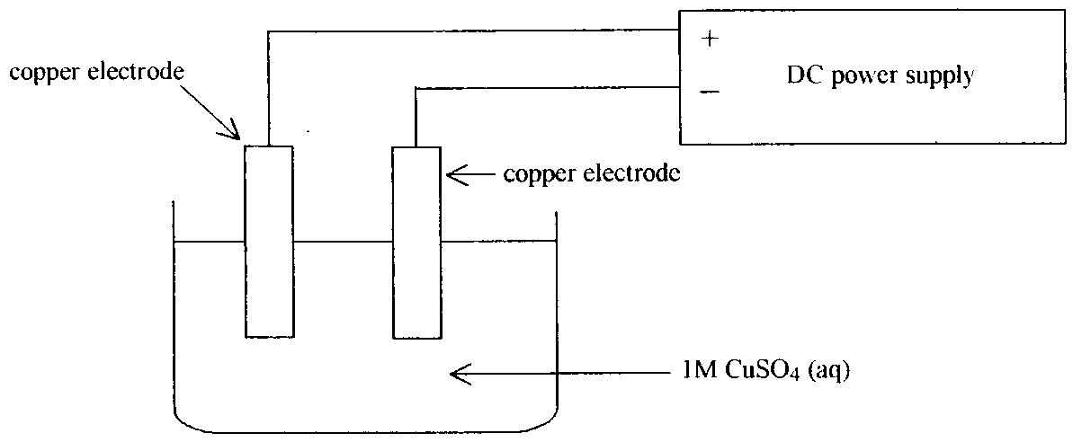
The voltage is adjusted so that no gas is observed at either of the two electrodes.
After a time of 12.0 minutes at an average current of 1.40 A, the electrodes are removed, carefully rinsed, dried and weighed. The mass of the negative electrode is found to have increased by 0.393 g.

- Determine the charge which flowed through the circuit in the 12.0 minutes.

- Determine the amount, in mol, of copper that has been deposited on the negative electrode.

- Use your answers to parts a. and b. to calculate a value for the Faraday constant, F.

- Calculate a value for the Avogadro constant, N_{A}, given that the charge on one electron is 1.60 × 10^{–19} C.

2 + 1 + 2 + 1 = 6 marks
Suggested time: 9 minutes

Question 5
A teacher wished to demonstrate the fading of a green cobalt (II) sulfate solution to form a colourless solution and solid cobalt. Several reagents were readily available. These included:

- lithium bromide (aq)
- copper (s)
- calcium chloride (aq)
- sodium (s)
- iron (II) iodide (aq)
- zinc (s)

- Choose a reagent from the six available substances that would be suitable for the demonstration.
_______________________________________________________________________________________
_______________________________________________________________________________________
_______________________________________________________________________________________
- (i) Explain the choice of reagent you made in part a.
____________________________________________________________________________________
____________________________________________________________________________________
____________________________________________________________________________________
____________________________________________________________________________________
(ii) Write an ionic equation for the reaction producing solid cobalt.
____________________________________________________________________________________
____________________________________________________________________________________
____________________________________________________________________________________
- Explain why the ionic compounds of many transition elements are coloured.
_______________________________________________________________________________________
_______________________________________________________________________________________
_______________________________________________________________________________________
_______________________________________________________________________________________
_______________________________________________________________________________________
_______________________________________________________________________________________
1 + 2 + 2 = 5 marks
Suggested time: 6 minutes

Question 6
A simplified carbon-oxygen cycle is shown in the diagram.
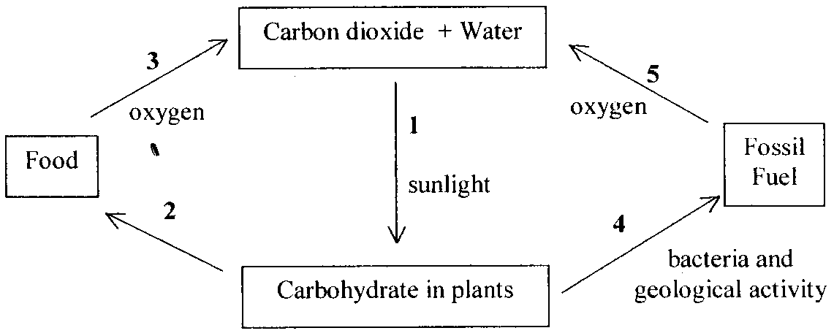

- Name the process in step 1 and write a balanced equation to represent the process.
_______________________________________________________________________________________
_______________________________________________________________________________________
- Name the process in step 3 and state whether it is an endothermic or exothermic reaction.
_______________________________________________________________________________________
_______________________________________________________________________________________
- In step 4 the polymer, cellulose, in plants is changed into fuel.
(i) What kind of chemical reaction is involved in forming cellulose?
____________________________________________________________________________________
____________________________________________________________________________________
(ii) Name the monomer from which it is formed.
____________________________________________________________________________________
- (i) What type of reaction possibly occurs in step 5?
____________________________________________________________________________________
(ii) Describe an advantage and a disadvantage of this reaction.
____________________________________________________________________________________
____________________________________________________________________________________
____________________________________________________________________________________
____________________________________________________________________________________
____________________________________________________________________________________
____________________________________________________________________________________
- State two foods obtained from plants that contain significant amounts of digestible carbohydrates.
_______________________________________________________________________________________
_______________________________________________________________________________________
_______________________________________________________________________________________
2 + 1 + 1 + 3 + 1 = 8 marks
Suggested time: 10 minutes

Question 7
The following questions refer to elements of Period 3.

- Solid sodium has a melting temperature of 98°C and solid chlorine has a melting temperature of –101°C.
(i) Describe the structure and bonding in each of these solids.
____________________________________________________________________________________
____________________________________________________________________________________
____________________________________________________________________________________
____________________________________________________________________________________
____________________________________________________________________________________
____________________________________________________________________________________
____________________________________________________________________________________
____________________________________________________________________________________
(ii) Use your description of the bonding to explain the reason for the difference in melting temperatures.
____________________________________________________________________________________
____________________________________________________________________________________
____________________________________________________________________________________
____________________________________________________________________________________
____________________________________________________________________________________
____________________________________________________________________________________
- A sodium atom is larger than a chlorine atom, although the chlorine atom has 17 electrons while a sodium atom has only 11. Give an explanation of this observation.
_______________________________________________________________________________________
_______________________________________________________________________________________
_______________________________________________________________________________________
_______________________________________________________________________________________
- Write a balanced equation for the reaction between an oxide of a Period 3 element and water, resulting in a basic solution.
_______________________________________________________________________________________
_______________________________________________________________________________________
- Write a balanced equation for the reaction between an oxide of a Period 3 element and water, resulting in an acidic solution.
_______________________________________________________________________________________
_______________________________________________________________________________________
7 + 2 + 1 + 1 = 11 marks
Suggested time: 14 minutes

