IARTV 2002 | Unit 3 Chemistry | Trial Examination Solutions

Section A – Multiple choice questions

1 mark per question

- B
- B
- D
- A
- D
- C
- C
- B
- A
- D
- D
- C
- C
- D
- B
- A
- B
- B
- A
- C

Section B – Short Answer Questions

Each * represents 1 mark

Question 1 (11 marks)
a. | n(NaOH) = 0.5380 × 0.02500 = 1.345 × 10⁻² mol | (*)
b. | n(HCl) = 0.1000 × 0.02010 = 2.010 × 10⁻³ mol | (*)
c. | n(NaOH) = n(HCl) = 2.010 × 10⁻³ mol | (*)
d. | n(NaOH = 2.010 × 10⁻³ × 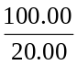 = 1.005 × 10⁻² mol | (*)
e. | n(NaOH) reacting = 1.345 × 10⁻² – 1.005 × 10⁻² = 3.40 × 10⁻³ mol | (*)
 | n(CH₃COOC₆H₄COOH) = 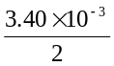 = 1.70 × 10⁻³ mol | (*)
f. | m(CH₃COOC₆H₄COOH) = n × M = 1.70 × 10⁻³ × 180 = 0.306 g | (*)
 | m(CH₃COOC₆H₄COOH) = 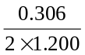 = 0.128 g/g = 128 mg/g | (*)
g. | m(undiluted solution) = 16.00 × 100 = 1600 mg/L = 160.0 mg / 100.00 mL  m(CH₃COOC₆H₄COOH per g) = 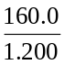 = 133.3 mg/g | (*)
h. | The student using the UV-visible spectrophotometer would have the more accurate result because there are fewer steps in the procedure and therefore fewer random errors. The UV-visible spectrophotometer is a sensitive instrument and if properly calibrated will give a very accurate reading. | (*)
i. | A number of standard solutions of aspirin would need to be prepared and a calibration curve of absorbance versus concentration plotted. | (*)

Question 2 (9 marks)
a. | Ammonia is a weak base and only partially ionizes whereas NaOH is fully dissociated in solution. | (**)
b. | No indicator will accurately detect the equivalence point because there is no sharp end point. | (*)
c. | n(NH₃) = n(HCl) = n(NaOH) since the mole ratios are 1:1 in both equations.  Since the concentrations of the solutions are all approximately the same, then the volume of HCl required for neutralisation of the ammonia is 10 mL. | (*)
 | If a titre of 20 mL of NaOH is required for the neutralisation of the excess HCl then the total HCl required is  v(HCl) = 10 + 20 = 30 mL | (*)
d. | m(SO₄²⁻) = 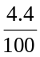 × 5.0 = 0.22 f  n(SO₄²⁻) = n(Ag₂SO₄) = 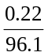 mol | (*)
 | m(Ag₂SO₄) = × 311.9 = 0.71 g | (*)
e. | Any two of  - Other anions besides SO₄²⁻ were precipitated with the addition of AgNO₃.  - Because the sample was not filtered initially, insoluble particles could have added to the mass.  - The precipitate was not completely dry.  - If the precipitate was not washed then residual AgNO₃ would add to the mass. | (**)

Question 3 (9 marks)
a. | 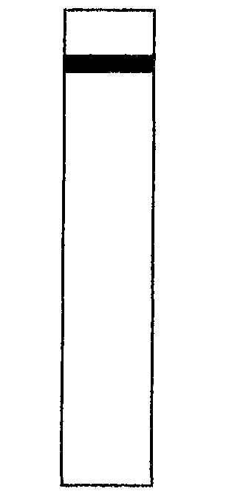 | 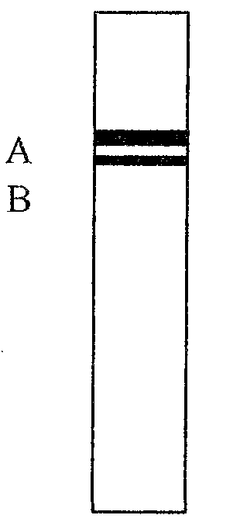 | 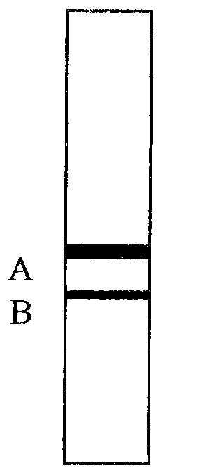 | 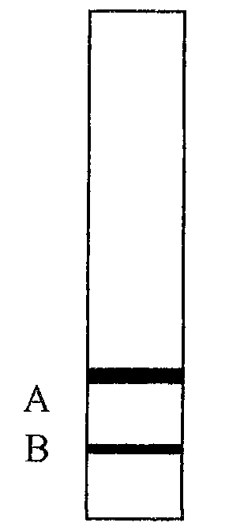 | One mark for showing lines approximately ⅓ and ⅔ down the column.  One mark for showing an increasing distance between the lines
 | 0 seconds | 5 seconds | 10 seconds | 15 seconds |  | (**)
b. | A |  |  |  |  | (*)
c. | A is more strongly bonded to the stationary phase and less soluble in the mobile phase.  Polarity and molecular mass are factors which affect retention time. |  |  |  |  | (**)
d. | 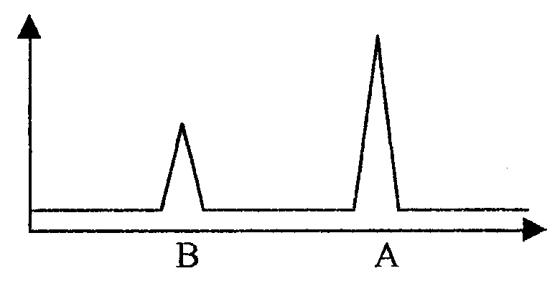 |  |  |  |  | (*)
e. | m(A) in 200 mL sample = 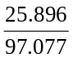 × 40 = 11 mg |  |  |  |  | (*)
 | m(A) in 50 mL sample = 11 × 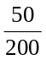 = 2.7 mg |  |  |  |  | (*)
f. | Distance travelled by component = R_{f} × distance travelled by the solvent front  Distance travelled by A = 0.60 × 15 = 9.0 cm  Distance travelled by B = 0.75 × 15 = 11.25 cm  Distance between A and B = 11.25 – 9.0 = 2.25 = 2.3 cm |  |  |  |  | (*)

Question 4 (12 marks)
a. | (i) |  | The rate increases because the mean speed of the molecules is greater and hence there will be more frequent collisions and a higher proportion of collisions will be fruitful since a higher proportion of interacting molecules will have the activation energy. |  |  |  |  |  |  | (*)
 | (ii) |  | The rate increases because the activation energy is lowered and hence a higher proportion of collisions will be fruitful. |  |  |  |  |  |  | (*)
 | (iii) |  | The rate increases because the concentration of HI increases and therefore the frequency of collision will be greater and so the number of fruitful collisions will increase. |  |  |  |  |  |  | (*)
b. | K = 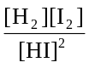 |  |  |  |  |  |  |  |  | (*)
c. |  |  |  |  | HI (g) | H₂ (g) |  | I₂ (g)
 |  | Initial mol |  |  | 5.0 | 0 |  | 0
 |  | Equilibrium mol |  |  | 5.0 – 4.4 = 0.6 | 2.2 |  | 2.2
 |  | Equilibrium concentration (M) |  |  | 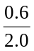 = 0.3 | 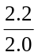 = 1.1 |  | = 1.1
 | At equilibrium [HI] = 0.3 M |  |  |  |  |  |  |  |  | (**)
d. | K = 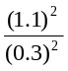 = 13 |  |  |  |  |  |  |  |  | (*)
e. | K₂ = 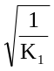 = 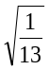 = 0.28 |  |  |  |  |  |  |  |  | (*)
f. | 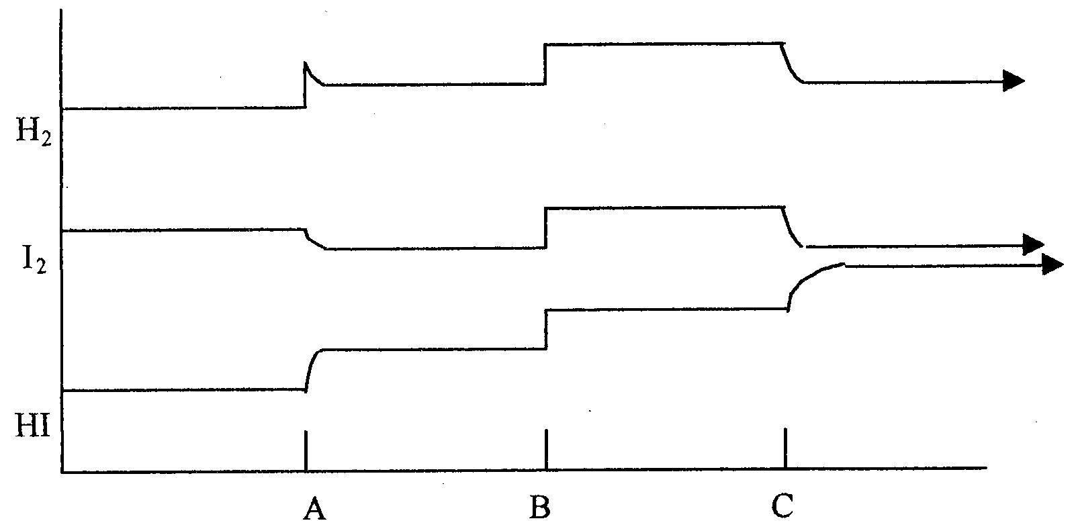 |  |  |  |  |  |  |  |  | (***)
g. | Time A |  |  | K remains the same.
 | Time B |  |  | K remains the same
 | Time C |  |  | K decreases. |  |  | All three correct for one mark |  |  | (*)

Question 5 (13 marks)
a. | The presence of an unsaturated bond or bonds. |  |  | (*)
b. | An addition reaction. |  |  | (*)
c. | 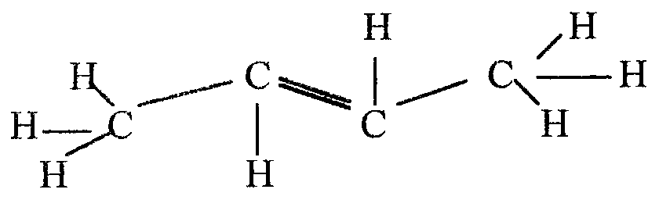 |  |  | (*)
d. | 2-chlorobutane |  |  | (*)
e. | Substitution |  |  | (*)
 | Addition polymerisation |  |  | (*)
 | Condensation or Esterification |  |  | (*)
 | Cracking |  |  | (*)
 | Oxidation |  |  | (*)
 | Hydrolysis |  |  | (*)
f. | 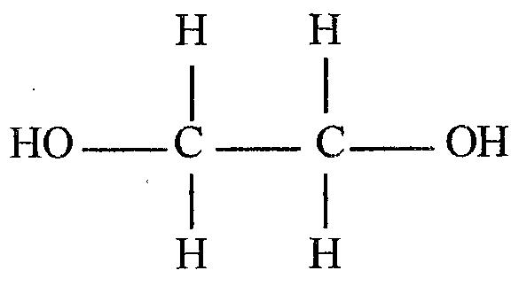 | + | 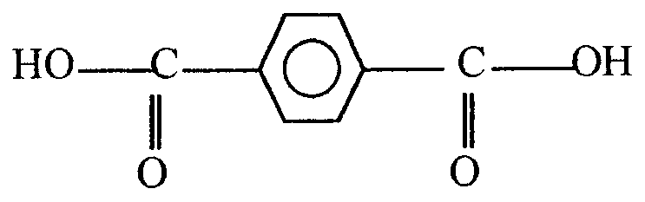 | (**)
g. | Water |  |  | (*)

