IARTV
2002
CHEMISTRY
Unit 3 Exam

Section A – Multiple Choice

Question 1
The volume of water that must be added to 50 mL of 5.0 M NaOH to dilute it to a 0.10 M solution is
- 2500 mL
- 2450 mL
- 250 mL
- 200 mL

Question 2
When water is added to a solution of NaOH, the pH of the solution will
- rise
- fall
- remain the same
- become neutral

Question 3
Anhydrous sodium carbonate is used as a primary standard in titration procedures. However a sample of sodium carbonate left in the atmosphere for several hours cannot be used to make a primary standard solution because
- it reacts with CO₂ in the air and forms another substance
- the absorption of atmospheric moisture causes the decomposition of sodium carbonate
- the sample is no longer dry and will not dissociate in solution
- the degree of hydration of sodium carbonate is unknown

Question 4
A chemist is given a hydrocarbon to identify. Elemental analysis reveals that the hydrocarbon contains 82.6 % carbon. The structure of the hydrocarbon could be
- butane
- but-1-ene
- heptane
- hept-1-ene

Question 5
Concentrated sulfuric acid reacts with zinc metal according to the following unbalanced equation.
__ Zn (s) + __ H₂SO₄ (l) → __ ZnSO₄ (aq) + __ SO₂ (g) + __ H₂O (l)
To balance the equation, the coefficient needed in front of sulfuric acid is
- 1 and the sulfuric acid is acting as a strong acid
- 2 and the sulfuric acid is acting as a strong acid
- 1 and the sulfuric acid is acting as a reductant
- 2 and the sulfuric acid is acting as an oxidant

Question 6
The oxidation numbers of the underlined elements, N₂O₃, VO²⁺, CrO₄^{2–}, NH₃ are respectively
- +3, –2, +6, +3
- –3, 0, +2, –3
- +3, +4, +6, –3
- –3, +4, +4, –3

Question 7
Which of the following is a redox reaction?
- 2 AgNO₃ (aq) + Na₂CrO₄ (aq) → 2 NaNO₃ (aq) + Ag₂CrO₄ (s)
- CH₃COOH (aq) + NH₃ (aq) → NH₄⁺ (aq) + CH₃COO– (aq)
- 4 KClO₃ (s) → 2 KClO₄ (s) + KCl (s)
- P₂O₅ (s) + 3 H₂O (l) → 2 H₃PO₄ (l)

The following information is referred to in Questions 8, 9 and 10

Hydrogen chloride gas was reacted with oxygen to produce chlorine and water in the following exothermic reaction. The reaction was allowed to reach equilibrium in a sealed vessel.
4 HCl (g) + O₂ (g)  2 Cl₂ (g) + 2 H₂O (g)

For the next three questions, two related statements are given. Each pair of statements should be classified as
- if both statements are TRU
- if statement I is TRUE and statement II is false
- if statement I is FALSE and statement II is true
- if both statements are FALSE

Question 8
I At constant temperature, an increase in pressure causes the equilibrium to move to the right.
II At constant pressure, an increase in temperature causes the equilibrium to move to the right

Question 9
I Adding oxygen causes the equilibrium to move to the right.
II Removing chlorine gas causes the equilibrium to move to the right

Question 10
I Adding a catalyst causes the equilibrium to move to the right.
II Adding helium gas causes the equilibrium to move to the right

Question 11
For the self-ionisation of water
2 H₂O (l)  H₃O⁺ (aq) + OH– (aq)
K_{w} = 1.00 × 10^{–14} M² at 25°C and K_{w} = 7.29 × 10^{–14} M² at 55°C.
From this information it can be shown that
- the concentration of H₃O⁺ ions in pure water decreases as the temperature increases
- the pH of pure water is always 7
- the self-ionisation of water is an exothermic reaction
- the self-ionisation of water is an endothermic reaction

Question 12
Limewater is prepared by dissolving calcium hydroxide in water.
H₂O

Ca(OH)₂ (s)  Ca²⁺ (aq) + 2 OH– (aq)
Limewater often looks cloudy due to the presence of some undissolved calcium hydroxide.
If a few drops of 2 M HNO₃ were added to a slightly cloudy sample of limewater, one would see
- no change
- the limewater becoming more cloudy
- the limewater becoming less cloudy
- bubbles of hydrogen gas

Question 13
If the K_{a} of hydrochloric acid, HCN at 25°C is 6.03 × 10^{–10} M, then the pH of 0.25 M HCN will be
- 10.1
- 9.8
- 4.9
- 4.6

Question 14
Production of sulfuric acid has increased significantly over the last 50 years in Australia. This increase is due to
- the discovery of vanadium pentoxide as a catalyst
- the discovery of extensive amounts of elemental sulfur
- increased demand for sulfur in the production of petrol from crude oil
- the widespread use of sulfuric acid in the chemical industry

Question 15
A mixture of nitrogen (II) oxide, NO, and nitrogen (IV) oxide, NO₂, was prepared by reacting copper with nitric acid. The mixture of gases was passed through water, which removed the NO₂, leaving the NO. This gas was then passed through concentrated sulfuric acid. In this last step sulfuric acid was acting as
- a strong acid
- a dehydrating agent
- an oxidant
- a catalyst

Question 16
One of the reactions involved in the production of sulfuric acid is given by the following equation
2 SO₂ (g) + O₂ (g)  2 SO₃ (g)
In order to maximise the yield,
- the mixture is passed over the catalyst bed several times
- low pressures are used
- pure oxygen is used
- the reaction is carried out at an elevated temperature

Question 17
The monomer required to make the polymer (–CH₂–CHBr– CH₂–CHBr– CH₂–CHBr– CH₂–CHBr–)_{n} is
- 1-bromoethane
- 1-bromoethene
- 1,2-dibromobutene
- 1,3 dibromobutane

Question 18
When C₂H₅OH combines with CH₃COOH in the presence of sulfuric acid the result is the formation of
- an alkene
- an ester
- an alcohol
- a carboxylic acid

Question 19
Unsaturated hydrocarbons are produced by the action of
- steam and alkanes at elevated temperatures and atmospheric pressure
- steam and alkenes at lower temperatures and high pressure
- hydrogen and alkenes at elevated temperatures and high pressure
- steam and alkanes at lower temperatures and atmospheric pressure

Question 20
CH₃COOH and CH₃CH₂CH₂CH₂CH₂CH₂CH₂COOH are named respectively
- methanoic acid and heptanoic acid
- methanoic acid and octanoic acid
- ethanoic acid and octanoic acid
- ethanoic acid and heptanoic acid

Section B – Short Answer Questions

Question 1 (13 minutes, 11 marks)
Two students wish to determine the amount of active ingredient (acetylsalicylic acid) in low-dose aspirin tablets.

One student performed the following volumetric analysis.

Two aspirin tablets each weighing 1.200 g were dissolved in exactly 25.00 mL of standard 0.5380 M NaOH. A measuring cylinder was used to add 25 mL deionised water to the flask and the solution was heated for 10 minutes and then cooled to room temperature. The solution was then transferred to a 100.00 mL volumetric flask and made up to the mark with deionised water.

Acetyl salicylic acid, CH₃=COOC₆H₄COOH, reacts with NaOH according to the equation:
CH₃COOC₆H₄COOH (s) + 2 NaOH (aq) → CH₃COONa (aq) + HOC₆H₄COONa (aq) + H₂O (l)

20.00 mL aliquots of the aspirin solution were then titrated against standard 0.1000 M HCl to find how much NaOH was in excess. An average of three concordant titres was calculated to be 20.10 mL.

- Calculate the number of mole of NaOH used to dissolve the aspirin tablets.
________________________________________________________________________________________________
________________________________________________________________________________________________
- Calculate the number of mole of HCl titrated with the aspirin solution.
________________________________________________________________________________________________
________________________________________________________________________________________________
- Calculate the number of mole of NaOH in excess in the 20.00 mL aspirin solution aliquot.
________________________________________________________________________________________________
________________________________________________________________________________________________
- Calculate the number of mole of NaOH in excess in the 100.00 mL volumetric flask.
________________________________________________________________________________________________
________________________________________________________________________________________________
- Find the number of mole of CH₃COOC₆H₄COOH which reacted with the NaOH.
________________________________________________________________________________________________
________________________________________________________________________________________________
________________________________________________________________________________________________
________________________________________________________________________________________________
- Determine the mass of acetylsalicylic acid in mg per g present in the tablets.
________________________________________________________________________________________________
________________________________________________________________________________________________
________________________________________________________________________________________________
________________________________________________________________________________________________

The other student performed the following analysis using a UV-visible spectrophotometer.

One tablet weighing 1.200 g was dissolved in deionised water and made up to the mark in a 100.00 mL volumetric flask. A sample of this solution was further diluted by 1:100. Absorbance occurred in the UV wavelength range. The result from the analysis was 16.00 mg per L for the diluted solution.

- Determine the mass of acetylsalicylic acid in the tablet in mg per g.
________________________________________________________________________________________________
________________________________________________________________________________________________
________________________________________________________________________________________________
- Which of the two students’ results would be considered to be more accurate? Explain your answer
________________________________________________________________________________________________
________________________________________________________________________________________________
________________________________________________________________________________________________
- Before carrying out the analysis of the aspirin solution using the UV-visible spectrophotometer what steps would the students have to take.
________________________________________________________________________________________________
________________________________________________________________________________________________
________________________________________________________________________________________________
________________________________________________________________________________________________
(1 + 1 + 1 + 1 + 2 + 2 + 1 + 1 + 1 = 11 marks)

Question 2 (12 minutes, 9 marks)
The chart below shows the changes in pH during the titration of 0.01 M CH₃COOH with 0.01 M NaOH and 0.01 M CH₃COOH with 0.01 M NH₃.
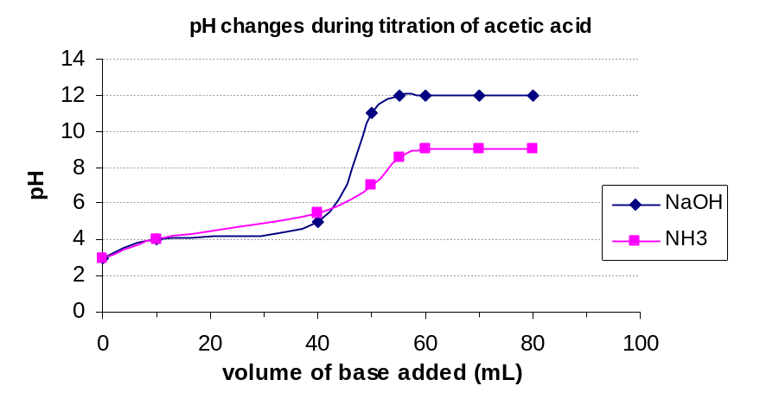

- For each titration, a base of 0.01 M concentration has been titrated against 0.01 M CH₃COOH. Why then, are the two graphs very different?
________________________________________________________________________________________________
________________________________________________________________________________________________
- Explain why no indicator will accurately detect the equivalence point when reacting 0.1 M CH₃COOH and 0.1 M NH₃.
________________________________________________________________________________________________
________________________________________________________________________________________________
________________________________________________________________________________________________
- A student wishes to determine the amount of NH in a sample of fertiliser by boiling the fertiliser solution with an excess of 0.1 M HCl then neutralising the solution with 0.1 M NaOH. The fertiliser solution has an approximate concentration of 0.1 M NH₃. If it is desirable that the sodium hydroxide titre be around 20 mL, what volume of 0.1 M HCl must be added to 10.00 mL of the NH₃ solution?
________________________________________________________________________________________________
________________________________________________________________________________________________
________________________________________________________________________________________________
________________________________________________________________________________________________
- Another student wished to analyse the fertiliser for sulfate content. The manufacturer claimed that the fertiliser contained 4.4% w/w SO₄^{2–}. A 5.0 g sample of Nitro-Jen fertiliser was dissolved in 100.0 mL of water and an excess of silver nitrate was added and stirred until precipitation was complete. The reaction may be represented by the following equation
2 AgNO₃ (aq) + SO₄^{2–} (aq) → 2 NO₃– (aq) + Ag₂SO₄ (s)
If the manufacturer’s claim was true, calculate the mass of precipitate that the student should expect.
________________________________________________________________________________________________
________________________________________________________________________________________________
________________________________________________________________________________________________
________________________________________________________________________________________________
- In fact the student produced a significantly larger mass of precipitate in the analysis. Ignoring random experimental error and assuming the manufacturer’s claim to be true, give two reasons why a higher mass might be obtained.
________________________________________________________________________________________________
________________________________________________________________________________________________
(2 + 1 + 2 + 2 + 2 = 9 marks)

Question 3 (11 minutes, 9 marks)
Below is a sketch of a High Performance Liquid Chromatography column. The band in the first column is a mixture of two substances, A and B. The two bands in the last diagram of this same column have been separated by elution of the column with a solvent.

- Sketch the position of the two bands of compounds A and B as they might appear after 5 and 10 seconds. Label the bands A and B.
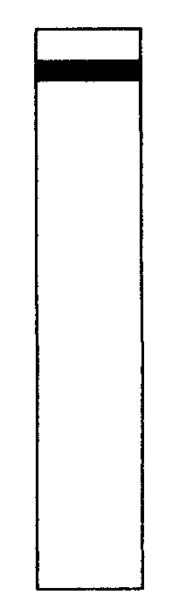 | 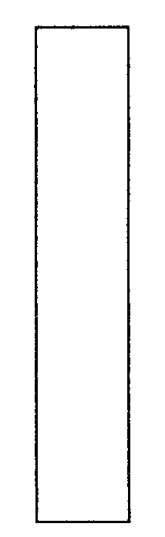 |  | 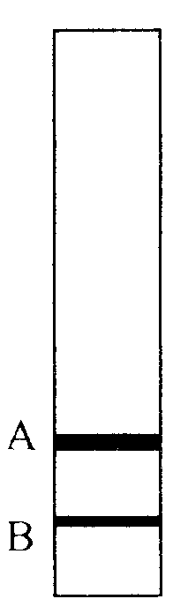
0 seconds | 5 seconds | 10 seconds | 15 seconds

- Which component has the greater retention time?
________________________________________________________________________________________________
- Why does this substance have a greater retention time?
________________________________________________________________________________________________
________________________________________________________________________________________________
- If the concentration of component A was twice that of component B, sketch what the chromatogram might look like in the figure below?

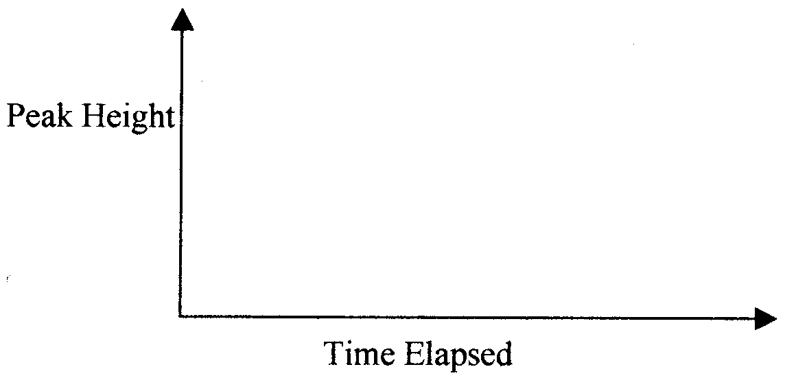

In determining the concentration of substance A in the sample mixture, a standard solution of substance A containing 40 mg per 200 mL was prepared and run thought the column. The following results were recorded.

 | Peak Area | Retention Time
Standard Solution A | 97.077 | 6.476
Sample Mixture | 25.896 | 6.479

- Calculate the mass of substance A in 50 mL of the unknown sample.
________________________________________________________________________________________________
________________________________________________________________________________________________
________________________________________________________________________________________________
- Paper chromatograph was used to separate A and B. The R_{f} values for substance A and B were 0.60 and 0.75 respectively, find the distance between each component if the solvent front moved 15 cm.
________________________________________________________________________________________________
________________________________________________________________________________________________
________________________________________________________________________________________________
(2 + 1 + 2 + 1 + 2 + 1 = 9 marks)

Question 5 (14 minutes, 12 marks)
Hydrogen iodide gas decomposes according to the equation
2 HI (g)  H₂ (g) + I₂ (g) ΔH = –28 kJ mol^{–1}

- Explain the effect on the rate of the reaction in terms of collision theory when
i. the temperature is increased
____________________________________________________________________________________________
ii. a catalyst is added
____________________________________________________________________________________________
iii. HI gas is added at constant volume
____________________________________________________________________________________________

5.0 mol of HI was placed in an empty sealed 2.0 L container. At equilibrium, 2.2 mol of hydrogen gas had formed.

- Write the equilibrium expression for this reaction.

- Calculate the concentration of HI at equilibrium.
________________________________________________________________________________________________
________________________________________________________________________________________________
________________________________________________________________________________________________
________________________________________________________________________________________________
- Calculate the equilibrium constant for the reaction at this temperature.
________________________________________________________________________________________________
________________________________________________________________________________________________
- Calculate the value of the equilibrium constant for the following equation at the temperature in part b.
½ H₂ (g) + ½ I₂ (g)  HI (g)
________________________________________________________________________________________________
________________________________________________________________________________________________
- A separate experiment on the equilibrium
2 HI (g)  H₂ (g) + I₂ (g)
was carried out at the same temperature. Complete the following concentration/time graph to show the effect on the system of the following changes.

Time A H₂ was added at constant volume and temperature.

Time B The volume of the reaction mixture was reduced at constant temperature.

Time C The temperature was increased.

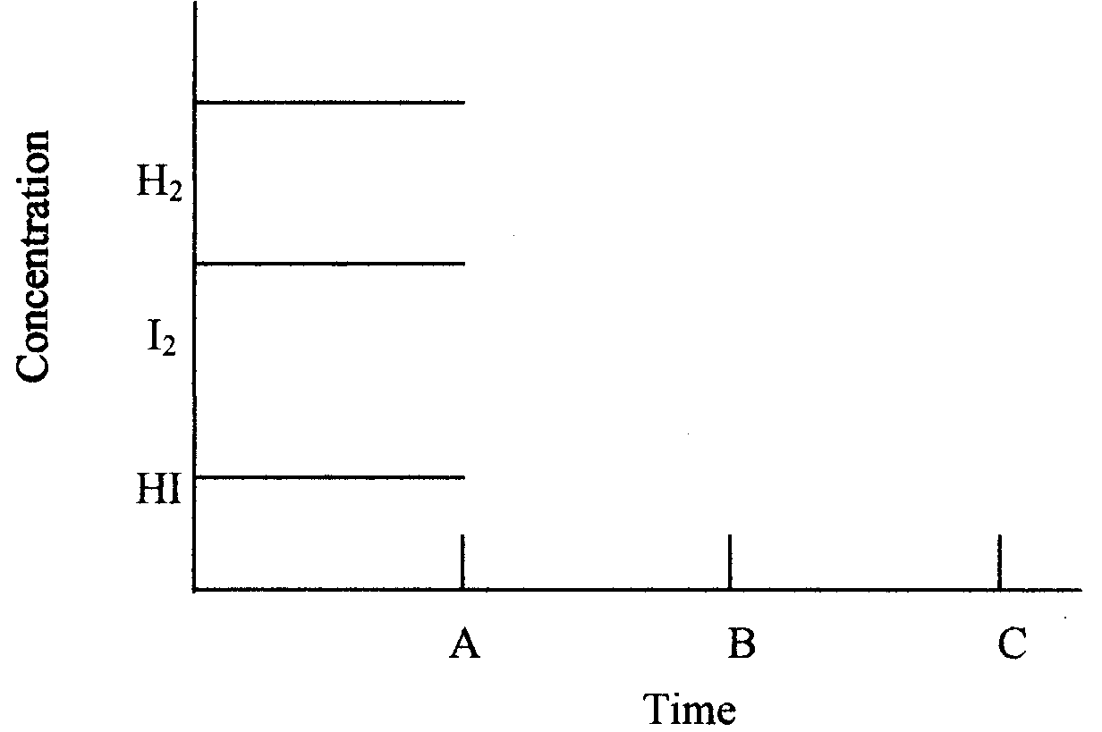
- What is the effect on the equilibrium constant, K, at Time A, Time B and Time C?
i. Time A _____________________________
ii. Time B _____________________________
iii. Time C _____________________________
(3 + 1 + 2 + 1 + 1 + 3 + 1 = 12 marks)

Question 6 (16 minutes, 13 marks)
A chemist was given an unknown hydrocarbon which was formed as a by-product of the catalytic cracking of oil.

The following laboratory experimental results were obtained
- The compound decolourised bromine solution.
- It was found that the relative molecular mass of the substance was 56.
- After reaction with HCl gas, a gas chromatograph showed on ly one peak with a relative molecular mass greater than the reactant hydrocarbon molecule.

- What did the bromine test indicate?
________________________________________________________________________________________________
- What reaction occurred between the unknown hydrocarbon and hydrogen chloride gas?
________________________________________________________________________________________________
- Draw the structural formula of the unknown hydrocarbon.

- Name the product formed as a result of the reaction with HCl gas.
________________________________________________________________________________________________
- Following are equations for some typical organic reactions. Place the name of the type of reaction in the box provided.

CH₄ (g) + Cl₂ (g) 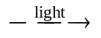 CH₃Cl (g) + HCl (g)
n C₂H₄ (l) 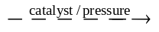 (–C₂H₄–)_{n} (s)
HCOOH (l) + CH₃OH (l) 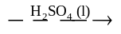 HCOOCH₃ (l)
C₁₀H₂₂ (g) → 2 C₄H₈ (g) + C₂H₆ (g)
CH₃CH₂OH (aq) 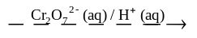 CH₃COOH (aq)
CH₃COOCH₂CH₃ (aq) + H₂O (l) → CH₃CH₂OH (aq) + CH₃COOH (aq)

- The most common polyester is polyethylene terephthalate. Complete the following equation for the formation of the polyester by inserting the structural formulae for the reactants.
+

→ | 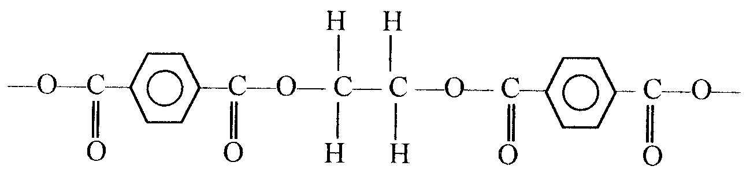
- What other substance is formed in the above reaction?
________________________________________________________________________________________________
(1 + 1 + 1 + 1 + 6 + 2 + 1 = 13 marks)

