Year 12

IARTV TEST – OCTOBER 2002

CHEMISTRY – ANSWERS AND SOLUTIONS

SECTION A
1 mark per question

Question 1 | C | Question 6 | B | Question 11 | B | Question 16 | B
Question 2 | C | Question 7 | B | Question 12 | A | Question 17 | D
Question 3 | C | Question 8 | C | Question 13 | D | Question 18 | D
Question 4 | B | Question 9 | B | Question 14 | A | Question 19 | D
Question 5 | A | Question 10 | D | Question 15 | A | Question 20 | C
(Note Qu 19. Electrons don’t pair up in orbitals until each orbital has an electron in it.)

SECTION B
Each * represents 1 mark

Question 1 (7 marks)
- A solution calorimeter cannot be used for a combustion reaction. (*)
or Water content cannot be determined in an aqueous environment or similar
- (i) ΔT = 21.53 – 21.03 = 0.50ºC
E = VIt = 4.50 × 2.10 × 1.50 × 60 = 851 J
C.F. = 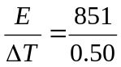 = 1700 J K⁻¹ (**)
- Energy for 0.354 g of Neatbix = C.F. × ΔT = 1700 × (21.03-18.01) = 5130 J = 5.13 kJ (*)
- Energy for 1 g of Neatbix = 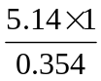 = 14.5 kJ g⁻¹ (*)
- % carbohydrate = 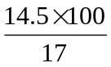 = 85%
% water = 100 – 85 = 15% (*)
- By repeating the experiment several times. (*)

Question 2 (11 marks)

Symbol | What the symbol represents | Unit
Q | Electric charge | Coulomb
F | The charge on one mole of electrons | Coulomb per mol
I | The current applied | Ampere
n(e⁻) | The number of mole of electrons | Mol
(****)
- n(H₂) = 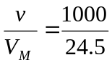 = 40.8 mol
n(e⁻) = 2 × 40.8 = 81.6 mol (*)
Q = n(e⁻) × F = 81.6 × 96500 = 7.88 × 10⁶ C
t = 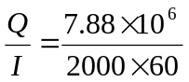 = 66 minutes (*)
- 2 H₂O (l) → O₂ (g) + 4 H⁺ (aq) + 4 e⁻ (*)
- 0.5 m³ or 500 L
- Water is not a good conductor because it only ionises to a very small extent. Current cannot be carried through the solution unless there are charged particles free to move. (*)
- (i) Silver would be deposited first followed by nickel. When these two metal ions were exhausted then bubbles of hydrogen gas would be seen. Magnesium would not be deposited because water is a stronger oxidant.
(ii) Bubbles of oxygen gas would be seen. (**)

Question 3 (5 marks)
- O₂ (g) + 2 H₂O (l) + 4 e⁻ → 4 OH⁻ (aq) (*)
- Al (s) + 3 OH⁻ (aq) → Al(OH)₃ (s) + 3 e⁻ (*)
- The two half-reactions must be separated so that the electron transfer can be harnessed. If the reactants were in direct contact, the energy released in the reaction would be wasted as heat. (*)
- Conditions are not standard. (*)
- The cell reactions are not reversible and therefore the cell cannot be recharged. (*)

Question 4 (6 marks)
- polysaccharide or carbohydrate (*)
- glycogen (*)
- glycosidic or ether linkage (*)
- condensation polymerisation (*)
- (i) C₆H₁₂O₆
(ii) C₆H₁₂O₆ (aq) + 6 O₂ (g) → 6 CO₂ (g) + 6 H₂O (l)

Question 5 (11 marks)
- A circle should be drawn around one of the –NH–CO– sequences (*)
- Peptide linkage or peptide bond. (*)
- An H and O within the peptide linkages should be shaded. (*)
- 4 (*)
- Hydrolysis (*)
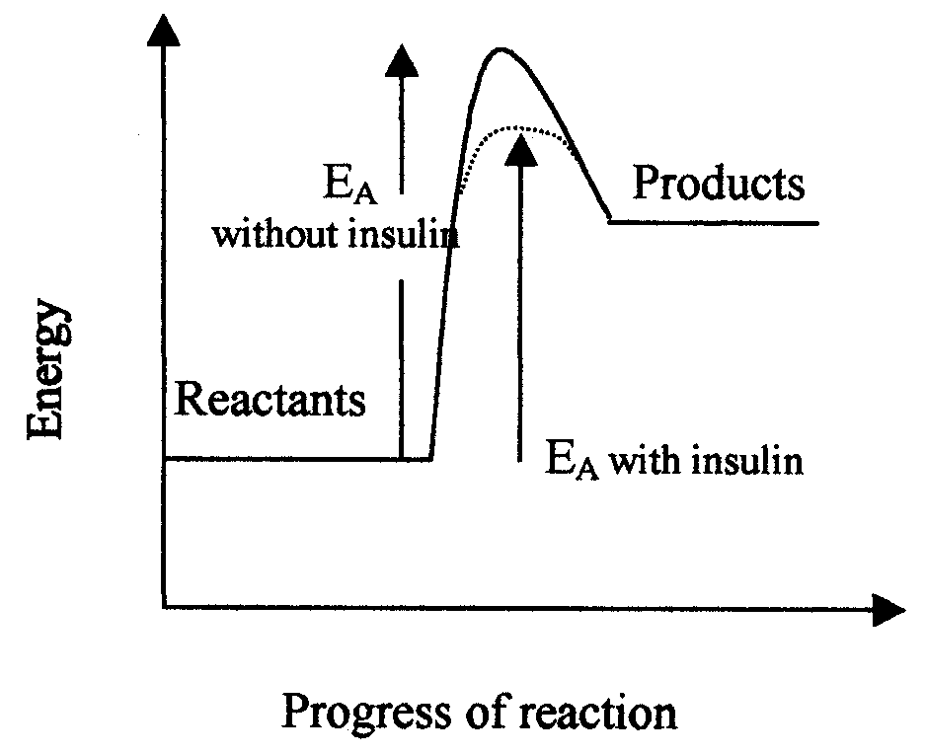

(* for labels, * for lowered E_{A}) (**)

- The glutamic acid changes the tertiary structure at the active site. The substrate molecule (sugar) doesn’t fit as well and therefore the rate of reaction slows. (*)
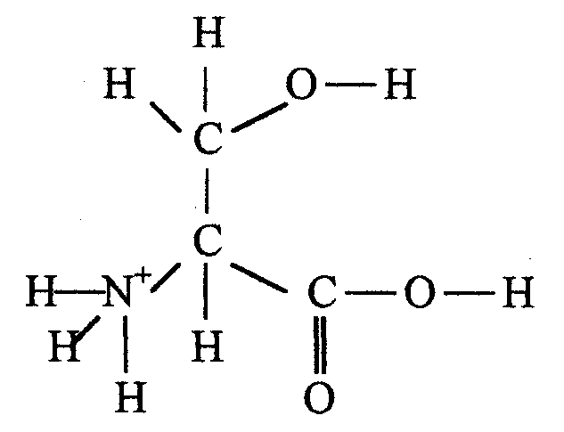

(*)

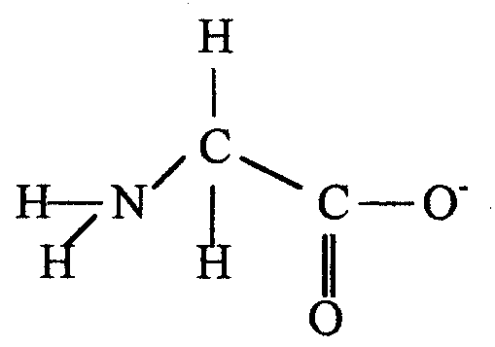

(*)

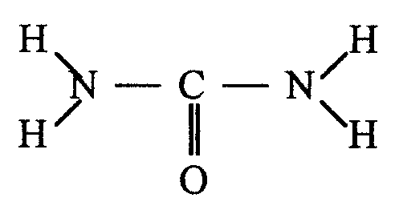
(*)

Question 6 (6 marks)
- As the atomic number increases across the period the core charge increases and attracts the outer electrons more strongly and the atomic radius decreases. (*)
- Zinc has the 3d subshell filled so electrons can only be removed from the 4s subshell. (*)
- The core charge increases and attracts the remaining electrons more strongly which means more energy is required to remove subsequent electrons. (*)
- The energy level of the 4s subshell is less than that of the 3d subshell. (*)
- Helium has a full outer shell and is an inert gas and therefore it does not resemble the metallic nature of the elements in Group 2 (II). (*)
- As the atomic radius increases down the group the electrons are held less tightly and therefore the metal becomes a stronger reductant. (*)

Question 7 (13 marks)
- (i) 1s²2s²2p⁶3s²3p¹
(ii) 1s²2s²2p⁶3s²3p⁶3d⁷4s² (**)
- Element X is iron. A half filled d subshell is more stable than other partly filled d subshells. In forming a 3+ ion, iron loses two 4s electrons and one 3d electron. This ion is more stable than the 2+ ion with a configuration that ends in d⁶. (**)
- (i) Al₂O₃ (s) + 6 H⁺ (aq) → 2 Al³⁺ (aq) + 3 H₂O (l)
(ii) Al₂O₃ (s) + 2 OH⁻ (aq) + 3 H₂O (l)→ 2 Al(OH)₄⁻ (aq) (**)
- Any two of:

Cobalt is harder, denser and has a higher melting point. Due to its higher core charge, it has a smaller atomic radius and is therefore able to pack its heavier atoms more closely resulting in higher density. The metallic bonding is stronger so it is harder and has a higher melting point.

Cobalt forms coloured compounds because photons of visible light can easily be absorbed and used to move electrons to d orbitals of slightly higher energy. The differences in d orbital energies arise because of the influence of surrounding ligands.

Cobalt and its compounds are magnetic. This is caused by the movement of unpaired electrons in the d orbitals.

Cobalt will form complexes because it has a small atomic radius and a high charge density which means polar compounds and ions can be held strongly by ion-dipole bonding. (**)
- (i) +3
(ii) ion-dippole
(iii) ligands
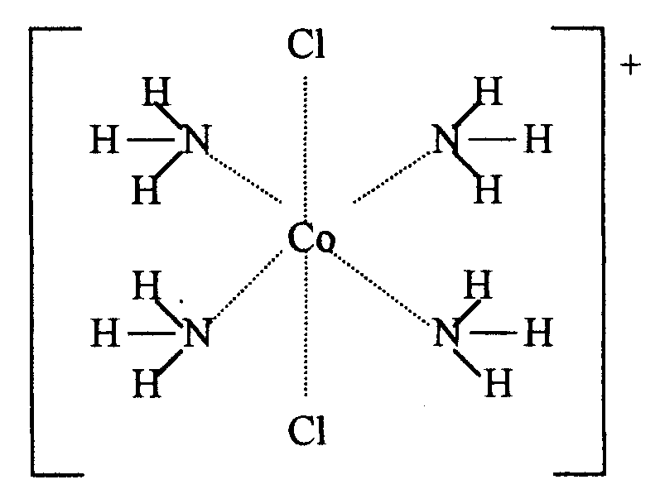
(iv)

(* for arrangement, * for orientation)
(*****)

