IARTV 2002
U4 Chemistry

SECTION A – Multiple-choice questions

Question 1
Of the following, the most efficient process is the conversion of
- light energy to chemical energy by photosynthesis
- chemical energy to mechanical energy in a petrol engine
- chemical energy to electrical energy in a battery
- light energy to electrical energy in a solar cell

Question 2
Some indigenous people boil water by dropping a large hot stone into the water. A hollow wooden vessel containing 1.0 litres of water (specific heat capacity 4.18 J g⁻¹K⁻¹) at 20ºC is to be boiled. A stone with a specific heat capacity of 2.00 J g⁻¹ K⁻¹ is placed in a fire. How much energy must be transferred to the water from the stone in order to raise the water to 100ºC?
- 160 kJ
- 200 kJ
- 330 kJ
- 420 kJ

Question 3
What mass of ethane must be burnt in excess oxygen to produce 1000 kJ of heat energy?
2 C₂H₆ (g) + 7 O₂ (g) → 4 CO₂ (g) + 6 H₂O (g) ΔH = -2856 kJ mol⁻¹
- 0.7001 g
- 10.50 g
- 21.01 g
- 42.02 g

Question 4
At a wind power station, the main stages in power production are shown below.
Wind energy
Blades
Rotating shaft
Generator

The rotating shaft changes
- kinetic energy in the movement of the blades into electrical energy
- kinetic energy in the movement of the blades into kinetic energy in the rotating shaft
- electrical energy in the movement of the blades into kinetic energy in the rotating shaft
- kinetic energy of the wind into kinetic energy in the rotating shaft

Question 5
The order of strongest to weakest reductant is
- Mg Al Zn
- Mg²⁺ Al³⁺ Zn²⁺
- Zn²⁺ Al³⁺ Mg²⁺
- Zn Al Mg

Question 6
In a Leclanché dry cell the anode is the
- graphite rod within the cell
- zinc casing
- ammonium chloride paste
- solid manganese dioxide

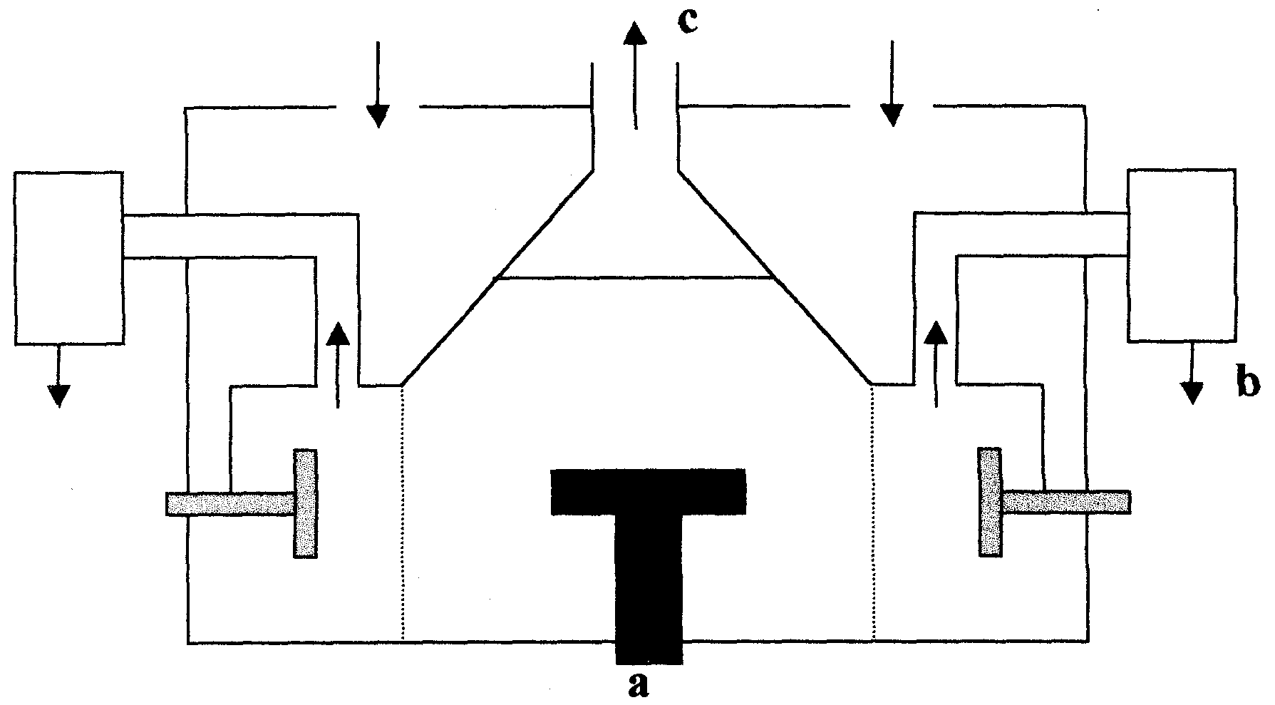
Questions 7, 8 and 9 refer to the following diagram of a Down’s Cell.

Question 7
The electrode marked a is
- made of platinum
- made of carbon
- the cathode
- made of iron mesh

Question 8
The substance at b is
- sodium chloride
- chlorine gas
- molten sodium
- sodium hydroxide

Question 9
The substance leaving the cell at c is
- hydrogen gas
- chlorine gas
- molten sodium
- sodium hydroxide

Question 10
Based on kJ g⁻¹, which of the following is the most energy rich storage molecule in biological systems?
- glucose
- glycogen
- glycerol
- a triglyceride

Question 11
For the human body to derive energy from the disaccharide sucrose, C₁₂H₂₂O₁₁, the biochemical reactions would be a
- condensation reaction followed by an exothermic cellular respiration reaction.
- hydrolysis reaction followed by an exothermic cellular respiration reaction.
- condensation reaction followed by an endothermic cellular respiration reaction..
- hydrolysis reaction followed by an endothermic cellular respiration reaction.

Question 12
Which molecule is not used for long term storage of energy by living organisms?
- glucose
- fat
- glycogen
- starch

Question 13
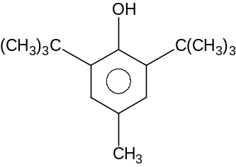Butylated hydroxytoluene, BHT, is a typical food additive which is added to potato chips.
This molecule would be added to act as
- a surfactant
- an emulsifying agent
- a dehydrating agent
- an antioxidant

Question 14
Hydrogen bonding is not significant in
- determining the primary structure of a protein molecule
- accounting for the high solubility of glucose in water
- determining the α-helical shape of a protein
- determining the specificity of enzymes

Question 15
Which of the following processes directly results in an increase in the amount of nitrogen in the air?
- The action of de-nitrifying bacteria on the remains of dead plants.
- The addition of ammonium nitrate fertiliser to the soil.
- The combustion of fossil fuels.
- Animals excreting on to the soil.

Question 16
The americium-241 isotope, ²⁴¹Am, is used in smoke detectors. ²⁴¹Am nuclei contain
- 95 protons and 95 neutrons
- 95 protons and 146 neutrons
- 95 protons and 241 neutrons
- 146 protons and 241 neutrons

Question 17
Our sun produces energy by
- nuclear fission of hydrogen nuclei to form helium nuclei
- nuclear fission of helium nuclei to form hydrogen nuclei
- nuclear fusion of helium nuclei to form hydrogen nuclei
- nuclear fusion of hydrogen nuclei to form helium nuclei

Question 18
Carbon-14 is produced in the upper atmosphere by the following nuclear reaction.
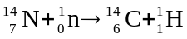
For this reaction energy is
- released and there is an overall loss in mass.
- released and there is an overall gain in mass.
- absorbed and there is an overall loss in mass.
- absorbed and there is an overall gain in mass.

Question 19
The period 2 element that has exactly 3 full atomic orbitals in its uncharged atoms is
- boron
- carbon
- nitrogen
- oxygen
Question 20
Bohr’s model of the atom suggested that electrons circled the nucleus in shells corresponding to particular energy levels. The experimental evidence that led to this model was
- the discovery of the electron
- the discovery of radioactivity
- emission spectra
- Rutherford’s gold foil experiments

SECTION B – Short-answer questions

Question 1 (8 minutes, 7 marks)
A chemist was asked to determine whether the biscuits, Neatbix, had the correct percentage of water as specified on the packet. The chemist decided to use a bomb calorimeter for the analysis.
The biscuit was weighed and placed in the bomb calorimeter. The biscuit was reacted with excess oxygen before calibration of the calorimeter. The following results were recorded.
Mass of Neatbix 0.354 g
Initial temperature of calorimeter 18.01ºC
Temperature of calorimeter after combustion 21.03ºC
Temperature of calorimeter after calibration 21.53ºC

- Why was a solution calorimeter inappropriate for this analysis?
________________________________________________________________________________________________
________________________________________________________________________________________________
1 mark
- The calibration was carried out by passing a current of 2.10 A through the electric heater of the bomb calorimeter for 1.50 minutes at a voltage of 4.50 V. Calculate the calibration factor for the calorimeter.
________________________________________________________________________________________________
________________________________________________________________________________________________
________________________________________________________________________________________________
________________________________________________________________________________________________
2 marks
- Calculate the energy released by the combustion of the Neatbix.
________________________________________________________________________________________________
________________________________________________________________________________________________
1 mark
- What is the energy released per gram of biscuit?
________________________________________________________________________________________________
________________________________________________________________________________________________
1 mark
- The information on the packet indicated that the biscuit consisted only of carbohydrate and water. If the energy content of carbohydrate is 17 kJ g⁻¹, what is the theoretical percentage of water in the biscuit?
________________________________________________________________________________________________
________________________________________________________________________________________________
1 mark
- How could the chemist improve the reliability of the data using the same equipment?
________________________________________________________________________________________________
________________________________________________________________________________________________
1 mark

Question 2 (12 minutes, 11 marks)
In electrolysis the two relationships derived from Faraday’s Laws are:
Q = I × t and Q = n(e⁻) × F

- In the following table explain what each of these symbols represents in words and give the unit for each.

Symbol | What the symbol represents | Unit
Q
F
I
n(e⁻)

4 marks
- When the water is electrolysed using graphite electrodes, the half-equation for the reaction at the cathode is
2 H₂O (l) + 2 e⁻ → H₂ (g) + 2 OH⁻ (aq)
For how many minutes would a current of 2000 A need to pass through 5.0 L of water to produce 1.0 m³ (1000 L) of H₂ gas at 25ºC and 1 atmosphere?
________________________________________________________________________________________________
________________________________________________________________________________________________
________________________________________________________________________________________________
________________________________________________________________________________________________
2 marks
- Oxygen is also produced when water is electrolysed. Write the half-equation for the production of oxygen.
________________________________________________________________________________________________
1 mark
- What volume of O₂ gas would be produced in this electrolysis?
________________________________________________________________________________________________
1 mark
- In reality, when this electrolysis is carried out an electrolyte is added to the water. Explain why this is necessary.
________________________________________________________________________________________________
________________________________________________________________________________________________
1 mark
- Solutions of silver nitrate (AgNO₃), nickel nitrate (Ni(NO₃)₂) and magnesium nitrate (Mg(NO₃)₂), were added to the water in the above electrolysis cell and a current was supplied over a long time. Explain what would be observed at the
- cathode.
________________________________________________________________________________________
________________________________________________________________________________________
________________________________________________________________________________________
- anode.
________________________________________________________________________________________
________________________________________________________________________________________
________________________________________________________________________________________
2 marks

Question 3 (6 minutes, 5 marks)
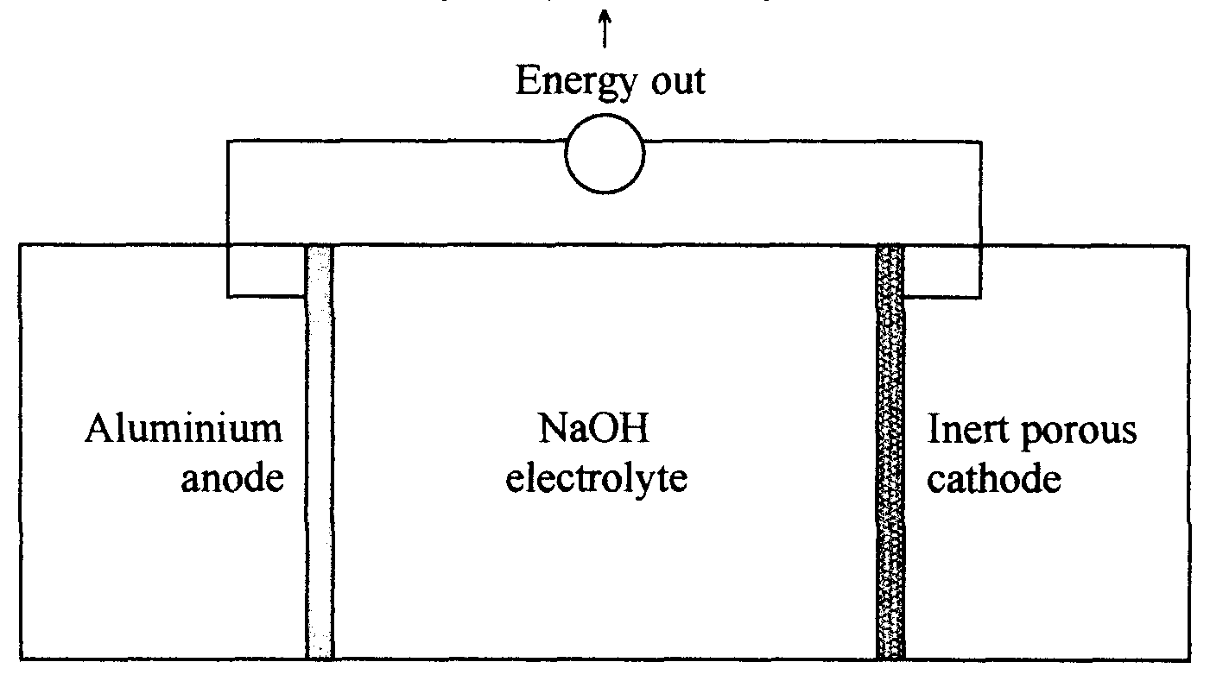
An aluminium air fuel cell contains a solid fuel rod anode of high purity aluminium and an electrolyte containing sodium hydroxide. Oxygen gas is passed through the porous inert cathode and dissolves in the water.
The net cell reaction is
4 Al (s) + 3 O₂ (g) + 6 H₂O (l) → 4 Al(OH)₃ (s)

- Write the half-equation for the reduction reaction.
________________________________________________________________________________________________
1 mark
- Write the half-equation for the oxidation reaction.
________________________________________________________________________________________________
1 mark
- Explain why the oxygen gas is not simply bubbled over the aluminium anode surface.
________________________________________________________________________________________________
________________________________________________________________________________________________
1 mark
- The Eº series predicts a cell voltage of 2.11 volts. Explain why this is not achieved in practice.
________________________________________________________________________________________________
1 mark
- Why is the aluminium fuel cell not classed as a secondary cell?
________________________________________________________________________________________________
________________________________________________________________________________________________
1 mark

Question 4 (7 minutes, 6 marks)
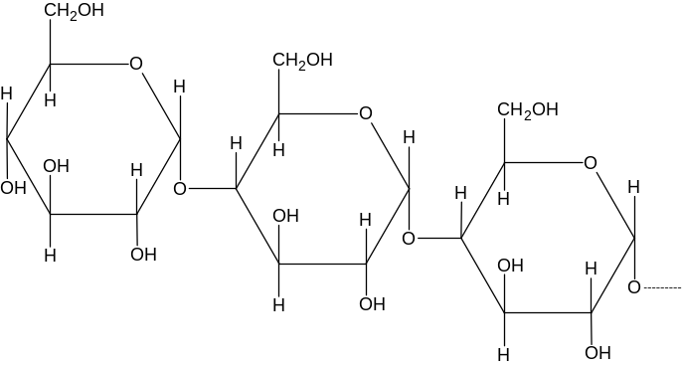The following diagram shows a part of a common molecule that stores energy in animal cells.
- What type of molecule is this?
________________________________________________________________________________________________
1 mark
- What is the name of this molecule?
________________________________________________________________________________________________
1 mark
- What is the name of the link that forms between the monomers in this molecule?
________________________________________________________________________________________________
1 mark
- What type of biochemical reaction produced this molecule?
________________________________________________________________________________________________
1 mark

- What is the molecular formula of the monomer used to make the above molecule?
________________________________________________________________________________________
- Write an equation for the reaction of this monomer that produces energy in the cells.
________________________________________________________________________________________
2 marks

Question 5 (12 minutes, 11 marks)
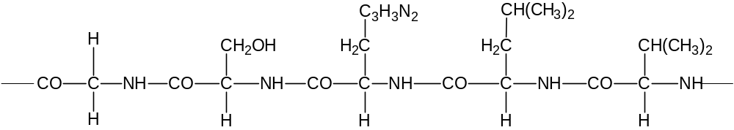Insulin is an enzyme responsible for the control of sugar levels in the blood stream. The molecule has a relative molecular mass of about 5700. The structural formula below is a key segment of the enzyme insulin formed from the amino acids in order: glycine, serine, histidine, leucine and valine.
A mutation can cause the replacement of the amino acid, glycine, with the amino acid, glutamic acid.
The structure of glutamic acid is shown below.
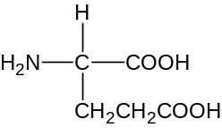

Glutamic acid

- On the structural formula of the insulin segment circle one of the links which connect the monomer units.
1 mark
- Name the link that you circled in a.
________________________________________________________________________________________________
1 mark
- On the structural formula of the insulin segment shade two different atoms that are responsible for determining the secondary structure of the molecule.
1 mark
- How many water molecules were formed during the reaction that formed this molecular segment?
________________________________________________________________________________________________
1 mark
- What is the name of the chemical reaction used to reform the monomer units?
________________________________________________________________________________________________
1 mark
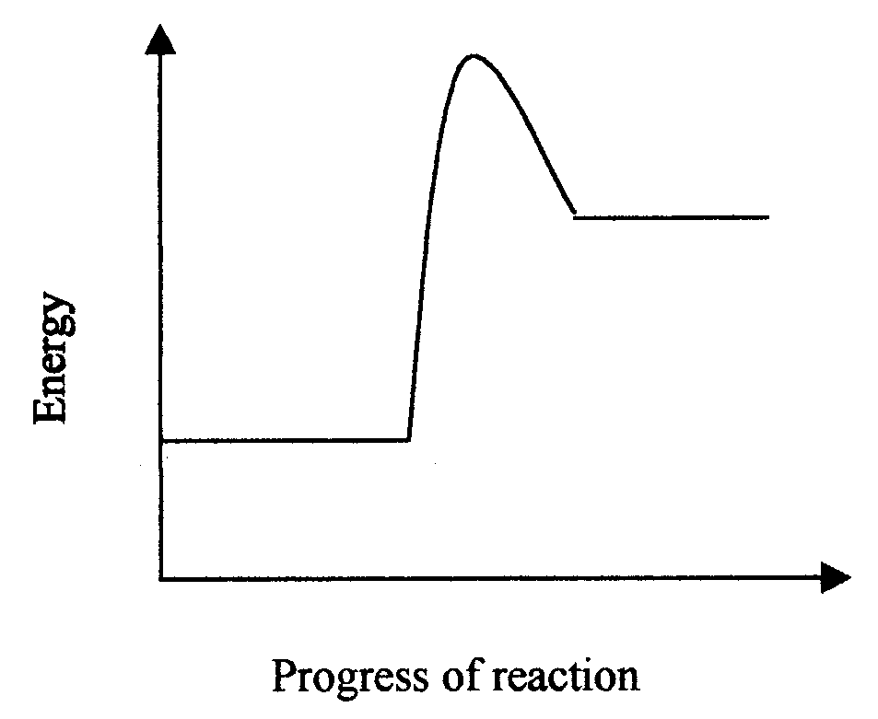
- Fully label this diagram below to show how the endothermic reaction associated with the enzyme insulin is made faster by the presence of insulin.
2 marks
- When the glycine is replaced by glutamic acid, the enzyme activity decreases significantly. Explain this in terms of protein structure.
________________________________________________________________________________________________
________________________________________________________________________________________________
________________________________________________________________________________________________
1 mark
- In the space below draw the structural formula of serine in a solution with a pH of 3.

1 mark
- Draw the structural formula of the amino acid monomer with the lowest molar mass after it is placed in a solution of 0.1 M sodium hydroxide.

1 mark
- Draw the structural formula for the end product of digestion that is unique for protein molecules.

1 mark

Question 6 (7 minutes, 6 marks)
Give explanations for the following:
- Sodium has the largest atomic radius of the first seven elements in its period.
________________________________________________________________________________________________
________________________________________________________________________________________________
________________________________________________________________________________________________
1 mark
- Although zinc is a transition metal it does not display variable oxidation numbers.
________________________________________________________________________________________________
________________________________________________________________________________________________
1 mark
- The ionisation energy of an element increases each time an electron is removed.
________________________________________________________________________________________________
________________________________________________________________________________________________
1 mark
- The fourth electron shell starts filling before the third shell is full.
________________________________________________________________________________________________
________________________________________________________________________________________________
1 mark
- Helium, with 2 electrons, is usually placed in Group 18 (VIII) of the periodic table rather than Group 2 (II).
________________________________________________________________________________________________
________________________________________________________________________________________________
1 mark
- The reducing strength of the Group 2 (II) elements increases from magnesium to barium.
________________________________________________________________________________________________
________________________________________________________________________________________________
1 mark

Question 7 (15 minutes, 13 marks)
Aluminium and cobalt are both metallic elements that form compounds in which they have an oxidation state of +3. Cobalt also forms compounds with other oxidation states.

- Give the electronic configuration for aluminium in its ground state.
________________________________________________________________________________________
- Give the electronic configuration for cobalt in its ground state.
________________________________________________________________________________________
2 marks
- The element X also forms 3+ ions but with an electron configuration of 1s²2s²2p⁶3s²3p⁶3d⁵. Name the element X and suggest why the 3+ oxidation state is the state that is most commonly found in its ores.
________________________________________________________________________________________________
________________________________________________________________________________________________
2 marks
- Aluminium oxide (Al₂O₃) can be found as the mineral corundum. Although hard and insoluble in water, corundum slowly reacts with strong acids and bases.
Write a balanced ionic equation showing corundum reacting with
- a dilute acid
________________________________________________________________________________________
- a dilute base
________________________________________________________________________________________
2 marks
- Cobalt is a transition metal and has properties different from main group metals such as aluminium.
Name two of these properties (apart from variable oxidation states) and explain why these properties are different.
Property 1 _____________________________________________________________________________________
________________________________________________________________________________________________
Property 2 _____________________________________________________________________________________
________________________________________________________________________________________________
2 marks
- The Swiss chemist Alfred Werner produced a number of cobalt compounds in the late 19th century.
One compound was later found to contain the complex ion [Co(NH₃)₄Cl₂]⁺.
- What is the oxidation number of Co in [Co(NH₃)₄Cl₂]⁺?
________________________________________________________________________________________
- What type of bonding exists between the cobalt in and the NH₃ molecules?
________________________________________________________________________________________
- What is the name given to molecules and ions such as ammonia and chloride in the complex?
________________________________________________________________________________________
- Draw the structure of [Co(NH₃)₄Cl₂]⁺, showing the arrangement and correct orientation of all molecules and ions.

5 marks

END OF BOOKLET

