NEAP 2002 | Unit 3 Chemistry | Trial Examination Solutions

Section A – Multiple choice questions

- C
- C
- D
- C
- A
- C
- B
- D
- B
- A
- D
- B
- A
- A
- B
- B
- C
- D
- D
- A

Section B – Short Answer Questions

Question 1
a. | Removes any insoluble material from the mixture. Washing ensures all the soluble ion passes into the filtrate. |  |  |  |  | 1 mark
b. | i. | n(BaSO₄) = 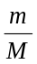 = 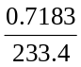 = 3.078 × 10⁻³ mol |  |  |  | 1 mark
 | ii. | n(S) = n(BaSO₄) = 3.078 × 10⁻³ mol  ∴ m(S) = n × M = 3.078 × 10⁻³ × 32.1 = 9.880 × 10⁻² g  ∴ %S = 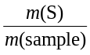 × 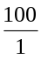 = 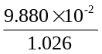 × 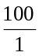 = 9.630% |  |  |  | 2 marks
c. | Possible sources of error |  | Effect of the error on the  calculated %S in the fertiliser
 |  |  | Increased | Decreased | No change
 | i. | Step 1 of the procedure in the flowchart was not carried out. |  |  |  | ½ mark
 | ii. | In Step 6, 25.0 mL of BaCl₂ was added. |  |  |  | ½ mark
 | iii. | In Step 8, the precipitate was not washed with water. |  |  |  | ½ mark
 | iv | In Step 9, the precipitate was not completely dry when weighed. |  |  |  | ½ mark
 | v. | If washing is not carried out, some ions may remain adsorbed to the precipitate. These ions could increase the mass of the precipitate, increasing the calculated %S. |  |  |  | 1 mark
Total 7 marks

Question 2
a. | i. | K_{a} = 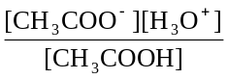 |  |  | 1 mark
 | ii. | [CH₃COO⁻] = [H₃O⁺] = 10^{-pH} = 10^{-2.88} M  [CH₃COO⁻] = 0.100 M  ∴ K_{a} = 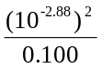 = 1.74 × 10⁻⁵ |  |  | 2 marks
b. | i. | H₂O |  |  | ½ mark
 | ii. | CH₃CH₂OH |  |  | ½ mark
 | iii. | H⁺ or H₂SO₄ or H₃PO₄ |  |  | ½ mark
 | iv. | H₂SO₄ |  |  | ½ mark
c. | CH₃COOH (aq) + CH₃OH (aq) |  | 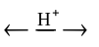 | CH₃COOCH₃ (aq) + H₂O (l) | 1 mark
d. | HOOCC₆H₄COOH and HOCH₂CH₂OH |  |  |  | 2 marks
Total 8 marks

Question 3
a. | H₂S (g) + 2 H₂O (l) → SO₂ (g) + 6 H⁺ (aq) + 6 e⁻ |  | 1 mark
b. | i. | m(S) = 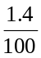 × 5.90 × 10⁶ kg = 8.26 × 10⁴ kg = 8.26 × 10⁷ g  n(S) = = 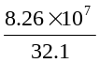 = 2.57 × 10⁶ mol | 2 marks
 | ii. | n(SO₂) = n(S) = 2.57 × 10⁶ mol  n(CaO) = n(SO₂) = 2.57 × 10⁶ mol  ∴ m(CaO) = n × M = 2.57 × 10⁶ × 56.1 = 1.44 × 10⁸ g = 1.44 × 10⁵ kg | 2 marks
c. | i. | I is an exothermic reaction. Heating will cause this reaction to proceed to the left. CO₂ (aq) will become CO₂ (g), ie. dissolved CO₂ will bubble out of the solution and the soft drink will go ‘flat’. | 2 marks
 | ii. | Adding H⁺ moves reactions III and IV to the left/backwards, increasing the [H₂CO₃]. This in turn pushes reaction II to the left. This in turn pushes reaction I to the left, ie. dissolved CO₂ bubbles out of solution and the soft drink will go ‘flat’. | 2 marks
Total 9 marks

Question 4
a. | Covalent bonds. |  | 1 mark
b. | Fractional distillation or GLC. |  | 1 mark
c. | When a C-C bond is broken, two hydrogen atoms are required to complete the bonding arrangement around each C atom. There are insufficient H atoms for this to occur, so at least one double C-C bond must form, ie. one product must be unsaturated. |  | 1 mark
d. | The products are smaller hydrocarbons than the reactants. For smaller hydrocarbons, the strength of dispersion forces between the molecules is weaker, hence boiling points are lower. |  | 2 marks
e. | For example:  - industrial cracking uses higher temperatures  - industrial cracking does not use a catalyst (like the steel wool used here). |  | 1 mark
 |  | Total 6 marks

Question 5
a. | Na₂CO₃ (aq) + 2 HCl (aq) → 2 NaCl (aq) + H₂O (l) + CO₂ (g) |  | 1 mark
d. | i. | n(HCl) = c × V = 0.100 × 19.33 × 10^{–3} = 1.933 × 10⁻³ | 1 mark
 | ii. | n(Na₂CO₃) = ½ × n(HCl) = ½ × 1.933 × 10^{–3} = 0.9665 × 10⁻³ mol  n(Na₂CO₃) in 250.0 mL = 0.96665 × 10⁻³ × 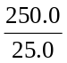 = 9.665 × 10⁻³ mol | 2 marks
 | iii. | M(Na₂CO₃.xH₂O) = 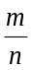 = 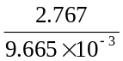 = 286.3 g mol^{–1} | 1 mark
 | iv. | (23.0 × 2) + (12) + 16.0 × 3) + x (18.0) = 286  ∴ x = 10 | 1 mark
c. | x must be a whole number, ie. there cannot be 0.5 molecules of water. |  | 1 mark
Total 7 marks

Question 6
a. | 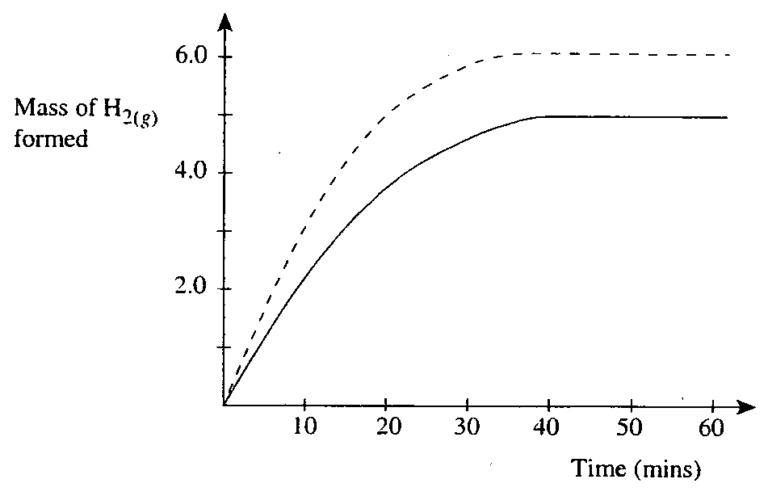 | 1 mark
b. | At higher temperatures, rate is faster, hence slope of graph is steeper. | 1 mark
 | For an endothermic reaction, increasing temperature will increase the value of K (producing more product), hence mass of H₂ formed will increase. | 1 mark
Total 3 marks

