NEAP 2002 | CHEMISTRY | Unit 4 | Trial Examination Solutions

Section A Multiple Choice Questions

- C
- D
- D
- D
- A
- A
- A
- D
- B
- C
- B
- D
- B
- C
- B
- C
- B
- A
- C
- A

Section B Short Answer
Question 1
a. | (i) | E = V I t = 4.81 × 2.26 × 155  CF = 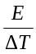 = 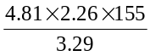  = 512 J °C^{–1} (3 sig figs) | 1 mark
 | (ii) | E = CF × ΔT = 512 × (30.90 – 21.35) = 4890 J  4.89 kJ for 0.330 g  ∴ x kJ for 1.0 g  ∴ x = 14.8 kJ g^{–1} | 2 marks
 | (iii) | To improve the efficiency of combustion by increasing the surface area for reaction. | 1 mark
b. | (i) | When glucose undergoes condensation to form starch and cellulose, water (H₂O) is removed as each ether link forms, ie C₆H₁₂O₆ – H₂O = C₆H₁₀O₅. | 1 mark
 | (ii) | Humans lack the enzyme which catalyses the hydrolysis of cellulose to glucose. | 1 mark
Total 6 marks

Question 2
a. |  | Oxide | Mixture of oxide and water |  |  |  | 3 marks
a. |  | Oxide | acidic | basic | neutral |  | 3 marks
a. |  | Al₂O₃ |  |  |  |  | 3 marks
a. |  | MgO |  |  |  |  | 3 marks
a. |  | P₂O₅ |  |  |  |  | 3 marks
b. | Both Mg and Na have outer-shell electrons in the third shell.  The core charge for Mg is +2, for Na +1.  Greater core charge (with electrons at approximately the same distance from the nucleus) means the electron is harder to remove from Mg. |  |  |  |  |  | 2 marks
Total 5 marks

Question 3
a. | (i) | 4 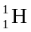 → 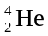 + 2 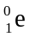 + energy | 1 mark
 | (ii) | 6 CO₂ (g) + 6 H₂O (l) 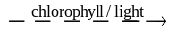 C₆H₁₂O₆ (aq) + 6 O₂ (g) | 1 mark
 | (iii) | thermal (or kinetic) energy → mechanical energy | 1 mark
 | (iv) | For every 100 units of chemical energy in coal, 30 units of electrical energy are produced. | 1 mark
b. | (i) | From equation, 1 mole C (12 g) releases 394 kJ  ∴ 1000 × 10³ g releases x kJ  x = 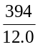 × 1000 × 10– = 3.3 × 10⁷ kJ | 2 marks
 | (ii) | Coal is not pure carbo. The other components of coal may not burn to release energy.  Coal contains water. Energy is lost in converting this water to steam. | 2 marks
Total 8 marks

Question 4
a. | (i) | 2 Cl– (l) → Cl₂ (g) + 2 e– | 1 mark
 | (ii) | Na⁺ is a stronger oxidant (higher E⁰ value) than Ca²⁺, therefore Na⁺ is reduced in preference to Ca²⁺. | 1 mark
 | (iii) | n(Na) = 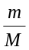 = 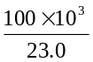  n(e–) = n(Na)  t = 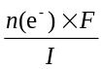  = 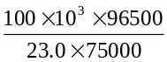  = 5594 s | 2 marks
 |  | Cell efficiency is only 85%  ∴ t required = 5594 × 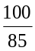 s = 110 min | 1 mark
b. | (i) | 2 H₂O (l) + 2 e– → H₂ (g) + 2 OH– (aq) | 1 mark
 | (ii) | Allows only Na⁺ ions to flow through it, thus preventing contamination of the product with Cl– ions.  or  Separates the products of the reaction (H₂, OH–, Cl₂) which would react spontaneously. | 1 mark
Total 7 marks

Question 5
a. | C₁₈H₃₆O₂  The saturated fatty acid C₁₈H₃₆O₂ has a higher melting ponit than the unsaturated C₁₈H₃₂O₂ (unsaturation leads to “bent” molecules which do not align well, lowering the melting point).  C₁₈H₃₆O₂ has a higher melting point than C₁₆H₃₂O₂ because it is larger in size (therefore dispersion forces are stronger. |  |  |  | 2 marks
b. | For example:
 | 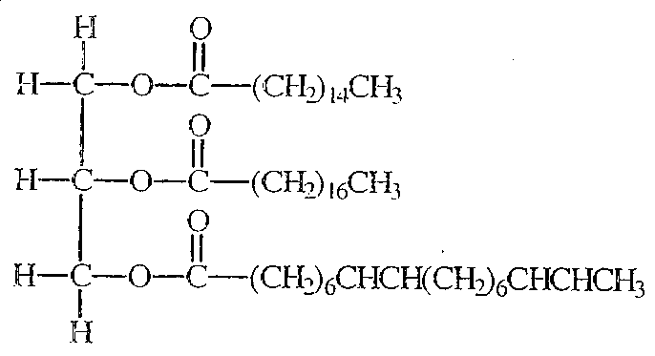 |  | or | 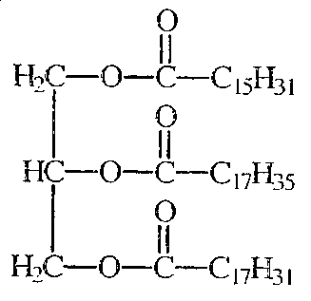 | 2 marks
c. | (i) | Bile acts as an emulsifier. Large fat droplets are broken down into smaller droplets with increased surface area. |  |  | 1 mark
 | (ii) | Lipases catalyse the hydrolysis of triglycerides to glycerol and fatty acids. |  |  | 1 mark
Total 6 marks

Question 6
a. | (i) | O₂ (g) + 4 H⁺ (aq) + 4 e– → 2 H₂O (l) | 1 mark
 | (ii) | 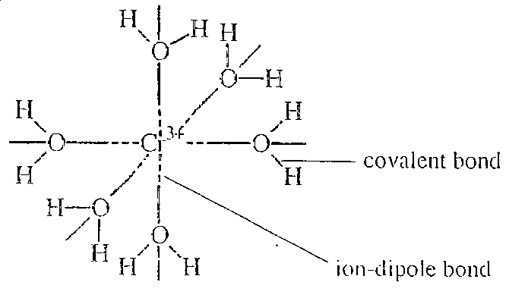 | 2 marks
b. | (i) | Cr³⁺ (aq) + 3 OH– (aq) → Cr(OH)₃ (s)  or  Cr(H₂O)₆³⁺ (aq) + 3 OH– (aq) → Cr(OH)₃ (s) + 6 H₂O (l) | 1 mark
 | (ii) | A complex ion forms, eg Cr(OH)₄– (as the Cr³⁺ is removed from solution the precipitate dissolves). | 1 mark
c. | (i) | 1s² 2s² 2p⁶ 3s² 3p⁶ 3d⁴ | 1 mark
 | (ii) | Any two of:  - variable oxidation states  - hard  - high melting point  - conducts electricity  - produces coloured compounds  - forms complex ions | 2 marks
Total 8 marks

