NEAP
2002
UNIT 4 CHEMISTRY

SECTION A – Multiple-choice questions

Question 1
The first mass spectrometers were designed by Frederick Aston and Ernest Rutherford between 1910 and 1920. The device separates ions of isotopes according to their mass/charge ratio by passing them through a strong magnetic field. A sample of gallium is passed through a mass spectrometer and the following ions are generated:
⁶⁹Ga⁺, ⁶⁹Ga²⁺, ⁷¹Ga⁺ and ⁷¹ Ga²⁺

The ion that will be deflected to the least extent as it passes through the magnetic field within the spectrometer is
- ⁶⁹Ga⁺
- ⁶⁹Ga²⁺
- ⁷¹Ga⁺
- ⁷¹Ga²⁺

Question 2
The relative atomic mass of gallium is 69.72. The two naturally occurring isotopes have relative isotopic masses of 68.95 and 70.95 respectively. The percentage abundance of each isotope is
- 69.0% and 31.0%
- 53.5% and 46.5%
- 73.8% and 26.2%
- 61.5% and 38.5%

Question 3
Which of the following statements concerning nitrogen fixation is incorrect?
Nitrogen fixation may involve the
- action of bacteria in root nodules of leguminous plants
- industrial production of nitrogen-containing fertilisers
- reaction of atmospheric gases at high temperatures
- action of denitrifying bacteria

Question 4
The amino acid aspartic acid has the chemical formula C₄H₇NO₄ and occurs in abundance in sugar cane and other plants. In the strongly acidic environment within the stomach, this amino acid would have the structure
A. | 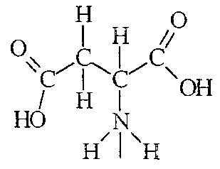 | B. | 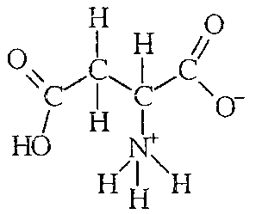 | C. | 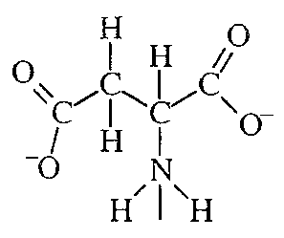 | D. | 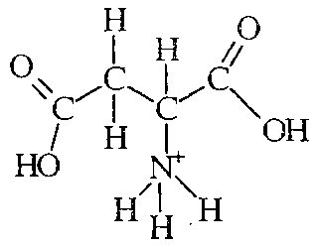

The following information is referred to in Questions 5 and 6

Fast breeder nuclear reactors rely on the nuclear reaction shown below, in which atoms of uranium-238 are bombarded with high energy neutrons to produce the highly radioactive substance plutonium-239 and two other particles.
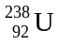 + 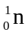 → 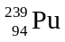 + 2 X

Question 5
The particles labelled X in the nuclear equation above are
- electrons, 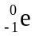
- positrons, 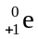
- alpha particles, 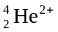
- protons, 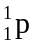

Question 6
This reaction is best describes as an
- endothermic reaction involving a gain in mass
- endothermic reaction involving a loss in mass
- exothermic reaction involving a gain in mass
- exothermic reaction involving a loss in mass

Question 7
26 J of energy is required to raise the temperature of 1.0 mole of nickel by 1°C. How much energy is required to raise the temperature of 100 g of nickel from 20°C to 30°C?
- 0.44 kJ
- 1.3 kJ
- 26 kJ
- 78 kJ

The following diagram showing part of the carbon cycle is referred to in Questions 8 and 9

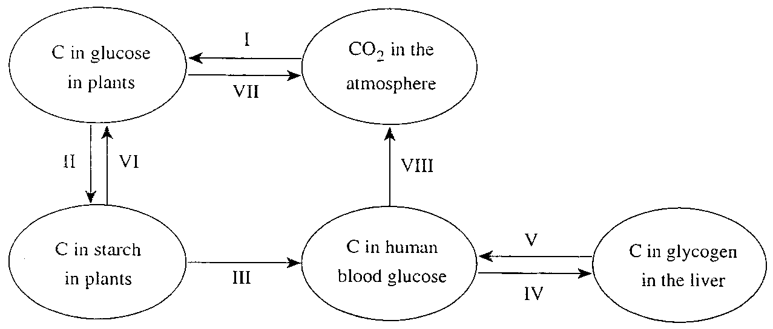

Question 8
Which of the following correctly identifies the types of chemical reactions involved in processes I, II and V in the diagram?
 | I | II | V
A. | exothermic | hydrolysis | condensation
B. | endothermic | hydrolysis | condensation
C. | exothermic | condensation | hydrolysis
D. | endothermic | condensation | hydrolysis

Question 9
Which of the processes shown involves an increase in the oxidation number of carbon?
- I only
- VII and VIII only
- I, II and IV only
- II, IV, VII and VIII only

Question 10
Three metals (X, Y and Z) form soluble nitrates (X(NO₃)₂, Y(NO₃)₂, Z(NO₃)₂). Strips of each metal were placed in 0.1 M solutions of each of the other metal nitrates. The following observations were recorded.
- Metal Y dissolved in solutions containing X²⁺ and Z²⁺.
- Metal X dissolved in a solution of Z²⁺, but did not dissolve in a solution of Y²⁺.
The order of increasing reductant strength for the three metals is
- X, Y, Z
- Y, X, Z
- Z, X, Y
- Y, Z, X

Question 11
Four energy profiles are shown in the diagrams below.
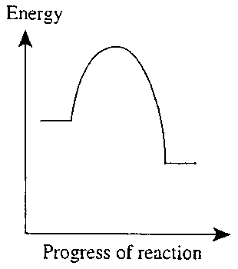 | 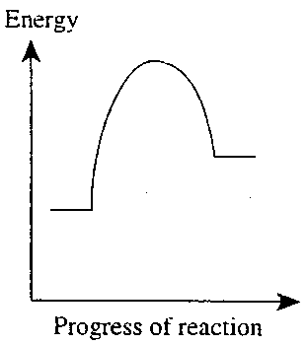 | 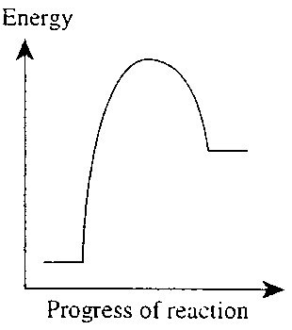 | 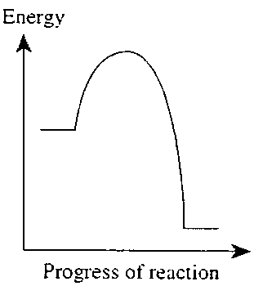
I | II | III | IV
Which two profiles are likely to represent aerobic and anaerobic respiration?
 | aerobic | anaerobic
A. | I | IV
B. | IV | I
C. | II | III
D. | III | II

Question 12
Which of the following statements concerning shells and subshells is incorrect?
- In any given shell, the energy of subshells increases in order s < p < d < f.
- The 2s subshell has a higher energy than the 1s subshell.
- For values of n less than 5, the nth shell of an atom holds n subshells.
- For values of n less than 5, the nth shell of an atom holds 2n² orbitals.

Question 13
The reaction shown below has an activation energy of 79 kJ mol^{–1}.
2 NO₂ (g) → N₂O₄ (g) ΔH = +55 kJ mol^{–1}
The activation energy for the reverse reaction, N₂O₄ (g) → 2 NO₂ (g), is
- –79 kJ mol^{–1}
- 24 kJ mol^{–1}
- 55 kJ mol^{–1}
- 79 kJ mol^{–1}

Question 14
Which of the following characteristics of a salad dressing would make it necessary to add an antioxidant to the dressing?
The dressing
- has low nutritional value
- consists of an oil and water mixture
- contains unsaturated fatty acids
- provides a suitable environment for microbes to grow in

The following information is referred to in Questions 15 and 16

The molten carbonate fuel cell shows considerable potential as a relatively small-scale energy source for use in developing countries, as a single cell can develop sufficient electrical power to meet the needs of a small village or factory.
The cell employs a molten mixture of lithium carbonate and potassium carbonate as its electrolyte, operating at a temperature of approximately 650°C.
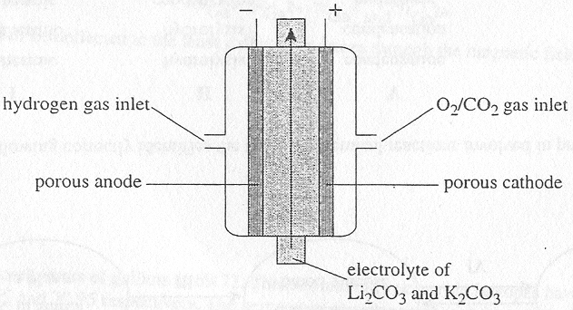
The electrode reactions are
Reaction I O₂ (g) + 2 CO₂ (g) + 4 e– → 2 CO₃^{2–} (l)
Reaction III H₂ (g) + CO₃^{2–} (l) → H₂O + CO₂ (g) + 2 e–

Question 15
In this cell,
- Reaction I occurs at the anode which is negative
- Reaction I occurs at the cathode which is positive
- Reaction I occurs at the anode which is positive
- Reaction I occurs at the cathode which is negative

Question 16
Which of the following would not be an advantage of the carbonate fuel cell over a petrol-driven generator?
- The efficiency of conversion of chemical energy to electrical energy is much higher for the fuel cell than the generator.
- The carbonate fuel cell uses a renewable source of energy.
- Fuel cells are generally less expensive and more portable than petrol driven generators.
- The carbonate fuel cell does not produce as many air pollutants as a petrol driven generator.

Question 17
Enzymes are long chain molecules made of amino acids joined together by
- ester linkages
- peptide linkages
- disulfide bridges
- hydrogen bonds

Question 18
Which of the following is least affected when an enzyme is heated to 100°C?
The enzyme’s
- primary structure
- secondary structure
- tertiary structure
- active site

Question 19
A current of 2.19 A is passed through a solution of X²⁺ (aq) ions for precisely 6.00 minutes. 0.260 g of metallic X is deposited on the inert platinum electrode over this time.
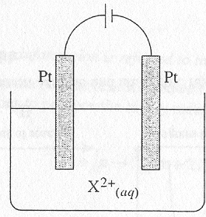
The identity of metal X is most likely to be
- Ni
- Zn
- Cu
- Fe

Question 20
Which combination of anode, cathode and electrolyte could be used to electroplate a copper spoon with silver?
 | cathode | anode | electrolyte
A. | Cu spoon | Ag | AgNO₃
B. | Cu spoon | Ag | Cu(NO₃)₂
C. | Ag | Cu spoon | AgNO₃
D. | Ag | Cu spoon | Cu(NO₃)₂

SECTION B – Short-answer questions

Question 1
- A chemist wishes to determine the heat of a sample of brown rice. A bomb calorimeter is first calibrated by passing a current of 2.26 A through a heating coil at a potential difference of 4.81 V for precisely 155 seconds. The temperature rise in the water surrounding the combustion chamber is measured as 3.29°C.

0.330 g of brown rice is ground to a fine powder and placed into the combustion chamber, which is then filled with oxygen gas. The rice is ignited, and the temperature of the surrounding water increases from 21.35°C to 30.90°C.

(i) Determine the calibration factor of the calorimeter (in J °C^{–1}).
____________________________________________________________________________________
____________________________________________________________________________________
____________________________________________________________________________________
(ii) Calculate the energy content of the brown rice (in kJ g^{–1}).
____________________________________________________________________________________
____________________________________________________________________________________
____________________________________________________________________________________
____________________________________________________________________________________
(iii) Suggest one reason why the brown rice was ground to a fine powder before placing it in the calorimeter.
____________________________________________________________________________________
____________________________________________________________________________________
1 + 2 + 1 = 4 marks
- Rice forms a significant part of the diet for many people around the world. The inner kernel (the white part) of a grain of rice is primarily made up of starch, whilst the outer husk is made of cellulose.

Starch and cellulose are both condensation polymers of glucose, but only starch can be used as an energy source for people.

(i) Explain why the formula of a glucose unit in starch and cellulose is C₆H₁₀O₅, rather than C₆H₁₂O₆.
____________________________________________________________________________________
____________________________________________________________________________________
____________________________________________________________________________________
(ii) Explain why humans are unable to use cellulose as an energy source in their diet.
____________________________________________________________________________________
____________________________________________________________________________________
____________________________________________________________________________________
1 + 1 = 2 marks
Total 6 marks

Question 2
Solid samples of three oxides (Al₂O₃, MgO and P₂O₅) were placed in separate test tubes. Water was added to each. The mixture in each test tube was tested with universal indicator to determine its acidity or basicity.

- Indicate the expected results of these tests by placing ticks in the appropriate columns of the table below.

Oxide | Mixture of oxide and water
Oxide | acidic | basic | neutral
Al₂O₃
MgO
P₂O₅
3 marks
- Explain why the first ionisation energy of magnesium (738 kJ mol^{–1} is greater than the first ionisation energy of sodium (496 kJ mol^{–1}).
_______________________________________________________________________________________
_______________________________________________________________________________________
_______________________________________________________________________________________
_______________________________________________________________________________________
2 marks
Total 5 marks

Question 3
Electricity may be produced on a large scale in a coal-fired power station. The immediate energy source for this process is coal, but the ultimate source is the Sun, as shown in the flowchart below.

 | light  energy |  | chemical  energy |  | chemical  energy
Sun |  | Plants |  | Coal |  | Power Station |  |  |  |  |  | Electricity
Sun |  | Plants |  | Coal |  | Boiler | → | Turbine | → | Generator |  | Electricity

- (i) Write a balanced equation for the process which generates energy in the Sun.
____________________________________________________________________________________
(ii) Write a balanced equation for the process which converts light energy to chemical energy in plants.
____________________________________________________________________________________
(iii) What type of energy conversion takes place in the turbine of a coal-fired power station?
____________________________________________________________________________________
(iv) The coal-fired power station has a 30% efficiency. Explain what is meant by 30% efficiency in this statement.
____________________________________________________________________________________
____________________________________________________________________________________
1 + 1 + 1 + 1 = 4 marks
- The reaction of carbon with oxygen is represented by the equation
C (s) + O₂ (g) → CO₂ (g) ΔH = –394 kJ mol^{–1}
(i) Calculate the energy released when 1.0 tonne (1000 kg) of carbon burns completely in air.
____________________________________________________________________________________
____________________________________________________________________________________
____________________________________________________________________________________
(ii) The brown coal used in some coal-fired power stations yields approximately 8.7 × 10⁶ kJ per tonne of coal. Suggest two reasons why burning 1.0 tonne of coal yields far less energy than burning 1.0 tonne of carbon.
____________________________________________________________________________________
____________________________________________________________________________________
____________________________________________________________________________________
2 + 2 = 4 marks
Total 8 marks

Question 4
Sodium chloride is used as an important raw material in two industrial processes: the Down’s cell and the Nelson (Diaphragm) cell.

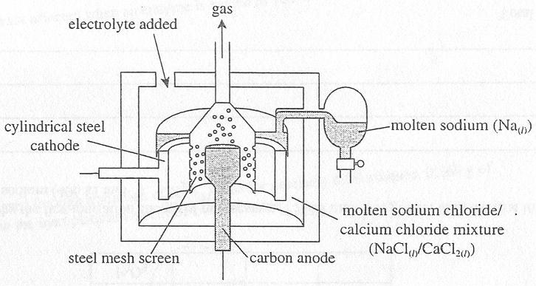
A molten mixture of sodium chloride and calcium chloride are placed in the Down’s cell and a current of 75000 A at a potential difference of 7 V is passed through the mixture.
(i) Write a half-equation for the reaction which occurs at the anode.
____________________________________________________________________________________
(ii) With reference to the table of standard electrode potentials supplied, explain why calcium metal is not produced at the negative electrode during this process.
____________________________________________________________________________________
____________________________________________________________________________________
(iii) Calculate the length of time required for the cell to produce 100 kg of sodium metal if the cell operates at 85% efficiency.
____________________________________________________________________________________
____________________________________________________________________________________
____________________________________________________________________________________
____________________________________________________________________________________
____________________________________________________________________________________
1 + 1 + 3 = 5 marks
- In the Nelson cell a saturated solution of sodium chloride is used.
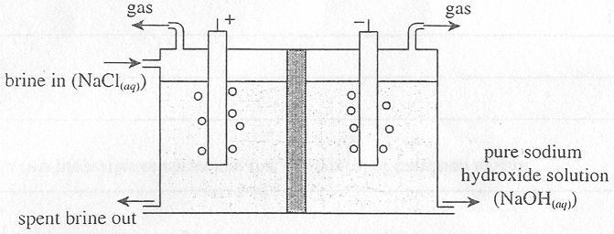
(i) Write a half-equation for the reaction which occurs at the cathode.
____________________________________________________________________________________
(ii) State onefunction of the semi-permeable membrane employed in this cell.
____________________________________________________________________________________
____________________________________________________________________________________
1 + 1 = 2 marks
Total 7 marks

Question 5
The diagram below shows some of the stages in the nitrogen cycle.

Fatty acid | Formula
palmitic acid | C₁₆H₃₂O₂
stearic acid | C₁₈H₃₆O₂
lineolic acid | C₁₈H₃₂O₂

- Which of these three fatty acids would be expected to have the highest melting point? Explain your choice.
_______________________________________________________________________________________
_______________________________________________________________________________________
_______________________________________________________________________________________
_______________________________________________________________________________________
2 marks
- Draw a structural formula for one possible product of the reaction between these three fatty acids and glycerol (C₃H₈O₃) to form a triglyceride.

2 marks
- Bile and enzymes called lipases have important roles in the breakdown of fats during digestion.
Describe the role of each.
(i) bile
____________________________________________________________________________________
____________________________________________________________________________________
____________________________________________________________________________________
(ii) lipases
____________________________________________________________________________________
____________________________________________________________________________________
____________________________________________________________________________________
1 + 1 = 2 marks
Total 6 marks

Question 6
Chromium metal is a very hard, lustrous metal that resists oxidation in air. It dissolves in a dilute solution of hydrochloric acid to produce a sky-blue solution of chromium (II) chloride, according to the equation
Cr (s) + 2 HCl (aq) → CrCl₂ (aq) + H₂ (g)

The chromium (II) ion is a strong reductant and reacts easily with oxygen in the air to produce the Cr³⁺ (aq) ion, which exists as Cr(H₂O)₆³⁺ (aq).

- (i) Oxidation of chromium (II) to chromium (III) is shown in the equation
4 Cr²⁺ (aq) + O₂ (g) + 4 H⁺ (aq) → 4 Cr³⁺ (aq) + 2 H₂O (l)
Write a balanced partial equation for the reduction processes in this reaction.
____________________________________________________________________________________
(ii) Draw the structure of the Cr(H₂O)₆³⁺ ion, clearly labelling all bond types within the ion.

1 + 2 = 3 marks
- If sodium hydroxide solution is added to a solution of chromium (III) ions, a grey-green gelatinous precipitate is formed. If an excess of sodium hydroxide is added, the precipitate dissolves and a bright green solution results.
(i) Write a balanced equation for the formation of the precipitate.
____________________________________________________________________________________
(ii) Explain the appearance of the bright green solution when excess sodium hydroxide is added.
____________________________________________________________________________________
____________________________________________________________________________________
1 + 1 = 2 marks
- (i) Write the electronic configuration of the chromium (II) ion.
____________________________________________________________________________________
(ii) State two properties of chromium that are typical of transition metals.
____________________________________________________________________________________
____________________________________________________________________________________
____________________________________________________________________________________
1 + 2 = 3 marks
Total 8 marks

