STAV 2002 | Unit 3 Chemistry | Trial Examination Solutions

Section A – Multiple choice questions

- B
- C
- A
- C
- C
- D
- C
- B
- C
- D
- B
- B
- B
- D
- A
- C
- D
- A
- A
- D
- A
- D

Section B – Short Answer Questions

Question 1
 | 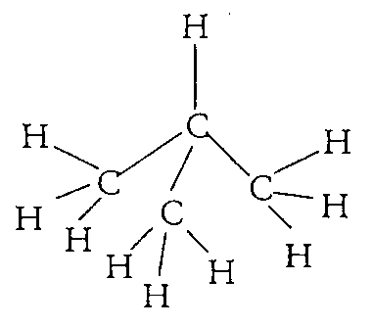 | (1 mark for structure of methyl propane)
- The greater the number of carbon atoms the longer the retention time. (1 mark)
Larger alkane molecules will have greater attraction to the stationary phase due to an increase in dispersion forces. (1 mark)
- (i) The retention times and, hence, the separation between the peaks would be greater. (1 mark)
(ii) The increase in temperature would reduce retentions times and the peaks would be closer together. (1 mark)

Question 2
- Qualitative analysis provides information as to the identity of chemicals in a sample, whereas quantitative analysis provides a measure of the amount of a chemical in a sample. (2 marks)
 | 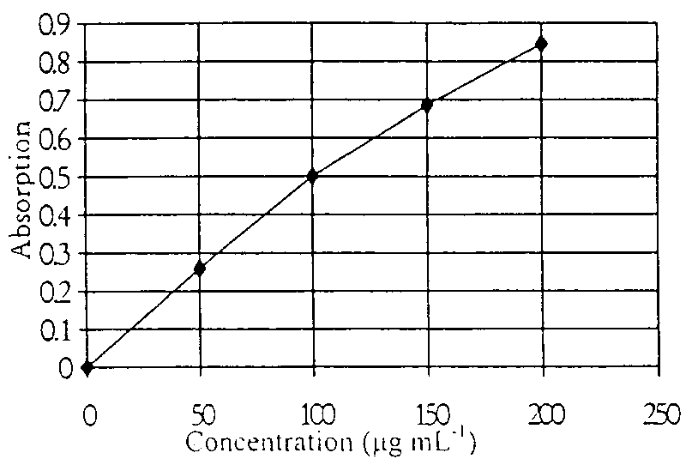 | 1 mark for appropriate scaling of the axes.  1 mark for graph plotted accurately.
- The calibration graph enables the absorption measurements to be converted to actual concentration values; it relates an absorption measurement to a concentration for the metal under analysis. (1 mark)
- From the calibration graph, an absorption measurement of 0.61 equates to a concentration of 125 to 130 µg mL^{–1} (1 mark)
Undiluted ore sample contains 100 × (125 to 130) = 12500 to 13000 µg mL^{–1} (1 mark)
Undiluted ore sample contains = 12.5 to 13.0 mg mL^{–1} (1 mark)
- The absorption of the sample must be within the range of the calibration and dilution achieves this. (1 mark)

Question 3
- Ag⁺ (aq) + Cl– (aq) → AgCl (s) (1 mark)
- (i) η(AgCl) = 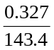 = 0.00225 mol (1 mark)
(ii) η(AgNO₃)_{Total} = cV = 0.500 × 0.100 = 0.00500 mol (1 mark)
η(AgNO₃)_{Excess} = η(AgNO₃)_{Total} – η(AgCl) = 0.00500 mol – 0.00228
η(AgNO₃)_{Excess} = 0.00272 mol (1 mark)
(iii) η(Na⁺) = η(Cl–) = η(AgCl) = 0.00228 mol (1 mark)
(iv) m(Na⁺) = 0.00228 × 23.0 = 0.0524 g (1 mark)
(v) % mass(Na) = 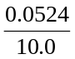 × 100 = 0.524% (m/m) (1 mark)
- Higher.
Not drying until constant mass will result in the precipitate being damp, making the mass of silver chloride appear to be greater. (1 mark)
For example, using m(AgCl) = 0.400 g, the % Na = 0.642 % (m/m)

Question 4
- CH₃COOH is the strongest acid. (1 mark)
It has the highest K_{a} value meaning that it ionises to a greater extent producing more H₃O⁺ (or H⁺) ions in aqueous solution. (1 mark)
- (i) K_{a} = 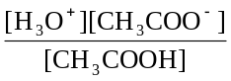 (1 mark)
(ii) [CH₃COO–] = [H₃O⁺]
[H₃O⁺]² = K_{a} [CH₃COOH] = 1.8 × 10^{–5} × 0.10
[H₃O⁺] = 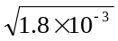 = 1.34 × 10^{–3} M (1 mark)
pH = –log₁₀[H₃O⁺] = –(–2.87)
pH = 2.9 (1 mark)
(iii) Percentage ionisation = 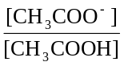 × 100
Percentage ionisation = × 100 = 1.34%
Percentage ionisation = 1.3% (1 mark)
- (i) An increase in pH results from a decrease in the [H₃O⁺] (or [H⁺]). This results from the reverse reaction occurring on the addition of the CN– anion. (1 mark
(ii) The equilibrium constant will be the same. (1 mark)
Only a temperature change will result in a change in the equilibrium constant. (1 mark)
- If the pH decreases then the [H₃O⁺] (or [H⁺]) has been increased and therefore the reaction must have moved in a forward direction. (1 mark)
As the forward reaction is exothermic the temperature must have been lowered. (1 mark)

Question 5
- For example: 2 SO₂ (g) + O₂ (g)  2 SO₃ (g) (1 mark)
- K = 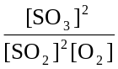 (1 mark)
- (i) Vanadium (V) oxide or V₂O₅ or vanadium pentoxide. (1 mark)
(ii) K = = 1.2 × 10³
[SO₂] = 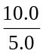 = 2.0 M
[O₂] = 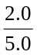 = 0.40 M (1 mark for method of calculating concentrations)
[SO₃]² = 1.2 × 10³ × (2.0)² × 0.40 = 1.92 × 10³
At equilibrium [SO₃] = 44 M (1 mark)
- The temperature selected is a compromise temperature used to ensure both an adequate equilibrium yield and a suitable rate of reaction. (1 mark)
Note: due to the very short contact time between the catalyst and the reactants a temperature of 450°C needs to be used to ensure a good yield for the reaction.

Question 6
- Structural formula for propene | 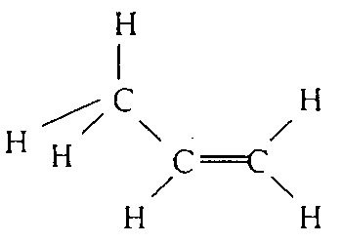 | (1 mark)
- (i) Propane (1 mark)
(ii) Addition (1 mark)
- (i) | 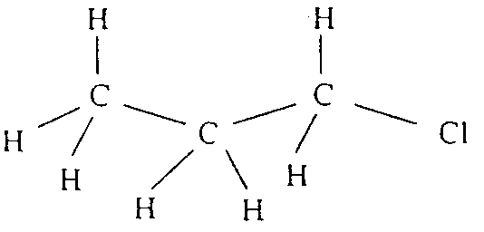 | (1 mark)
(ii) A substitution reaction is one in which an atom, or group of atoms, in a molecule is replaced by another atom, or group of atoms. In this case, a chlorine atom replaces a hydrogen atom in the propane molecule. (1 mark)
- (i) 2-chloropropane (1 mark)
(ii) A strong base such as an aqueous sodium hydroxide solution. (1 mark)
- (i) CH₃CH₂CH₂OH (l) + CH₃COOH (l) CH₃COOCH₂CH₂CH₃ (l) + H₂O (l)
propan-1-ol
1 mark for each semi-structural formula of the organic substances = 3 marks
Note that the mark for the ester can be awarded even if the formulas of the alcohol (alkanol) and carboxylic acid (alkanoic acid) are incorrect, provided that the ester is correctly indicated. Only award 2 marks if the alcohol is not labelled correctly.
(ii) Ester (1 mark)
(iii) Propyl ethanoate (1 mark)

