STAV 2002 | CHEMISTRY | Unit 4 | Trial Examination Solutions

Section A Multiple Choice Questions

- A
- B
- B
- A
- D
- C
- D
- A
- B
- C
- D
- D
- D
- D
- A
- B
- C
- A
- C
- B

Section B Short Answer

Question 1
 | 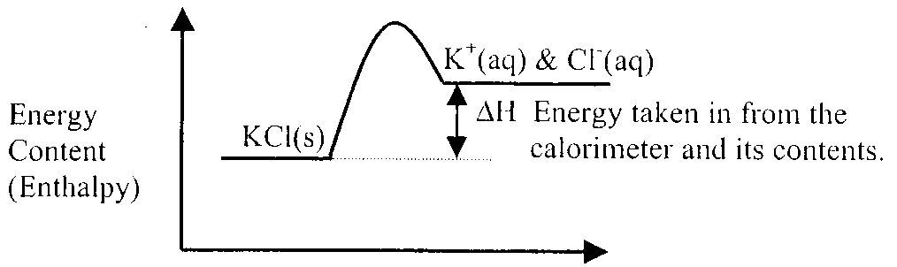 | 1 mark
When the potassium chloride dissolves the energy content (Enthalpy) of the products is greater than that of the reactants. |  | 1 mark
(That is, the bonds in the products are less stable. This is indicated for this endothermic reaction by a positive value of ΔH for the reaction.)
The difference in energy content is absorbed from the surroundings (calorimeter and its contents) resulting in the observed drop in temperature. |  | 1 mark
- n(KCl) = mass / M = 5.1592 / 74.6 = 0.069458 mol |  | 1 mark
Therefore, energy absorbed = 0.069158 × 17.0 = 1.1757 kJ  Energy absorbed = 1.18 kJ |  | 1 mark
- ΔT (temperature change) = 14.56 – 12.08 = 2.48°C
The heat energy to raise the calorimeter and its contents by 1°C is the calibration factor (CF) of the calorimeter and its contents.  Therefore, CF = 1.1757 / 2.48 = 0.474068 kJ / °C  Calibration Factor is 474 J °C^{–1} |  | 1 mark
Correct number of significant figures. (This should be exact.) |  | 1 mark

Question 2
- (i) anode |  |  | CH₃OH (l) + H₂O (l)  CO₂ (g) + 6 H⁺ (aq) + 6 e– | 1 mark
(ii) cathode |  |  | O₂ (g) + 4 H⁺ (aq) + 4 e–  2 H₂O (l) | 1 mark
 | 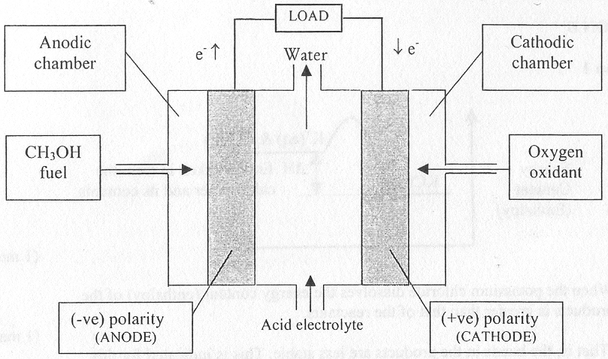
(i) |  | Anodic and cathodic chambers |  | 1 mark
(ii) |  | Polarity of the electrodes |  | 1 mark
(iii) |  | Input connections for the fuel and oxidant |  | 1 mark
- porous |  |  |  | 1 mark
Catalytic |  |  |  | 1 mark
- H⁺ ions are produced at the anode and therefore the pH decreases near the anode. However the H⁺ ions migrate to the cathode where they are consumed. When the rate of production of H⁺ at the anode is equal to the rate of migration to the cathode the pH will remain constant. |  |  |  | 1 mark
(This is assuming that water is removed at the same rate as it is produced.)
- For example: |  |  |  | 1 mark
- more efficient in converting chemical energy into electrical energy or  - methanol is renewable or  - less polluting |  |  |  | 1 mark

Question 3
- Aluminium electrode. |  | 1 mark
- (i) | Zn²⁺ (aq) + 2 e–  Zn (s) | 1 mark
(ii) | 2 H₂O (l)  O₂ (g) + 4 H⁺ (aq) + 4 e– | 1 mark
- 2 H₂O (l) + 2 e–  H₂ (g) + 2OH– (aq) |  | 1 mark
- (i) | n(Zn) per 24 hours = mass / molar mass = 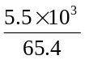 = 84.10 mol | 1 mark
 | n(Zn) per hour = 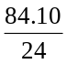 = 3.5 mol | 1 mark
(ii) | n(e–) = 2 × n(Zn) = 2 × 3.504 = 7.0 mol | 1 mark
 | Charge (Q) = n(e–) × F = 7.008 × 96500 = 6.763 × 10⁵ coulomb  E = V I t = V Q = 4.1 × 6.763 × 10⁵ = 2.773 × 10⁶ joules  Energy required is 2.8 megajoules | 1 mark

Question 4
 | 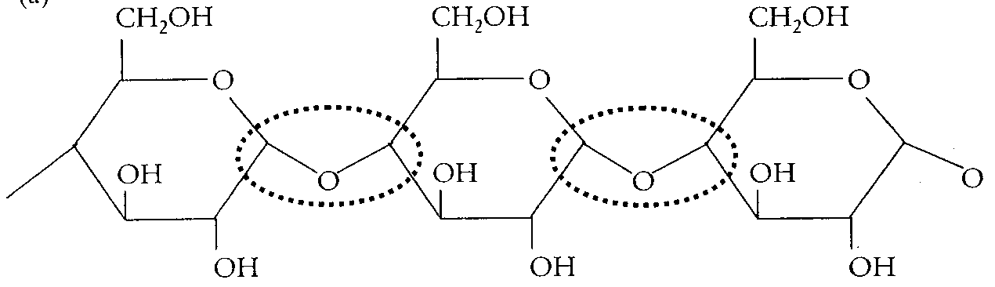
Either of the two complete glycosidic links can be indicated. |  |  | 1 mark
- (i) Water |  |  | 1 mark
(ii) |  | 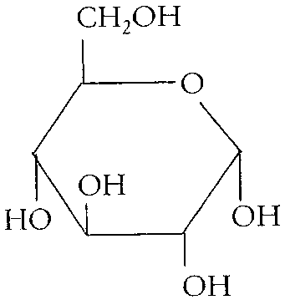 | 1 mark
- Cellulose does not fit into the active site(s) of the enzyme that hydrolyse starch. |  |  | 1 mark
- Starch takes time to be hydrolysed down to simple sugars, such as glucose. This means that it cannot be absorbed into the body rapidly. |  |  | 1 mark
- (i) C₆H₁₂O₆ (aq) + 6 O₂ (aq)  CO₂ (aq) + 6 H₂O (l) |  |  | 1 mark
(ii) M(C₆H₁₂O₆) = 180 g mol^{–1} |  |  | 1 mark
2800 kJ per 1 mol  2800 kJ per 180 g  x kJ per 1.0 g  x = 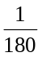 × 2800 = 15.6 kJ g^{–1} |  |  | 1 mark

Question 5
 | 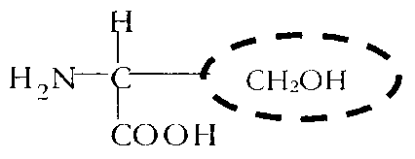 |  | 1 mark
 | 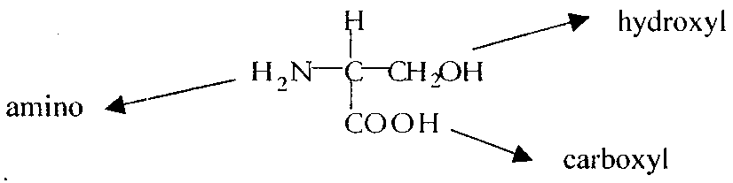 |  | 1 × 3 = 3 marks
- Yes it will be soluble in water. The functional groups are able to form hydrogen bonds with water. |  |  | 1 mark
 | 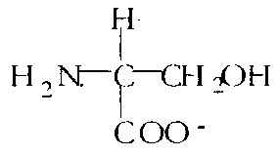 |  | 1 mark
- condensation (polymerisation) |  |  | 1 mark
- (i) |  | 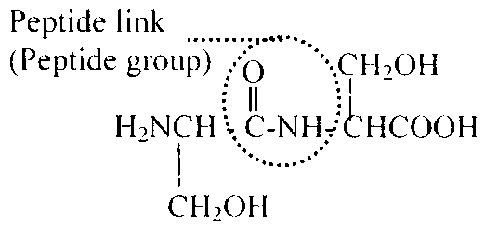 | 2 marks
(ii) enzyme catalysed hydrolysis |  |  | 1 mark

Question 6
- (i) | 1s² 2s² 2p⁶ 3s² 3p⁶ 3d⁷ 4s² | 1 mark
(ii) | 1s² 2s² 2p⁶ 3s² 3p⁶ 3d⁷ | 1 mark
(iii) | d-block elements (also known as transition metals) have partially filled or just completely filled d-subshells. In the case of cobalt the third shell contains a partially filled d-subshell. | 1 mark
- (i) | Letter X. | 1 mark
(ii) | Properties typically exhibited by d-block (transition) elements are high melting points, high densities, and the ability to conduct an electric current. Only the element corresponding to the letter X exhibits these three properties. | 1 mark

Question 7
- LHS of nuclear equation = 92 p and 144 n
RHS = 38 p + protons in particle R and (52 + 3 = 55 neutrons and particle R. |  | 1 mark
(i) | Therefore the number of protons in particle R is 92 – 38 = 54  Hence atomic number is 54. | 1 mark
(ii) | Particle R must have (144 + 92) – (90 + 3) = 236 – 93  Particle R has 143 neutrons and protons  Hence mass number of particle R is 143 | 1 mark
(iii) | Atomic number of 54 implies the element is Xenon. | 1 mark
- Fission – the neutron induced fission of ²³⁵ U |  | 1 mark
- Group II or 2 |  | 1 mark
5th row implies the element is in Period 5 |  | 1 mark
- As strontium is in Group II a charge of 2+ is expected. |  | 1 mark
- SrO |  | 1 mark
- SrO is likely to be ionic so it will be a solid. |  | 1 mark

