STAV
2002
UNIT 4 CHEMISTRY

SECTION A – Multiple-choice questions

Question 1
In third world countries, farmers can use dung to produce methane. When burnt, the methane can supply sufficient energy for several families.
The combustion reaction is represented by
CH₄ (g) + 2 O₂ (g) → CO₂ (g) + 2 H₂O (g) ΔH = -890 kJ mol⁻¹
If 1.00 kg of methane, at STP, was reacted completely with oxygen, the amount of energy generated is

- 55.6 × 10³ kJ
- 890 kJ
- 55.6 kJ
- 22.4 kJ

Question 2
A student calibrated a solution calorimeter containing 100 mL of water using electrical apparatus. The specific heat capacity of water is 4.18 J °C⁻¹ g⁻¹. Assuming that the student’s measurements were reliable, which calibration factor is most likely for a well-insulated calorimeter?

- 240 J K⁻¹
- 480 J K⁻¹
- 960 J K⁻¹
- 1418 J K⁻¹

Question 3
When the Daniell cell functions under standard conditions, the equation for the reaction occurring is
Zn (s) + Cu²⁺ (aq) → Zn²⁺ + Cu (s)
It may be deduced that
- copper is a stronger reductant than zinc
- copper (II) ion is a stronger oxidant than zinc ion
- copper (II) ion is a stronger reductant than zinc ion
- copper is more likely to react with dilute hydrochloric acid than zinc

Question 4
The specific heat capacity of a dilute aqueous solution is approximately 4.2 J mL⁻¹ °C⁻¹.
The equation for the reaction between sodium hydroxide and hydrochloric acid is
HCl (aq) + NaOH (aq) → NaCl (aq) + H₂O (l) ΔH = -55.0 kJ mol⁻¹
The temperature change when 50.0 mL of 0.25 M hydrochloric acid is mixed with 25.0 mL of 0.50 M sodium hydroxide would be

- 2.2 °C
- -2.2°C
- 3.3°C
- -3.3°C

Question 5
Secondary cells, such as the lead-acid accumulator, can only be recharged because
- they can store electrons
- new chemicals can be added to the cell
- the products of the discharge reactions are not gaseous
- the products of the discharge reactions remain in contact with the electrodes

Question 6
Sodium hydroxide is produced by electrolysis of hot, concentrated NaCl solution (brine). If 1.0 mol of electrons is used in the process

- 2.0 mol of NaOH is formed
- 1.0 mol of chlorine gas is produced
- 1.0 mol of gas is produced
- 36 g of water reacts

Question 7
The pair of species that would be expected to react spontaneously under standard conditions is

- Ni²⁺ with Zn²⁺
- Ni with Zn²⁺
- Ni²⁺ with H⁺
- Ni²⁺ with Zn

Question 8
Aluminium is produced using the Hall-Heroult cell. A purpose of the cryolite in this cell is to

- lower the melting temperature of the alumina
- react with the alumina to produce aluminium
- reduce the waste gases produced by the process
- increase the rate of the electrode reactions

Question 9
Which of the following is least likely to act as a ligand in a transition metal complex?

- OH⁻
- NH₄⁺
- Cl⁻
- NH₂CH₂CH₂NH₂

Question 10
The oxidation numbers of manganese in MnCl₂, MnO₂ and KMnO₄ respectively are

- +2, +2 and +4
- +2, +2 and +7
- +2, +4 and +7
- +4, +4 and +9

Question 11
A sample of gallium consists of 60.4% of ⁶⁹Ga and 39.6% of ⁷¹Ga. If the relative isotopic mass of ⁶⁹Ga is 68.9, the relative isotopic mass of ⁷¹Ga is

- 69.2
- 69.4
- 70.2
- 70.9

Question 12
The labelling on a tub of ice cream indicated that an emulsifier was present.
The purpose of the emulsifier in the ice cream was to

- provide flavour
- act as a preservative
- prevent oxidation of fats
- stabilise the water and cream mixture

Question 13
When triglyceride molecules are formed in a living organism
- unsaturated fatty acids are always involved
- the process is termed a hydrolysis reaction
- the substrates combine in a 1:1 ratio
- hydroxyl and carboxyl functional groups are involved

Question 14
Nitrogen fixation could involve the
- oxidation of nitrite to nitrate ions
- oxidation of ammonium ions to nitrate ions
- reduction of nitrate ions to atmospheric nitrogen
- reduction of atmospheric nitrogen to ammonium ions

Question 15
In the process of cellular respiration, molecules such as glucose, C₆H₁₂O₆, are broken down into water and carbon dioxide. Respiration is an example of a reaction that is
- exothermic, with oxygen acting as the oxidant
- endothermic, with oxygen acting as the reductant
- exothermic, with oxygen acting as the reductant
- endothermic, with oxygen acting as the oxidant

Question 16
The secondary structure of proteins generally refers to
- the amino acid sequence of the protein
- hydrogen bonding between peptide bonds within the protein molecule
- hydrogen bonding between peptide bonds of adjacent protein molecules
- all forms of bonding between sections of the same protein molecule

Question 17
In the period consisting of the elements from sodium to chlorine, there is an increase in the core charge of the nucleus, leading to the outer shell electrons being more firmly held by the nucleus.
Which one of the following trends does this explain?

- A decrease in ionisation energy.
- A decrease in the acidity of the oxides.
- An increase in electronegativity.
- An increase in atomic mass.

Question 18
James Chadwick’s contribution to atomic theory was that he
- demonstrated the existence of the neutron
- demonstrated the existence of the electron
- proposed that electrons orbited the nucleus in fixed energy levels, called shells
- demonstrated that the atom contained a dense, positively charged nucleus at its centre

Question 19
Which of the following lists only basic oxides?

- Na₂O, MgO, Al₂O₃
- Na₂O, MgO, SO₂
- Na₂O, K₂O, CaO
- Al₂O₃, SO₂, SO₃

Question 20
Which of the following nuclear reactions is a fusion reaction that is endothermic?

- 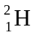 + → 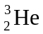 + 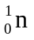
- 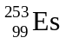 + 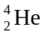 → 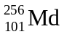 +
- + → +
- + → +

SECTION B – Short-answer questions

Question 1
A well insulated calorimeter containing 100 mL of water was calibrated by dissolving a known amount of potassium chloride in the calorimeter. The dissolution of potassium chloride in water can be represented by the equation
KCl (s) 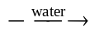 K⁺ (aq) + Cl⁻ (aq) ΔH = +17.0 kJ mol⁻¹
The temperature of the calorimeter was initially 14.56°C. A sample of 5.1592 g of potassium chloride was dissolved in the 100 mL of water and the temperature was recorded as 12.08°C.

- Draw an energy profile diagram and explain why the temperature of the calorimeter and its contents decreased.

_______________________________________________________________________________________
_______________________________________________________________________________________
_______________________________________________________________________________________
_______________________________________________________________________________________
_______________________________________________________________________________________
- Calculate the change in energy, in kJ, that occurred when the 5.1592 g of potassium chloride was dissolved.
_______________________________________________________________________________________
_______________________________________________________________________________________
_______________________________________________________________________________________
- Determine the calibration factor for the calorimeter and its contents.
Be careful to use the appropriate number of significant figures in your answer.
_______________________________________________________________________________________
_______________________________________________________________________________________
_______________________________________________________________________________________
_______________________________________________________________________________________
_______________________________________________________________________________________
3+2+2 = 7 marks
Suggested time = 8 minutes

Question 2
An experimental fuel cell is based on methanol, oxygen and a simple acidic electrolyte. The overall reaction occurring is
2 CH₃OH (l) + 3 O₂ (g) → 2 CO₂ (g) + 4 H₂O (l)

- Write balanced half equations for the reaction occurring at the
- anode _______________________________________________________________________
- cathode _______________________________________________________________________
- Label the diagram of the fuel cell to indicate the
- anodic and cathodic chambers
- polarity of the electrodes
- input connections for the fuel and oxidant
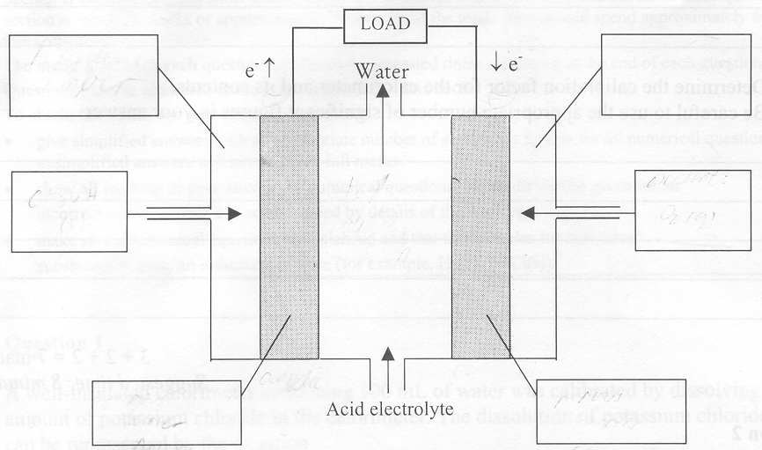
- What two features of the electrodes (in addition to being a solid electrical conductor) would be needed?
_______________________________________________________________________________________
_______________________________________________________________________________________
_______________________________________________________________________________________
- When the cell starts producing energy the pH of the electrolyte near the anode decreases but eventually reaches a constant value. Explain these observations.
_______________________________________________________________________________________
_______________________________________________________________________________________
_______________________________________________________________________________________
_______________________________________________________________________________________
- State one major advantage fuel cells have over the current use of conventional fuels such as coal and petroleum.
_______________________________________________________________________________________
_______________________________________________________________________________________
2+3+2+1+1= 9 marks
Suggested time: 11 minutes

Question 3
A simple representation of an electrolytic cell is shown in the diagram.
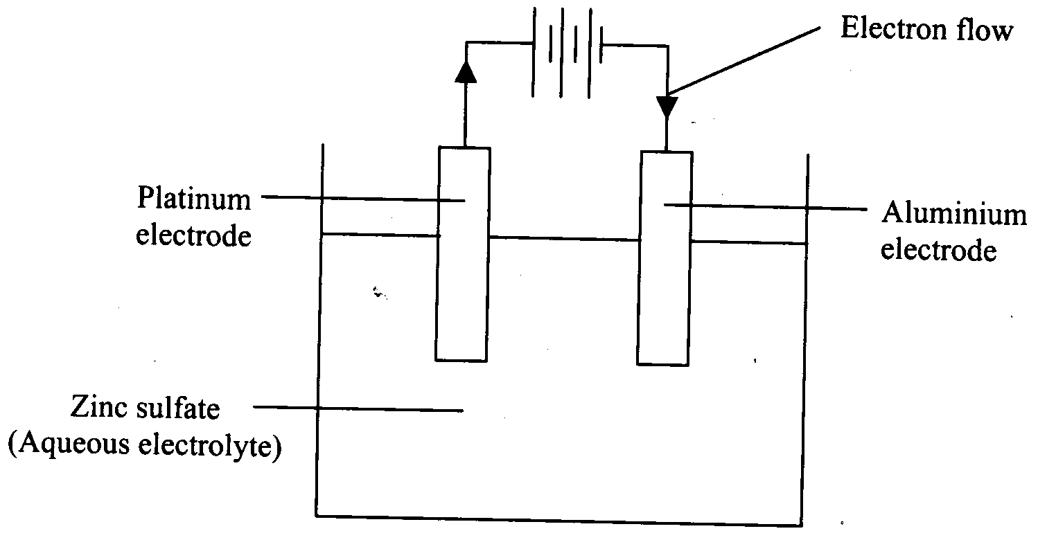
- Which of the electrodes in the representation is the cathode?
_______________________________________________________________________________________
- Write the half equations for the reactions expected at the
- Aluminium electrode
__________________________________________________________________________________
- Platinum electrode
__________________________________________________________________________________
- If the zinc sulfate electrolyte was replaced by a solution of manganese(II) sulfate, write the half equation for the reaction expected at the cathode.
_______________________________________________________________________________________
- The Electrolytic Zinc Company in Australia uses an electrolytic cell similar to that in the diagram. The cell produces 5.5 kg of zinc every 24 hours using a voltage of 4.1 volt.
- Calculate the amount, in mol, of zinc produced per hour by the Electrolytic Zinc Company.

- Calculate the energy, in megajoules, that must be supplied to produce this amount of zinc per hour.

1+2+1+4 = 8 marks
Suggested time: 9 minutes

Question 4
Starch is a major carbohydrate store in many plants, such as potatoes. It is a polymer of glucose.
A simplified diagram of a section of a starch molecule is shown.

- On the diagram, circle one example of a glycosidic (ether) link.
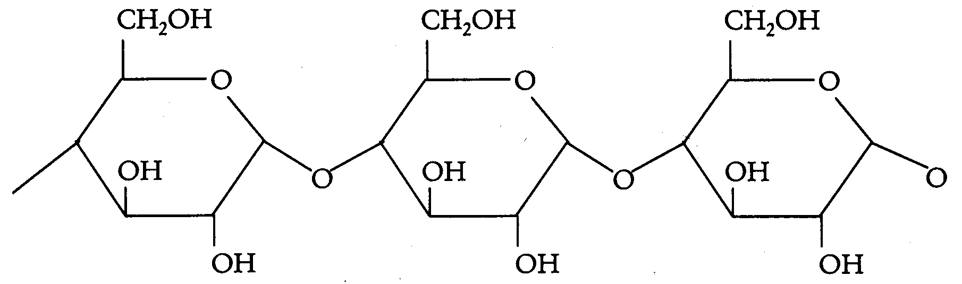
- In the intestine, starch undergoes enzyme-catalysed hydrolysis.
- What molecule, other than the starch and the enzyme, is required for this hydrolysis reaction?
__________________________________________________________________________________
- Draw the structure of the monomer that is formed by the enzyme-catalysed hydrolysis of starch.

- Cellulose is also a polymer of glucose, yet the enzymes that are able to hydrolyse starch are unable to hydrolyse cellulose. Explain why this is so.
_______________________________________________________________________________________
_______________________________________________________________________________________
- Briefly explain why an athlete would not eat a food high in starch as a means of providing an immediate source of energy.
_______________________________________________________________________________________
_______________________________________________________________________________________
- i. Write a balanced chemical equation for the complete oxidation of glucose in the body.
__________________________________________________________________________________
- The heat energy liberated for this reaction is 2800 kJ mol⁻¹. Express this as kJ g⁻¹.

1+2+1+1+3 = 8 marks
Suggested time: 9 minutes

Question 5
The following diagrams A and B represent the structure of the amino acid serine.
A. | 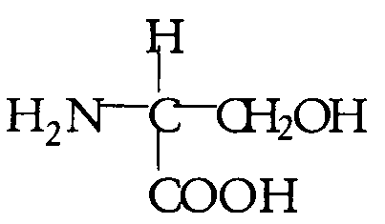 | B. | 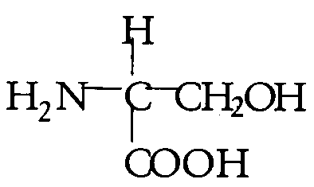
- Circle the side chain in the serine molecule shown in diagram A.
- Clearly identify and name all the functional groups present in serine in the second diagram B.
- Would you expect serine to be soluble in water? Explain your answer in chemical terms.
_______________________________________________________________________________________
_______________________________________________________________________________________
- Some serine is placed in a solution of sodium hydroxide. Draw the structure of the serine as it would exist in this solution.

- Serine molecules are able to joint together to form a polymer chain.
Name the type of reaction that occurs when molecules of serine join together.
_______________________________________________________________________________________
- i. Draw the structure of the dipeptide formed when two molecules of serine combine and circle the peptide link.

- Name the process by which this dipeptide can be reverted back to serine molecules.
____________________________________________________________________________________
1+[1+3+1]+2+[2+2] = 12 marks
Suggested time: 15 minutes

Question 6
- Cobalt is a transition element; its compounds exhibit many oxidation states and they are typically coloured.
- Write the ground state subshell configuration for cobalt, Co.
__________________________________________________________________________________
- Write the ground state subshell configuration for the cobalt(II) ion.
__________________________________________________________________________________
- Why is cobalt classified as a transition element?
__________________________________________________________________________________
__________________________________________________________________________________
__________________________________________________________________________________
- Consider the following data for the elements, Q, X, Y and Z.

Element | Conductivity  (High or Low) | Melting Point  (°C) | Density  (g cm⁻³)
Q | high | 98 | 0.97
X | high | 1495 | 8.90
Y | high | 651 | 1.74
Z | low | 3547 | 3.51

- Write the letter that is most likely to correspond to the element cobalt.
__________________________________________________________________________________
- Explain your selection.
__________________________________________________________________________________
__________________________________________________________________________________
__________________________________________________________________________________
3+2 = 5 marks
Suggested time: 6 minutes

Question 7
Energy can be produced by nuclear reactions. One example is the nuclear reaction involving uranium-235 shown below.
²³⁵U + ¹n → ⁹⁰Sr + 3 ¹n + R
- Identify the particle R by giving the
- atomic number ______________________________________________________
- mass number ______________________________________________________
- name of the element ______________________________________________________
- Name the type of nuclear reaction given. Briefly explain your answer.
_______________________________________________________________________________________
- State the Group and Period in which strontium is found on the Periodic Table.
_______________________________________________________________________________________
- State the charge that would most likely be present on the ion formed by strontium.
_______________________________________________________________________________________
- Write the formula for strontium oxide.
_______________________________________________________________________________________
- Would strontium oxide be a solid, liquid or gas at room temperature. Briefly explain your answer.
_______________________________________________________________________________________
_______________________________________________________________________________________
_______________________________________________________________________________________
_______________________________________________________________________________________
1+3+2+1+1+1 = 9 marks
Suggested time: 11 minutes

