Chemistry exam Name: ________________

SECTION A – Multiple-choice questions

Instructions for Section A
Answer all questions.
Choose the response that is correct or best answers the question.
A correct answer scores 1, an incorrect answer scores 0.
No mark will be given if more than one answer is completed for any question.
Marks will not be deducted for incorrect answers.

Use the following information to answer Questions 1 and 2
The diagram below summarises the use of animal waste as a source of energy.
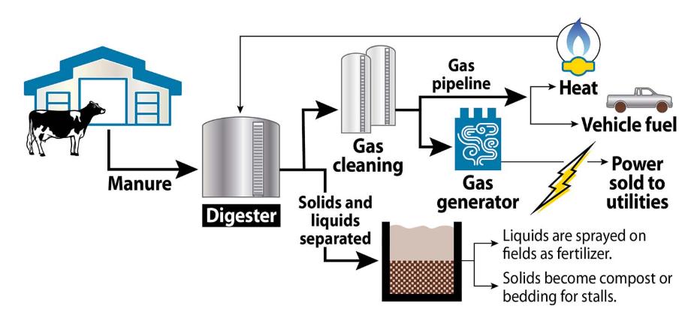

Question 1
Select the best description of the environmental impact of this industry.

A. In this process, light energy is converted to electrical energy.
B. The use of solids and liquids as fertilizer adds to the circular economy benefits.
C. This process is still an example of a linear economy due to the waste produced.
D. This process produces significant emissions of the potent greenhouse gas, methane.

Question 2
The chemical reaction occurring in the gas generator shown in the diagram is

A. CH₄(aq) + 2O₂(g) CO₂(g) + 2H₂O(g)
B. CH₄(g) + 2O₂(g) CO₂(g) + 2H₂O(g)
C. CH₄(g) + 2O₂(g) CO₂(g) + 4H⁺(g)
D. C₆H₁₂O₆(aq) 2C₂H₆O(aq) + 2CO₂(g)

Question 3
The mass of CO₂ formed from the complete combustion of 0.25 mole of an alkane is 44 g. The alkane is

A. methane
B. ethane
C. propane
D. butane

Use the following information to answer Questions 4 and 5
Refer to the following energy profile to answer
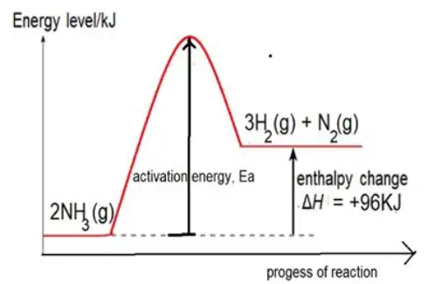

Question 4
Select the correct conclusion from the energy profile diagram.

A. Activation energy of the forward reaction equals the activation energy of the reverse reaction
B. The enthalpy change for the forward reaction is greater than that of the reverse reaction.
C. Energy required to break the bonds in NH₃ is greater than the energy released by N₂ and H₂
D. Energy required to break the bonds in NH₃ is less than the energy released by N₂ and H₂

Question 5
A thermochemical equation for the reverse reaction is

A. 3H₂(g) + N₂(g) 2NH₃(g) ΔH = -288 kJ
B. 3/2H₂(g) + 1/2N₂(g) NH₃(g) ΔH = -48 kJ
C. 3H₂(g) + N₂(g) 2NH₃(g) ΔH = -48 kJ
D. 2NH₃(g) 3H₂(g) + N₂(g) ΔH = +96 kJ

Question 6
The oxidation state change of carbon in the fermentation reaction is
A. -4 to +4
B. 0 to +2
C. 0 to +4
D. +2 to +4

Use the following information to answer Questions 7 and 8
The diagram below shows a zinc-air cell.
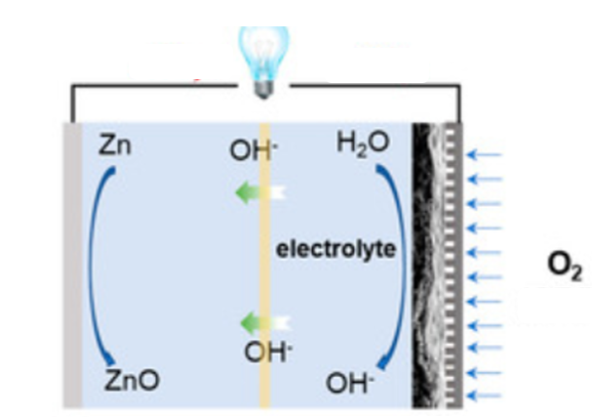

Question 7
In this cell,

A. electrons flow from the zinc electrode to the oxygen electrode.
B. OH⁻ ions flow from the zinc electrode to the oxygen electrode.
C. H⁺ ions will move through the electrolyte to complete the circuit.
D. the electrodes will be made from different materials.

Question 8
The overall equation occurring in this cell is

A. Zn(s) + 2OH⁻(aq) ZnO(s) + H₂O(l)
B. Zn(s) + O²⁻(aq) ZnO(s)
C. 2Zn(s) + H₂O(l) 2ZnO(s) + 2OH(aq)
D. 2Zn(s) + O₂(g) 2ZnO(s)

Use the following information to answer Questions 9 and 10
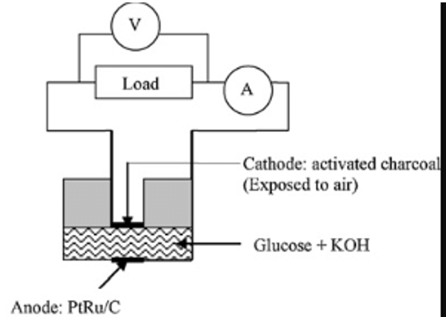
An interesting line of research is into the use of glucose as a fuel in a fuel cell. The diagram below shows the design of these cells. The cell uses the enzyme glucose oxidase to convert glucose to glucathone, C₆H₁₂O₇.

Question 9
The half-equation for the reaction at the anode in this cell is

A. O₂(aq) + 4H⁺(aq) + 4e 2H₂O(l)
B. C₆H₁₂O₆(aq) + 2OH⁻(aq) C₆H₁₂O₇(aq) + H₂O(l) + 2e
C. C₆H₁₂O₆(aq) + H₂O(aq) C₆H₁₂O₇(aq) + 2H⁺(aq)) + 2e
D. C₆H₁₂O₆(aq) + 2OH⁻(aq) + 2e C₆H₁₂O₇(aq) + H₂O(l)

Question 10
Many fuel cells run more efficiently at temperatures around 200 ⁰C. The maximum efficiency of this cell, however, is achieved at 34 ⁰C.
The problem with the use of high temperatures in this cell is that

A. the reaction is exothermic and the yield drops with temperature.
B. elevated temperatures will cause a series of side reactions to occur.
C. elevated temperatures will denature the enzymes in the cell.
D. elevated temperature cause complete combustion of glucose to CO₂ and H₂O.

Use the following information to answer Questions 11 to 13
The diagram below shows a commercial electrolytic cell.
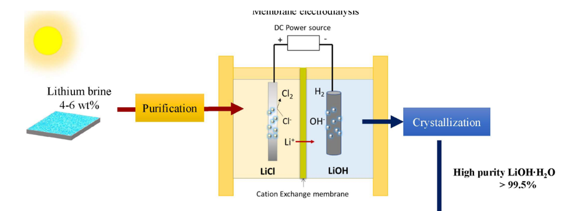

Question 11
In this cell, the half-equations are

A. the reduction of water and the oxidation of chloride ions.
B. the reduction of lithium and the oxidation of water.
C. the reduction of water and the oxidation of water.
D. the reduction of water and the oxidation of chlorine gas.

Question 12
The overall equation occurring in this cell is

A. 2Li⁺(l) + 2Cl⁻(l) 2Li(l) + Cl₂(g)
B. 2H₂O(l) 2H₂(g) + O₂(g)
C. 2Li⁺(aq) + 2Cl⁻(aq) + 2H₂O(l) H₂(g) + O₂(g) + 2LiOH(aq)
D. 2Li⁺(aq) + 2Cl⁻(aq) + 2H₂O(l) H₂(g) + Cl₂(g) + 2LiOH(aq)

Question 13
The volume of gas produced in this cell at SLC from the passage of 0.400 mol of electrons is, in L,

A. 4.96
B. 9.92
C. 19.84
D. 24.80

Use the following information to answer Questions 14 and 15
Nitrosyl chloride can be formed in the reaction between nitrogen oxide and chlorine gas. The equation is

2NO(g) + Cl₂(g) ⇌ 2NOCl(g)
Chlorine gas has a light green colour. The other gases are colourless.

Question 14
The volume of an equilibrium mixture of the above gases is halved. When equilibrium is re-established

A. the green intensity will be greater than at the first point of equilibrium.
B. the green intensity will be less than at the first point of equilibrium.
C. the amount of Cl₂ will be greater than at the first point of equilibrium.
D. the value of K will be greater than at the first point of equilibrium.

Question 15
A change is made to an equilibrium mixture that causes an immediate drop in Q. The change could be

A. some NO was removed.
B. the injection of Cl₂ gas.
C. the volume was doubled.
D. an inert gas was added.

Question 16
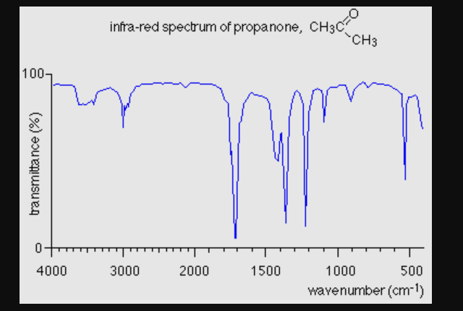

The molecule in the spectrum above could be

A. propanoic acid
B. propan-1-ol
C. propan-2-one
D. propan-1-amine

Question 17

The IUPAC name for this molecule is

A. 5-chloro-2-ethylpentan-1-ol
B. 1-chloro-4-ethyl-3-hydroxylhexane
C. 2-ethyl-5-chloro-2-pentan-1-ol
D. 1-chloro-4-ethylpentan-5-ol

Question 18
Which of the following samples will react with the greatest mass of iodine?

A. 0.7 mol of arachidonic acid
B. 30 mol of stearic acid
C. 2.5 mol of oleic acid
D. 0.9 mol of linolenic acid

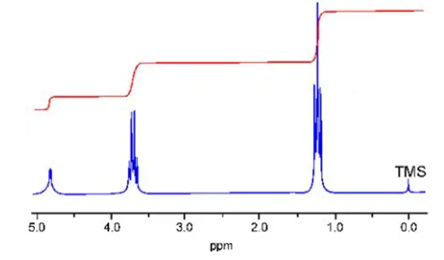
Question 19

The H-NMR shown could be of

A. 2-chloropropane
B. 1-chloropropane
C. ethanol
D. propan-1-ol

Question 20
A high-resolution proton-NMR is shown below.
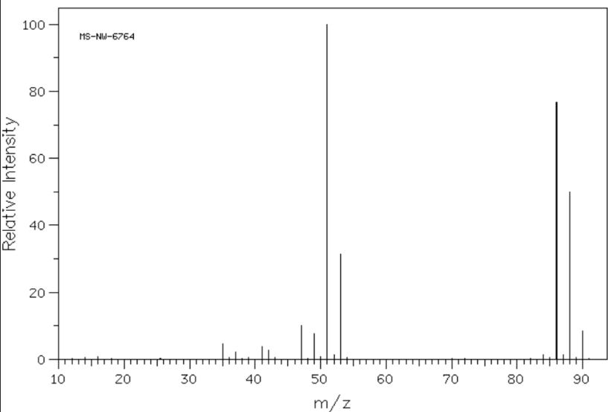

This molecule has three parent molecular ions. The pattern of three parent molecular ions with the intensities shown is characteristic of

A. a molecule with a single chlorine atom.
B. a molecule with both H and C isotopes.
C. a molecule that easily loses hydrogen atoms.
D. a molecule with two chlorine atoms.

Question 21
An unlabelled compound is heated with acidified KMnO₄. The purple colour of the permanganate is unchanged. Which structure could be that of the unlabelled compound?
A. B.

C. D.

Question 22
The three molecules shown are all present in guava leaves.
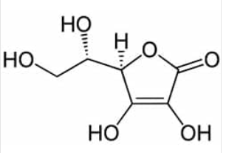
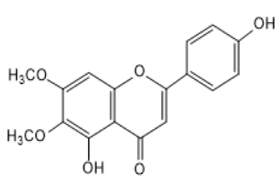
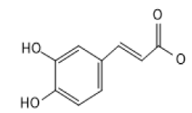

Refer to the mass

Select the correct statement about the solvent extraction of the three compounds.

A. A non-polar solvent should be used due to the low polarity of the compounds.
B. A blend of hexane and ethanol should be used to capture both polar and non-polar.
C. Ethanol could be used to extract all three compounds..
D. All three compounds will have the same degree of solubility in a polar solvent.

Question 23
The molecule shown is tested in both proton-NMR and carbon-NMR.

It will have
 | Hydrogen environments | Carbon environments
A. | 2 | 2
B. | 3 | 3
C. | 3 | 4
D. | 3 | 5

Use the following information to answer Questions 24 and 25
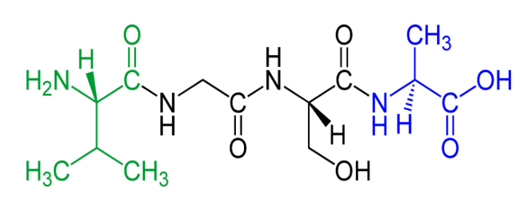

Question 24
The circled functional groups on this molecule are, from left to right,

A. amine, amine and carboxyl
B. amino, amide and carbonyl
C. amide, amino and carboxyl
D. amino, amide and carboxyl

Question 25
The amino acids in this polypeptide are, in alphabetical order,

A. alanine, glycine and leucine
B. alanine, glycine, leucine and serine
C. alanine, glycine, serine and valine
D. alanine, glycine threonine and valine

Question 26
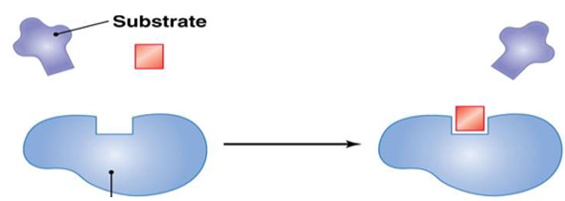

The diagram below can be used to explain

A. the lock and key mechanism of an enzyme.
B. the way in which different enantiomers might interact with an active site.
C. the action of a competitive enzyme inhibitor.
D. the dependence of an enzyme upon temperature.

Question 27
Select the correct statement about chiral centres.

A. A molecule will have no chiral centres or one chiral centre.
B. A compound can have multiple chiral centres and multiple enantiomers.
C. Chiral centres only occur in biochemical compounds.
D. If a molecule has more than one chiral centre it will still have only two enantiomers.

Question 28
A student is investigating the relationship between reaction time and pH for the action of the enzyme catalase on hydrogen peroxide, H₂O₂.
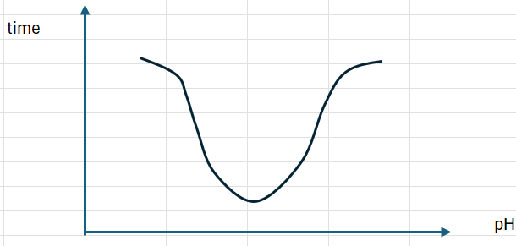
Which graph represents the likely data collected by the student?
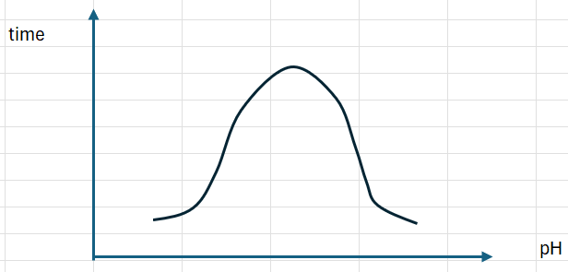
B.
A.

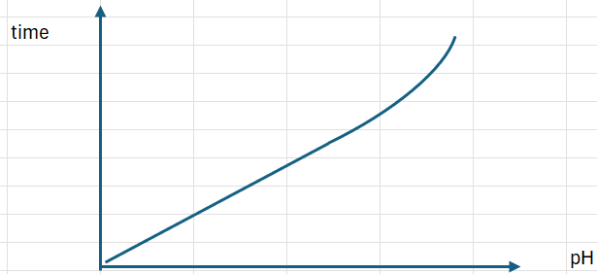
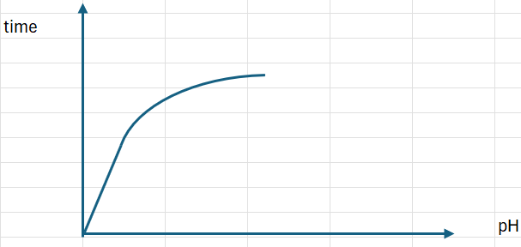
C.
D.

Question 29
The manufacture of ammonia is a reversible reaction with the equation:

N₂(g) + 3H₂(g) ⇌ 2NH₃(g)

The reaction is also an exothermic one. A manufacturer installs heat exchange units. They transfer the heat released in the reactor to the pipes used to transfer nitrogen and hydrogen gases into the reactor. This installation is an example of the green chemistry principle of

A. design for energy efficiency.
B. prevention of waste.
C. catalysis.
D. design for degradation.

Question 30
The chemistry study design lists a set of important scientific investigations methodologies, one of which is simulations. Which alternative best summarises simulations?

A. The effect on a system of heating.
B. Controlling an experiment by making systematic changes to the independent variable.
C. The testing of a method using completely different equipment in a different location.
D. The process of using a model to study the behaviour of a real or theoretical system.

Section A 30 marks ____

Total Section B 97 marks ____

Total exam 127 marks ____

SECTION B - Short-answer questions
Instructions for Section B
Questions must be answered in the spaces provided in this book.
To obtain full marks for your responses you should
- give simplified answers with an appropriate number of significant figures to all numerical questions; unsimplified answers will not be given full marks.
- show all workings in your answers to numerical questions. No credit will be given for an incorrect answer unless it is accompanied by details of the working.
- make sure chemical equations are balanced and that the formulas for individual substances include an indication of state; for example, H₂(g); NaCl(s)

Question 1 (17 marks)
Fuels can be produced through the action of microorganisms on biomass.

a. Wheat industry waste that is high in starch can be used to produce bioethanol. Elevated levels
of amylase and maltase are used to increase the rate of the reactions occurring in the first
stages of this process.

i. Refer to this process to explain the lock and key mechanism of enzymes. 3 marks

________________________________________________________________________

________________________________________________________________________

_______________________________________________________________________

ii. The above reactions are slow but high temperatures cannot be used to increase the reaction
rate. Explain why. 1 mark

________________________________________________________________________

iii. Write a balanced equation for the formation of bioethanol in this process. 1 mark

________________________________________________________________________

iv. Determine the atom economy of this reaction. 2 marks

________________________________________________________________________

________________________________________________________________________

b. Waste fish and chip oil can be used to produce biodiesel. The oil is heated with bioethanol and
concentrated KOH to produce biodiesel.

i. Determine the mass of bioethanol required to react exactly with 240 mole of plant oil.
2 marks
________________________________________________________________________

________________________________________________________________________

________________________________________________________________________

ii. Does the above reaction produce a pure product or a range of products? Discuss. 2 marks

________________________________________________________________________

________________________________________________________________________

________________________________________________________________________

iii. One of the biodiesel molecules can be hydrolysed to form oleic acid. Draw this biodiesel
molecule. 2 marks

c. i. Biogas can also be formed from biomass. Explain why some biomass is used to form biogas,
while other sources of biomass are used to make bioethanol. 2 marks

________________________________________________________________________

________________________________________________________________________

________________________________________________________________________

ii, Write a thermochemical equation for the complete combustion of the main component of
biogas. 2 marks

________________________________________________________________________

________________________________________________________________________

Question 2 (12 marks)
The cell shown below is a direct methanol fuel cell. As the name suggests, the fuel in the cell is methanol. The cell operates under acidic conditions.
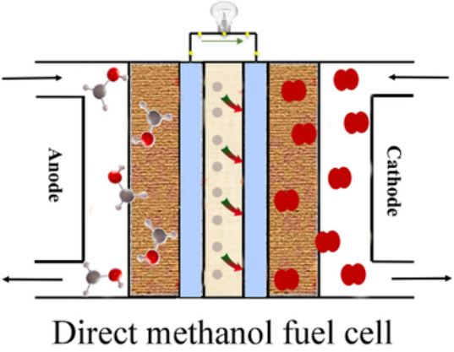

a. i. Use the boxes provided to name the reactant at each electrode. 2 marks

ii. Use the template below to write the half-equations and overall equation for the reaction
occurring: 3 marks

anode: ____________________________________________________________

cathode: ____________________________________________________________

overall: ____________________________________________________________

iii. Identify the ions that flow through the electrolyte and the direction they flow. 1 mark

_________________________________________________________________________

b. This methanol cell is often used to replace equivalent hydrogen fuel cells as it is considered to
be a safer cell to use. Discuss why. 2 marks

__________________________________________________________________________

__________________________________________________________________________

___________________________________________________________________________

c. i. Use the grid provided to draw an energy profile diagram for the complete combustion of
methanol. Include an appropriate scale for the vertical axis.
(Note: The exact activation energy for the reaction is not known) 2 marks



ii. A 2.34 g sample of methanol is burnt under a steel container holding 440 g of water. The
energy transfer to the water is 65 % efficient. Determine the change in temperature of the
water. 2 marks

________________________________________________________________________

________________________________________________________________________

________________________________________________________________________

Question 3 (12 marks)
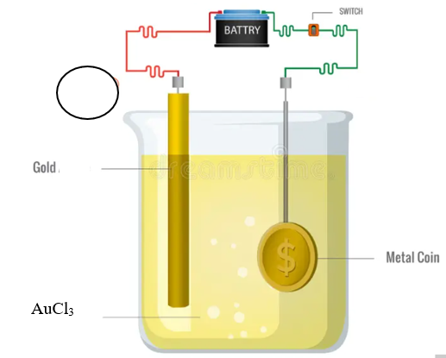
The diagram below is a representation of the cell used for electroplating of gold. The solution used is gold(III) chloride, AuCl₃(aq).

AuCl₃

a. i. Use the circle provided on the diagram to identify the polarity of the gold electrode. 1 mark

ii. Use the headings below to write half-equations and an overall equation for the process.

anode: _________________________________________ 3 marks

cathode: _________________________________________

overall equation: ___________________________________

b. The mass of gold applied to each coin is 2.80 mg.
Determine the current required to plate 1000 coins in a day. 3 marks

_______________________________________________________________________

_______________________________________________________________________

_______________________________________________________________________

c. The graph below has been obtained the gold cell above. It can be used to discuss Faraday’s
Laws for electrolysis.

___________

________

i. Label both axes on the graph above. 2 marks

ii. State Faraday’s first law and how this graph illustrates it. 2 marks

_______________________________________________________________________

_______________________________________________________________________

iii. Draw on the graph above the equivalent line that would be formed from 2 marks
- silver solutions and
- copper solutions
Question 4 (8 marks)
The flowchart below shows the skeletal structure of a molecule that can be formed from at least three different pathways.

A B

H₂O(l)/H₃PO₄(aq)

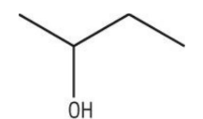
KOH(aq)

C D
Cr₂O₇²⁻//H⁺(aq)

E

a. i. Draw and name compounds A and B.
(Use the boxes provided. The order you choose does not matter) 2 marks

ii. Write a balanced equation for the reaction of compound A to form compound D. 1 mark
(states not required)

______________________________________________________________________

b. i. Draw the structure of molecule E in the box provided. 1 mark

ii. Write a balanced half-equation for its formation from molecule D. 1 mark

_______________________________________________________________________

iii. State how will you know this reaction is proceeding. 1 mark

________________________________________________________________________

iv. When this reaction stops it is likely that there are still traces of compound D in the product
mixture. Explain how a pure sample of molecule can be obtained. 2 marks
_______________________________________________________________________

________________________________________________________________________

_________________________________________________________________________
Question 5 (10 marks)
A molecule of an organic compound is known to contain carbon, hydrogen and oxygen. All spectra in this question refer to this compound, which is referred to compound M.

a. The infrared spectrum of the compound is shown below.
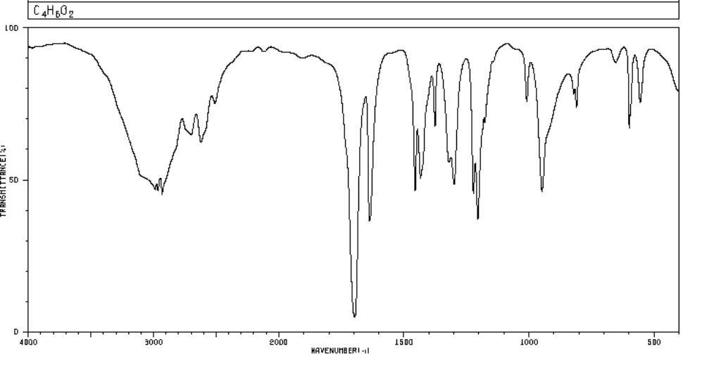
i. State two conclusions you can draw from this spectrum. 2 marks

Conclusion 1: _________________________________________

reason: _________________________________________

Conclusion 2: ________________________________________

reason: ______________________________________________

b. The mass spectrum of compound M is shown below.
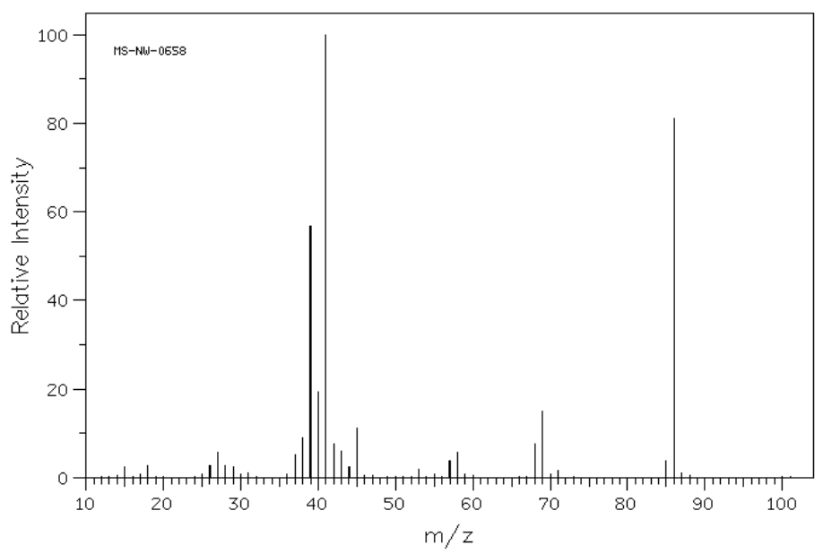
i. Use the mass spectrum to provide a likely molecular formula for compound M.
Justify your answer. 2 marks

_______________________________________________________________________

_______________________________________________________________________

ii. Suggest a fragment that could produce the base peak on this spectrum.
this peak. 1 mark

_______________________________________________________________________

c. The C-NMR for this compound is shown below.
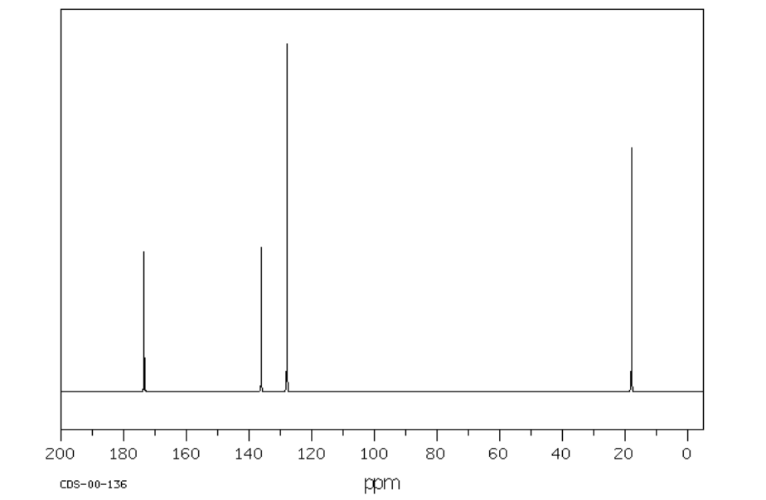

Suggest a functional group that might produce the peak with shift: 2 marks

173 ppm _________________________________

138 ppm _________________________________

d. The high resolution proton-NMR is shown below.
(Note: the peak at shift 5.8 is actually two separate peaks almost overlapping. VCE texts are
likely to show the 2 H environments as equivalent but there is a slight difference between them)
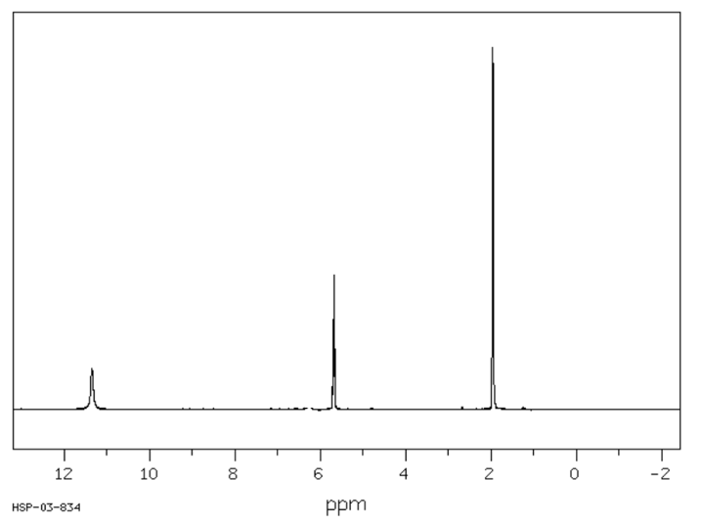

Draw a structure for Compound M that is consistent with the spectral information
provided. Justify your structure. 3 marks

________________________________________________________________

________________________________________________________________

________________________________________________________________

Question 6 (12 marks)
a. A tripeptide is drawn below.

i. Identify the amino acids present. 1 mark

______________________________________________________________________

ii. Draw a zwitterion of the amino acid that is the least soluble in water. 1 mark

iii. How many different tripeptides could you form from these three amino acids?
(Each tripeptide must contain the three different amino acids) 1 mark

______________________________________________________________________

iv. Refer to this tripeptide to explain how proteins can form a secondary structure. 2 marks

______________________________________________________________________

______________________________________________________________________

______________________________________________________________________

b. Enzymes are biochemical catalysts. Chemists also use inorganic catalysts.

Compare the action of inorganic catalysts and enzymes. In your response,
- list two similarities between the two categories
- list two differences between the two categories. 4 marks

______________________________________________________________________

______________________________________________________________________

______________________________________________________________________

______________________________________________________________________

______________________________________________________________________

Question 7 (11 marks)
a. The diagram below shows two enantiomers of a common pharmaceutical.

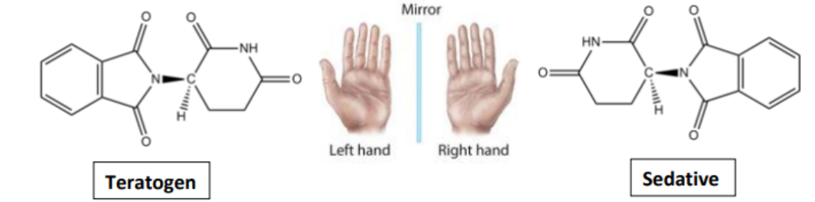
i. Use an asterisk to identify the chiral carbon in the teratogen. 1 mark

ii. Can a melting point determination be used to distinguish these enantiomers?
Justify your answer. 2 marks

_____________________________________________________________________

_____________________________________________________________________

iii. A researcher trials a solvent that is thought to be ‘chiral sensitive’. HPLC A below is
produced using ethanol as a solvent, while HPLC B uses the new solvent. The left hand
peak with a retention time of around 4 minutes is the solvent passing through.

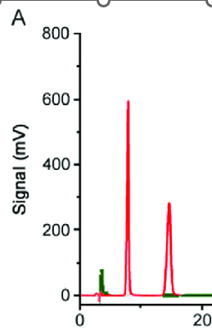
HPLC A HPLC B
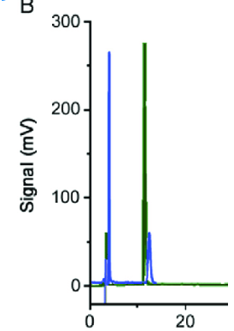

State the conclusion you can draw from the two chromatograms.
Justify your answer. 2 marks

___________________________________________________________________

___________________________________________________________________

____________________________________________________________________

b. The concentration of hydrogen peroxide (H₂O₂) solutions can be determined by titration
against a standardised and acidified potassium permangante solution. A student analysing a
commercial sample of hydrogen peroxide records the following data.

Commercial hydrogen peroxide purchased from chemist: 300mL
Solution was diluted to 1.00 L using a volumetric flask.
20.00 mL aliquots added to conical flasks.

KMnO₄ concentration: 0.150 M, added to the burette.
Mean titre 2.40 mL

i. Write a balanced equation for the titration reaction.
You may find it helpful to write the two relevant half-equations first. 2 marks

______________________________________________________________________

______________________________________________________________________

______________________________________________________________________

ii. Use the data provided to determine the concentrated of the commercial sample. 3 marks

______________________________________________________________________

______________________________________________________________________

______________________________________________________________________

______________________________________________________________________

iii. Suggest a change to the proceudure thart should be made to improve the accuracy of the
result. 1 mark

______________________________________________________________________

______________________________________________________________________

Question 8 (9 marks)
A researcher is investigating the rate of hydrolysis of starch by diastase enzyme. She obtains diastase by soaking barley seeds in water.
Brown iodine solution can be used to detect starch. When starch and iodine mix, the starch turns blue. When diastase is added to a starch, iodine mixture, the blue colour will disappear as the starch is hydrolysed. The experimental design is shown below.
Prepared agar and starch plates. The agar has been soaked in both starch and iodine solutions. Iodine solution turns blue in the presence of starch.
The blue colour in the middle of the agar disappears as the starch there has been hydrolysed.
A germinating barley seed is placed on the agar. It contains diastase enzyme which hydrolyses the starch

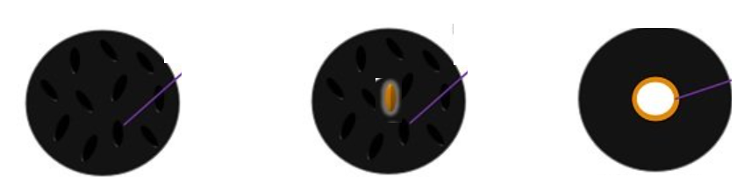

a. The researcher presents the results of her first investigation as a scientific poster. The diagram
below summarises her procedure and observations.
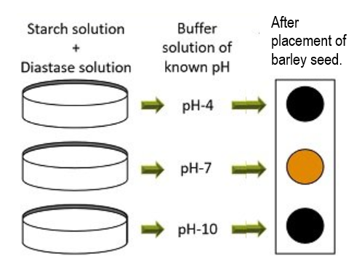

i. Suggest a relevant hypothesis for this investigation. 1 mark

________________________________________________________________________

ii. What conclusion can you draw from this data? 1 mark

________________________________________________________________________

iii. Use the axes provided to plot a typical graph of this type of investigation. For your graph:
- use the independent variable from the above investigation on the horizontal axis.
- select a quantity that could be measured for the vertical axis. 3 marks
(Your graph will ‘show a trend’ not plot exact points)



b. The diagram below shows the researcher’s summary of a second, related investigation.
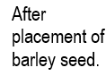
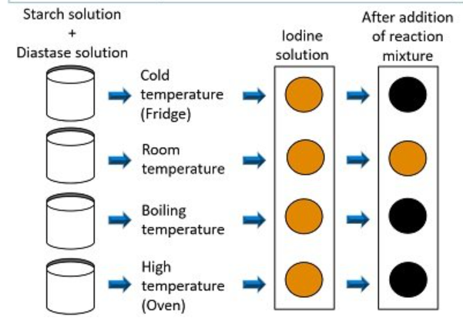

i. Suggest a hypothesis that is applicable to this investigation. 1 mark

____________________________________________________________________

ii. State the conclusions you can draw from this diagram and explain the reasons for the
observations that are evident. 3 marks

____________________________________________________________________

____________________________________________________________________

____________________________________________________________________

____________________________________________________________________

Question 9 (6 marks)
The key step in the production of sulfuric acid is the conversion of SO₂ gas into SO₃ gas. The equation for this reaction is
2SO₂(g) + O₂(g) ⇌ 2SO₃(g) ΔH = -197 kJ

a. A manufacturer of sulfuric acid investigates the impact of pressure on this step of the Contact
Process, running the plant at a range of pressures from 50 to 5000 kPa. Temperature is held
constant.

Use and label the axes provided to show the trend the researcher is likely to find in each of the
following: 3 marks

Graph A: Show the relationship between pressure and yield for a particular mixture.

Graph B: Show the relationship between pressure and time required to reach equilibrium for a
range of mixtures.

Graph C: Show the relationship between pressure and rate of the forward reaction for the
mixtures used for Graph B.

You do not have data to plot a graph, you can only show the likely trend. The
independent variable should be on the vertical axis.

Graph A Graph B Graph C




b. The concentrations in a 1.0 L equilibrium mixture of the above gases are found to be
[SO₃] = 2.0 M [SO₂] = 1.0 M [O₂] = 1.0 M

The volume of the reactor is increased to 2.0 L. Calculate the new concentrations of each
gas the instant the volume is doubled and use these new concentrations, and the value of Q,
to mathematically explain the direction the system will need to move to re-establish
equilibrium. 3 marks

____________________________________________________________________

____________________________________________________________________

____________________________________________________________________

____________________________________________________________________

END OF EXAM

Total: Section A __ /30 Section B __/97 Total ___/ 127

