IARTV 2003
UNIT 4 CHEMISTRY
SOLUTIONS

SECTION A (20 marks)

- A
- B
- A
- D
- D
- C
- C
- A
- A
- C
- B
- C
- A
- A
- D
- B
- D
- C
- B
- D

SECTION B

Question 1 (13 marks)
Part A
a. | Anode positive, cathode negative, electron glow from anode to cathode. |  | (*)(*)(*)
b. | (i) | 2 Cl– (l) → Cl₂ (g) + 2 e– | (*)
 | (ii) | Mg²⁺ (l) + 2 e– → Mg (l) | (*)
c. | (i) | If aqueous magnesium chloride were used the reaction above would not occur. H₂O is a stronger oxidant than Mg²⁺ ions and would be preferentially discharged. | (*)
 | (ii) | The products will react spontaneously to produce MgCl₂. | (*)
Part B
a. | Q = It = 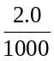 × 30 × 24 × 60 × 60 = 5184 C |  |  |  |  | (*)
 | n(e–) = = 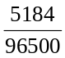 = 0.054 mol |  |  |  |  | (*)
 | n(Zn) = ½ × n(e–) = 0.027 mol  m(Zn) = n × M = 0.0269 × 65.4 = 1.8 g |  |  |  |  | (*)
b. | (i) | Anode: | O₂, H⁺ | Cathode: | Ag | (*)
 | (ii) | Anode: | I₂ | Cathode: | H₂, OH– | (*)
 | (iii) | Anode: | Br₂ | Cathode: | Cu | (*)
c. | (i) | If aqueous magnesium chloride were used the reaction above would not occur. H₂O is a stronger oxidant than Mg²⁺ ions and would be preferentially discharged. |  |  |  | (*)
 | (ii) | The products will react spontaneously to produce MgCl₂. |  |  |  | (*)

Question 2 (7 marks)
a. | Stage I nuclear to thermal  Stage II thermal to kinetic  Stage III kinetic to mechanical | (*)(*)(*)
b. | Any two of:  Large accessible reserves of coal are available  Coal is comparatively inexpensive.  Does not require handling of radioactive substances. | (*)(*)
c. | Any two of:  Produces large quantities of greenhouse gases  Environment damage caused by mining process  Thermal pollutant  Produces pollutants that cause acid rain and particulate matter | (*)(*)

Question 3 (8 marks)
a. | CF = 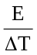 = 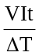 = 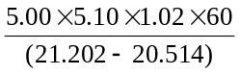 = 2.27 × 10³ J °C^{–1} | (*)(*)
b. | E = CF × ΔT = 2.27 × 10³ × (20.514 – 17.234)  = 7.44 × 10³ J = 7.44 kJ | (*)
c. | Energy content = 7.44/0.298 = 25.0 kJ/g | (*)
d. | Any of: lacks minerals, vitamins, carbohydrates, fibre essential amino acids, essential fatty acids. | (*)
e. | 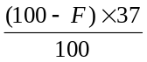+ 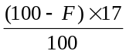 = 24.9 | (*)(*)
 | 1700 – 17F + 37 F = 2490  20F = 2500 – 1700  F = 40% so ‘Protofat’ has 40% fat content | (*)

Question 4 (8 marks)
a. | Any NHCO linkage | (*)
b. | Peptide or amid linkage | (*)
c. | Any hydrogen atom attached to an N or O atom | (*)
d. | 3 | (*)
e. | enzyme | (*)
f. | urea, carbon dioxide and water. | (*)
g. | 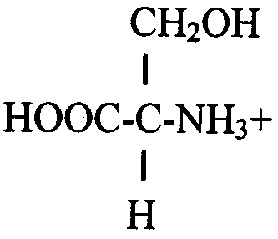 | (*)(*)

Question 5 (5 marks)
a. | C₆H₁₂O₆ | (*)
b. | 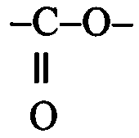 | (*)
c. | NH₄⁺, NO₂–, NO₃– | (*)
d. | C, O, H | (*)
e. | structural formula of glycerol | (*)

Question 6 (9 marks)
a. | One mark per point. Transition metals have stronger bonds between cations because the atoms are smaller in size than group 1 metals. This is due to a greater nuclear core charge in transition metals. This draws the valence electrons inwards. |  | (*)(*)
b. | (i) | +2 | (*)
 | (ii) | 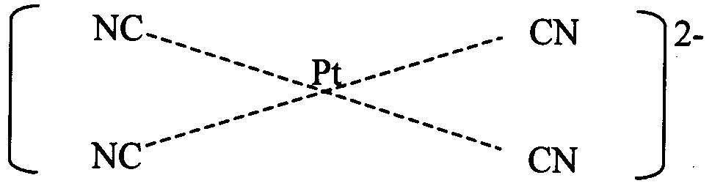 | (*)  (*)
c. | (i) | 1s²2s²2p⁶3s²3p⁶3d⁵4s² | (*)
 | (ii) | 1s²2s²2p³3s¹ or other excited state. | (*)
 | (iii) | +7 | (*)
 | (iv) | Electrons in the 3d and 4s subshells have similar energies. Electrons in both subshells can be lost to form ions with different oxidation states. | (*)

Question 7 (4 marks)
a. | Atomic size decreases.  Ionisation energy increases.  Electronegativity increases.  Metallic character decreases.  First ionisation energy increases.  Oxidising strength increases.  Explanation – increasing core charge attracts electrons more strongly. |  | (*)(*)
b. | (i) | Na₂O (s) + 2 HNO₃ (aq) → 2 NaNO₃ (aq) + H₂O (l) | (*)
 | (ii) | 2 Al₂O₃ (s) + 6 HNO₃ (aq) → 2 Al(NO₃)₃ (aq) + 3 H₂O (l) | (*)

Question 8 (3 marks)
a. | Hydrogen undergoes nuclear fusion to form helium atoms and is consumed. | (*)
b. | Light observed from telescopes is passed through a prism and the absorption spectra analysed. | (*)
c. | Our Sun is too small a star to reach the temperatures required to produce the range of elements found on Earth. | (*)

