IARTV 2003
Unit 4 Chemistry

SECTION A – Multiple-choice questions

Question 1
In a galvanic cell, oxidation occurs at the
- anode which is the negative electrode
- anode which is the positive electrode
- cathode which is the negative electrode
- cathode which is the positive electrode

Question 2
The correct order of weakest to strongest oxidant is
- Sn²⁺, Fe²⁺, Br₂, Cr₂O₇–
- Fe²⁺, Sn²⁺, Br₂, Cr₂O₇–
- Cr₂O₇–, Sn²⁺, Fe²⁺, Br₂
- Cr₂O₇–, Br₂, Sn²⁺, Fe²⁺

Question 3
The salt bridge of a galvanic cell balances the charges in the half cells by supplying
- cations to the cathode and anions to the anode
- anions to the cathode and cations to the anode
- electrons to the cathode and receiving electrons from the anode
- electrons to the anode and receiving electrons from the cathode

Question 4
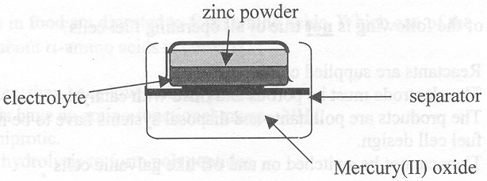
The diagram above shows the basic structure of a mercury-zinc button cell. The cell can be classified as an alkaline cell. The reaction occurring at the cathode could be written as
- Zn (s) + 2 OH– (aq) → ZnO (s) + H₂O (l) + 2 e–
- ZnO (s) + H₂O (l) + 2 e– → Zn (s) + 2 OH– (aq)
- Hg (l) + 2 OH– (aq) → HgO (s) + H₂O (l) + 2 e–
- HgO (s) + H₂O (l) + 2 e– → Hg (l) + 2 OH– (aq)

Question 5
During the discharge of a lead-acid battery, the following occurs
Pb (s) + PbO₂ (s) + 2 H₂SO₄ (aq) → 2 PbSO₄ (s) + 2 H₂O (l)
The oxidant and the electrolyte are respectively
- lead(II) sulfate and water
- lead and sulfuric acid
- leav(IV) oxide and water
- lead(IV) oxide and sulfuric acid

Question 6
A metal object to be electroplated is connected to the negative terminal of the power supply and suspended in an electrolyte containing copper(II) ions, silver(I) ions, gold(I) ions and magnesium(II) ions. The other inert electrode is connected to the positive terminal. The metal that initially deposits is
- copper
- silver
- gold
- magnesium

Question 7
Which of the following is not true of all operating fuel cells?
- Reactants are supplied continuously.
- The electrode must be porous and lined with catalysts.
- The products are pollutants and disposal systems have to be incorporated into the fuel cell design.
- They cannot be switched on and off like galvanic cells.

Question 8
As opposed to the galvanic cell, the electrolytic cell involves a
- non-spontaneous reaction and energy is required.
- spontaneous reaction and energy is required.
- non-spontaneous reaction and energy is released.
- spontaneous reaction and energy is released.

Question 9
Hydrogen bonding is not a significant factor in
- determining the primary structure of a protein molecule
- accounting for the high solubility of glucose in water
- determining the α-helical shape of a protein molecule
- determining the specificity of enzymes

Question 10
When the disaccharide sucrose reacts to form glucose and fructose, it undergoes a
- condensation reaction involving the breakage of an ester linkage
- hydrolysis reaction involving the formation of an ether linkage
- hydrolysis reaction with all products having a formula of C₆H₁₂O₆
- reaction involving the formation of an ether linkage

Question 11
Amylase acts as an enzyme in the hydrolysis of the carbohydrate starch by
- decreasing the enthalpy of the reaction
- decreasing the activation energy of the reaction
- increasing the activation energy of the reaction
- causing a different type of biochemical reaction

Question 12
The protein molecules in food are digested to form amino acids. Which one of the following statements about α-amino acids is correct?
- Being molecules, they have low melting points.
- All amino acids have an amino functional group, –NH₃.
- They are amphiprotic.
- They undergo hydrolysis to form polypeptides.

Question 13
When a glycine solution of pH 6.0 is placed in an electrochemical cell the glycine molecules do not migrate to either electrode. At this pH glycine mostly exists as
- NH₃⁺–CH₂COO–
- NH₂–CH₂–COOH
- NH₃⁺–CH₂COOH
- equal amounts of NH₂–CH₂COO– and NH₃⁺–CH₂–COOH

Question 14
Acid rain is partly due to the presence of SO₂ in the atmosphere. One source of SO₂ is the gases produced during combustion of fossil fuels. Fossil fuels are formed from the decomposition of plants. The molecules in the original plants that produced the SO₂ are
- proteins
- carbohydrates
- unsaturated fats
- saturated fats

Question 15
One step in the radioactive decay of sodium is
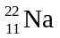 → 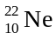 + X
Particles X is
- a proton
- a neutron
- an electron
- a positron

Question 16
In our Sun,
- nuclear fission occurs, with the absorption of energy
- nuclear fusion occurs, with the release of energy
- nuclear fusion occurs, with the absorption of energy
- nuclear fission occurs, with the release of energy

Question 17
When our Sun first formed, it’s core became extremely hot because
- hydrogen combustion occurred there
- electrons were stripped off hydrogen atoms
- the hydrogen gas expanded
- as gas particles were pulled into the core their kinetic energy increased

Question 18
In the original version of the Periodic Table devised by the Russian Dmitri Mendeleev, elements were arranged in order of increasing
- atomic number with elements of similar properties placed in vertical groups
- atomic number with elements of similar properties placed in horizontal periods
- atomic mass with elements of similar properties placed in vertical groups
- atomic mass with elements of similar properties placed in horizontal periods

Question 19
The element with electronic configuration 1s²2s²2p⁶3s²3p⁶3d¹4s² in the Periodic Table is
- in Group 2, Period 3, p block
- in Group 3, Period 4, d block
- in Group 2, Period 4, s block
- in Group 4, Period 3, s block

Question 20
For the first five elements of the first-row transition metals, the maximum oxidation number occurs when all 4s and 3d electrons are lost. The maximum oxidation number of chromium is
- +3
- +4
- +5
- +6

SECTION B – Short-answer questions

Question 1 (15 minutes, 13 marks)

Part A

In a commercial process called the Dow process, molten magnesium chloride is electrolysed and molten magnesium metal is produced.

- On the following schematic diagram, label the boxes
- anode and cathode
- the polarity of the electrodes
- the direction of electron flow
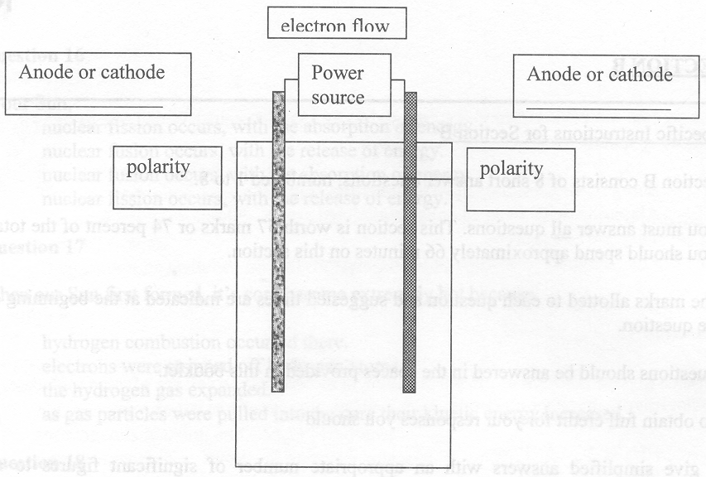
3 marks
- Write the equation for the reaction that occurs at
(i) the anode ______________________________________________________________________________
(ii) the cathode ______________________________________________________________________________
2 marks
- Explain why
(i) molten and not aqueous magnesium chloride is used.
____________________________________________________________________________________________
____________________________________________________________________________________________
____________________________________________________________________________________________
(ii) the products must be kept separate.
____________________________________________________________________________________________
____________________________________________________________________________________________
____________________________________________________________________________________________
2 marks

Part B

- Thomas Edison needed to find how much electricity his customers had used. One of his first solutions to this problem was to take a small fraction of that current and use it to electrolyse a zinc salt solution and then to weight the mass of zinc deposited. The cell was called a zinc ‘coulometer’. Calculate the mass of zinc that would be deposited in the month of November (30 days) if 2.0 mA of current passed through the coulometer.
________________________________________________________________________________________________
________________________________________________________________________________________________
________________________________________________________________________________________________
3 marks
- A student electrolyses the following solutions using inert graphite electrodes. Predict the products likely to form at each electrode and write the formulae in the space provided.
(i) 1 M silver nitrate Anode: _______________________ Cathode: _______________________
(ii) 1 M sodium iodide Anode: _______________________ Cathode: _______________________
(iii) 1 M copper(II) bromide Anode: _______________________ Cathode: _______________________
3 marks

Question 2 (8 minutes, 7 marks)
- A flowchart of a nuclear power station is shown below. Below the flowchart describe the energy transformations that have occurred at stages I, II and III.
Nuclear reaction | → | Steam generated | → | Steam moves | → | Turbine rotated | → | Electricity generated
 | I |  | II |  | III
Stage I _______________________ to _______________________
Stage II _______________________ to _______________________
Stage III _______________________ to _______________________
3 marks

In Australia, most electricity is produced in Coal-fired power stations.

- List two advantages of coal-fired power stations compared to Nuclear power stations.
________________________________________________________________________________________________
________________________________________________________________________________________________
2 marks
- List two disadvantages of coal-fired power stations compared to Nuclear power stations.
________________________________________________________________________________________________
________________________________________________________________________________________________
2 marks

Question 3 (8 minutes, 8 marks)
A health food company investigates a new product, ‘Protofat’. This product was hoped to act as a synthetic food in third world countries. ‘Protofat’ is a combination of fat and protein exclusively. The energy content of this new product was determined by means of bomb calorimetry. A 0.298 g sample of ‘Protofat’ was placed in a bomb calorimeter and then allowed to react with excess oxygen gas. The results of the experiment were recorded.
Initial temperature of the bomb calorimeter and sample | = 17.234°C
Temperature after complete combustion of the sample | = 20.514°C
Temperature after a 5.10 A current at 5.00 V was passed through the heating coil for 1.02 minutes | = 21.202°C

- Calculate the calibration factor for the calorimeter.
________________________________________________________________________________________________
________________________________________________________________________________________________
2 marks
- Calculate the heat energy released by the sample.
________________________________________________________________________________________________
________________________________________________________________________________________________
1 mark
- What is the energy content of ‘Protofat’ in kJ/g?
________________________________________________________________________________________________
________________________________________________________________________________________________
1 mark
- What is the dietary problem with using ‘Protofat’ as the only food source in a person’s diet?
________________________________________________________________________________________________
________________________________________________________________________________________________
1 mark
- Given that protein has an energy content of 17 kJ/g and fat has an energy content of 37 kJ/g, calculate the percentage of fat in the ‘Protofat’ sample.
________________________________________________________________________________________________
________________________________________________________________________________________________
________________________________________________________________________________________________
________________________________________________________________________________________________
3 marks

Question 4 (8 minutes, 8 marks)
The structural formula below is a segment of a molecule with a relative molecular mass of 23 000. The molecule was isolated from E. coli bacteria.
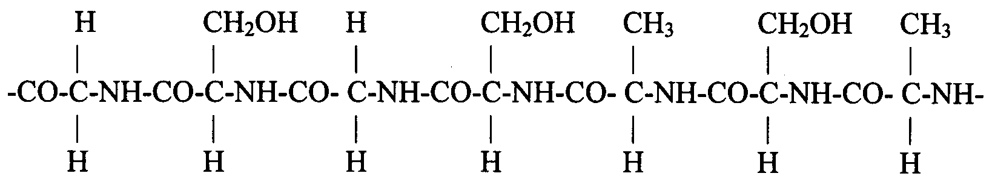

- On the diagram circle one linkage which connects the monomer units together.
1 mark
- Write the name of this linkage. ____________________________________________________________________
1 mark
- On the structural formula, circle on hydrogen atom that is capable of forming bonds associated with the secondary structure of the protein.
1 mark
- How many different amino acids are present in this section of the molecule? ________________________________
1 mark
- What could be a possible biological function of this molecule?
________________________________________________________________________________________________
1 mark
- Name the molecules that are formed as the waste products in the complete digestion of this polypeptide molecule.
________________________________________________________________________________________________
1 mark
- The second amino acid in the polypeptide chain is serine residue. In the space below draw a structural formula of serine in a pH 3 solution.

2 marks

Question 5 (5 minutes, 5 marks)
- Write the molecular formula for the reductant that is consumed in cellular respiration.
________________________________________________________________________________________________
1 mark
- Draw the structure of the bond linking fatty acids to glycerol.

________________________________________________________________________________________________
1 mark
- Give the formula of two products of N-fixing bacteria.
________________________________________________________________________________________________
1 mark
- Write the symbols for the elements contained in all carbohydrates.
________________________________________________________________________________________________
1 mark
- Draw the structural formula of glycerol.

1 mark

Question 6 (12 minutes, 9 marks)
A British scientist Hymphry Davy investigated the properties of many metals. In 1812, he wrote “Potassium and platinum, if we except their lustre, colour and power of conducting electricity, are bodies extremely dissimilar.”

- Davy noticed that potassium, a group I metal, is much less dense than platinum, a transition metal. Explain this difference.
________________________________________________________________________________________________
________________________________________________________________________________________________
________________________________________________________________________________________________
2 marks
- Platinum, in a similar reaction to gold, can be dissolved by solutions containing cyanide ions, CN–, to form the complex ion tetracyanoplatinate Pt(CN)₄^{2–}.
(i) What is the oxidation number of Pt in Pt(CN)₄^{2–}? __________________________________________________
(ii) Draw a diagram showing the structure of Pt(CN)₄^{2–}.

3 marks
- Another metal studied by Davy was manganese.
(i) Write the electron configuration of manganese in the ground state.
____________________________________________________________________________________________
(ii) Write the electron configuration of oxygen with one electron in an excited state.
____________________________________________________________________________________________
(iii) One compound containing the elements manganese and oxygen is MnO₄–. What is the oxidation number of manganese in this compound?
____________________________________________________________________________________________
(iv) Why is manganese able to form compounds in which it has different oxidation states?
____________________________________________________________________________________________
____________________________________________________________________________________________
4 marks

Question 7 (5 minutes, 4 marks)
Sodium, aluminium and sulfur are three elements found in period 3.

- Name two trends in the chemical properties of elements that can be seen across period 3 and give brief explanations for these trends.
________________________________________________________________________________________________
________________________________________________________________________________________________
________________________________________________________________________________________________
________________________________________________________________________________________________
________________________________________________________________________________________________
________________________________________________________________________________________________
2 marks
- The oxides of two of these three elements would be expected to react with nitric acid solution. Write a full balanced equation to show each of these reactions.
Write a balanced ionic equation showing corundum reacting with
(i) ____________________________________________________________________________________________
____________________________________________________________________________________________
(ii) ____________________________________________________________________________________________
____________________________________________________________________________________________
2 marks

Question 8 (5 minutes, 3 marks)
Hydrogen is the most abundant element in the Universe, over 90% by mass.

- Why is the mass of hydrogen in the universe decreasing?
________________________________________________________________________________________________
________________________________________________________________________________________________
________________________________________________________________________________________________
1 mark
- How do we know the composition of elements in stars and other parts of the universe?
________________________________________________________________________________________________
________________________________________________________________________________________________
________________________________________________________________________________________________
1 mark
- Why can’t our Sun produce the range of elements found on Earth?
________________________________________________________________________________________________
________________________________________________________________________________________________
________________________________________________________________________________________________
1 mark

END OF TASK

