Lisachem 2003 | Unit 3 Chemistry | Trial Examination Solutions

Section A – Multiple choice questions

1. | D | Inspection of the polymer chain shows that it was produced from two different repeating units of monomers.  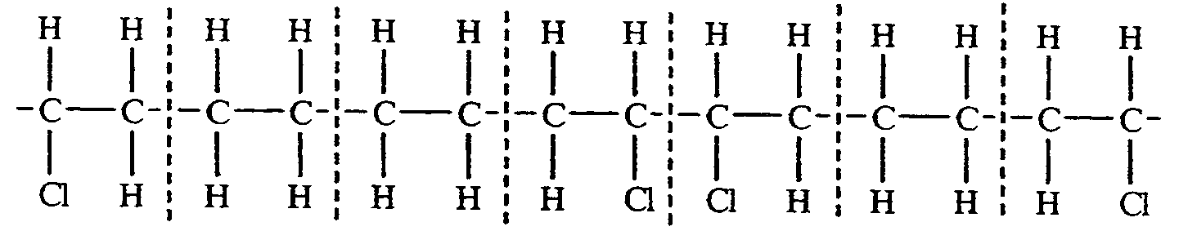  These monomers are: CH₂=CHCl – vinyl chloride; and CH₂=CH₂ – ethene
2. | B | Since the compound is 18.4%, by mass, S, then 32.1 g = 18.4% of M(compound)  32.1 = (18.4 / 100) × M(compound)  32.1 × 100 = 18.4 × M(compound)  M(compound) = 3210 /118.4  = 174.5 g mol⁻¹  - M(PbSO₄) = 207.2 + 32.1 + 4 × 16.0 = 255.3 g mol⁻¹  - M(K₂SO₄) = 2 × 39.1 + 32.1 + 4 × 16.0 = 174.3 g mol⁻¹  - M(Na₂SO₄) = 2 × 23 + 32.1 + 4 × 16.0 = 139.1 g mol⁻¹  - M{(NH₄)₂SO₄} = 2 × 14.0 + 8 × 1.0 + 32.1 + 4 × 16.0 = 132 g mol⁻¹
3. | D | HCl (aq)  H⁺ + Cl⁻ (aq)  [H⁺] = [HCl] = 10 M  Since [H₃O⁺][OH⁻] = 10⁻¹⁴ at 25°C  [OH⁻] = 10⁻¹⁴ / [H₃O⁺]  = 10⁻¹⁴ / 10  = 10⁻¹⁵  Ratio [H⁺] / [OH⁻] = 10 / 10⁻¹⁵  = 10^{1 – (-15)}  = 10¹⁶
4. | C | Oxygen is normally transported around the body via equilibrium (I) Hb₄ + 4 O₂  Hb₄(O₂)₄.  However when CO is present in the air we breathe equilibrium (II) Hb₄ + 4 CO  Hb₄(CO)₄ is established.  Because equilibrium (II) has a higher equilibrium constant, associated with the greater affinity of CO, compared to O₂, for haemoglobin the position of equilibrium (I) is pushed left to free up Hb for reaction with CO. Consequently the amount of oxygen carried to the cells is greatly reduced and carbon monoxide poisoning occurs.
5. | C | CH₃OH (g) + ½ O₂ (g)  CH₂O (g) + H₂O (g), K₁  Given that the equilibrium law is 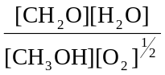 = K₁  reversing the equilibrium giving  CH₂O (g) + H₂O (g)  CH₃OH (g) + ½ O₂ (g), K₂ = ?  leads to the equilibrium law 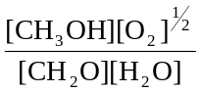 = 1/ K₁  so K₂ = 1 / K₁  Doubling the equation stoichiometry to give  2 CH₂O (g) + 2 H₂O (g)  2 CH₃OH (g) + O₂ (g), K₃ = ?  means that in the equilibrium law all the powers are doubled giving  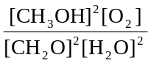 = 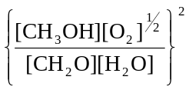  = K₂²  = (1 / K₁)²  = 1 / K₁²
6. | A | To get an increase in the ratio m(SO₃)/m(SO₂) it is necessary to impose a change that will push the position of equilibrium for  2 SO₂ (g) + O₂ (g)  2 SO₃ (g); ΔH = -197.8 kJ mol⁻¹  to the right to produce more SO₃.  An increase in pressure will cause the system to compensate by the position of equilibrium moving to the side with fewer particles, ie produce more SO₃ and use up some SO₂, thus increasing the ratio m(SO₃)/m(SO₂)  Since the forward reaction is exothermic (ΔH < 0) an increase in temperature will favour the endothermic reverse reaction reducing the m(SO₃) and increasing the m(SO₂) thus decreasing the ratio m(SO₃) / m(SO₂)
7. | C | Equations for the reactions occurring are  NaOH (aq) + HNO₃ (aq)  NaNO₃ (aq) + H₂O (l)  2 NaOH (aq) + H₂SO₄ (aq)  2 Na₂SO₄ (aq) + H₂O (l)  Since n(NaOH) is the same in both reactions and  n(HNO₃) required = n(NaOH) reacting  n(H₂SO₄) required = ½ × n(NaOH) reacting  it follows that  n(H₂SO₄) required = ½ × n(HNO₃) required  c(H₂SO₄) × V(H₂SO₄) = ½ × c(HNO₃) × V(HNO₃)  c(H₂SO₄) × 7.5×10⁻³ = ½ × 1.00 × 22.5×10⁻³  c(H₂SO₄) = ½ × 1.00 × 22.5×10⁻³ / 7.5×10⁻³  = 0.150 M
8. | B | The concentration time graph shows tat in getting to equilibrium  [X] has increased from 1 M to 4 M, ie by 3 M or 3 mol in 1 L  [Y} has increased from 2 M to 3 M, ie by 1 M or 1 mol in 1 L  [Z] has decreased from 4 M to 2 M, ie by 2 M or 2 mol in 1 L  So in effect 2 mol Z has reacted to produce 3 mol X and 1 mol Y ie 2 Z  3 X + Y  this is consistent with the equilibrium 2 Z  3 X + Y being established from the reaction side, or the equilibrium 3 X + Y  2 Z being achieved from the product side.
9. | A | An oxidant is required if the oxidation number of one of the elements increases in the reaction.  - Cl(-1)⁻  Cl(+1)O⁻, Cl has been oxidised  - S(+6)O(-2)₃  S(+6)O(-2)₄²⁻, no change in oxidation number  - 2 H(+1)⁺  H(0)₂, decrease in oxidation number, requires a reductant  - Cr(+6)O(-2)₃  Cr(+6)₂O(-2)₇²⁻, no change in oxidation number
10. | D | HCl (aq) is a strong acid and donates proton readily, so in the ionisation reaction,  HCl (aq) + H₂O (l)  H₃O⁺ (aq) + Cl⁻ (aq), almost all the HCl (aq) molecules donate a proton.  CH₃COOH (aq) is a weak acid and donates protons reluctantly so in the ionisation reaction,  CH₃COOH (aq) + H₂O (l)  CH₃COO⁻ (aq) + H₃O⁺ (aq), only a small proportion of the CH₃COOH (aq) molecules donate a proton and produce H₃O⁺ (aq) ions.  Alternative D is clearly a better answer than C, because all CH₃COOH (aq) molecules are capable of donating a proton (as evidenced when CH₃COOH (aq) reacts with a strong base), but only a proportion of those present in aqueous solution do.  Alternative A may be an accurate statement but is not the cause of the lower c(H₃O⁺) in CH₃COOH (aq).
11. | B | When the volume of the equilibrium mixture was halved the pressure and concentration of each species immediately doubles. The effect of this change is represented on the concentration time diagram below.  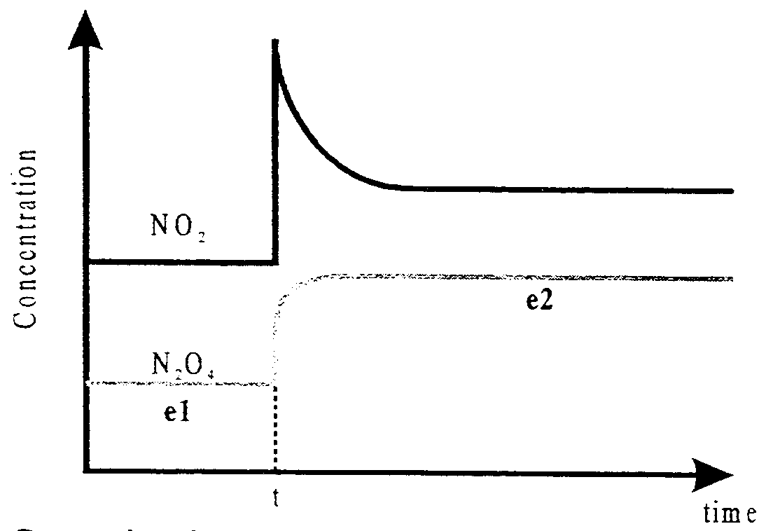  Comparing the amounts and concentrations of NO₂ and N₂O₄ present at the equilibrium positions e1 – before the volume change, and e2 – after the volume change is interesting.  The concentration-time graph shows clearly that [NO₂]_{e2} > [NO₂]_{e1}. After the change they system returns to equilibrium before the [NO₂] drops to its original value.  As the system returns to equilibrium NO₂ is converted into N₂O₄, consistent with Le Chatelier’s principle that the system will compensate for the pressure increase by moving to the side with fewer particles, so it follows that m(NO₂)_{e2} < m(NO₂)_{e1}.
12. | B | The final pressure in the connected flasks will be the sum of the pressures exerted by the N₂ and the Ne in the combined volume of 6 L.  Since the temperature and amount of each gas is constant use p₂V₂ = p₁V₁
12. | B | N₂: | p₁ = 101.3 kPa, V₁ = 1 L, V₂ = 6 L:  p₂ = p₁V₁ / V₂ = 101.3 × 1 / 6  = 16.88 kPa
 |  | Ne: | p₁ = 202.6 kPa, V₁ = 5 L, V₂ = 6 L:  p₂ = p₁V₁ / V₂ = 202.6 × 5 / 6  = 168.8 kPa
 |  | Total pressure = 16.88 + 168.8 = 185.7 kPa
13. | A | The black colour is the result of the sulfuric acid dehydrating the cellulose in the paper to carbon.
14. | D | % by mass = [m(CaCO₃) / m(sample)] × 100  n(CaCO₃) reacting = n(CO₂) produced  = m(CO₂) / M(CO₂)  = 6.60 g / 44.0 g mol⁻¹  = 0.150 mol  m(CaCO₃) present = n(CaCO₃) × M(CaCO₃)  = 0.150 × 100  = 15.0 g  % CaCO₃ = (15.0 / 20.0) × 100 = 75.0%
15. | C | Factors which influence the rate of reaction include temperature, pressure, concentration, surface area and the presence of a catalyst.  Explosions in coal mines or flour mills can occur if a spark sets off the reaction between coal dust or flour (a carbohydrate) and oxygen.  The explosive nature of the reactions is due to the rate of reaction being increased by the large surface area to volume ratio of the coal dust or flour.
16. | D | 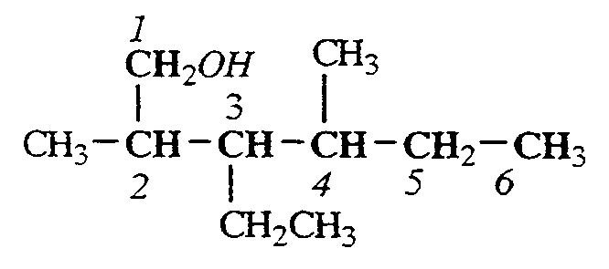  The molecule has a longest carbon chain of 6 carbons, hence derived from hexane.  The carbons are numbered so that the alcohol function group, –OH, is on the lowest possible number, hence it is a 1-hexanol.  On the third carbon there is an attached ethyl, CH₃CH₂-, group, hence 3-ethyl-1-hexanol.  On the second and fourth carbons there are methyl, CH₃-, groups, hence the compound is  2,4-dimethyl-3-ethyl-1-hexanol
17. | A | Assigning oxidation numbers, it is clear that the oxidation number of sulfur has both increased (oxidation) and decreased (reduction)  2 H(+1)₂S(+6)O(-2)₄ + 6 H(+1)₂S(-2)  S(0)₈ + 8 H(+1)₂O(-2)  The oxidation number of S has increased in the oxidation of H₂S to S₈.  The oxidation number of S has decreased in the reduction of H₂SO₄ to S₈.
18. | D | Since the mobile phase moves at a constant rate and each component X, Y and Z travels the same distance through the column, they must all spend the same time in the mobile phase. The chromatogram reflects the time attracted to the stationary phase. Z, with the highest retention time, spent the longest time in the stationary phase, whilst X, with the lowest retention time, spent the least time in the stationary phase.
19. | A | R_{F} values are determined by dividing the distance moved by each component by the distance moved by the solvent front, ie R_{F} = d_{x} / d_{s}.  So the lower the R_{F} value the stronger the attraction to the stationary phase. Hence alternative A is the incorrect statement.  Retention times reflect the time taken for each component to pass through the column. So the stronger the attraction to the stationary phase, the higher the retention time. Alternative B is a correct statement.  In effect a high retention time is caused by the same factor as a low R_{F} value, strong attraction to the stationary phase, so in effect they convey similar information. Alternative C is a correct statement.  Because the solvent is the key to separating the components of a mixture by paper or thin-layer chromatography, the distance moved by the solvent will never be less than the distance moved by a component of the mixture and R_{F} values are never greater than 1. Alternative D is a correct statement.
20. | C | The catalyst is used with the reaction 2 SO₂ (g) + O₂ (g)  2 SO₃ (g). The catalyst increases the rate of the forward reaction (oxidation of SO₂ to SO₃) and the rate of the reverse reaction (reduction of SO₃ to SO₂).
21. | C | The molar mass (and hence relative molecular mass) of the compound can be determined by manipulating the general gas equation pV = nRT.  Since n = m / M then the equation becomes pV = (m/M)RT  pVM = mRT  M = mRT / pV  m = 1.45 g; T = 179 + 273 = 452 K; p = 1.25×10² Pa = 1.25×10² kPa; V = 484 mL = 484×10⁻³ L  M = mRT / pV  = 1.45 × 8.31 × 452 / (1.25×10² × 484×10⁻³)  = 90.0 g mol⁻¹  So M_{r} = 90.0  Empirical Formula Mass (EFM) = 12.0 + 2 × 1.0 + 16.0 = 30.0  Molecular formula = (M_{r} / EFM) × Empirical Formula  = (90 / 30) × CH₂O  = 3 × CH₂O  = C₃H₆O₃

Section B – Short Answer Questions

Question 1
(a) | n(Na₂CO₃) in 250 mL = m(Na₂CO₃) / M(Na₂CO₃)  = 1.330 g / 106 g mol⁻¹  = 1.25×10⁻² mol   n(Na₂CO₃) in 20.00 mL = (1.25×10⁻² / 250) × 20  = 1.00×10⁻³ mol 
(b) | According to Na₂CO₃ (aq) + 2 HCl (aq)  2 NaCl (Aq) + CO₂ (g) + H₂O (l)  n(HCl) reacting with Na₂CO₃ = 2 × n(Na₂CO₃)  = 2 × 1.00×10⁻³  = 2.00×10⁻³ mol   c(HCl) = n(HCl) / V(HCl)  = 2.00×10⁻³ mol / 20.30×10⁻³ L  = 0.0989 M 
(c) | According to HCl (aq) + NaOH (aq)  NaCl (aq) + H₂O (l)  n(NaOH) reacting = n(HCl) reacting  = c(HCl) × V(HCl)  = 0.0989 mol L⁻¹ × 20.00×10⁻³ L  = 1.98×10⁻³ mol   c(NaOH) = n(NaOH) / V(NaOH)  = 1.98×10⁻³ mol / 29.85×10⁻³ L  = 0.0663 M 
(d) | According to CH₃COOH (aq) + NaOH (aq)  CH₃COONa (aq) + H₂O (l)  n(CH₃COOH) in 20.00 mL diluted vinegar = n(NaOH) reacting  = c(NaOH) × V(NaOH)  = 0.0663 mol L⁻¹ × 19.00×10⁻³ L  = 1.26×10⁻³ mol 
(e) | n(CH₃COOH) in 19.95 g ‘Ethac’ = n(CH₃COOH) in 250 mL of dilute vinegar  = {n(CH₃COOH) in 20 mL of dilute vinegar / 20} × 250  = {1.26×10⁻³ / 20} × 250  = 1.57×10⁻² mol 
(f) | c(CH₃COOH) = n(CH₃COOH) / V(vinegar)  = 1.57×10⁻² mol / 20.00×10⁻³ L  = 0.787 mol L⁻¹ 
(g) | m(CH₃COOH) in vinegar sample = n(CH₃COOH) × M(CH₃COOH)  = 1.57×10⁻² mol × 60.0 g mol⁻¹  = 0.944 g   % CH₃COOH = {m(CH₃COOOH) / m(vinegar)} × 100  = {0.944 / 19.95} × 100  = 4.73 % 

Question 2
(a) | n(CH₃COOH) present at equilibrium = m(CH₃COOH) /M)CH₃COOH)  = 172.8 g / 60.0 g mol⁻¹  = 2.88 mol  Therefore n(CH₃COOH) reacting before equilibrium reached = 8.64 – 2.88  = 5.76 mol   Determining the mole amounts of other species present at equilibrium
(a) |  | CH₃CH₂OH (l) | + | CH₃COOH (l) |  | CH₃COOCH₂CH₃(l) | + | H₂O (l)
(a) | Initially present | 8.64 mol |  | 8.64 mol |  | - |  | -
(a) | Reacting | 5.76 mol |  | 5.76 mol |  | 5.76 mol |  | 5.76 mol
(a) | Equilibrium | 2.88 mol |  | 2.88 mol |  | 5.76 mol |  | 5.76 mol | 
(a) | Because of the miscibility of CH₃CH₂OH, CH₃COOH and H₂O the total volume of the mixture may differ from 1 L, however this does not affect the calculation of K.  K = 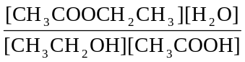  = 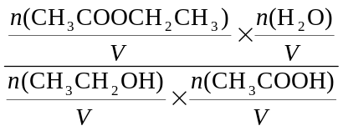  = 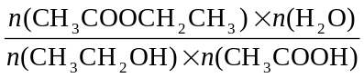  = 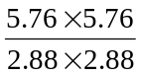 = 4.00 
(b) | Esterification 
(c) | - Ethene is converted to ethanol y reaction with steam in the presence of an acid catalyst.   CH₂=CH₂ (g) + H₂O (g) 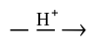 CH₃CH₂OH (l)  This is an addition reaction.   - Having obtained some ethanol, ethanoic acid is produced by reacting ethanol with acidified dichromate solution.   CH₃CH₂OH 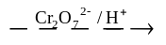 CH₃COOH  This is a redox reaction. 

Question 3
(a) | According to the calibration curve  c(Fe²⁺) in the solution analysed = 3.90 mg L⁻¹   So in 500 mL solution, m(Fe) = 3.90 / 2 = 1.95 mg  m(Fe) in 28.4 g cereal = 1.95 mg   m(Fe) in 1 g cereal = 1.95 / 28.4 mg  m(Fe) in a standard serve (45 g) = (1.95 / 28.4) × 45  = 3.09 mg 
(b) | An iron light source (iron cathode lamp) is used.   In atomic absorption spectroscopy the light source must contain wavelengths, which the element being tested for will definitely absorb but other elements will not. Hence, if testing the iron content of a sample an iron cathode would be used. This is consistent with the fact that the wavelengths of light emitted by excited Fe atoms will be exactly those which will be absorbed by Fe atoms in their ground states. 
(c) | Flame / atomiser, monochromator, detector. 

Question 4
(a) | According to the data when the pressure increases (at constant temperature) the yield of NH₃ increases. This is consistent with Le Chatelier’s principle because an increase in pressure causes an equilibrium system to compensate by moving to reduce the pressure. So the position of the equilibrium N₂ (g) + 3 H₂ (g)  2 NH₃ (g) will move to the side with fewer particles, ie increases the yield of NH₃. 
(b) | Exothermic.   According to the data, at constant pressure, the yield of NH₃ decreases as the temperature decreases (or increases as the temperature decreases) hence the production of NH₃ is exothermic. 
(c) | The yield of NH₃ will, according to equilibrium theory, be increased at high pressures and low temperatures.   However at low temperatures the rate of reaction may be too low, and the costs of maintaining high pressures have to be taken into account. 
(d) | K_{c} = [NH₃]² / {[N₂][H₂]³} 
(e) | As the temperature is increased the value of K_{c} will decrease. This is because the forward reaction is exothermic so a temperature increase will favour the endothermic reverse reaction. So the [products] decreases and [reactants] increases leading to a lower K_{c} value. 
(f) | (i) | Rate of production of NH₃ will increase. 
 | (ii) | Position of equilibrium will not change.   A catalyst will get the system to equilibrium faster but does not affect the proportion of reactants converted to products.

Question 5
(a) | CH₃COOH (aq) + H₂O (l)  CH₃COO⁻ (aq) + H₃O⁺ (aq)  K_{a} = [CH₃COO⁻]_{e}[H₃O⁺]_{e} / [CH₃COOH]_{e}  Since CH₃COOH (aq) is a weak acid we can assume  [CH₃COOH]_{e} = [CH₃COOH]_{initially}  [CH₃COO⁻]_{e} = [H₃O⁺]_{e}  So 1.76×10⁻⁵ = [H₃O⁺]² / 0.0500  [H₃O⁺]² = 1.76×10⁻⁵ × 0.0500  [H₃O⁺] = √8.80×10⁻⁷  = 9.38×10⁻⁴ M   pH = -log₁₀[H₃O⁺] = -log₁₀(9.38×10⁻⁴)  = 3.03 
(b) | (i) |  | K_{a} × K_{b} = 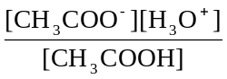 × 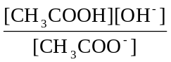   = ×  = [H₃O⁺] [OH⁻]  = K_{w} 
 | (ii) | Since K_{a} × K_{b} = K_{w}  K_{b}(CH₃COO⁻) = K_{w} / K_{a}(CH₃COOH)  = 10⁻¹⁴ / 1.76×10⁻⁵  = 5.68×10⁻¹⁰ 
 | (iii) | CH₃COONa (aq)  CH₃COO⁻ (aq) + Na⁺ (aq)  So c(CH₃COO⁻) = c(CH₃COONa) = 0.200 M  CH₃COO⁻ (aq) + H₂O (l)  CH₃COOH (aq) + OH⁻ (aq)  K_{b} = [CH₃COOH][OH⁻] / [CH₃COO⁻]  Since CH₃COO⁻ (aq) is a weak base we can assume  [CH₃COO⁻]_{e} = [CH₃COO⁻]_{initially}  [CH₃COO⁻]_{e} = [OH⁻]_{e}  So 5.68×10⁻¹⁰ = [OH⁻]² / [CH₃COO⁻]  = [OH⁻]² / 0.200  [OH⁻]² = 5.68×10⁻¹⁰ × 0.200  [OH⁻] = √1.14×10⁻¹⁰  = 1.07×10⁻⁵ M 
 | (iv) | Since [H₃O⁺] [OH⁻] = 10⁻¹⁴  [H₃O⁺] = 10⁻¹⁴ / [OH⁻] = 10⁻¹⁴ / 1.07×10⁻⁵  = 9,38×10⁻¹⁰ M  pH = -log(9.38×10⁻¹⁰)  = 9.01 

Question 6
(a) | (i) | Natural Resource A – crude oil (or natural gas) 
 | (ii) | Process X – fractional distillation 
 | (iii) | Process Y – cracking 
(b) | Mixture B is a mixture of alkanes, compounds of carbon and hydrogen, which have the general formula C_{n}H_{2n+2}. These are saturated hydrocarbons. 
(c) | (i) | ethene, CH₂=CH₂ / C₂H₄   propene, CH₃CH=CH₂ 
 | (ii) | methane, CH₄   hydrogen, H₂ 
 | (ii) | NB: Answers to c(ii) are based on the cracking equations | C₂H₆  CH₂=CH₂ + H₂  C₃H₈  CH₂=CH₂ + CH₄  C₃H₈  CH₃CH=CH₂ + H₂  C₄H₁₀  CH₃CH=CH₂ + CH₄
(d) | C₇H₁₆ (g)  CH₃CH₂CH=CH₂ (g) + C₃H₈ (g) 
(e) | Cracking is an endothermic process and so the yield of CH₃CH₂CH=CH₂ is favoured by high temperatures.   From Le Chatelier’s principle the position of the equilibrium C₇H₁₆ (g)  CH₃CH₂CH=CH₂ (g) + C₃H₈ (g) will move to the right at low pressures (system moves to compensate by increasing the total number of particles). So the yield of CH₃CH₂CH=CH₂ is favoured by low pressures.   Conditions used would probably be around 1100°C and slightly lower than atmospheric pressure.

