Lisachem
2003
UNIT 4 CHEMISTRY

SECTION A – Multiple-choice questions

Question 1
The same amount of electricity was passed through two electrolytic cells. The first cell contained an aqueous solution of copper (II) sulfate, CuSO₄ (aq). The second cell contained an aqueous solution of silver nitrate, AgNO₃ (aq). Graphite electrodes were used in both cells. In both cells a solid is deposited on one of the electrodes.
If 1.59 g of solid was deposited in the first cell, then in the second cell
- 5.40 g of Cu would be deposited
- 5.40 g of Ag would be deposited
- 3.18 g of Ag would be deposited
- 3.18 g of Cu would be deposited

Question 2
A simple calorimeter, containing 200 mL of water is calibrated electrically by the passage of a current of 2.52 A at 5.00 V through a heating coil for one and a half minutes.
During heating the temperature of the calorimeter contents rose from 20.18°C to 23.24°C.
According to this data the calibration factor of the calorimeter was
- 18.9 J °C^{–1}
- 1.13 × 10³ J °C^{–1}
- 371 J °C^{–1}
- 3.47 × 10³ J °C^{–1}

Question 3
In aqueous solutions, amino acids often exist in the form of zwitterions. On zwitterions
- the basic end is the –NH₂ and the acidic end is –COOH
- the basic end is the –NH₃⁺ and the acidic end is –COO–
- the basic end is the –COO– and the acidic end is –NH₃⁺
- there is no basic or acidic end since proton transfer occurs during the formation of a zwitterion

Question 4
Element other than hydrogen have been manufactured by nuclear reactions occurring inside stars. As these reactions proceed within a star, the number of nuclei in the star
- increases, and the mass of the star decreases
- decreases, and the mass of the star increases
- increases, and the mass of the star increases
- decreases, and the mass of the star decreases

Question 5
Triglycerides obtained from vegetable sources, like olive oil and peanut oil are called vegetable oils, and are liquids at room temperature. Triglycerides from animal sources, such as lard, are called animal fats, and are solids at room temperature.
The best explanation for this variation in state at room temperature is that
- vegetable oils are saturated and the animal fats are unsaturated
- vegetable oils have more carbon-carbon double bonds per molecule than animal fats
- vegetable oils are monounsaturated whereas animal fats are polyunsaturated
- vegetable oils have a higher ratio of H to C atoms than animal fats

Question 6
Urine contains about 96 per cent water and 4 per cent dissolved organic and inorganic waste products. The composition of urine is a strong indicator of the state of health and consequently urine tests are often part of a physical check-up. Urine contains small amounts of Na⁺, K⁺, Ca²⁺ and Mg²⁺ ions amongst others, however the major nitrogen containing species in urine has the chemical formula
- NH₄⁺
- NH₂CH(Z)COOH
- (NH₂)₂CO
- NO₃–

Question 7
Nuclear binding energy is the energy needed to separate a nucleus into its nucleons (ie. protons and neutrons). The greater the binding energy per nucleon the more stable the nucleus. On this basis the most stable nucleus is Fe-56. Under appropriate conditions iron-56 can be produced from elements of lower atomic mass by nuclear fusion and from elements of higher atomic mass by nuclear fission. This suggests that
- both nuclear fusion and nuclear fission release energy
- nuclear fusion absorbs energy whilst nuclear fission releases energy
- nuclear fusion involves and increase in mass but nuclear fission involves a decrease in mass
- both nuclear fusion and nuclear fission absorb energy

Question 8
With the increased demands for portable power supplies in devices such as mobile phones and lap-top computers there are ongoing developments in battery technology.
One relatively new battery is the ‘Nickel-Metal Hydride’ battery.
In this battery, also referred to as the nickel-hydrogen battery, the reductant is hydrogen, released from the metal hydride, and KOH (aq) is the electrolyte.
The half-equation for the reaction occurring at the (+) electrode when the battery is delivering energy is
NiOOH (s) + H₂O (l) + e– → Ni(OH)₂ (s) + OH– (aq)
The equation for the half-equation occurring at the (–) electrode would be
- H₂ (g) → 2 H⁺ (aq) + 2 e–
- Ni(OH)₂ (s) + OH– (aq) → NiOOH (s) + H₂O (l) + e–
- 2 H₂O (l) + 2 e– → H₂ (g) + 2 OH–
- H₂ (g) + 2 OH– (aq) → 2 H₂O (l) + 2 e–

Question 9
The use of ethanol in petrol in Australia has been a topic of some discussion throughout 2003. The major component of petrol is octane, C₈H₁₈. The thermochemical equations for the combustion of octane and ethanol are given below.
2 C₈H₁₈ (g) + 25 O₂ (g) → 16 CO₂ (g) + 18 H₂O (g) | ΔH = –10090 kJ mol^{–1}
C₂H₅OH (l) + 9 O₂ (g) → 2 CO₂ (g) + 6 H₂O (g) | ΔH = –1367 kJ mol^{–1}
The ratio of energy produced per gram of octane : energy produced per gram of ethanol is closest to
- 1.5 : 1
- 7.4 : 1
- 3.7 : 1
- 2.6 : 1

Question 10
One of the suggested advantages of the use of ethanol in petrol is that it has the potential to provide energy with relatively low net greenhouse gas emissions. A significant contributing factor to this net reduction in greenhouse gas emissions is
- the amount of coil or natural gas saved by producing ethanol from ethene
- the production of ethanol by fermentation of carbohydrates from plants such as sugarcane
- the amount of water produced for each gram of ethanol being oxidised
- the reduction in the amount of carbon monoxide released into the atmosphere when ethanol petrol blends are used in motor vehicles
Question 11
Which of the following statements about the first row transition metals is not correct?
- They often act as catalysts in redox reactions.
- They all have at least three different oxidation states.
- They all form at least one stable compound with oxygen.
- When oxidised they lose electrons from the 4s subshell before the 3d subshell.

Question 12
Vanadium is a transition metal that exhibits a wide variety of oxidation states.
Some of its oxidation state changes are represented in the standard half-cell potentials below.
VO₃– (aq) + 4 H⁺ (aq) + e– → VO²⁺ (aq) + 2 H₂O (l) | E⁰ = 1.00 V
VO²⁺ (aq) + 2 H⁺ (aq) + e– → V³⁺ (aq) + H₂O (l) | E⁰ = 0.32 V
V³⁺ (aq) + e– → V²⁺ | E⁰ = –0.26 V
The colours associated with the oxidation states of vanadium are:
+2 | purple
+3 | green
+4 | blue
+5 | yellow
If each of the following substances was added, in excess, to separate aqueous solutions of ammonium vanadate, NH₄VO₃ (aq), which one would produce a green solution?
- Zn (s)
- KI (aq)
- Sn (s)
- NaCl (aq)

Question 13
In order to identify a compound, x, a number of chemical tests were carried out in a fume hood. The observations recorded during these test are given in the table below.

 | Test | Observations
1. | A sample of X is heated strongly. | A brown gas is produced and a black solid remains.
2. | A sample of X is dissolved in water and 2 M NaOH (aq) was added to the solution formed. | A light blue precipitate is produced.
3. | Concentrated ammonia solution is added to the precipitated produced in 2. | The precipitate dissolves and a deep blue solution forms.

According to these observations, compound X is most likely to have the chemical formula
- Fe(NO₃)₃
- Cu(NO₃)₂
- Zn(NO₃)₂
- Mn(NO₃)₂

Question 14
The first ionisation energy of lithium is 519 kJ mol^{–1}. Given that the ionisation occurs in the gas phase we can deduce that
- 519 kJ of energy would be released when one electron is removed from each of the 1s subshells in 1 mole of lithium atoms
- 519 kJ of energy must be supplied in order to remove one electron from each of the 1s subshells in 1 mole of lithium atoms
- 519 kJ of energy would be released when one electron is removed from each of the 2s subshells in 1 mole of lithium atoms
- 519 kJ of energy must be supplied in order to remove one electron from each of the 2s subshells in 1 mole of lithium atoms

Question 15
Three cells involved in the industrial production of chemicals by electrolysis are the Down’s Cell, the Hall Cell and the Membrane Cell.
Which of the following statements with respect to the operation of these cells is correct?
- In the production of aluminium by electrolysis of alumina in the Hall Cell, the aluminium floats on top of the alumina because it is less dense.
- The electrolysis of brine (concentrated NaCl (aq)) in the Membrane Cell produces three useful products.
- Cryolite is used in the Down’s Cell to lower the melting temperature of sodium chloride and hence reduce the expenditure of energy.
- In all three cells reduction occurs at the positive electrode.

Questions 16 and 17 refer to the diagram below

Outcomes of the digestion of the major food groups are represented in the diagram below:
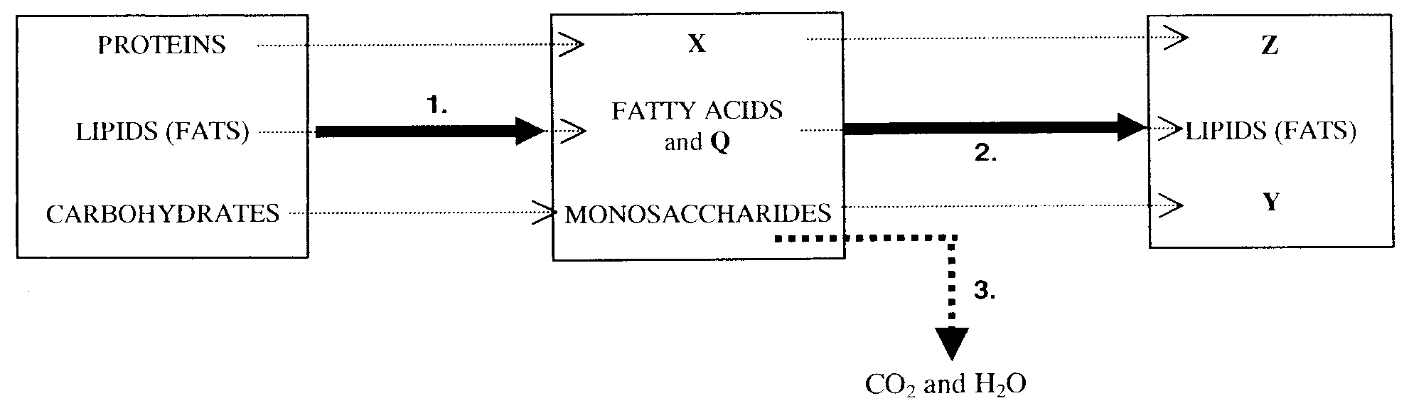

Question 16
The reactions represented by 1, 2 and 3 are
- 1 – condensation; 2 – respiration, 3 – photosynthesis
- 1 –respiration; 2 – hydrolysis, 3 – condensation
- 1 – condensation; 2 – hydrolysis, 3 – respiration
- 1 – hydrolysis; 2 – condensation, 3 – respiration
Question 17
The substance containing the greatest percentage, by mass, of oxygen is represented by
- Q
- W
- Y
- Z

Question 18
Which of the following functional groups, associated with the formation and digestion of the major food groups, contains the largest number of atoms?
- ether
- amino
- peptide
- ester

Question 19
Element number 107, known as Bohrium, symbol Bh, was named after Niels Bohr whose work on electron arrangements contributed significantly to the development of modern atomic theory.
Where would you find Bohrium on the Periodic Table?
- In Period 8.
- In the same group as manganese.
- In the same group as chromium.
- In the actinides.

Question 20
An electrolytic cell used to electroplate objects with copper is represented below.
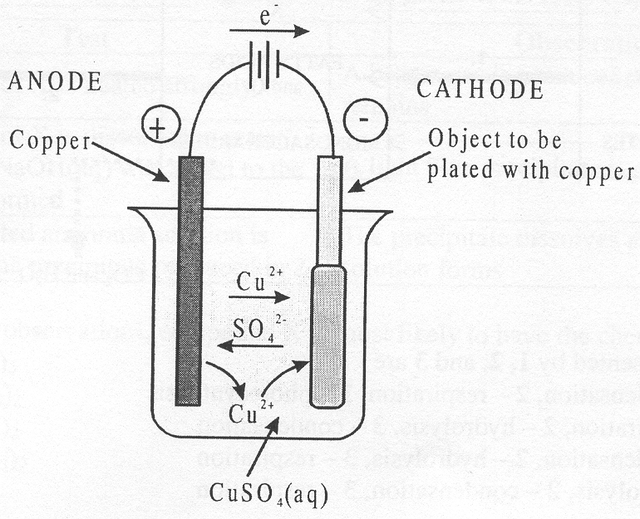
Periodically the copper anode is replaced with a new copper anode. If the copper anode was mistakenly replaced with a carbon (graphite) anode
- the pH of the solution would decrease
- the formation of copper at the cathode would cease immediately
- the concentration of Cu²⁺ (aq) would not be affected
- the carbon anode becomes coated with copper

SECTION B – Short-answer questions

Question 1
The disposal of waste fruit, peelings and off cuts from food canneries can be a problem. However bacteria in an airtight tank could be used to convert this food waste to methane gas. A cannery with an annual output of 30 000 tonnes of food waste could produce about 1.5 × 10⁹ L of methane, measured at STP, each year.
This methane can replace heating oil currently used by the cannery.
Methane reacts according to the equation:
CH₄ (g) + 2 O₂ (g) → CO₂ (g) + 2 H₂O (l); ΔH = –890 kJ mol^{–1}

- How much energy, in kJ, would be produced from the combustion of the 1.5 × 10⁹ L of methane?

2 marks
- If the average value of heating oil is 38 500 kJ L^{–1}, how many litres of heating oil could be saved by the cannery each year?

1 mark
- The cannery might decide to use some of the methane to produce electricity using fuel cells. Consider the fuel cell setup represented below.
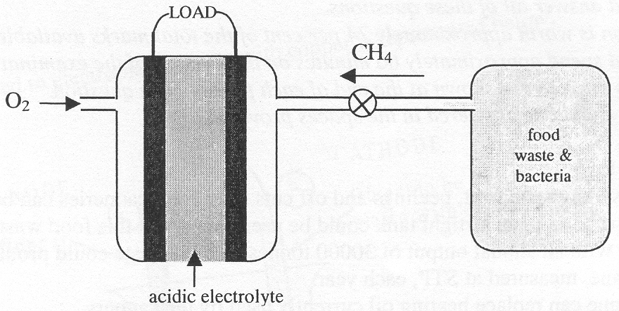
(i) Write half-equations for the reactions occurring at the two electrodes in this fuel cell.

(ii) Write a balanced equation for the overall reaction occurring in the fuel cell.

(iii) State three required properties of the electrodes used in a fuel cell.

(iv) Methane may also be used in gas-fired power stations to produce electricity.
Explain why such power stations are less efficient than generating electricity using methane in a fuel cell.

2 + 1 + 2 + 1 = 6 mark s
Total 9 marks

Question 2
Properties of the chemical elements often show regular variation with respect to their positions in the Periodic Table.

- Describe the general trend in acid-base behaviour of the oxides of the elements in Period 3. Give examples of one acidic oxide and one basic oxide, and show using equations how these oxides react with water.

3 marks
- Consider the following information from the electrochemical series.
F₂ (g) + 2 e– → 2 F– (aq) E₀ = +2.87 V
Li⁺ (aq) + e– → Li (s) E₀ = –3.02 V
What chemical properties of the elements fluorine and lithium are represented in this information and how are these properties related to their positions on the Periodic Table?

3 marks
- State the trends in (i) atomic radius; (ii) first ionisation energy; and (iii) electronegativity down a group of the Periodic Table and explain how these trends are possible given the constant core charge.

4 marks
Total 10 marks

Question 3
In an experiment to determine the amount of energy available from a sample of potato chips a group of students burnt some fothe chips under an open can containing 100 mL of water and used the energy released to heat the water.
The data obtained from the experiment is shown below.

Initial mass of chips | 2.954 g
Final mass of chips | 2.167 g
Initial temperature of 100 mL of water | 19.2°C
Final temperature of 100 mL of water | 29.5°C

- Assuming that the water absorbs all of the energy released, calculate the energy released by the burning potato chips.

2 marks
- Determine the energy content (in kilojoules) per 100 g of the potato chips based on the students’ data.

2 marks
- When the students checked the bag of chips the energy content per 100 g was stated as 2090 kJ. Suggest reasons why their calculated value was so much smaller than the actual value.

2 marks
- Briefly describe the method that was probably used to determine the actual energy content of the chips and indicate why this method is much more accurate than the students’ method.

2 marks
- The energy available to a consumer of the potato chips would be less than the calculated energy content. Give two reasons why this would be the case.

2 mark s
Total 10 marks

Question 4
- The internationally accepted standard for the determination of relative isotopic masses and relative atomic masses is the carbon-12 isotope, 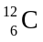.
This isotope is assigned a mass of 12 exactly. If atoms have a relative mass of 12 exactly, why is the accurate value for the relative atomic mass of carbon recorded as 12.011?

2 marks
- What does the relative atomic mass of 12.011 tell us about a naturally occurring sample of carbon?

1 mark
- Using the electronic configuration of a carbon atom, explain the difference between the ground and excited states of an atom.

2 marks
- Using carbon as an example, briefly explain the difference between an emission spectrum and an absorption spectrum. Clearly specify what the lines on these spectra represent.

5 marks
- Give balanced equations for two reactions, other than respiration, which play major roles in the carbon cycle.

2 marks
Total 12 marks

Question 5
The diagram below represents components of one cell of a car battery, also known as the lead-acid accumulator.
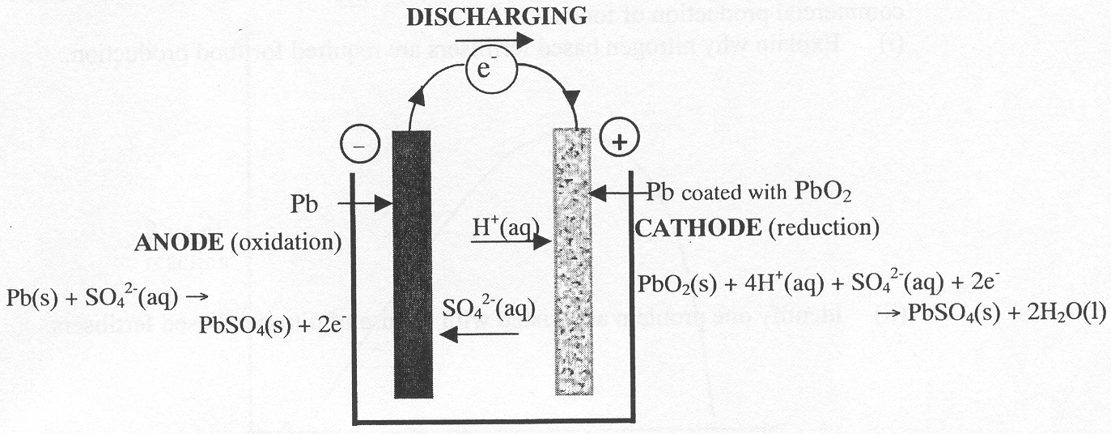

- The cells in a lead-acid accumulator are secondary cells and hence are rechargeable.
Describe the characteristic of these cells which allows them to be recharged and write half-equations for the reactions occurring at the (–) and (+) electrodes during recharging.

2 marks
- One cell of a lead-acid battery delivers a current of 4.20 A for 5.00 minutes at a particular difference of 2.0 V.
(i) What mass of PbSO₄ is produced in that cell?

(ii) How much electrical energy is produced by the cell?

4 + 1 = 5 marks
Total 7 marks

Question 6
- Ammonium nitrate, NH₄NO₃, fertiliser is one example of a chemical involved in the commercial production of foods.
(i) Explain why nitrogen based fertilisers are required for food production.

(ii) Identify one problem associated with the use of nitrogen-based fertilisers.

2 + 1 = 3 marks
- Many substances may be added to foods during their production to improve their quality. Two common additives are Vitamin E in margarine and lecithin in mayonnaise. What roles do Vitamin E and lecithin play in these foods?

2 marks
- The graph below represents the effect of pH on the activity of a particular enzyme. Explain this graph in terms of the structure of the enzyme.
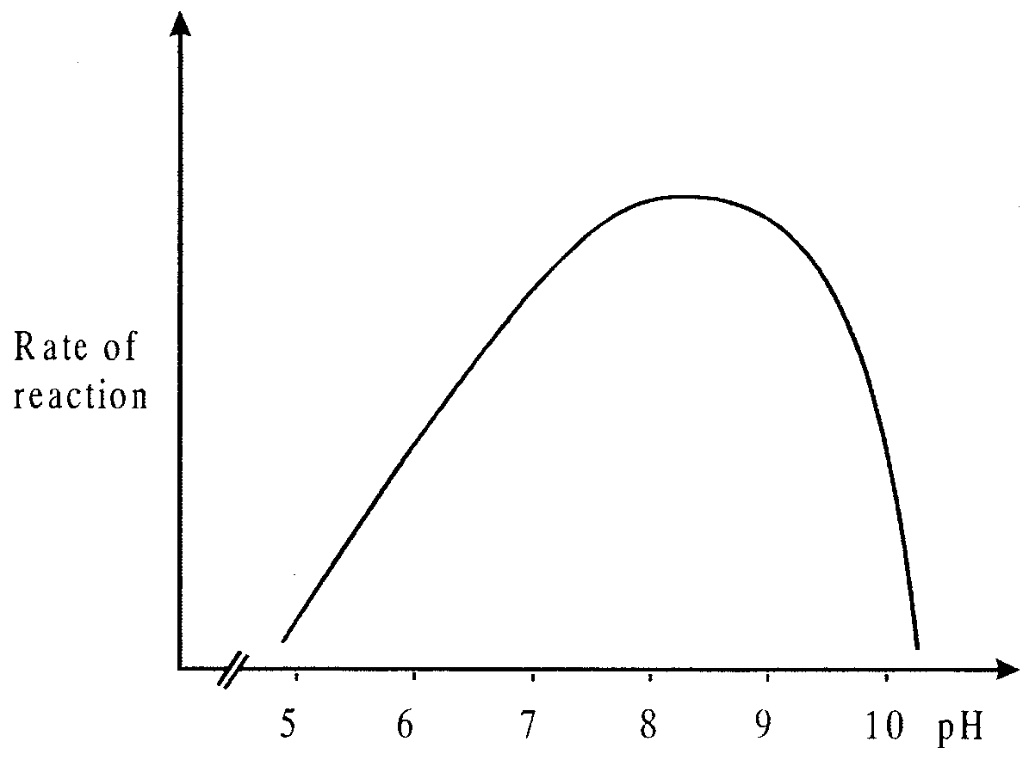

3 marks
Total 8 marks

