STAV 2003 | Unit 3 Chemistry | Trial Examination Solutions

Section A – Multiple choice questions

- A
- C
- D
- D
- A
- A
- B
- C
- B
- A
- B
- B
- C
- C
- B
- D
- C
- A
- A
- D
- C
- B

Section B – Short Answer Questions

Question 1
- % oxygen = 100 – (48.65 + 8.11) = 43.24%
n(C) : n(H) : n(O) = 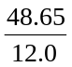 : 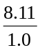 : 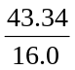 (1 mark)
n(C) : n(H) : n(O) = 4.054 : 8.11 : 2.271 (1 mark)
n(C) : n(H) : n(O) = 3.0 : 6.0 : 2.0 (1 mark)
Therefore the empirical formula is C₃H₆O₂ (1 mark)
- As the relative molecular mass is equal to the relative (empirical) formula mass, 74, them molecular formula is the same as the empirical formula. Hence molecular formula is C₃H₆O₂.. (1 mark)
 | 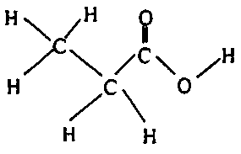 | Structure  Name: Propanoic acid | (1 mark)  (1 mark)
- (i) CH₃CH₂COOH (aq) + H₂O (l)  CH₃CH₂COO– (aq) + H₃O⁺ (aq)
(ii) K_{a} = 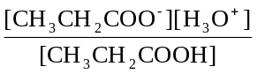 = 4.0 × 10^{–5} (1 mark)
[CH₃CH₂COO–] = [H₃O⁺]
[H₃O⁺]² = K_{a} [CH₃CH₂COOH] = 4.0 × 10^{–5} × 0.10
[H₃O⁺] = 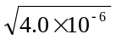 = 2.0 × 10^{–3} M (1 mark)
pH = –log₁₀[H₃O⁺] = –(–2.699)
pH = 2.7 (1 mark)
(iii) Note: This can be done by inspection as the concentration is halved for the base, NaOH, therefore the volume required will be doubled.
NaOH (aq) + HA (aq) → NaA (aq) + H₂O (l)
Therefore n(NaOH) = n(HA) = cV = 0.100 × 0.1000 mol
n(NaOH) = 0.0100 mol
Therefore V(NaOH) = = 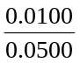 = 0.200 L
V(NaOH) = 200 mL (1 mark)

Question 2
- (i) Cr₂O₇^{2–} + 14 H⁺ (aq) + 6 e– → 2 Cr³⁺ (aq) + 7 H₂O (l) (1 mark)
(ii) Cr₂O₇^{2–} is reduced.
The chromium changes oxidation number from +6 in Cr₂O₇^{2–} to +3 in Cr³⁺. (1 mark)
A decrease in oxidation number indicates reduction. (1 mark)
- (i) A standard solution is a solution of accurately known concentration. (1 mark)
(ii) Any two valid characteristics of a primary standard. (2 × 1 = 2 marks)
For example, any two of
- compound must be pure
- compound must be known chemical composition
- compound must be stable and not react with components of the air
- compound must react with the unknown by a known chemical reaction
- compound must be soluble in water

Question 3
- NaCl (aq) + AgNO₃ (aq) → AgCl (s) + NaNO₃ (aq)
or Ag⁺ (aq) + Cl– (aq) → AgCl (s) (1 mark)
- Quantitative analysis
The procedure enables a determination of the amount, in specified units, of a component (sodium chloride) in the sample (soil). (1 mark)
- mass of NaCl = 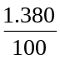 × 50.0 = 0.690 g (1 mark)
n(NaCl) = 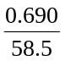 = 0.118 mol (1 mark)
n(AgNO₃) = n(NaCl) = 0.118 mol
V(AgNO₃) = = 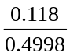 = 0.0236 L
V(AgNO₃) = 23.6 mL (1 mark)
- Any valid response – example listed. (1 mark)
- Other anions in the soil such as iodide ions may have precipitated along with the Cl– ions. This would have resulted in a greater volume of silver nitrated being required to reach the end point of the titration.
- Original concentration of the AgNO₃ could have been lower than the stated 0.4998 M. A greater volume of AgNO₃ would be required.
- Apparatus calibrated incorrectly, such as burette delivering a smaller volume than indicated by graduations.
- Analytical balance used to measure 50 g mass may be reading consistently too low.

Question 4
- (i) C₇H₁₆ (1 mark)
(ii) heptane (1 mark)
- eg 12 (to 16) mg/L (answer must be greater than 10 mg/L) (1 mark)
- Diagram C
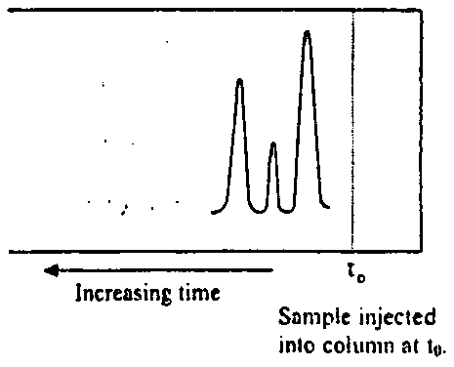
Any diagram showing a shorter retention for sample of alcohols is acceptable. (1 mark)

Question 5
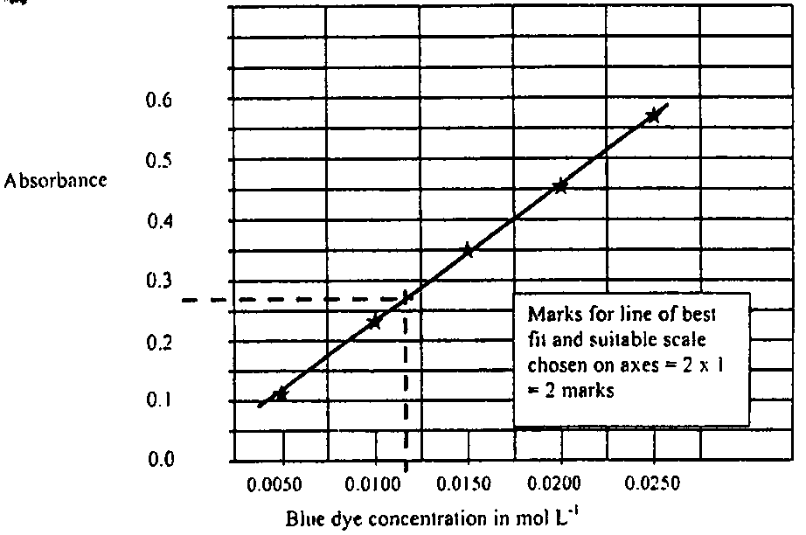

- Absorbance = 0.27 (±0.01) (1 mark)
Concentration of diluted blue dye is 0.012 (±0.001) M (1 mark)
Therefore concentration of blue dye = 100 × 0.012 = 1.2 (±0.1) M (1 mark)
- From the spectrum in part (b) it can be seen that this wavelength corresponds to the maximum absorbance by the blue dye. (1 mark)

Question 6
- Any two of the following three structures.
- Explanations are example responses only.
Change to conditions  (all other conditions remain unchanged.) |  | Insert ‘increase’, ‘decrease’, or ‘remains unchanged’ | Explanation
1. | Temperature is increased | (i) Effect on [NO]  Increase | The forward reaction is endothermic. Therefore the reaction moves to the right to decrease the temperature.
 |  | (ii) Effect on K  Increase | The formation of more products (and the decrease in reactants) will result in K increasing.
2. | O₂ is added | (i) Effect on [NO]  Increase | The addition of a reactant will cause a net forward reaction to partially counteract the addition of O₂.
 |  | (ii) Effect on K  Remains unchanged | Since the concentration fraction returns to its original value the equilibrium constant, K, remains unchanged. Note: only a change in temperature will cause a change in the equilibrium constant.
3. | Pressure is reduced by increasing the volume | (i) Effect on [NO]  Decrease  (Due to increase in the volume) | An increase in volume will lead to a decrease in concentration of all species. Therefore the concentration fraction is unchanged.  As there are equal number of particles on each side of the equation the reaction will not compensate at all for this change. Note, in any event the initial change will outweigh any subsequent reaction effect.
(Only the bolded response is required for 1 mark for explanation = 5 marks)

Question 7
- (i) CH₃CH₂Cl (g) + OH– (aq) → CH₃CH₂OH (aq) + Cl– (aq) (1 mark)
(ii) CH₂CH₂ (g) + H₂O (g) 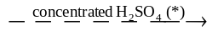 CH₃CH₂OH (g) (1 mark)
(*) alternatively solid H₃PO₄ can be used as a catalyst
- (i) A homologous series is a series of organic compounds where each successive member differs from the proceeding member by a –CH₂– group. (1 mark)
General formula for alcohols (alkanols): C_{n}H_{2n+2}O or C_{n}H_{2n+1}OH (1 mark)
(ii) | 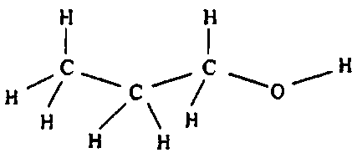 | (1 mark)
 | 1-propanol or propan-1-ol | (1 mark)
 | 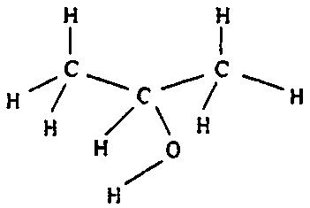 | (1 mark)
 | 2-propanol or propan-2-ol | (1 mark)

