STAV
2003
UNIT 4 CHEMISTRY

SECTION A – Multiple-choice questions

Question 1
The most efficient conversion of energy would occur in a
- coal-fired power station
- solar cell
- fuel cell
- methanol fuelled racing car

Question 2
Oxyacetylene torches may be used to cut metal due to the heat generated by the reaction
2 C₂H₂ (g) + 5 O₂ (g) → 4 CO₂ (g) + 2 H₂O (g) ΔH = –2600 kJ mol^{–1}
The energy available from the combustion of 1.0 L of acetylene, measured at 25°C and 1.0 atm pressure, is closest to
- 53 kJ
- 106 kJ
- 212 kJ
- 1300 kJ

Question 3
A nickel medallion is copper plated in an electrolytic cell using 200 mL of 1.00 M copper (II) sulfate solution and a copper anode. A current of 10.72 A is run through the cell for 15.0 minutes. The final concentration of the copper (II) sulfate solution is
- 0.250 M
- 0.500 M
- 0.750 M
- 1.00 M

Question 4
Considering redox properties, which of the following compounds would be least likely to exist in aqueous solution?
- FeCl₃
- FeCl₂
- FeI₃
- FeI₂

Question 5
The same quantity of electricity is passed through two solutions, one containing a salt of the unknown metal, X, and the other containing a salt of the unknown metal, Y.
If 0.020 mole of X is produced at the cathode of one cell, and 0.040 mole of Y is produced at the cathode of the other, which of the following conclusions can be drawn.
- The ions of X and Y are positively charged.
- The X ion has a charge of positive one.
- The charge on the X ion is double the charge on the Y ion
- The Y ion has a charge of positive two.
- I only
- I and III only
- II and IV only
- I, II and IV only

Question 6
To test whether a car battery is recharging, a student might note whether
- [H⁺] rises and pH rises
- [H⁺] rises and pH falls
- [OH–] rises and pH rises
- [OH–] rises and pH falls

Question 7
A steady current of 25.0 amperes is passed through an aqueous solution of NiSO₄ for 30.0 minutes. What is the maximum mass, in gram, of nickel that can be deposited?
- 6.84
- 13.7
- 27.4
- 58.7

Question 8
In the electrolysis of very dilute sodium chloride solution using platinum electrodes, a product at the anode is most likely to be
- chlorine
- oxygen
- sodium
- hydrogen

Question 9
Which of the following compounds would release the most energy per gram on oxidation?
- CH₃(CH₂)₁₆COOH
- C₆H₁₂O₆
- CH₂PHCHOHCH₂OH
- NH₂CH₂COOH

Question 10
Fatty acids combine in cells with another important biomolecule to form fats.
This biomolecule is called
- glycogen
- glucose
- glycerol
- glycine

Question 11
Which of the following types of bonding is responsible for the primary structure of proteins?
- ester linkages
- dipole-dipole bonds
- peptide linkages
- hydrogen bonds

Questions 12 and 13 refer to the following information

The table contains information about fatty acids that are found in foods.

Fatty acid | Semi-Structural Formula
Stearic acid | CH₃(CH₂)₁₆COOH
Oleic acid | CH₃(CH₂)₇CH=CH(CH₂)₇COOH
Linoleic acid | CH₃(CH₂)₄CH=CH₂CH=CH(CH₂)₇COOH
Eleostearic acid | CH₃(CH₂)₇CH=CHCH=CHCH=CH(CH₂)₃COOH

Question 12
The fatty acid with the highest melting point is likely to be
- stearic acid
- oleic acid
- linoleic acid
- eleostearic acid

Question 13
Each of these four fatty acids is capable of forming a triglyceride. The degree of unsaturation of a triglyceride can be determined by hydrolysing the triglyceride and reacting the resulting fatty acids with iodine. The triglyceride requiring the greatest amount of iodine would be composed of
- stearic acid
- oleic acid
- linoleic acid
- eleostearic acid

Question 14
The oxidation numbers of chromium in CrCl₃, CrO₂, K₂Cr₂O₇ respectively are
- +2, +2 and +4
- +3, +4 and +6
- +3, +4 and +7
- +3, +2 and +12

Question 15
The diagram shows part of the nitrogen cycle.
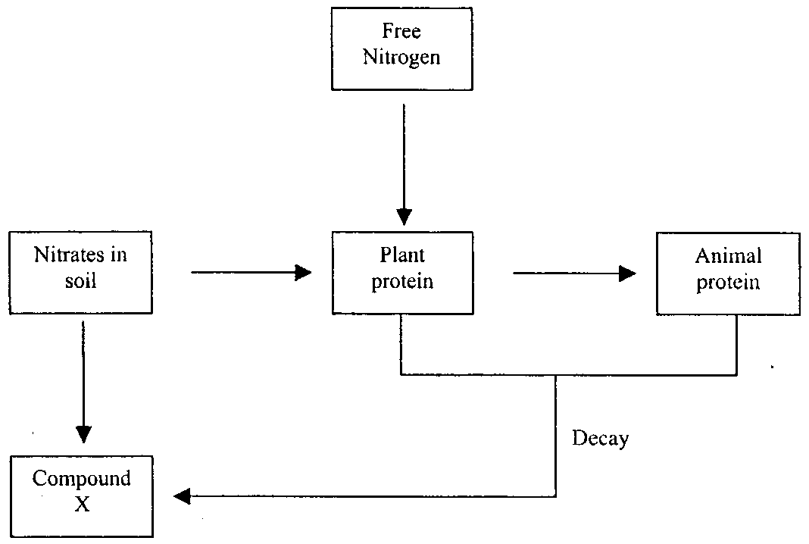
Compound X is most likely to be
- urea
- nitrogen dioxide
- ammonia
- alanine
Question 16
A sample of neon is analysed by using a mass spectrometer. Four peaks are observed corresponding to ²⁰Ne⁺, ²⁰Ne²⁺, ^{22/}Ne⁺, and ²²Ne²⁺. Which of the particles was least deflected in the magnetic field?
- ²²Ne⁺
- ²²Ne²⁺
- ²⁰Ne⁺
- ²⁰Ne²⁺

Question 17
Which of the following elements is least likely to have been synthesised by an exothermic reaction in the lifetime of a very massive star?
- helium
- carbon
- iron
- uranium

Question 18
In a certain nuclear reaction, the nucleus ⁴⁰K emits an electron. The nucleus produced is
- ³⁹K
- ⁴¹K
- ⁴⁰Ar
- ⁴⁰Ca

Questions 19 and 20 refer to the following information

Atoms of element X form an ionic compound with scandium having the formula Sc₂X₃.

Question 19
Which of the following is the electron configuration of Sc in this compound?
- 1s² 2s² 2p⁶ 3s² 3p⁶ 3d¹
- 1s² 2s² 2p⁶ 3s² 3p⁶ 3d¹ 4s²
- 1s² 2s² 2p⁶ 3s² 3p⁶ 4s² 4p¹
- 1s² 2s² 2p⁶ 3s² 3p⁶

Question 20
The element X could be
- oxygen
- nitrogen
- fluorine
- hydrogen

SECTION B – Short-answer questions

Question 1
Write concise explanations for the following observations.

- A car battery can be recharged
_______________________________________________________________________________________
_______________________________________________________________________________________
_______________________________________________________________________________________
_______________________________________________________________________________________
- Elements become more metallic down a Group on the Periodic Table.
_______________________________________________________________________________________
_______________________________________________________________________________________
_______________________________________________________________________________________
_______________________________________________________________________________________
- Atomic radius decreases across a Period on the Periodic Table.
_______________________________________________________________________________________
_______________________________________________________________________________________
_______________________________________________________________________________________
_______________________________________________________________________________________
- The electronegativity of fluorine is greater than that of chlorine.
_______________________________________________________________________________________
_______________________________________________________________________________________
_______________________________________________________________________________________
_______________________________________________________________________________________
- The transition element zinc forms colourless ionic compounds while most ionic compounds of transition metals are coloured.
_______________________________________________________________________________________
_______________________________________________________________________________________
_______________________________________________________________________________________
_______________________________________________________________________________________
- Polyunsaturated margarine often contains antioxidants such as α-tocopherol (vitamin E) and emulsifiers such as soyabean lecithin.
_______________________________________________________________________________________
_______________________________________________________________________________________
_______________________________________________________________________________________
_______________________________________________________________________________________
2 + 2 + 2 + 2 + 2 + 2 = 12 marks
Suggested time = 15 minutes

Question 2
A small scale source of safe electrical energy used in school laboratories prior to the mains connected ‘Power Pack’ was the Daniell cell. This cell typically consisted of a zinc rod dipping into a 1.0 M zinc sulfate solution. This solution was contained in a porous ceramic pot that, in turn, was placed in a copper cylinder containing 1.0 M copper (II) sulfate. The cell is capable of producing a maximum cell potential of 1.10 volts.
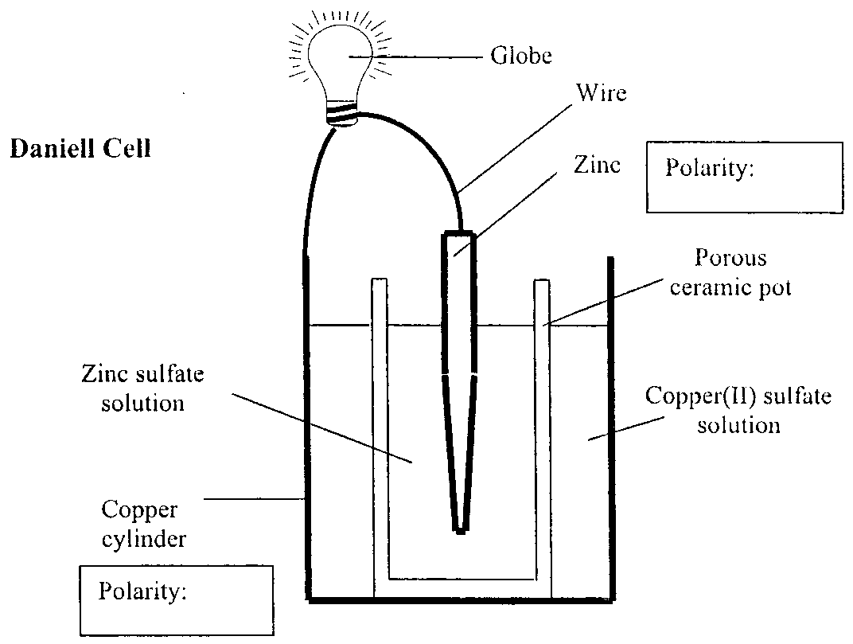
- On the diagram indicate
i. The direction of movement of the electrons in the wire to the globe.
ii. The polarity of the zinc rod and copper cylinder.
- Give the half-cell equations for the processes that occur as the cell discharges.
Equation for the process occurring at the positive electrode (cathode)
_______________________________________________________________________________________
Equation for the process occurring at the negative electrode (anode)
_______________________________________________________________________________________
- Write the overall cell reaction for the Daniell cell.
_______________________________________________________________________________________
- The porous barrier is made of a chemically inert material. What is the main function of the porous barrier?
_______________________________________________________________________________________
_______________________________________________________________________________________
- The cell could be constructed with a zinc cylinder containing zinc sulfate with the porous pot containing copper (II) sulfate solution and a copper rod.
Explain why the outer cylinder is made of copper rather than zinc.
_______________________________________________________________________________________
_______________________________________________________________________________________
- (i) If the original zinc rod has a mass of 125 g, what is the amount of charge, in coulombs, produced by the reaction of the zinc?
____________________________________________________________________________________
____________________________________________________________________________________
____________________________________________________________________________________
____________________________________________________________________________________
(ii) Calculate the amount of energy released (in kJ) by the complete reaction of 125 g of zinc in this cell.
____________________________________________________________________________________
____________________________________________________________________________________
[1+1] + 2 + 1 + 1 + 1 + [2+3] = 10 marks
Suggested time: 13 minutes

Question 3
The Hall-Heroult process for the industrial production of aluminium involves the electrolysis of alumina, Al₂O₃, dissolved in cryolite, Na₃AlF₆. A diagram of the cell is shown.
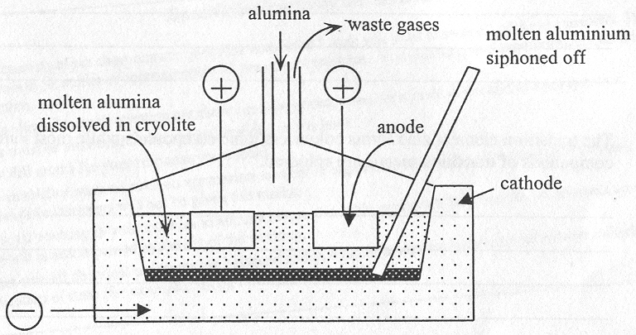
- Complete the following table.

 | Electrode material | Electrode reaction
Anode
Cathode

- What is the function of the cryolite?
_______________________________________________________________________________________
_______________________________________________________________________________________
_______________________________________________________________________________________
- Why is the electrolysis of an aluminium salt not carried out under aqueous conditions?
_______________________________________________________________________________________
_______________________________________________________________________________________
_______________________________________________________________________________________
- List two environmental implications of this means of extracting aluminium.
_______________________________________________________________________________________
_______________________________________________________________________________________
2 + 1 + 1 + 2 = 6 marks
Suggested time: 7 minutes

Question 4
The following flow chart represents the chemical process involving the reaction of compounds (I) and (II) to form compound (III).

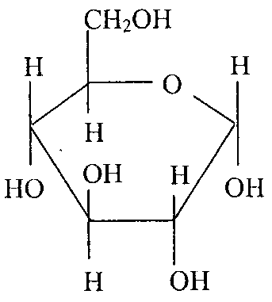 | + | 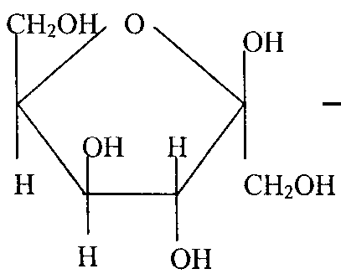 |  | 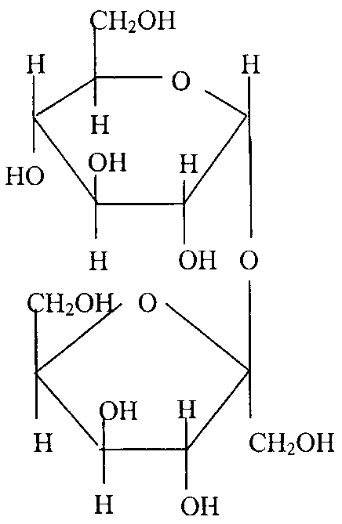
Compound (I) |  | Compound (II) |  | Compound (III)

- State the name for this type of chemical reaction.
_______________________________________________________________________________________
- Give the chemical formula for the other product formed in this chemical reaction.
_______________________________________________________________________________________
- Name the two groups of carbohydrates represented by these three molecules.
_______________________________________________________________________________________
_______________________________________________________________________________________
- Compound (I) is a very important biomolecule.
(i) State the name of this compound.
____________________________________________________________________________________
(ii) Write an equation for the chemical reaction of compound (I) that produces energy in the cells.
____________________________________________________________________________________
(iii) Compound (I) and a structural isomer of this compound are monomers that produce three important polymers that are biomolecules.
Name the polymer that is most likely to be found in human cells.
____________________________________________________________________________________
Give the empirical formula of this polymer
____________________________________________________________________________________
State the main function of this polymer.
____________________________________________________________________________________
____________________________________________________________________________________
1 + 1 + 2 + [1 + 1 + 1 + 1 + 1] = 9 marks
Suggested time: 11 minutes

Question 5
Amino acids are often shown as in the table.

Name | Structural Formula Representation
Valine | 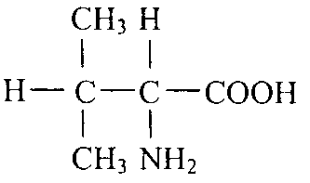
Threonine | 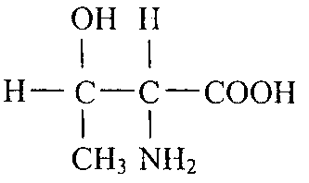
Alanine | Space for part a. response.

- In the space provided in the table above draw the structural formula representation of alanine.
- Name the three functional groups on the threonine molecule.
_______________________________________________________________________________________
_______________________________________________________________________________________
_______________________________________________________________________________________
- Amino acids really exist as zwitterions in neutral aqueous solutions.
(i) Draw the zwitterions representation of valine.

(ii) Draw the zwitterions representation of valine in an aqueous solution of pH 3.

- Enzymes are essential to the functioning of all cells.
(i) To which group of biological molecules do most enzymes belong?
(ii) Globular enzymes represented by structure (I) undergo physical changes to form more linear structures represented by structure (II).
 |  | 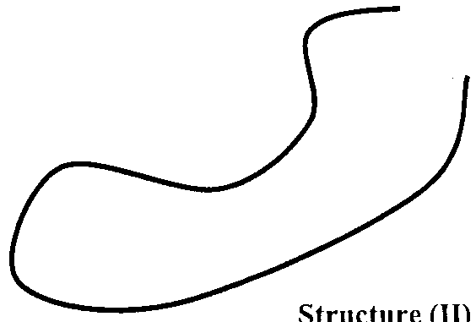
Structure (I) |  | Structure (II)

  - Name the process causing this unraveling of the enzyme.
_______________________________________________________________________________
  - State one agent that can cause this change.
_______________________________________________________________________________
_______________________________________________________________________________
1 + 1 + [1+1] + [1+2] = 7 marks
Suggested time: 9 minutes

Question 6
A student sets out to prepare a sample of the royal blue coloured complex ion, Cu(NH₃)₄(H₂O)₂²⁺. Blue crystals were first dissolved to produce the hexaquocopper (II) ion, CuSO₄.6H₂O.
- Draw the structure and fully label all of the types of bonding in the hexaquo complex ion.

- What is the name used to describe the water molecules in this complex ion?
_______________________________________________________________________________________
- Addition of a few drops of concentrated ammonia to the solution containing the complex ion results in the precipitation of a light blue precipitate. Write an ionic equation for the formation of this precipitate.
_______________________________________________________________________________________
- On addition of more of the concentrated ammonia the royal blue complex ion forms.
Explain why the colour of Cu(NH₃)₄(H₂)O₂²⁺ is different to the colour of the hexaquocopper (II) ion.
_______________________________________________________________________________________
_______________________________________________________________________________________
_______________________________________________________________________________________
_______________________________________________________________________________________
- Write the electron configuration of the copper (II) ion.
_______________________________________________________________________________________
_______________________________________________________________________________________
3 + 1 + 1 + 2 + 1 = 8 marks
Suggested time: 10 minutes

