CHEMOLOGY 2004 Unit 3 Chemistry Solutions

Section A – Multiple choice questions

1 | A | Oxidation number of Fe changes from 0  +3. This is oxidation.
2 | C | Carboxylic acid functional group.
3 | C
4 | B
5 | D | Mole initially HI = 3.00  Mole initially H₂ & I₂ = 0  Mole H₂ produced = 0.44 ⇒ mole HI reacts = 2 × 0.44 = 0.88  Mole at equilibrium HI = 3.00 – 0.88 = 2.12  K = (0.44) × (0.44) / 2.12 = 0.091 M
6 | D
7 | D | K for the reverse reaction would be 1/9
8 | A | [H⁺] = 2 × 5×10⁻⁴  pH = -log₁₀(2 × 5×10⁻⁴) = 3
9 | A
10 | B
11 | C | The flask will have some extra base. Thus more acid will be needed.
12 | A | pH = -log₁₀(0.5) = 0.3
13 | B | n(Mg) = 2.43 / 24.3 = 0.01 = n(H₂)  V_{SLC} = 0.01 × 24.5 = 0.245 L
14 | A | n(HCl) reacts = 2 × 0.01 = 0.02  n(HCl) left = 0.05 – 0.02 = 0.03  [HCl] = 0.03 / 0.1 = 0.3  pH = -log₁₀(0.3) = 0.5
15 | A
16 | D | K_{a} = 6.03×10⁻¹⁰ = [H⁺]² / 0.25 = 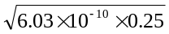 = 1.23×10⁻⁵  pH = -log₁₀(1.23×10⁻⁵) = 4.9
17 | B
18 | B | 3 mg / L = 0.3 mg / 100 mL  0.3 mg in 1 mL ⇒ 3 mg in the 10 mL sample  3 / 320 × 100 = 0.94%
19 | B
20 | B
21 | C

Section B – Short answer questions

Question 1
a. |  | C | H | O
a. | Mass | 64.9 | 13.5 | 21.6
a. | Mole | 64.9 / 12 = 5.41 | 13.5 / 1 = 13.5 | 21.6 / 16 = 1.35
a. | Divide by smallest | 4 | 10 | 1
 | empirical formula C₄H₁₀O 
b. | M_{r} C₄H₁₀I = 74   74 / 74 = 1  Molecular formula C₄H₁₀O 
c. | CH₃CH₂CH₂CH₂OH   1-butanol 
d. | CH₃CH₂CH₂COOH   butanoic acid 
e. | CH₃CH₂CH₂CH₂OH + CH₃CH₂CH₂COOH  CH₃CH₂CH₂CH₂OOCCH₃ 
f. | butyl ethanoate 

Question 2
 | 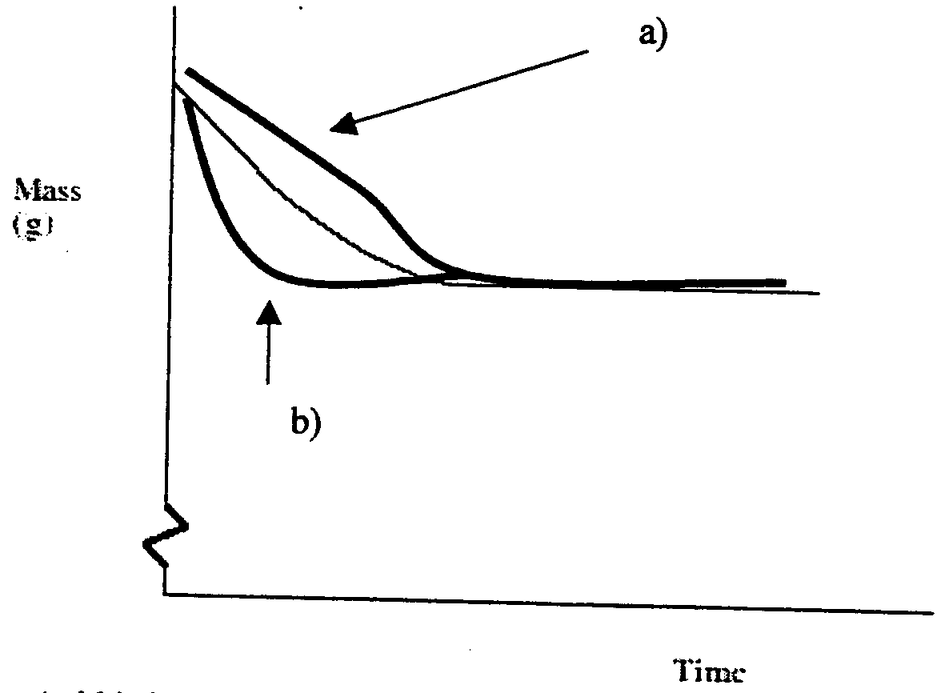
a. | Acid is half the concentration, the rate will be slower. Acid is still in excess. 
b. | When ground, there is a larger surface area, thus the rate will be faster. 

Question 3
a. | K = [HBr]² / [H₂]×[Br₂] 
b. | K = (0.099)² / (0.0005)² = 39204
c. | 45.5×10⁻³ mol H₂ reacts  1:1 ratio ⇒ 45.5×10⁻³ mol Br₂ reacts ⇒ 50×10⁻³ mol initially.   2 × 45.5×10⁻³ mol = 91×10⁻³ mol HBr produced ⇒ 8×10⁻³ mol initially 
d. | 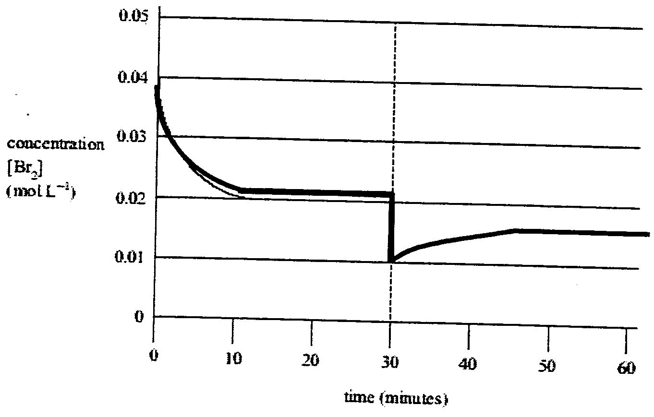

Question 4
a. | 2 SO₂ (g) + O₂ (g)  2 SO₃ (g) 
b. | SO₃ (g) + H₂S₂O₇ (l)  2 H₂SO₄ (l) 
c. | C₈H₁₈ (g)  C₂H₄ (g) + C₆H₁₄ (g) 
d. | C₂H₄ (g) + H₂O (l)  C₂H₅OH (l) 
e. | CuSO₄.5H₂O (s) 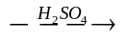 CuSO₄ (s) + 5 H₂O (l) 

Question 5
a. | ethene 
b. | 2-propanol 
c. | butanoic acid 
d. | ethyl propanoate 
e. | polyethene 

Question 6
a. | pH decreases. 
b. | 5% 
c. | As the [H₂SO₄] increases the [H⁺] increases in equation 3.  This causes the equilibrium in equation 1 to shift to the left  thus the [HCO₃⁻] also decreases. 
d. | pH = 9.5 
e. | (i) | K = [H⁺] × [CO₃²⁻] / [HCO₃⁻] 
 | (ii) | 7.9×10⁻¹¹ = [H⁺] × 1 / 4 = 3.16×10⁻¹⁰ 
 | (iii) | pH = -log₁₀(3.16×10⁻¹⁰) = 9.5 
f. | n(H⁺) = 3.2×10⁻⁵ × 10⁹ = 32 000 mol   n(CaCO₃) = ½ × n(H⁺) = ½ × 32 000 = 16 000 mol   m(CaCO₃) = 16 000 × 100.1 = 1601 kg = 1.6 tonnes 

Question 7
a. | n(HCl) = 0.1971 × 0.05 = 0.00985 mol 
b. | n(NaOH) = 1.000 × 5.90 / 1000 = 0.0059 mol  = n(HCl) 
c. | n(HCl) reacts – 0.00985 – 0.00590 = 0.00395 mol 
d. | n(NH₃) = n(HCl) = 0.00395 mol = n(N)   m(N) = 0.00395 × 14.0 = 0.0553 g   %N = 0.055s / 0.895 × 100 = 6.18 % 

