IARTV 2004 | Unit 3 Chemistry | Trial Examination Solutions

Section A – Multiple choice questions

- D
- C
- C
- B
- D
- D
- D
- B
- D
- A
- B
- B
- B
- A
- D
- C
- A
- C
- B
- C

Section B – Short Answer Questions

Question 1 (15 marks)
a. | Weigh a sample of spread accurately.  Dissolve in water, filter and rinse residue.  Add excess AgNO₃ to filtrate.  Filter out precipitate.  Dry precipitate.  Weigh precipitate.  Calculate mass of chloride ions and hence salt. |  | (3 marks)  (half mark for each step)
b. |  | Ag⁺ (aq) + Cl– (aq)  AgCl (s) |  | (1 mark)
 |  | Excess AgNO₃ is added to ensure all chloride ions are precipitated. |  | (1 mark)
c. |  | So that the precipitate does not redissolve. |  | (1 mark)
d. |  | n(AgCl) = 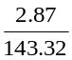 = 0.0200 mol |  | (1 mark)
e. |  | n(Na⁺ = n(AgCl) = 0.0200 mol  m(Na⁺) = 0.0200 × 23.0 = 0.461 g |  | (1 mark)
f. |  | % mass Na = 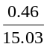 = 3.06 % |  | (1 mark)
g. |  | Manufacturers claim of 3100 mg/100 g = 3.10 %. The experimental result is lower. |  | (1 mark)
h. |  | Reasons for lower amount. Any two of: variation in manufacturing so contents will vary, loss of precipitate during filtering, redissolving while washing, salt sample not fully dissolved in initial solution. |  | (2 marks)
i. |  | Atomic absorption spectroscopy. |  | (1 mark)
j. |  | Prepare sample by diluting and ensuring correct dilution.  Prepare and run standard solution to graph calibration curve. |  | (1 mark)  (1 mark)

Question 2 (7 marks)
a. | Ozone | (1 mark)
b. | Starch | (1 mark)
c. | n(S²O₃^{2–} = 1.25 × 21.34 × 10^{–3} = 0.0267 mol | (1 mark)
 | n(I₂) = 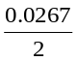 = 0.0133 mol | (1 mark)
d. | n(O₃) = n(I₂) = 1.33 × 10^{–2} mol in 20 mL aliquots | (1 mark)
 | n(O₃) = 1.33 × 10^{–2} × 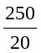 in sample  = 0.167 mol | (1 mark)
e. | V = n × V_{M} = 0.167 × 24.5 = 4.08 L | (1 mark)

Question 3 (9 marks)
a. |  |  |  | Effect on position of equilibrium |  |  | Effect on equilibrium constant |  |  |  | (4 marks)
a. |  | Addition of nitrogen dioxide |  | left |  |  | no effect |  |  |  | (4 marks)
a. |  | Increase of pressure |  | no effect |  |  | no effect |  |  |  | (4 marks)
a. |  | Removal of sulfur dioxide |  | right |  |  | no effect |  |  |  | (4 marks)
a. |  | Increase of temperature |  | right |  |  | increase |  |  |  | (4 marks)
b. |  | Gas | SO₃ |  | NO | SO₂ |  | NO₂ |  |  | (3 marks)
b. |  | initial amount of moles | 0.150 |  | 0.200 | nil |  | nil |  |  | (3 marks)
b. |  | equilibrium amount of moles | 0.005 |  | 0.055 | 0.145 |  | 0.145 |  |  | (3 marks)
b. |  | equilibrium concentrations | 0.001 |  | 0.011 | 0.029 |  | 0.029 |  |  | (3 marks)
c. | K = 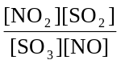 |  |  |  |  |  |  |  |  |  | (1 mark)
d. | K = 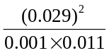 = 76.5 |  |  |  |  |  |  |  |  |  | (1 mark)

Question 4 (6 marks)

Chemical reaction | Role of sulfuric acid
CH₃OH (l) + CH₃COOH (l) 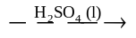 CH₃COOCH₃ (l) + H₂O (l) | dehydrating agent, catalyst
Zn (s) + H₂SO₄ (aq)  ZnSO₄ (aq) + H₂ (g) | oxidant | (3 × 2 = 6 marks)
H₂SO₄ (aq) + CuCO₃ (s)  CuSO₄ (aq) + H₂O (l) + CO₂ (g) | acid | include 1 mark overall for states

Question 5 (6 × 2 = 12 marks)
a. | 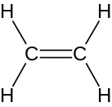
b. | 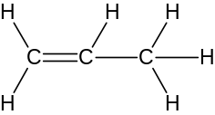
c. | 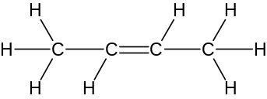
d. | 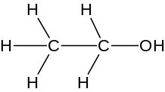
e. | 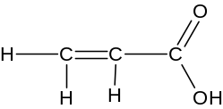
f. | 