IARTV
2004
CHEMISTRY
Unit 3 Exam

Section A – Multiple Choice

Question 1
A perfume manufacturer wishes to examine and identify the components in a competitor’s product. The most useful analytical method would be
- UV-visible spectroscopy
- atomic absorption spectroscopy
- volumetric analysis
- gas chromatography

Question 2
Many companies rely on analysis of their produces to ensure that the quality of the product is as specified. Which one of the following processes is a quantitative analysis?
- Determination of the retention time of ethanol in gas chromatography.
- Separation of amino acids by thin layer chromatography.
- Measurement of peak heights in a chromatogram produced by gas chromatography.
- Identification of caffeine in a 1.00 mL blood sample by high performance liquid chromatography.

Question 3
Solutions of 50 mL 0.10 M HCl and 50 mL 0.10 NaOH are mixed and then diluted to 1.0 L. The pH of the resulting solution would be
- 2.0
- 2.3
- 7.0
- 8.0

Question 4
Vitamin C (ascorbic acid) is shown to have a percentage composition of 40.9% carbon, 4.58% hydrogen with the remaining percentage being made up of oxygen. From this data, the empirical formula for Vitamin C can be calculated to be
- C₉HO₁₂
- C₃H₄O₃
- C₄H₃O₄
- C₃H₅O₃

Question 5
A chemist needs to adjust the pH of a 25 mL calcium hydroxide solution from +10 to +8. The initial concentration of the undiluted calcium hydroxide is
- 1 × 10^{–10} M
- 5 × 10^{–11} M
- 1 × 10^{–4} M
- 5 × 10^{–5} M

Question 6
During an acid/base titration of sodium carbonate solution and hydrochloric acid, the calculated value of the hydrochloric acid was found to be lower than its true value. This could be due to which of the following?
- The student rinsed the pipette with water instead of the primary standard sodium carbonate solution.
- The student filled the pipette with sodium carbonate solution so that the top of the meniscus was level with the calibration mark.
- The conical flask used in the titration was rinsed with water.
- The student overshot the endpoint of the titration.

Question 7
The weak acid in the following list is
- 0.001 M HCl
- 0.01 M HNO₃
- 0.05 M H₂SO₄
- 1.0 M CH₃COOH

Question 8
Which of the following contains the greatest number of copper ions?
- 64 mg of copper nitrate
- 0.5 cm³ of metallic copper that has a density of 8.94 g/cm³
- 20.00 mL of a 0.20 M copper(II) sulfate solution
- 20.00 mL of a 10% (w/v) copper(I) nitrate solution

Question 9
In one of the following lists each of the elements in bold text has the same oxidation number as its neighbours. Identify the list.
- K₂Cr₂O₇, HNO₃, H₂SO₄, Na₂S₂O₃
- N₂, KIO₃, H₃PO₄, K₂CrO₄
- TiCl₄, NO₂, KMnO₄, P₂O₅
- FeCl₃, Al₂(SO₄)₃, H₃PO₃, B₂O₃

Question 10
In the human body, the drug methamphetamine known as ‘speed’ has adverse effects on health. Speed C₁₀H₅N reacts with oxygen and ultimately forms carbon dioxide, nitrogen and water. The overall reaction could be represented by the equation
- 4 C₁₀H₁₅N (s) + 55 O₂ (g)  40 CO₂ (g) + 30 H₂O (l) + 2 N₂ (g)
- 2 C₁₀H₁₅N (s) + 55 O₂ (g)  20 CO₂ (g) + 15 H₂O (l) + N₂ (g)
- 2 C₁₀H₁₅N (s) + 55 O₂ (g)  20 CO₂ (g) + 15 H₂O (l) + 2 N₂ (g)
- 2 C₁₀H₁₅N (s) + 25 O₂ (g)  10 CO₂ (g) + 30 H₂O (l) + N₂ (g)

Question 11
Chromium metal can be obtained by reacting molten aluminium with dichromium trioxide according to the equation
2 Al (l) + Cr₂O₃ (s) → Al₂O₃ (s) + 2 Cr (l)
2.00 tonnes of dichromium trioxide are reacted with 1 tonne of aluminium and the reaction goes to completion. What mass of chromium metal will be produced?
- 1.00 tonne
- 1.37 tonne
- 13.2 kg
- 4.00 tonnes

Question 12
The gas ethyne (acetylene) can be produced by dripping water on calcium carbide which reacts completely according to the equation
CaC₂ (s) + 2 H₂O (l) → Ca(OH)₂ (s) + C₂H₂ (g)
What volume of ethyne would be produced from 25 g of CaC₂ if the temperature was 27°C and the pressure 104 kPa?
- 8.7 L
- 9.3 L
- 9.6 L
- 62 L

Question 13
The K_{a} for lactic acid is 8.4 × 10^{–4}. Therefore the pH of 0.10 M lactic acid is
- 1.5
- 2.0
- 3.1
- 4.1

Question 14
For the reaction
PCl₅ (g)  PCl₃ (g) + Cl₂ (g)
Given that K = 1.1 × 10^{–2} M at 125°C and K = 0.61 M at 225°C, it can be concluded that
- the reaction is endothermic
- the reaction is exothermic
- the reaction has a lower activation energy as the temperature increases
- ΔH would need to be known before the nature of the reaction could be determined

Question 15
The ionic equation for the neutralisation of an acid by a base may be written as
H₃O⁺ (aq) + OH– (aq)  2 H₂O (l) ΔH = –57.2 kJ/mol
As the temperature of water is raised there will be
- more hydroxide ions than hydronium ions and the pH will increase
- equal concentrations of hydroxide ions and hydronium ions and the pH will not change
- equal concentrations of hydroxide ions and hydronium ions and the pH will increase
- equal concentrations of hydroxide ions and hydronium ions and the pH will decrease

Question 16
One of the reactions involved in the production of H₂SO₄ is given by the following equation.
2 SO₂ (g) + O₂ (g)  2 SO₃ (g)
Although the reaction is exothermic, an industrial plant would still maintain the reaction at moderately high temperatures, because
- the equilibrium constant is too low at low temperatures
- sulfur dioxide is liquid at room temperature
- the rate of the reaction is too low at room temperature
- the sulfur dioxide used is already at a moderate temperature from the previous reaction

Question 17
A chemist was asked to prepare 500 mL of an approximately 0.10 M sulfuric acid solution from a 12 M solution of sulfuric acid. The correct procedure would involve, while stirring
- adding 4 mL of concentrated sulfuric acid to 500 mL of water
- adding 500 mL of water to 4 mL of stirred concentrated sulfuric acid
- adding 500 mL of water to 60 mL of concentrated sulfuric acid
- adding 4 L of concentrated sulfuric acid to 500 mL of water

Question 18
For the Contact Process, which one of the following graphs shows the change in oxidation states of sulfur (versus reaction stage) as it is converted from sulfur to sulfuric acid?
A | 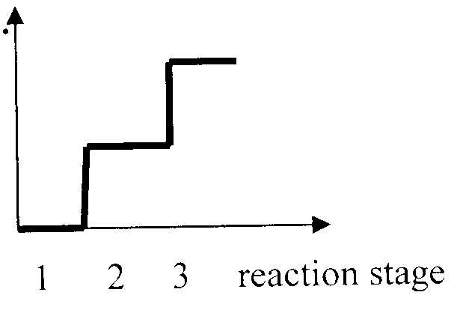 | B | 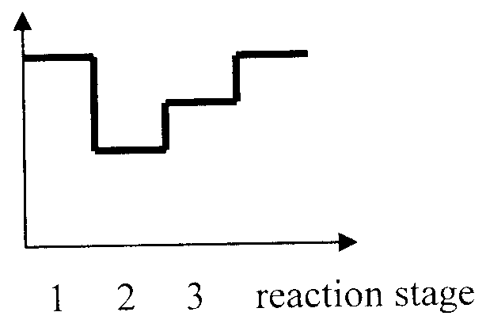 | C | 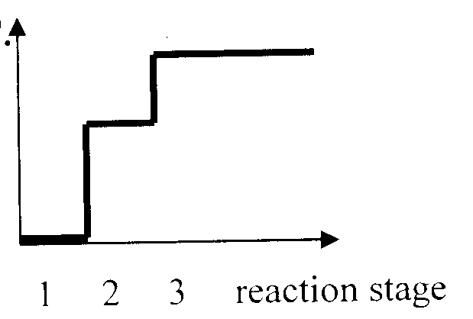 | D | 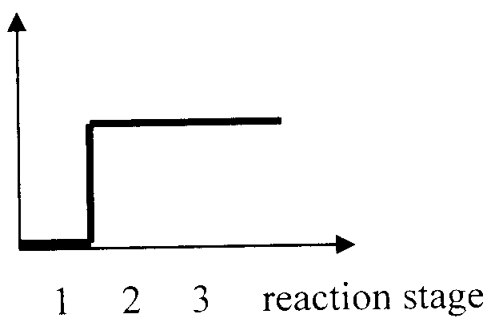

Question 19
Which monomer is required to make the following polymer?
–CH₂– CHBr–CH₂– CHBr–CH₂– CHBr–
- 1-bromoethane
- 1-bromoethene
- 1,2-dibromobut-2-ene
- 1,3-dibromobutane

Question 20
What is the name of the following compound?
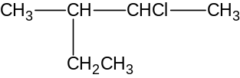
- 2-ethyl-3-chlorobutane
- 3-chloro-2-ethylbutane
- 2-chloro-3-methylpentane
- 2-chloro-3-ethylbutane

Section B – Short Answer Questions

Question 1
A student wishes to confirm the accuracy of the manufacturer’s claim that a popular spread for toast contains 3100 mg of sodium per 100 g of spread. It is assumed that all the sodium present is in the form of sodium chloride.

- During the analysis the precipitating reagent AgNO₃ (aq) is added in excess. Draw a flow chart to show the main steps that the student would take to carry out the analysis.

(3 marks)
- Write an ionic equation for the precipitation process and use it to explain why the precipitating reagent is added in excess during the analysis.
________________________________________________________________________________________________
________________________________________________________________________________________________
________________________________________________________________________________________________
(2 marks)
- The student is careful to wash the impurities from the precipitate with only a small volume of water. Why is the amount of water minimised?
________________________________________________________________________________________________
________________________________________________________________________________________________
(1 mark)
- The student weighs out 15.03 g of the spread. From this sample a precipitate of 2.87 g is obtained. Calculate the amount of the precipitate in moles.
________________________________________________________________________________________________
________________________________________________________________________________________________
(1 mark)
- Calculate the mass of sodium in the sample.
________________________________________________________________________________________________
(1 mark)
- Calculate the % w/w of sodium in the sample.
________________________________________________________________________________________________
________________________________________________________________________________________________
(1 mark)
- How does the experimental result compare with the manufacturer’s claim?
________________________________________________________________________________________________
________________________________________________________________________________________________
(1 mark)
- Suggest two possible reasons why the experimental result is different to the manufacturer’s claim.
________________________________________________________________________________________________
________________________________________________________________________________________________
(2 marks)
- Suggest an alternative instrumental analysis that could be used to determine the sodium content of the spread.
________________________________________________________________________________________________
(1 mark)
- To prepare for the above instrumental analysis, what two experimental procedures must be carried out?
________________________________________________________________________________________________
________________________________________________________________________________________________
(2 marks)
Total 15 marks

Question 2
One method used to find the concentration of ozone in the atmosphere is to bubble an air sample through potassium iodide solution. Iodine is produced according to the equation
O₃ (g) + 2 I– (aq) + H₂O (l) → O₂ (g) + I₂ (aq) + 2 OH– (aq)

The iodine is then titrated with sodium thiosulfate solution until the end point is reached when the solution becomes colourless.
I₂ (aq) + 2 S₂O₃^{2–} (aq) → 2 I– (aq) + S₄O₆^{2–} (aq)

In the first instance the solution from the ‘bubbler’ was placed in a 250.0 mL volumetric flask and made up to the mark with distilled water. Aliquots of 20.00 mL were then titrated against 1.25 M S₂O₃^{2–} solution. An average titre of 21.34 mL was recorded.

- Name the oxidant in the first equation.
________________________________________________________________________________________________
(1 mark)
- In titrations involving iodine, even though a colour change occurs at the equivalence point, an indicator is often used to clarify this point. What is the name of the indicator.
________________________________________________________________________________________________
(1 mark)
- Calculate the number of moles of iodine in the 20.00 mL aliquot.
________________________________________________________________________________________________
________________________________________________________________________________________________
________________________________________________________________________________________________
________________________________________________________________________________________________
________________________________________________________________________________________________
(2 marks)
- Calculate the number of moles of ozone in the original air sample
________________________________________________________________________________________________
________________________________________________________________________________________________
________________________________________________________________________________________________
________________________________________________________________________________________________
________________________________________________________________________________________________
(2 marks)
- Determine the volume that this amount of ozone would occupy at SLC.
________________________________________________________________________________________________
________________________________________________________________________________________________
________________________________________________________________________________________________
________________________________________________________________________________________________
(1 mark)
Total 7 marks

Question 3
- For the equilibrium system shown below, complete the table.
SO₃ (g) + NO (g)  SO₂ (g) + NO₂ (g) ΔH = + 83.6 kJ mol^{–1}

 | Effect on position of equilibrium | Effect on equilibrium constant
Addition of nitrogen dioxide
Increase of pressure
Removal of sulfur dioxide
Increase of temperature

(4 marks)
- A reaction mixture was prepared by mixing 0.150 mol SO₃ (g) and 0.200 mol NO (g) in a 5.00 L vessel. The mixture was allowed to come to equilibrium at 450°C. At equilibrium 0.145 mol of SO₂ had formed.
Complete the table below.

Gas | SO₃ | NO | SO₂ | NO₂
Initial amount of moles
Equilibrium amount of moles
Equilibrium concentrations

(3 marks)
- Write an expression for the equilibrium constant for the above reaction mixture.

(1 mark)
- Using the values from the above table determine the value of the equilibrium constant.

(1 mark)
Total 9 marks

Question 4
Complete the following table by completing and balancing the chemical equations and classifying the type of role that sulfuric acid is playing.

Chemical reaction |  | Role of sulfuric acid
CH₃OH (l) + CH₃COOH (l) 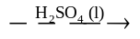
Zn (s) + H₂SO₄ (aq) →
H₂SO₄ (aq) + CuCO₃ (s) →

(3 × 2 = 6 marks)

Question 5
Draw the structural formula for the following molecules.

- A molecule that undergoes polymerisation to form a polymer often used in packaging and with an empirical formula of CH₂.

- A molecule that reacts with HCl gas to produce two possible isomers. The molecule has an empirical formula of CH₂ and reacts with hydrogen to form propane.

- A molecule that has a M_{r} of 56 and that decolourises bromine solution. Reaction with this hydrocarbon and hydrogen chloride produces only one product.

- When an ester is hydrolysed, one of the chemicals produced is propionic acid. The other product has a 52% carbon content. Draw the structural formula of this product

- Draw the molecule with formula C₃H₄O₂ that reacts with aqueous sodium carbonate to produce carbon dioxide gas and reacts with hydrogen to form a molecule with a molecular formula of C₃H₆O₂.

- An alcohol that reacts with propionic acid to form methyl propionate when a condensation reaction occurs.

(6 × 2 = 12 marks)

