IARTV 2004 | CHEMISTRY | Unit 4 | Trial Examination Solutions

Section A Multiple Choice Questions (1 mark each)

- A
- B
- D
- C
- A
- D
- C
- C
- A
- D
- B
- B
- C
- C
- C
- C
- D
- B
- D
- A

Section B Short Answer

Question 1 (4 marks)
a. | ΔH = CF × ΔT  = 6475 × (23.647 – 21.135)  = 16265.2 J | 1 mark
 | Heat per gram = 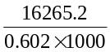 = 27.0 kJ g^{–1} | 1 mark
b. | If the two foods were carbohydrate and protein the combined available energy would be 17 kJ g^{–1}. However the total is higher than this value so the other food must be fat. Fat has the higher available energy of 37 kJ g^{–1}. | 2 marks

Question 2 (11 marks)
a. | 2 CH₃OH (l) + 3 O₂ (g)  2 CO₂ (g) + 4 H₂O (g) |  |  |  | 1 mark
b. | Reaction | Spontaneous | Oxidant | Voltage | 3 marks
b. | 2 Fe²⁺ (aq) → Fe³⁺ (aq) + Fe (s) |  |  |  | 3 marks
b. | 2 Cl– (aq) + Br₂ (l) → Cl₂ (g) + 2 Br– (aq) |  |  |  | 3 marks
b. | 5 Sn²⁺ (aq) + 2 MnO₄– (aq) + 16 H⁺ (aq) →  5 Sn⁴⁺ (aq) + 2 Mn²⁺ (aq) + 8 H₂O (l) |  | MnO₄– | 1.35 V | 3 marks
b. | Pb²⁺ (aq) + H₂ (g) + 2 OH– (aq) → Pb (s) + 2 H₂O (l) |  | Pb²⁺ | 0.70 V | 3 marks
b. |  | 1 mark | 1 mark | 1 mark | 3 marks
c. | 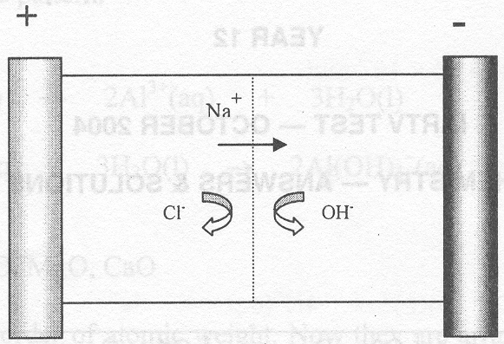 |  |  |  | 1 mark
d. | 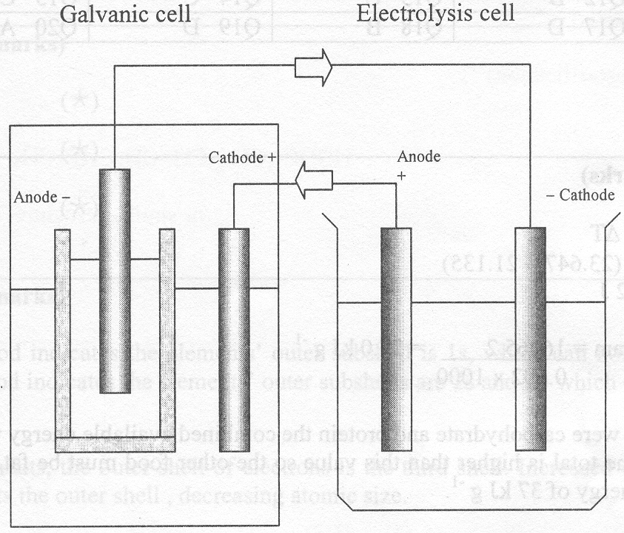 |  |  |  | 5 marks
e. | A galvanic cell is set up between the aluminium and the metals in the amalgam. A small current flow creates an unpleasant sensation in the nerves of the tooth. |  |  |  | 1 mark

Question 3 (10 marks)
a. | Negative | 1 mark
b. | Copper | 1 mark
c. | Q = I × t = 10.0 × 10.0 × 60 = 6000 C | 1 mark
d. | n(Cu) = 0.500 × 0.500 = 0.0250 mol  m(Cu) = 0.0250 × 63.6 = 1.59 g | 2 marks
e. | Total charge available = 6000 C  Charge needed to deposit Cu = 2 × 0.0250 × 96500 = 4825 C | 1 mark
 | Charge left to deposit Chromium = 6000 – 4825 = 1175 C  n(e–) = 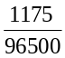 | 1 mark
 | n(Cr) = 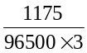 = 4.06 × 10^{–3} mol | 1 mark
 | m(Cr) = 4.06 × 10^{–3} × 52.0 = 0.210 g
f. | At the anode: 2 H₂O (l)  O₂ (g) + 4 H⁺ (aq) + 4 e– | 1 mark
 | Because H⁺ (aq) is produced the pH decreases. | 1 mark

Question 4 (5 marks)
a. | Condensation (esterification) |  | 1 mark
b. | 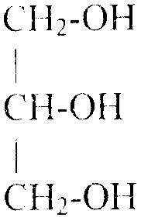 | HOOC–(CH₂)₂CH=CH(CH₂)₆CH₃ | 2 marks
b. |  | or similar structure | 2 marks
c. | Hydrolysis. Water |  | 1 mark
d. | Plants. |  | 1 mark

Question 5 (5 marks
a. | Non-essential. |  |  | 1 mark
b. | 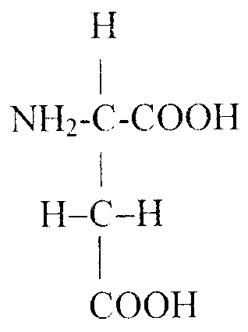 |  |  | 2 marks
c. | 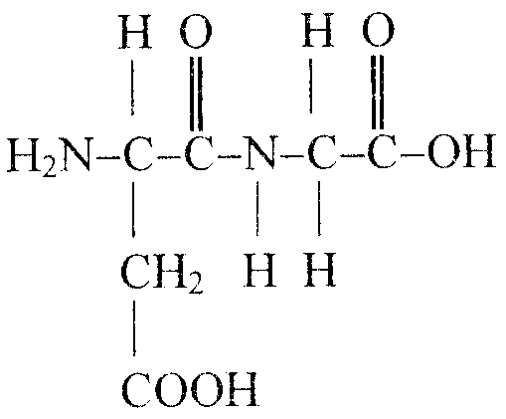 | or | 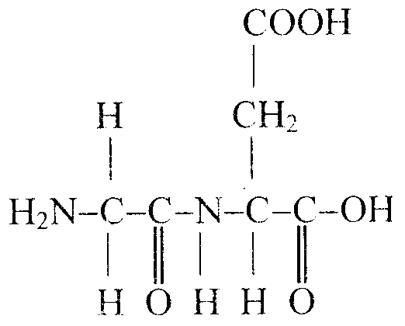 | 2 marks

Question 6 (8 marks
a. | They all have 1 electron in their outermost occupied shell. It is their outer shells that dictate their chemical properties. |  | 1 mark
b. | These gases are unreactive or inert. With the exception of argon they occur only in trace amounts therefore it was hard to detect or isolate them. |  | 1 mark
c. | The transition elements follow calcium, with the filling of the 3d subshell which has 10 electrons. This disrupts the pattern. |  | 1 mark
d. | (i) | +3 | 1 mark
 | (ii) | Al₂O₃ (s) + 6 H⁺ (aq) → 2 Al³⁺ (aq) + 3 H₂O | 1 mark
 |  | Al₂O₃ (s) + 2 OH– (aq) + 3 H₂O → 2 Al(OH)₄– (aq) | 1 mark
e. | One of Li₂O, Na₂O, K₂O, MgO, CaO |  | 1 mark
f. | They were arranged in order of atomic weight. Now they are arranged in order of atomic number. The sequence did not place elements of similar properties in the same groups. |  | 1 mark

Question 7 (3 marks)
a. |  | 1 mark
b. | Positron | 1 mark
c. | Fission | 1 mark

Question 8 (6 marks)
a. | The first period indicates the elements’ outer shell is 1s, which can hold 2 electrons. The second period indicates the elements’ outer subshells are 2s and 2p which can hold up to 8 electrons. | 1 mark
b. | For both elements, the outer shell of electrons is the third shell. Increased core charge in chlorine contracts the outer shell, decreasing atomic size. | 1 mark
c. | All gaps in the periodic table, before uranium, are filled. Elements heavier than 93 are unstable and must be synthesised. Each electronic configuration predicted by electronic configuration theory has been accounted for. | 1 mark
d. | Excited electrons in atoms drop to their ground state emitting discrete quanta of energy, corresponding to the energy difference between shells. These particular wavelengths are released as coloured light. The black background indicates the wavelengths not produced by excited elements. | 1 mark
e. | Zinc atoms or ions have a filled 3d¹⁰ subshell. Coloured light does not provide enough energy to promote an electron to the next subshell. Colour is associated with the 3d¹⁰ and 4s² subshells. | 1 mark
f. | Transition metals like iron are harder because they have a higher nuclear core charge than sodium and hence smaller atoms. These smaller sized atoms can pack closer together forming stronger metallic bonds than main group metals like sodium. | 1 mark

