NEAP 2004 | Chemistry Unit 4 | Solutions

Section A - Multiple Choice Questions
1. | C | Amylose (C₆H₁₀O₅)_{n}  Molar mass = [(6 × 12.0) + (10 × 1.0) + 5 × 16.0]] × n  = 162 n  ∴ n = 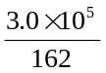 = 1852  Note: If you incorrectly calculate answer B using 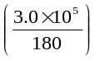 you have forgotten that when glucose polymerises, water is removed.
2. | B | Let abundance of ¹⁵¹Eu = x  Then abundance of ¹⁵³Eu = 1 – x  RAM = Σ(RIM × abundance fraction)  ∴ 151.96 = 150.92 x + 152.92 (1 – x)  ∴ 151.96 = 150.92 x + 152.92 – 152.92 x  ∴ x = 0.480
3. | A | Species present: Cu²⁺ (aq), Br– (aq), Cu (s), H₂O (l).  At the cathode the strongest oxidant is reduced.  Cu²⁺ (aq) + 2 e– → Cu (s)  At the anode the strongest reductant is oxidised.  Cu (s) → Cu²⁺ (aq) + 2 e–  The Cu²⁺ (aq) concentration will remain unchanged.  The Br– (aq) ion does not take part in the reaction, so it too remains unchanged.
4. | C | The relevant equations are:  Ni²⁺ (aq) + 2 CN– (aq)  Ni(CN)₂ (s)  Ni(CN)₂ (s) + 2 CN– (aq)  Ni(CN)₄^{2–} (aq)  The yellow colour is due to the complex ion Ni(CN)₄^{2–}.  The Ni(H₂O)₆²⁺ (aq) ion is present in the initial green-coloured solution.
5. | D | Oxidants present: Ni²⁺ (aq), and Cu²⁺ (aq).  Reductants present: Ni (s) and Cu (s).  Using the electrochemical series we find the strongest oxidant is Cu²⁺ and the strongest reductant is Ni.  Reduction is: Cu²⁺ (aq) + Ni (s) → Cu (s) + Ni²⁺ (aq)  Therefore the [Cu²⁺] decreases ∴ not A.  Positive ions flow into the CuCl₂ beaker to replace Cu²⁺ ions ∴ not B.  Electrons flow from the Ni to Cu²⁺ ∴ not C.
6. | C | The sixth electron is much more difficult to remove than the fifth electron. This indicates that the outer shell contains five electrons, ie. 3s² 2p³.
7. | B | n(C₆H₁₂O₆) = 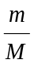 = 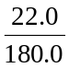  For 1 mol C₆H₁₂O₆ to be produced, 2820 kJ are required.  ∴ for 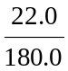 mol C₆H₁₂O₆ to be produced, 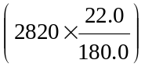 kJ are required.  ∴ 345 kJ of chemical energy is produced per hour per hectare.
8. | B | Light energy provided per hour per hectare is 1 × 60 × 60 × 10 000 × 10^{–3} = 36 000 kJ.  Chemical energy produced per hour per hectare is 345 kJ.  % efficiency = 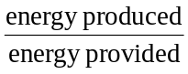 × 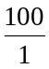  = 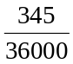 × = 0.96 %
9. | A | Relevant equation: M²⁺ (aq) + 2 e– → M (s)  n(e–) = 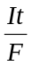 = 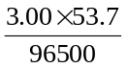 = 1.669 × 10^{–3} mol  n(M) = ½ × n(e–) = ½ × 1.669 × 10^{–3} = 8.345 × 10^{–4} mol  M(M) = 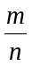 = 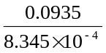 = 112 g mol^{–1}  From the Periodic Table, a molar mass of 112 g mol^{–1} corresponds to Cd.
10. | A | Relevant equation: C₆H₁₂O₆ (aq) + 6 O₂ (g) → 6 CO₂ (g) + 6 GH₂O (l)  The reaction releases energy, ie. is exothermic.  Oxidation numbers: C in C₆H₂O₆ is 0  C in CO₂ is +4.  An increase in oxidation number ∴ oxidation is occurring.
11. | D | Linoleic acid: C₁₇H₃COOH.  The hydrocarbon chain has the formula C_{n}H_{2n–3}, indicating the presence of two double bonds (saturated is C_{n}H_{2n+1})  In triglycerides, three acid molecules are present, hence 6 double bonds, hence 6 mole of H₂ needed per mole of triglyceride.
12. | B | X and Y are both absorved by plants.  Urea, OC(NH₂)₂, and amino acids like glycine, H₂NCH₂CO₂H are not absorbed by plants ∴ not A, C or D.
13. | C | 1. | N₂ → NO₃– | Oxidation number of N changes from 0 to +5.
 |  | 2. | NO₃– → N₂ | Oxidation number of N changes from +5 to 0.
 |  | 3. | NO₃– → NH₄⁺ | Oxidation number of N changes from +5 to –3.
 |  | 4. | NH₄⁺ → NO₃– | Oxidation number of N changes from –3 to +5.
 |  | Oxidation involves an increase in oxidation number, hence 1 and 4 are oxidations.
14. | D | A. Hydrolysis, eg. Protein → amino acids in the digestive system.  B. Deamination in the liver to produce urea.  C. Condensation, eg. Amino acids → protein in cells.  D. Denitrification by bacteria, NO₃ → N₂ occurs in the soil, not in the body of an animal  ∴ D is the required response.
15. | D | Products have higher binding energy per nucleon (more stable) ∴ it is an exothermic reaction, which releases energy. This energy comes from a decrease in mass (mass converted to energy).
16. | B | Using E = m × c × ΔT we have:  45.0 × c × (22.7 – 90.6) = 70.0 × 4.18 × (22.7 – 18.6)  Solving for c gives 0.393
17. | A | Moving down Group VII, boiling point increases (due to increasing dispersion forces between molecules as then increase in size). Electronegativity, ionisation energy and oxidant strength all decrease down groups.
18. | C | The molecule shown has both polar (hydrophilic) and non-polar (hydrophobic) sections.  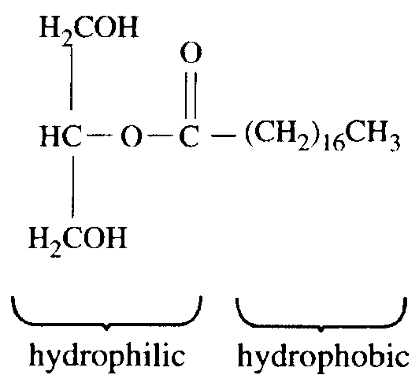  This structure is characteristic of emulsifying agents, ie substances used to stabilise water and oil mixtures.
19. | D | The calibration factor depends on the type of calorimeter (degree of insulation provided, etc), type of solvent (different solvents have different heat capacities) and the amount of solvent.
20. | A | Non-metallic oxides like Cl₂O₇ are acidic. The reaction produces an acidic solution.

Section B – Answers to Short Answer Questions

Question 1
a. | Monosaccharides contain polar –OH groups. Amino acids contain polar –COOH and –NH₂ groups. Polar molecules are generally water soluble.  Fatty acids are largely non-polar and hence are not soluble in water. | 1 mark
b. | Very high temperatures are needed to provide positively charged nuclei with sufficient energy to overcome electrostatic repulsions and so enable them to be close enough for the strong nuclear force to operate. | 1 mark
c. | A mixed electrolyte containing CaCl₂ and NaCl is used. This electrolyte has a melting temperature around 600°C. | 1 mark
d. | The human body contains the enzyme needed to hydrolyse starch, but does not contain the enzyme needed to hydrolyse cellulose. | 1 mark
Total 4 marks

Question 2
a. | i. | A cell that can be recharged. | 1 mark
 | ii. | The product of the reaction (PbSO₄) remains in contact with the electrodes. This enables the reaction to be reversed during recharging. | 1 mark
b. | Either of:  - The pH of the electrolyte increases as H⁺ ions are used during the discharge reaction.  - The density of the electrolyte decreases as H₂SO₄ (density 1.8 g mL^{–1}) is used during the discharge reaction. |  | 1 mark
c. | II – (during recharge, electrons are removed from the reductant at the positively charged electrode) |  | 1 mark
d. | i. | 2 H₂O (l) → O₂ (g) + 4 H⁺ (aq) + 4 e– | 1 mark
 | ii. | 2 H⁺ (aq) + 2 e– → H₂ (g) | 1 mark
e. | To allow safe removal of the H₂ and O₂gases produced during recharging. |  | 1 mark
f. | Any one of:  - PbSO₄ slowly crumbles off the electrodes.  - Pb grid slowly corrodes.  - Recharging is incomplete due to side-reactions. |  | 1 mark
Total 8 marks

Question 3
a. | Yes, an α-amino acid has the general formula H₂NCHZCO₂H. β-carboxyaspartic acid has this form (where Z = –CH(CO₂H₂) and would there fore be classified as an α-amino acid. |  | 1 mark
b. | i. | Different rates due to different molecular masses. | 1 mark
 | ii. | Positive. | 1 mark
 | iii. | 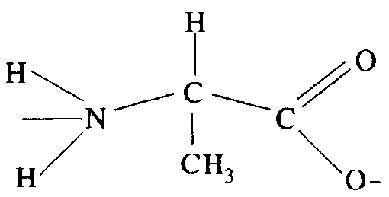 | 1 mark
c. | i. | Peptide link or covalent bond. | 1 mark
 | ii. | An enzyme. | 1 mark
 | iii. | 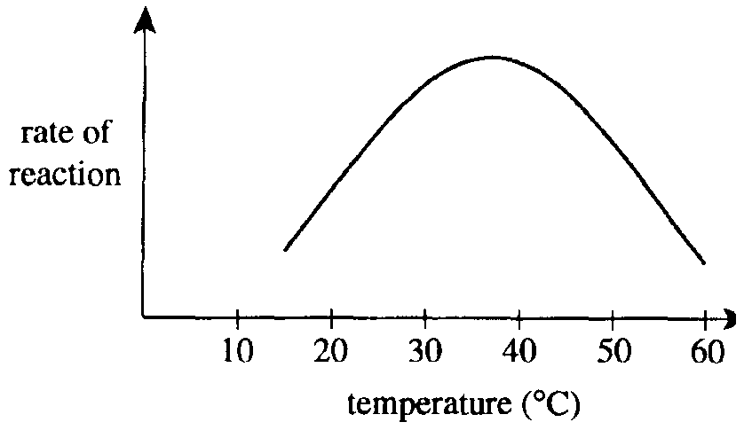  (As temperature increases, rate increases. However, at higher temperatures the enzyme is denatures and so rate decreases. Maximum rate near body temperature, 37°C) | 2 marks
Total 8 marks

Question 4
a. | Transition metals are those elements where the d subshell is filling. Co has 7 electrons in the 3d subshell. | 1 mark
b. | 1s² 2s² 2p⁶ 3s² 3p⁶ 3d⁶ | 1 mark

c. | Using the electrochemical series, HNO₃ will act as an oxidant to oxidise Co to Co²⁺. HNO₃ is not a strong enough oxidant to oxidise Co²⁺ to Co³⁺. The expected product is therefore Co²⁺.
 | Relevant E⁰ values: | Co³⁺ → Co²⁺ | +1.81
 |  | NO₃– / H⁺ → NO | +0.96
 |  | Co²⁺ → Co | –0.28 | 2 marks
d. | 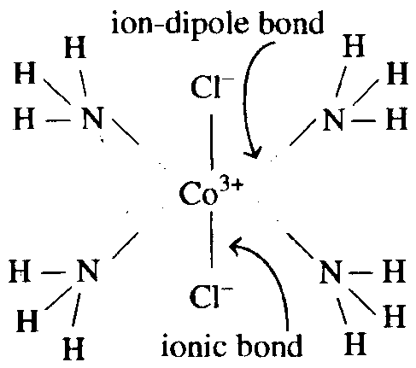 |  |  | 2 marks
Total 6 marks

Question 5
a. | 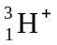 → 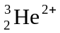 + 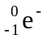 |  | 1 mark
b. | 4 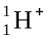 → 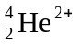 + 2 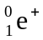 + energy |  | 1 mark
c. | i. | Reactant 1 is O₂. | 1 mark
 | ii. | O₂ (g) + 4 H⁺ (aq) + 4 e– → 2 H₂O (g) | 1 mark
d. | i. | 2 H₂O (l) + 2 e– → H₂ (g) + 2 OH– (aq) | 1 mark
 | ii. | To separate the products (Cl₂, H₂, OH–). These would react spontaneously if they were to be combined. | 1 mark
 | iii. | In dilute NaCl the anode reaction would produce O₂, not Cl₂.  2 H₂O (l) → O₂ (g) + 4 H⁺ (aq) + 4 e– | 1 mark
 |  | A higher concentration of Cl– in solution ensures the production of Cl₂ at the anode.  2 Cl– (aq) → Cl₂ (g) + 2 e– | 1 mark
Total 8 marks

Question 6
a. |  | 1 mark
b. | Most of the α-particles passed straight through the foil. | 1 mark
 | Some of the α-particles were deflected at large angles and a few were reflected back towards the source. | 1 mark
c. | 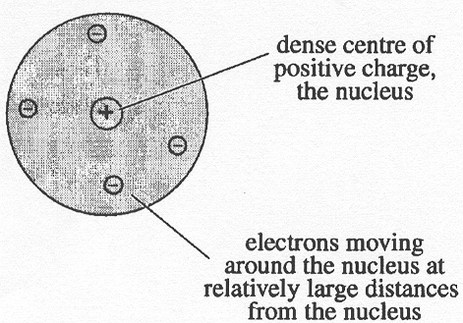 | 2 marks
d. | For example: the current model includes  - neutrons in the nucleus  - electrons with specific energy levels  - orbitals – regions of space occupied by electrons | 1 mark
Total 6 marks

