NEAP
2004
UNIT 4 CHEMISTRY

SECTION A – Multiple-choice questions

Question 1
Amylose is a polysaccharide formed by the condensation polymerisation of glucose molecules. Amylose has a molar mass of 3.0 × 10⁵ g mol^{–1}.
Approximately how many glucose molecules are needed to form one amylose molecule?
- 1520
- 1670
- 1850
- 2010

Question 2
The relative atomic mass of europium (Eu) is 151.96. Europium is composed of two isotopes, ¹⁵¹Eu and ¹⁵³Eu, with relative isotopic masses of 150.92 and 152.92 respectively.
What is the fraction of ¹⁵¹Eu in europium?
- 0.475
- 0.480
- 0.520
- 0.525

Question 3
Which of the following shows the changes in the concentration of copper (II) ions and bromide ions in the solution when a copper (II) bromide (CuBr₂) solution is electrolysed using copper electrodes?

 | Concentration of Cu²⁺ (aq) | Concentration of Br– (aq)
A. | unchanged | unchanged
B. | decreased | unchanged
C. | decreased | decreased
D. | unchanged | decreased

Question 4
When an aqueous solution containing cyanide ions (CN–) is added to a green-coloured solution containing nickel (II) ions a precipitate forms. This precipitate dissolves when excess cyanide ions are added, and a yellow solution forms. The chemical species most likely to be responsible for the yellow-coloured solution is
- Ni(CN)₂ (s)
- Ni(CN)₄²⁺ (aq)
- Ni(CN)₄^{2–} (aq)
- Ni(H₂O)₆²⁺ (aq)

Question 5
An electrochemical cell was arranged as shown in the diagram below. The two beakers are connected by an inverted U-tube containing potassium nitrate solution.
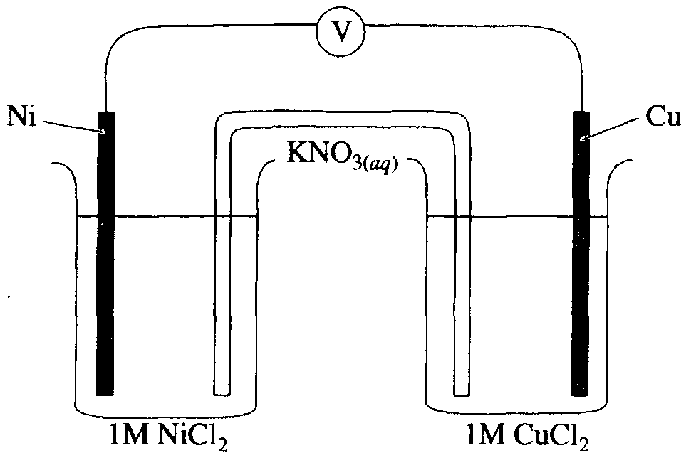
Which of the following observations could be made when the current has been flowing for around 20 minutes?
- The blue colour of the copper (II) chloride solution would become darker.
- Potassium ions from the U-tube would flow into the beaker containing the nickel chloride.
- Electrons would flow from the copper electrode toward the nickel electrode.
- The mass of the nickel electrode would decrease.
Question 6
The first six successive ionisation energies of an atom of element X are shown below.

electron removed | 1st | 2nd | 3rd | 4th | 5th | 6th
energy required (eV) | 1.018 | 1.909 | 2.918 | 4.983 | 6.280 | 21.275

Which of the following is the most likely electron configuration of element X?
- 1s² 2s² 2p¹
- 1s² 2s² 2p⁴
- 1s² 2s² 2p⁶ 3s² 3p³
- 1s² 2s² 2p⁶ 3s² 3p⁵

Questions 7 and 8 refer to the following information

In a particular region the Sun supplies energy at a rate of 1.0 J s^{–1} m^{–2} of surface area. The plants in this region photosynthesise to produce 22.0 g of glucose per hour per hectare. (1 hectare = 10 000 m²)
6 CO₂ (g) + 6 H₂O (l) → C₆H₁₂O₆ (aq) + 6 O₂ (g) ΔH = +2820 kJ mol^{–1}

Question 7
The chemical energy produced during photosynthesis per hour per hectare is
- 128 kJ
- 345 kJ
- 2.31 × 10⁴ kJ
- 6.21 × 10⁴ kJ

Question 8
Based on the data provided for this region, the efficiency of plants in converting light energy to chemical energy is
- 0.36%
- 0.96%
- 1.3%
- 64%

Question 9
During an electrolysis experiment, 0.0935 g of metal was electroplated from a solution of metal ions (M²⁺) using a current of 3.00 A for 53.7 s. The metal electroplated was
- Cd
- Cr
- Fe
- Zn

Question 10
The process of aerobic respiration that occurs in the cells of most living things is
- exothermic and involves the oxidation of carbon atoms
- endothermic and involves the oxidation of carbon atoms
- exothermic and involves the reduction of carbon atoms
- endothermic and involves the reduction of carbon atoms

Question 11
Hydrogenation refers to the addition of hydrogen (H₂) to an alkene to form an alkane in the presence of a suitable catalyst. How many mole of hydrogen (H₂) would be required to completely hydrogenate a triglyceride formed by the reaction of glycerol (C₃H₈O) and linoleic acid (C₁₈H₃₂O₂)?
- 1
- 2
- 3
- 6

Questions 12 to 14 refer to the diagram below that shows the
possible pathways for a nitrogen atom to cycle through the biosphere

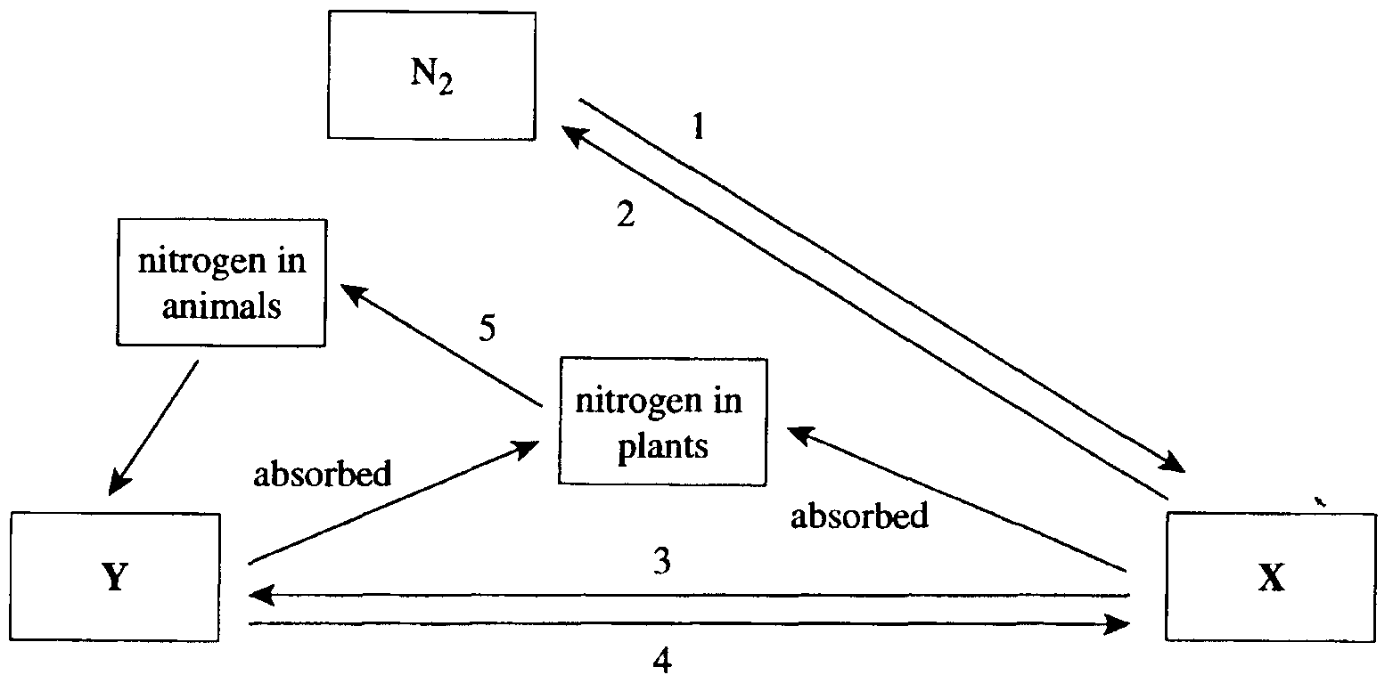

Question 12
Which of the following correctly identifies X and Y on the diagram?

 | X | Y
A. | NO₂ | OC(NH₂)₂
B. | NO₃– | NH₄⁺
C. | NH₄⁺ | H₂NCH₂CO₂H
D. | H₂NCH₂CO₂H | NO₃–

Question 13
Which change, or changes, shown on the diagram involve the oxidation of nitrogen atoms?
- 1 only
- 2 only
- 1 and 4
- 2 and 3

Question 14
Between the time when ‘nitrogen in plants’ enters an animal and is later excreted from that animal, which of the following processes could not occur?
- hydrolysis
- deamination
- condensation
- denitrification

Question 15
A nuclear reaction is represented by the equation:
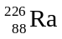 → 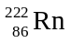 + 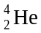
During this reaction it would be expected that energy would be
- absorbed and there would be an increase in mass
- absorbed and there would be a decrease in mass
- released and there would be an increase in mass
- released and there would be a decrease in mass

Question 16
A 45.0 g block of copper was heated to 90.6°C. The block was then placed in an insulated vessel containing 70.0 g of water at a temperature of 18.6°C. The copper block and water both reached a temperature of 22.7°C. Based on these experimental results, the specific heat capacity of copper (in J °C^{–1} g^{–1}) is
- 0.189
- 0.393
- 1.63
- 1.97

Question 17
Which of the following properties would be expected to show an increase when moving down the elements in Group VII of the Periodic Table?
- boiling point
- electronegativity
- ionisation strength
- oxidant strength

Question 18
Food additive number 471 has the structure shown below.
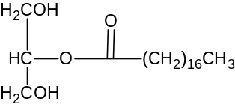
Based on its structure, it is likely that additive 471 would be used in foods that
- have a tendency to absorb water
- readily oxidise and become rancid
- contain both oil-based and water-based components
- would otherwise taste very bland

Question 19
The calibration factor of a calorimeter is the amount of energy required to change the temperature of the calorimeter and its contents by 1°C.
Which of the following characteristics does the calibration factor not depend on?
- type of calorimeter
- amount of solvent present
- type of solvent used
- electricity source used during calibration

Question 20
Cl₂O₇ reacts with water according to the equation: Cl₂O₇ (g) + H₂O (l) → 2 HClO₄ (aq)
In this reaction, Cl₂O₇ is acting as
- an acidic oxide
- a basic oxide
- an amphoteric oxide
- neither an acidic nor basic oxide

SECTION B – Short-answer questions

Question 1
Give a concise explanation for each of the following:
- Monosaccharides and amino acids are water soluble, but fatty acids are not.
_______________________________________________________________________________________
_______________________________________________________________________________________
_______________________________________________________________________________________
_______________________________________________________________________________________
1 mark
- Nuclear fusion reactions only occur at extremely high temperatures.
_______________________________________________________________________________________
_______________________________________________________________________________________
_______________________________________________________________________________________
_______________________________________________________________________________________
1 mark
- The Down’s cell used for the production of sodium has an operating temperature of 600°C, but the melting point of sodium chloride used in the electrolyte is 800°C.
_______________________________________________________________________________________
_______________________________________________________________________________________
_______________________________________________________________________________________
_______________________________________________________________________________________
1 mark
- Starch and cellulose are both polymers of glucose. Starch can be digested in the human body, but cellulose cannot.
_______________________________________________________________________________________
_______________________________________________________________________________________
_______________________________________________________________________________________
_______________________________________________________________________________________
1 mark
Total 4 marks

Question 2
The lead-acid accumulator, known to many people simply as the car battery, is a well-known example of a secondary cell. The battery consists of six separate cells connected in series. The electrolyte used is an approximately 4 M H₂SO₄ solution.
The reaction occurring during discharge of the battery may be represented by the half-equations:
Pb (s) + HSO₄– (aq) | → | PbSO₄ (s) + H⁺ (aq) + 2 e– | I.
PbO₂ (s) + HSO₄– (aq) + 3 H⁺ (aq) + 2 e– | → | PbSO₄ (s) + 2 H₂O (l) | II.
- i. What is meant by a secondary cell?
____________________________________________________________________________________
ii. Which feature of the lead-acid accumulator enables it to function as a secondary cell?
____________________________________________________________________________________
____________________________________________________________________________________
1 + 1 = 2 marks
- Describe one change that would be expected to occur to a property of the electrolyte as the battery discharges.
_______________________________________________________________________________________
_______________________________________________________________________________________
1 mark
- Which half-equation (I or II) in reverse, represents the reaction occurring at the positive electrode during recharging of the battery?
_______________________________________________________________________________________
1 mark
- During recharging of the car battery, additional reactions may occur. In addition to the lead (II) sulfate, hydrogen ions and water in the electrolyte may be reduced or oxidised.
Write half-equations for reactions that involve the reduction or oxidation of H⁺ (aq) ions and H₂O (l) molecules during the recharging.
i. Anode reaction:
____________________________________________________________________________________
ii. Cathode reaction:
____________________________________________________________________________________
1 + 1 = 2 marks
- Explain why it is wise to remove the plastic sealing caps from each cell of the car battery during the recharging process.
_______________________________________________________________________________________
_______________________________________________________________________________________
_______________________________________________________________________________________
1 mark
- The average lifespan of a car battery is around four years. Suggest one reason why the life of a car battery is limited.
_______________________________________________________________________________________
_______________________________________________________________________________________
1 mark
Total 8 marks

Question 3
- A substance isolated from the bacterium E. coli is known as β-carboxyaspartic acid. It has the structure shown below.
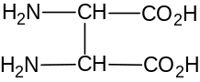
Would β-carboxyaspartic acid be classified as an α-amino acid? Explain your choice.
_______________________________________________________________________________________
_______________________________________________________________________________________
_______________________________________________________________________________________
1 mark
- Mixtures of amino acids can be separated using a technique called electrophoresis. This technique relies on the different rates of movement of ions in an electric field. A solution containing the amino acids is applied to a strip of filter paper. The paper is placed between the electrodes of a DC source and the amino acid ions in the solution migrate towards one of the electrodes, depending on the pH of the solution used.
The technique is applied to a solution containing leucine [(CH₃)₂CHCH₂CH(NH₂)COOH] and alanine [CH₃CH(NH₂)COOH] at a pH of 11.
i. Suggest why ions of these two amino acids would move at different rates in an electric field.
____________________________________________________________________________________
____________________________________________________________________________________
ii. At a pH of 11, which electrode (positive or negative) would alanine ions migrate towards during electrophoresis? )Indicate your response by ticking the appropriate box below.)

positive 
negative 

iii. Use a sketch of the alanine ion present to explain your choice in ii.

1 + 1 + 1 = 3 marks
- Albumin, found in egg white, is a large protein. Part of the polypeptide chain in albumin includes the amino acids aspartic acid (ASP) and phenylalanine (PHE).
The reaction represented in the equation below involves breaking the bond between ASP and PHE in the albumin polypeptide chain. This reaction occurs during the digestion of albumin.
~ ASP–PHE ~ + H₂O 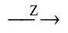 ~ ASP + PHE ~
i. Name the type of bond broken during this reaction.
____________________________________________________________________________________
ii. What type of substance is represented by the letter Z in this equation?
____________________________________________________________________________________
iii. On the axes below, sketch the expected shape of the graph, showing how the rate of this reaction changes with increasing temperature.
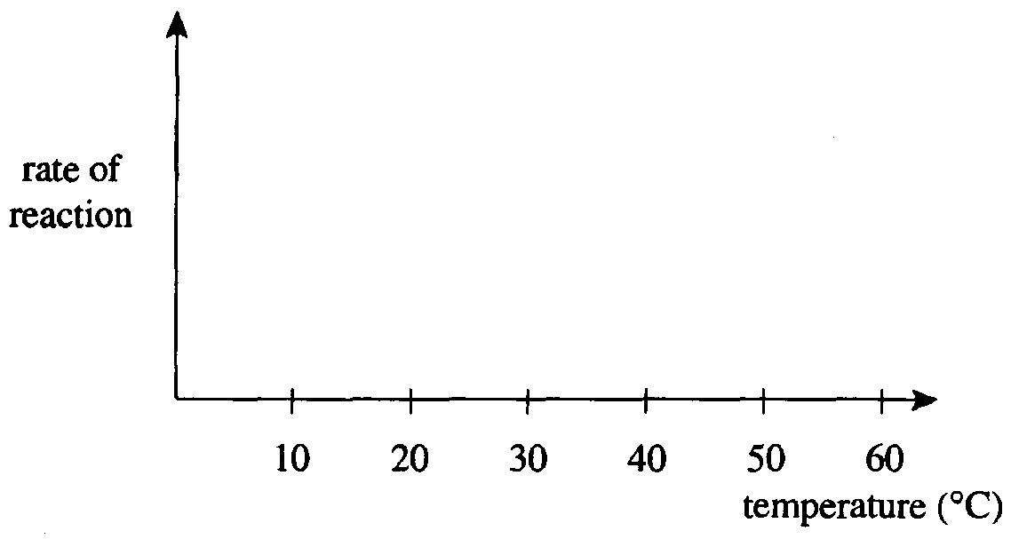
1 + 1 + 2 = 4 marks
Total 8 marks

Question 4
Cobalt has an atomic number of 27.
- Explain why cobalt is classified as a transition metal.
_______________________________________________________________________________________
_______________________________________________________________________________________
1 mark
- Write the electron configuration of the Co³⁺ ion, using s, p, d, f notation.
_______________________________________________________________________________________
1 mark
- Cobalt reacts with 1.0 M nitric acid (HNO₃) to produce nitrogen monoxide (NO).
With the aid of the electrochemical series, state which ion, Co²⁺ or Co³⁺, you would expect to be the main product of this reaction. Explain your choice.
_______________________________________________________________________________________
_______________________________________________________________________________________
_______________________________________________________________________________________
_______________________________________________________________________________________
_______________________________________________________________________________________
2 marks
- Cobalt forms a complex ion with the formula Co(NH₃)Cl₂⁺. Draw a diagram of this complex ion clearly labelling all bond types within the ion.

2 marks
Total 6 marks

Question 5
Hydrogen is the most abundant element in the universe. It exists as three isotopes, hydrogen, deuterium and tritium. Tritium, 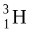, is radioactive.
- Tritium undergoes radioactive decay to form an electron and one other product. Write a balanced nuclear equation for this decay reaction.
_______________________________________________________________________________________
1 mark
- Write an equation to show how hydrogen is involved in energy production in the Sun.
_______________________________________________________________________________________
1 mark
- For many years spacecraft, including space shuttle programs, have used hydrogen gas as an energy source in a fuel cell. The diagram below shows a hydrogen-oxygen fuel cell with an acidic electrolyte.
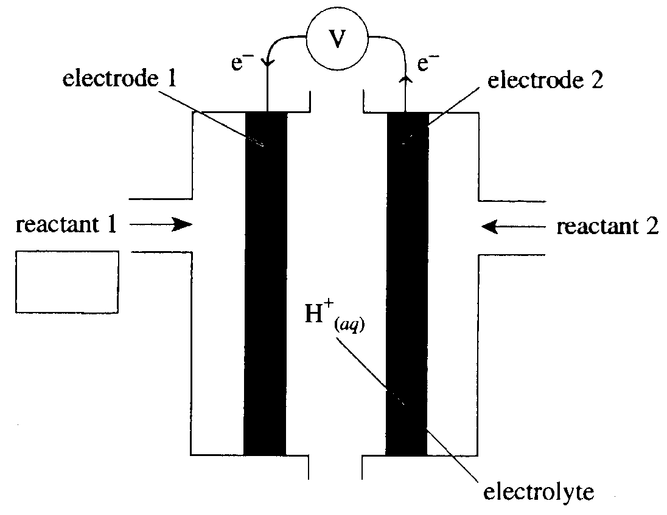
Complete the labeling of this diagram by writing the
i. formula for reactant 1 (write the formula in the box).
ii. half-equation for the reaction occurring at electrode 1.
____________________________________________________________________________________
1 + 1 = 2 marks
- Hydrogen is a by-product produced during the electrolysis of concentrated sodium chloride using the diaphragm cell.
i. Write the half-equation for the reaction that produces hydrogen in the diaphragm cell.
____________________________________________________________________________________
ii. What is the purpose of the asbestos diaphragm used in this cell?
____________________________________________________________________________________
iii. Why is it necessary to use concentrated sodium chloride rather than dilute sodium chloride in this cell?
____________________________________________________________________________________
____________________________________________________________________________________
____________________________________________________________________________________
____________________________________________________________________________________
____________________________________________________________________________________
1 + 1 + 2 = 4 marks
Total 8 marks

Question 6
In the late 1800s, J. J. Thomson proposed a model for the atom known as the plum pudding model. Around 1910, Ernest Rutherford, with his students Geiger and Marsden, conducted an experiment to test this model. The experiment consisted of firing α-particles at high speed at a thin sheet of gold foil and observing the scattering of these α-particles using a fluorescent screen.
The design of the experiment is illustrated below.
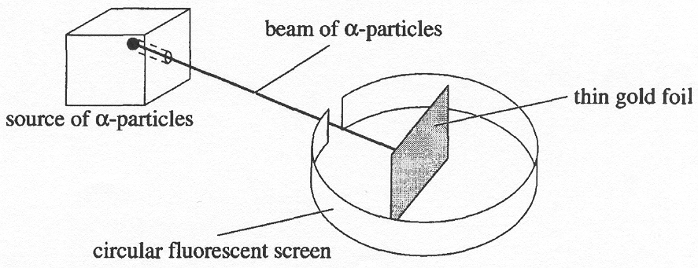
- Using the 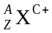 notation, show the nature of an α-particle.
_______________________________________________________________________________________
1 mark
- Describe the scattering pattern of the α-particles as observed during the Rutherford, Geiger and Marsden experiment.
_______________________________________________________________________________________
_______________________________________________________________________________________
_______________________________________________________________________________________
_______________________________________________________________________________________
_______________________________________________________________________________________
2 marks
- Draw a labelled sketch of the main features of the new model of the atom proposed as a result of this experiment.

2 marks
- State one difference between the model shown in c. and our current model of the atom.
_______________________________________________________________________________________
_______________________________________________________________________________________
1 mark
Total 6 marks

