STAV 2004 | Unit 3 Chemistry | Trial Examination Solutions

Section A – Multiple choice questions

- B
- B
- D
- B
- B
- C
- C
- D
- A
- B
- D
- D
- A
- C
- A
- C
- C
- A
- D
- B
- A
- A

Section B – Short Answer Questions

Question 1 (Total = 11 marks)
- Zn (s) + 2 HCl (aq) → H₂ (g) + ZnCl₂ (aq) (1 mark)
- Shavings provide a greater surface area so that reaction is more rapid than with a whole piece. (1 mark)
- n(NaOH) = cV = 0.100 × 23.4 × 10^{–3} = 2.34 × 10^{–3} mol (1 mark)
- n(HCl)_{originally} = cV = 0.150 × 100 × 10^{–3} = 0.0150 mol (1 mark)
n(HCl)_{reacting with 25 mL NaOH} = 2.34 × 10^{–3} mol
As the 25 mL aliquot of NaOH represented one quarter of the 100 mL of solution formed by treating the shavings with HCl:
n(HCl)_{reacting with 100 mL NaOH} = 4 × 2.34 × 10^{–3} = 9.36 × 10^{–3} mol
n(HCl)_{reacting with zinc} = 0.0150 – 9.36 × 10^{–3} = 5.64 × 10^{–3} mol (1 mark)
- n(Zn) = ½ n(HCl) = ½ × 5.64 × 10^{–3} = 2.82 × 10^{–3} mol
m(Zn) = n × M = 2.82 × 10^{–3} × 65.4 = 0.184 g (1 mark)
m(Cu) = sample mass – mass of zinc = 0.500 – 0.184 = 0.316 g
% Cu = 0.316 × 100 ÷ 0.500 = 63.2% (1 mark)
- n(H₂) = n(Zn) = 2.82 × 10^{–3} mol
V(H₂) = nRT/P = (2.82 × 10^{–3} × 8.31 × 298) / 101 = 0.0691 L = 69.1 mL (1 mark)
Therefore teh 100 mL gas syringe is large enough. (1 mark)
Alternatively
V(H₂) = n × Vm(at SLC) = 2.82 × 10^{–3} × 24.5 = 0.0691 L = 69.1 mL
- Atomic Absorption Spectroscopy – used for determination of metals. (1 + 1 = 2 marks)

Question 2 (Total = 9 marks)
- ‘SupaWhite’ may contain other substances which absorb UV light at the wavelength of 240 nm.
(Also ‘SupaWhite’ may absorb more strongly at 375 nm.). (1 mark)

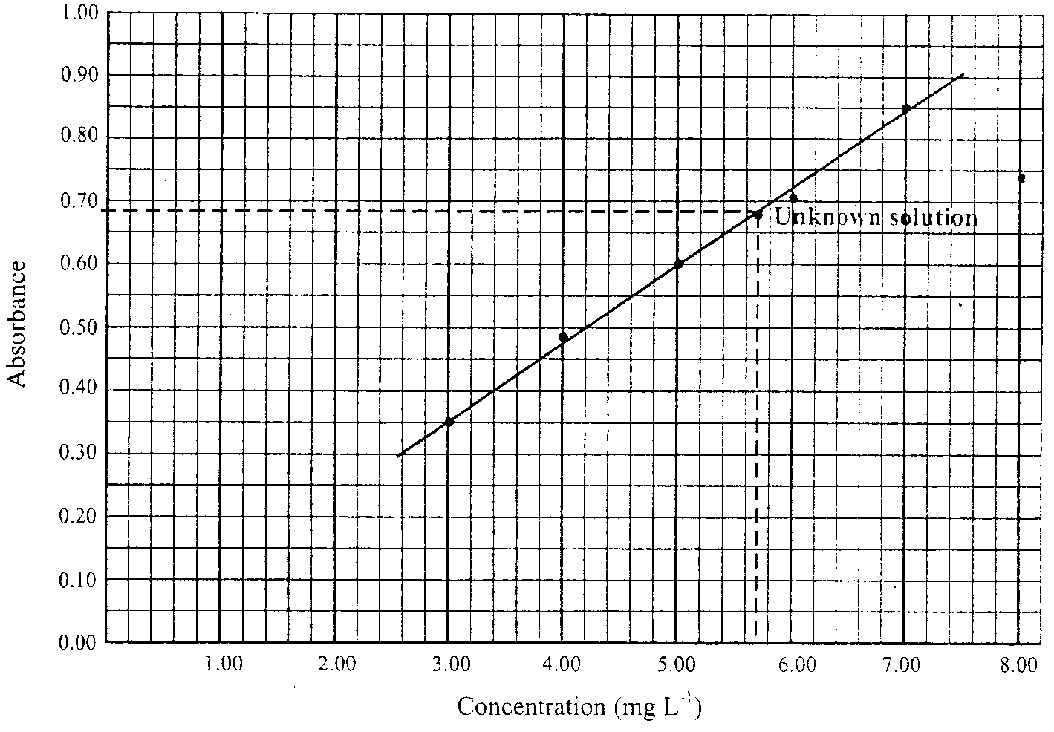
Accurate plotting of points (and drawing of line of best fit). (1 mark)
Label axes (showing Absorbance and Concentration (mg L^{–1})) (1 mark)
Appropriate scaling so that much of the area of the grid provided is used. (1 mark)
- Concentration in sample is 5.70 mg L^{–1} (Allow ±0.15 mg L^{–1}) (1 mark)
- (i) mass of fluorescent brightener 101 = 500 mL is 2.85 mg (1 mark)
(ii) Molar mass = 16 × 12.0 + 12 × 1.0 + 3 × 16.0 = 252 g mol^{–1} (1 mark)
n_{fluorescent brightener 101} = mass / M = 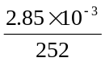 = 1.13 × 10^{–5} mol (1 mark)
number of molecules = n × N_{A} = 1.13 × 10^{–5} × 6.02 × 10²³
number of molecules = 6.80 × 10¹⁸ (or 6.81 × 10¹⁸) (1 mark)

Question 3 (Total = 6 marks)
- The equation for the reaction is
HOCl (aq) + H₂O (l) → OCl– (aq) + H₃O⁺ (aq)
Therefore
K_{a} = 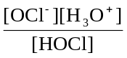 = 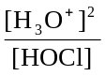 = 3.5 × 10⁻⁸ (1 mark)
[H₃O⁺]² = 0.10 × 3.5 × 10^{–8}
Hence [H₃O⁺] = 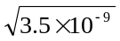 = 5.9 × 10^{–5} M
pH = –log₁₀[H₃O⁺] = –log₁₀(5.9 × 10^{–5}) = 4.23
Therefore pH = 4.2 (1 mark)
- Assumption (1): The self-ionisation of water contributes a negligible amount towards the hydronium ion concentration at equilibrium. Hence [H₃O⁺]_{e} = [OCl–]_{e}.
Assumption (2): The equilibrium concentration of the HOCl is equal to the initial concentration of HOCl. (1 mark)
Note: Explanation of these assumptions.
Assumption (1): The hydronium ion concentration due to the self-ionisation of water is approximately 10^{–7} M. this is over 100 times less than that contributed by the hydrolysis of hypochlorous acid.
Assumption (2): This assumption is valid as only 0.059% (as calculated in part (c)) of the acid is hydrolysed. This results in over 99% of the original HOCl molecules to be still in the molecular form at equilibrium. Typically if the percentage ionisation is less than 5% this assumption is valid.
- % ionisation = × 100 = = 5.9 × 10^{–2} %
% ionisation = 0.059% (1 mark)

Question 4 (Total = 7 marks)
- (i) At equilibrium, the rate of the forward reaction equals the rate of the back reaction. (1 mark)
(ii) At equilibrium, the concentration(s) of reactant(s) and product(s) are not changing. (1 mark)
- [NH₃]² / [N₂] [H₂]³
- 0.200² / (0.040 × 0.010³) = 1.0 × 10⁶ mol^{–2}dm⁶ (or M^{–2}).
Note: units not required for the mark as question asks for the value of the equilibrium constant. (1 mark)
- (i) If a change is made to disturb a system at equilibrium, then the system will, if possible, partially oppose the change to restore equilibrium. (1 mark)
(ii) The forward reaction is exothermic. (1 mark)
If the temperature is increased, the system will move in the direction that will reduce the temperature and therefore a net back reaction will occur so yield is lower. (1 mark)

Question 5 (Total 8 marks)
- Reaction with bromine solution suggests presence of a C to C double bond.
 | 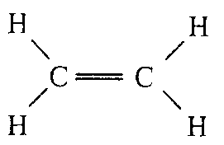 | 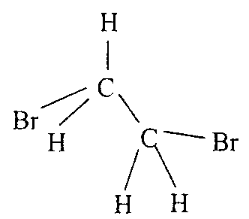
 | Reactant | Product | (1 + 1 = 2 marks)
- Crude oil or natural gas (1 mark)
- (i) Thermal cracking is the breaking of C to C bonds in alkanes using high temperatures (eg 750 to 900°C) in the presence of steam. (1 mark)
Products include alkenes, such as ethene, and smaller alkanes. (1 mark)
(Hydrogen gas is also a product.)
(ii) C₆H₁₄ (g) → C₂ H₄ (g) + C₄H₁₀ (g) (1 mark)

Question 6 (Total = 11 marks)
- Any two of the following three structures.
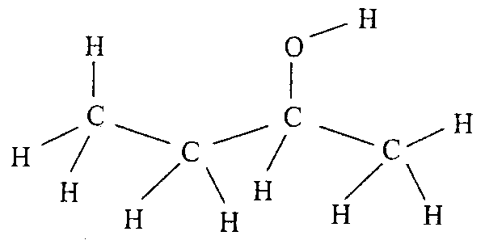 | 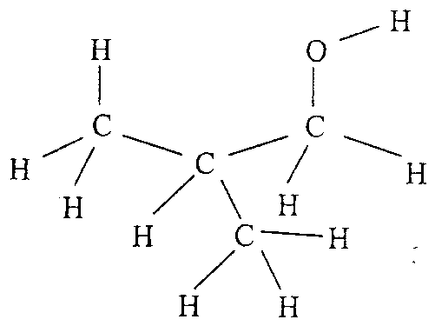 | 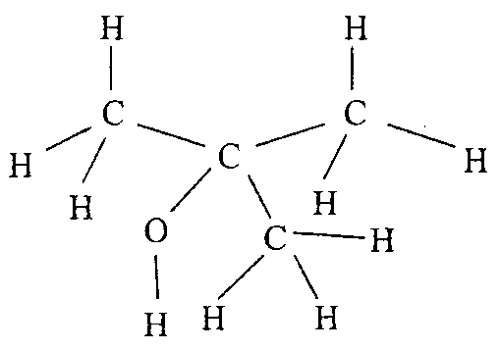
butan-2- ol or 2-butanol | 2-methylpropan-1-ol | 2-methylpropan-2-ol
(1 mark for each structure and 1 mark for each chemical name = maximum of 4 marks)
- C₄H₉OH (l) + CH₃COOH (l) → CH₃COOC₄H₉ (l) + H₂O (l) (1 mark)
Note: semi-structural formulae are not required.
- ester (1 mark)
- C₄H₉OH (g) + 6 O₂ (g) → 4 CO₂ (g) + 5 H₂O (g) (1 mark)
- (i)
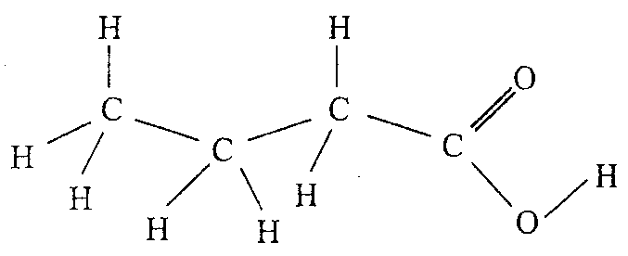 | (1 mark)
(ii) butanoic acid (1 mark)
(iii) bubbles of (carbon dioxide) gas will be observed. (1 mark)
2 C₃H₇COOH (aq) + CO₃^{2–} (aq) → 2 C₃H₇COO– (aq) + CO₂ (g) + H₂O (l)
or
2 C₃H₇COOH (aq) + Na₂CO₃ (aq) → 2 C₃H₇COONa (aq) + CO₂ (g) + H₂O (l) (1 mark)
Note: C₄H₈O₂ could be used in place of C₃H₇COOH and C₄H₇O₂– could be used in place of C₃H₇COO–.

