IARTV 2005 | CHEMISTRY | Unit 4 | Trial Examination Solutions

Section A Multiple Choice Questions (1 mark per each)

- B
- C
- C
- C
- A
- D
- A
- B
- B
- A
- C
- B
- B
- B
- A
- D
- A
- A
- C
- C

Section B Short Answer (total 47 marks)

Question 1 (7 marks)
a. | 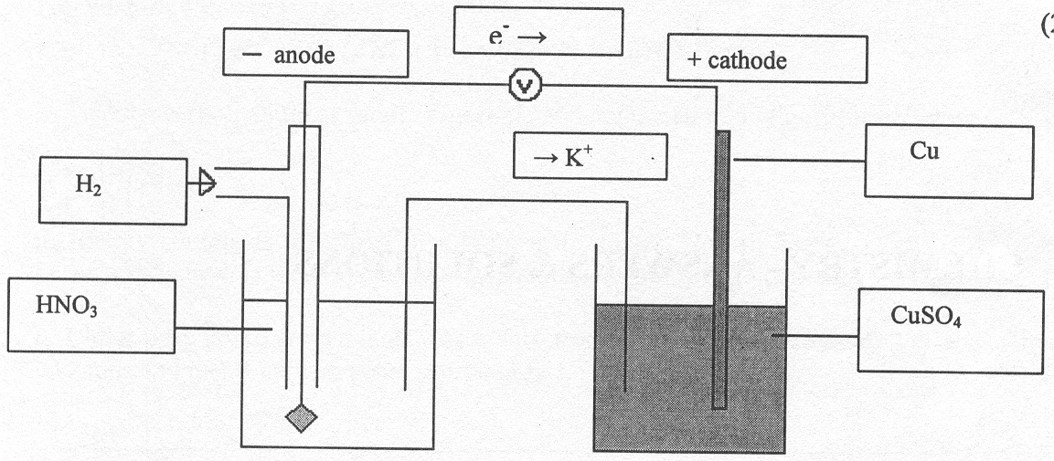 |  |  | 2 marks  1 mark  1 mark
d. |  | Equation for half-reaction | oxidation or reduction | 2 marks
d. | Anode | H₂ (g) → 2 H⁺ (aq) + 2 e– | oxidation | 2 marks
d. | Cathode | Cu²⁺ (aq) + 2 e– → Cu (s) | reduction | 2 marks
e. | Cu²⁺ (aq) + H₂ (g) → 2 H⁺ (aq) + Cu (s) |  |  | 1 mark

Question 2 (6 marks)
a. | HNO₃ (aq) + NaOH (aq) → NaNO₃ (aq) + H₂O (l) | 1 mark
b. | H⁺ (aq) + OH– (aq) → H₂O (l) | 1 mark
c. | ΔH = 335 × 3.30 = 1110 J | 1 mark
d. | n(HNO₃) = 0.400 × 0.0500 = 0.0200 mol  ΔH = 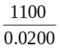 = –55300 J  So ΔH = –55.3 kJ mol^{–1} | 2 marks
e. | ΔH = 100 × 4.18 × 3.30 = 1380 J | 1 mark

Question 3 (7 marks)
a. | sulfuric acid | 1 mark
b. | PbO₂ (s) + SO₄^{2–} (aq) + 4 H⁺ (aq) + 2 e– → PbSO₄ (s) + 2 H₂O (l) | 2 marks
c. | 4 M sulfuric acid is more viscous than water and has a higher density. As the sulfuric acid is consumed the density of the electrolyte drops. | 1 mark
d. | The pH decreases because the electrolyte becomes more acidic. | 1 mark
e. | 2 H⁺ (aq) + 2 e– → H₂ (g) | 1 mark
f. | Any two of:  - Batteries are heavy, mass is a factor in electric cars.  - Lead and its salts are environmental pollutants.  - The electrolyte is corrosive.  - Range of car. | 1 mark

Question 4 (5 marks)
a. | 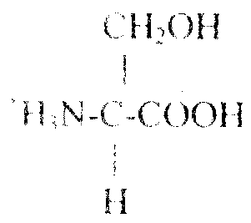 | 1 mark
b. | 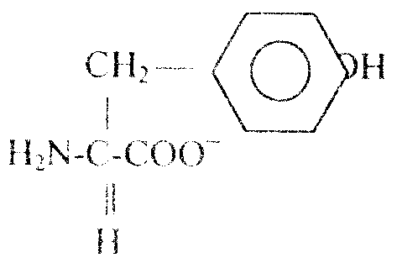 | 1 mark
c. | Hydrogen bonding | 1 mark
d. | 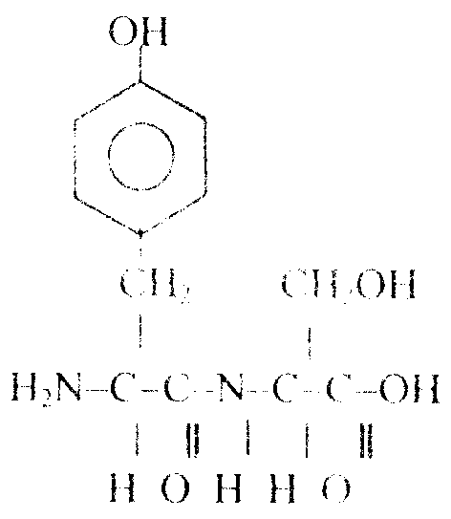 | 2 marks
e. | Condensation polymer | 1 mark

Question 5 (4 marks
a. | Sample answer: amylase is an enzyme in saliva. It helps catalyse the digestion of starch. The starch, the substrate, weakly bonds itself tot eh active site of the enzyme. This lowers the activation energy of the reaction. | 2 marks
b. | Two sample points: enzymes operate over a very narrow range of temperatures and pH, they are unique to a specific reaction; increase reaction rates. Inorganic catalysts do not increase reaction rates to the same extent; they can operate over a wider range of temperatures. | 1 mark
c. | The arsenic bonds to the enzyme at the active site preventing access by the substrate. | 1 mark

Question 6 (7 marks)
a. | (7.4 × 17) + 2.8 × 37) + 27.7 × 16) = 672 600 J = 670 kJ | 2 marks
b. | That the carbohydrate as totally digestible and contained no indigestible cellulose. | 1 mark
c. | Starch 27.2 g | 2 marks
d. | Energy content is measured in a bomb calorimeter. Not all energy is available to the body because oxidation is incomplete and digestion is not totally efficient. | 1 mark
e. | Chick peas come from plants. Most fats from plants are unsaturated. The exception is that coconuts and meats contain some saturated fats. | 1 mark

Question 7 (6 marks)
a. | 1s² 2s² 2p⁶ 3s² 3p⁶ 3d⁶ 4s¹ | 1 mark
b. | 1s² 2s² 2p⁶ 3s² 3p⁶ | 1 mark
c. | The 3d and 4s subshells of Cr have similar energy. | 1 mark
d. | 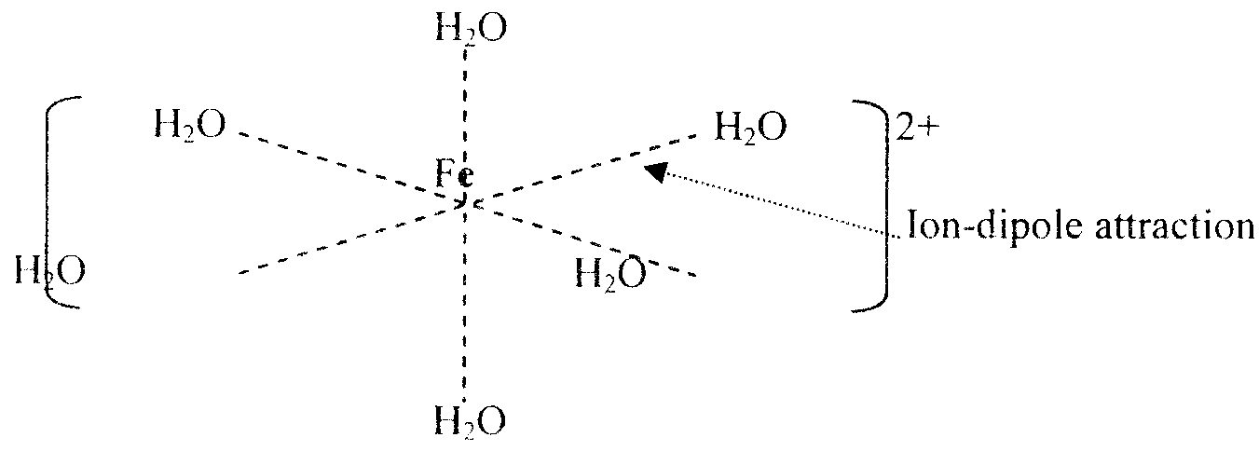 | 2 marks
 | Note: the water molecules in this diagram have been simplified for clarity. Student answers should have water drawn in structural style showing the correct orientation of the ligands.
e. | Iron has two oxidation states, Fe²⁺ 1s² 2s² 2p⁶ 3s² 3p⁶ 3d⁵ 4s¹ and Fe³⁺ 1s² 2s² 2p⁶ 3s² 3p⁶ 3d⁵ each has a stable structure. | 1 mark

Question 8 (5 marks)
a. | C | 1 mark
b. | B | 1 mark
c. | D | 1 mark
d. | B | 1 mark
e. | D | 1 mark

