IARTV
2005
UNIT 4 CHEMISTRY

SECTION A – Multiple-choice questions

Question 1
Dinitrogen trioxide decomposes according to the equation
2 N₂O₃ (g)  2 N₂ (g) + 3 O₂ ΔH = –169 kJ mol^{–1}
The value of ΔH for the reaction N₂ (g) + 1½ O₂ (g)  N₂O₃ (g) is
- +169 kJ mol^{–1}
- +84.5 kJ mol^{–1}
- +13 kJ mol^{–1}
- –84.5 kJ mol^{–1}

Question 2
Chlorine gas is used to kill bacteria in some water supplies but it can harm fish. To convert chlorine gas to the less harmful chloride ions, chlorinated water could be treated with
- sodium fluoride
- iodine solution
- iron(II) chloride solution
- iron(III) chloride solution

Question 3
For a given galvanic cell, the potential difference for the cell depends mainly on
- the sizes of the electrodes
- the volumes of the solutions in the two half cells
- the concentrations of solutions
- the substance in the salt bridge

Question 4
Electricity can be generated in a cell using iron and silver electrodes by the reaction
Fe (s) + 2 Ag⁺ (aq)  Fe²⁺ (aq) + 2 Ag (s)
In this cell
- Ag is the cathode and Fe is the oxidant
- Ag is the anode and Fe is the reductant
- Fe is the anode and Ag⁺ is the oxidant
- Fe is the cathode and Ag is the reductant

Question 5
The diagram below shows a typical fuel cell.
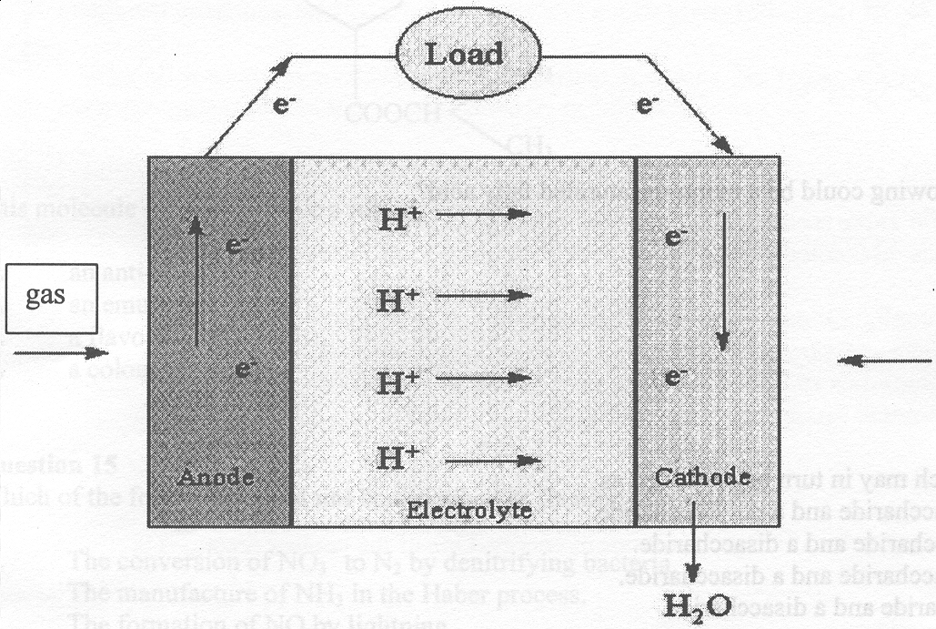
The fuel is most likely to be
- hydrogen gas in an acidic electrolyte
- hydrogen gas in an alkaline electrolyte
- hydrogen chloride gas in an acidic electrolyte
- hydrogen chloride gas in an alkaline electrolyte

Question 6
During electrolysis of alumina, the anode reaction discharges oxide ions, which then react with the carbon electrode to produce carbon dioxide. How many Faradays of electricity are required to produce 1 mole of carbon dioxide?
- ¼
- ½
- 2
- 4

Question 7
An electric current is passed through a solution of dilute sodium fluoride and 20 mL of hydrogen gas is collected at one electrode. At the other electrode
- 10 mL of oxygen gas is produced
- 20 mL of oxygen gas is produced
- 10 mL of fluorine gas is produced
- 20 mL of fluorine gas is produced

Question 8
1.00 mole of electrons passes a certain point in a wire connected to a galvanic cell over a 24 hour period. The current flowing in the wire is approximately
- 1.00 A
- 1.12 A
- 6.02 A
- 9.65 A

Question 9
Which one of the following could be a mono-unsaturated fatty acid?
- C₂₀H₃₆O₂
- C₂₀H₃₈O₂
- C₂₀H₄₀O₂
- C₂₀H₄₃O₂
Question 10
Fructose and starch may in turn be described as
- a monosaccharide and a polysaccharide
- a polysaccharide and a disaccharide
- a monosaccharide and a disaccharide
- a disaccharide and a disaccharide

Question 11
Unsaturated fats have lower melting points than saturated fats because
- their molecules can pack more closely and thus they form stronger dispersion forces with neighbouring molecules
- their double bonds are reactive and can form cross-links with neighbouring molecules
- double bonds alter the shape of the molecule preventing close alignment with neighbouring molecules
- only a small portion of a fat molecule is polar so dipole-dipole bonding is at a minimum

Question 12
Which of the following statements is not true?
- A non-essential amino acid is manufactured by the body and need not be part of the diet.
- The hydrolysis of a triglyceride results in the formation of glycogen and three fatty acids.
- The human body does not have an appropriate enzyme to catalyse the hydrolysis of cellulose.
- Enzymes are themselves proteins.

Question 13
The tertiary structure of proteins involves
- interaction between neighbouring protein molecules
- folding and bending caused by interaction between the Z (or R) groups
- hydrogen bonding between neighbouring –CO and –NH groups
- the sequence of covalently bonded amino acids

Question 14
A common additive in food is
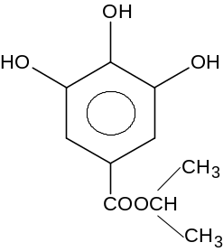
This molecules is likely to have a role as
- an antioxidant
- an emulsifier
- a flavour enhancer
- a colouring agent

Question 15
Which of the following could not be describes as fixation of nitrogen?
- The conversion of NO₃– to N₂ by denitrifying bacteria.
- The manufacture of NH₃ in the Haber process.
- The formation of NO by lightning.
- The formation of NO and NO₂ in combustion engines.

Question 16
If 1.0 mol of the fat, tristearin (C₅₇H₁₁₀O₆), is hydrolysed the total mass for all of the products formed will be
- 836 g
- 890 g
- 908 g
- 944 g

Question 17
Of the pairs of elements listed below, which of the first element names would have a greater first ionisation energy than the second element?
- Li and Na
- Br and Cl
- Cr and Mn
- Li and Be

Question 18
Element X forms amphoteric oxides and is located in the third period. The electron configuration of this element in its ionic state is
- 1s² 2s² 2p⁶
- 1s² 2s² 2p⁶ 3s² 3p¹
- 1s² 2s² 2p⁶ 3s² 3p³
- 1s² 2s² 2p⁶ 3s² 3p⁶ 4s² 3d¹

Question 19
The present Periodic Table represents the combination of experimental work conducted by chemists over several decades. Mendeleev was able to develop his original periodic table based on
- electronic configurations and chemical properties
- mass numbers and atomic numbers
- chemical properties and experimentally derived atomic masses
- trends in isotopic masses across periods and down groups

Question 20
The Sun provides the Earth with huge quantities of energy. One of the nuclear reactions is
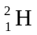 + 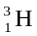  X + 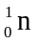
The particle X is
- a positron
- an electron
- an alpha particle
- a proton

SECTION B – Short-answer questions

Question 1 (7 marks)
For the following galvanic cell all substances are at standard conditions and the voltmeter reading is +0.34 V.
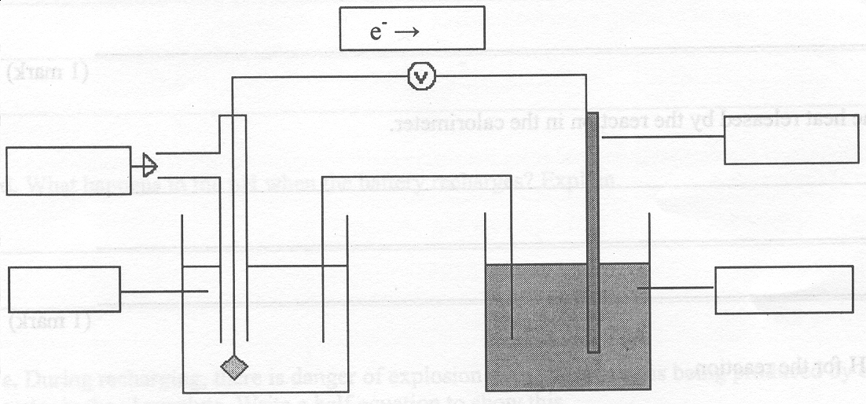
- In each of the four boxes on the diagram, write a formula of a suitable substance that could be used in this galvanic cell, which will give the required reading on the voltmeter.
2 marks
- (i) Label the polarity of each electrode on the diagram.
(ii) Label the anode and cathode on the diagram.
1 mark
- The salt bridge contains potassium nitrate solution. On the diagram label, with arrows, the direction of potassium ions through the salt bridge.
1 mark
- Complete the following table for the reaction.
 | Half-equation | Oxidation or reduction
Anode
Cathode
2 marks
- Write the overall equation for the reaction.
_______________________________________________________________________________________
_______________________________________________________________________________________
1 mark

Question 2 (6 marks)
50.0 mL of 0.400 M HNO₃ solution is added to 50.0 mL of 0.400 M NaOH solution in a calorimeter which has a calibration factor of 335 J °C^{–1}. The temperature of the calorimeter and each solution was originally 16.30°C and after mixing, the temperature of the mixture plus calorimeter was 19.60°C.

- Write a balanced full equation for the reaction in the calorimeter.
_______________________________________________________________________________________
1 mark
- Write a balanced ionic equation for the same reaction.
_______________________________________________________________________________________
1 mark
- Calculate the heat released by the reaction in the calorimeter.
_______________________________________________________________________________________
_______________________________________________________________________________________
_______________________________________________________________________________________
- Calculate ΔH for the reaction.
_______________________________________________________________________________________
_______________________________________________________________________________________
_______________________________________________________________________________________
2 marks
- In the experiment above, how much heat energy is absorbed by the water during the reaction? Assume that the specific heat capacity of water is 4.18 J g^{–1} °C^{–1} and that the densities of all solutions are 1.00 g m^{–1}.
_______________________________________________________________________________________
_______________________________________________________________________________________
1 mark

Question 3 (7 marks)
In a lead-acid battery, the overall equation when the battery is supplying energy can be written as
Pb (s) + PbO₂ (s) + 2 SO₄^{2–} (aq) + 4 H⁺ (aq)  2 PbSO₄ (s) + 2 H₂O (l)

- What is the electrolyte used in this battery?
_______________________________________________________________________________________
1 mark
- Write a half-equation for the reaction that occurs at the positive electrode.
_______________________________________________________________________________________
_______________________________________________________________________________________
2 marks
- Explain why the density of the electrolyte decreases when the battery discharges.
_______________________________________________________________________________________
_______________________________________________________________________________________
_______________________________________________________________________________________
1 mark
- What happens to the pH when the battery recharges? Explain.
_______________________________________________________________________________________
_______________________________________________________________________________________
1 mark
- During recharging, there is a danger of explosion with hydrogen gas being produced by the electrolysis of water in the electrolyte. Write a half equation to show this.
_______________________________________________________________________________________
1 mark
- Lead-acid batteries have been used in electric cars. What are two disadvantages of electric cars compared to petrol or LPG cars?
_______________________________________________________________________________________
_______________________________________________________________________________________
1 mark

Question 4 (5 marks)
Two naturally occurring α-amino acids are serine and tyrosine.
The Z (or R) group for serine is –CH₂OH and for tyrosine is | 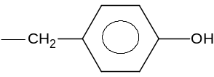

- Draw the structure of serine at a pH of 2.

1 mark
- Draw the structure of tyrosine at a pH of 10.

1 mark
- What is the strongest type of bonding expected between these Z (or R) groups?
_______________________________________________________________________________________
1 mark
- Draw the structure of the dipeptide formed from the reaction of the amine group of the serine and the acid group of the tyrosine.

1 mark
- Food proteins have been called edible polymers. What type of polymer is a protein?
_______________________________________________________________________________________
1 mark

Question 5 (4 marks)
- Describe how an enzyme functions in a chemical reaction using a specific example.
_______________________________________________________________________________________
_______________________________________________________________________________________
_______________________________________________________________________________________
_______________________________________________________________________________________
2 marks
- List two differences between inorganic catalysts and enzymes.
_______________________________________________________________________________________
_______________________________________________________________________________________
_______________________________________________________________________________________
1 mark
- Some substances like compounds containing arsenic, poison enzymes in the body. Suggest how this may happen.
_______________________________________________________________________________________
_______________________________________________________________________________________
_______________________________________________________________________________________
_______________________________________________________________________________________
1 mark

Question 6 (7 marks)
The label on a can of vegetables containing chick peas contains the following information.

 | Quantity per serving 120 g | Quantity per 100 g
Energy | 695.5 kJ | 579.6 kJ
Protein | 7.4 g | 6.2 g
Fat total  – saturated | 2.8 g  0 g | 2.3 g  0 g
Carbohydrate total  – sugars | 27.7 g  0.5 g | 23.1 g  0.4 g
Sodium | 461.5 mg | 384.6 mg

Drained weight 240 g
Serving size 120 g

If we assume that the available energy to the body is

Protein: 17 kJ g^{–1}
Fat: 37 kJ g^{–1}
Carbohydrate: 16 kJ g^{–1}

- Calculate the total energy available from a 120 g serving using the figures given above.
_______________________________________________________________________________________
_______________________________________________________________________________________
_______________________________________________________________________________________
2 marks
- In your calculation what assumption did you make about the carbohydrate present?
_______________________________________________________________________________________
_______________________________________________________________________________________
_______________________________________________________________________________________
1 mark
- Which carbohydrate predominates in chick peas and how much of it is in a serving?
_______________________________________________________________________________________
_______________________________________________________________________________________
2 marks
- Explain why there is a discrepancy between your figure and the label claim?
_______________________________________________________________________________________
_______________________________________________________________________________________
1 mark
- Why is there no saturated fat present in the can of chick peas?
_______________________________________________________________________________________
_______________________________________________________________________________________
1 mark

Question 7 (6 marks)
The first transition series of metals show properties quite different from the alkali metals and the alkaline earth metals.

- Write the electronic configuration of iron metal.
_______________________________________________________________________________________
1 mark
- Write the electronic configuration of the potassium cation.
_______________________________________________________________________________________
1 mark
- Explain why chromium has multiple oxidation states.
_______________________________________________________________________________________
1 mark
- Draw a coordination complex when [Fe(H₂O)₆]²⁺ is in aqueous solution. Label the types of bonding in the complex. Show the correct orientation of the ligands.

2 marks
- Explain why the elements iron has two oxidation states.
_______________________________________________________________________________________
_______________________________________________________________________________________
1 mark

Question 8 (5 marks)
Consider the following sketch graphs of trends in the Periodic Table.

A. | 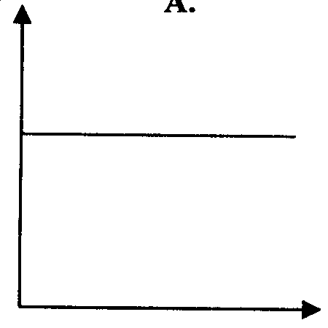  Z (atomic number) | B. | 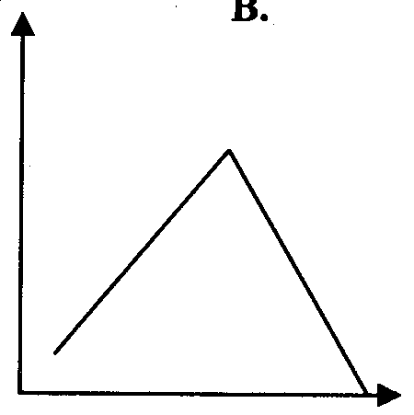  Z (atomic number) | C. | 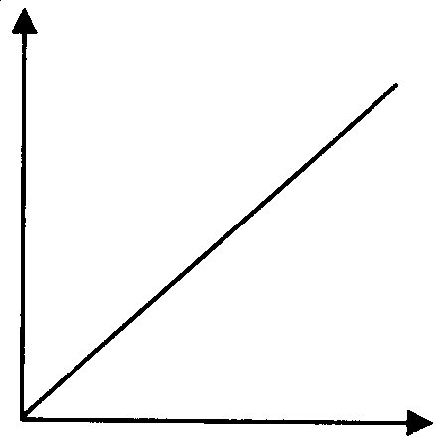  Z (atomic number)

D. | 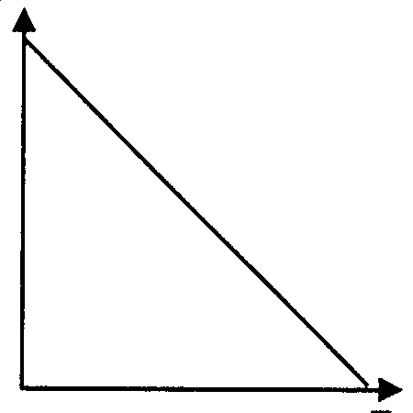  Z (atomic number) | E. | 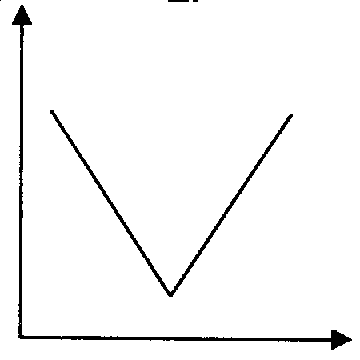  Z (atomic number)

- Which graph best represents the trend of the number of isotopes for a particular element versus atomic number? | ________
- Which graph best represents the number of possible oxidation states across the first transition series? | ________
- Which graph best represents the pH of the oxides across the third period elements? | ________
- Which graph best represents the magnetic properties across the fist transition metal elements? | ________
- Which graph best represents the atomic radius across the third period elements? | ________

