INSIGHT
2005
UNIT 4 CHEMISTRY

SECTION A – Multiple-choice questions

Question 1
Answer is C
    - Remember that the lower number on the left of the element’s symbol, 94, is the atomic number, which equals the number of protons in the nucleus of the atom.
    - The higher number on the left of the element’s symbol, 239, is the mass number, which equals the number of protons plus the number of neutrons.
    - The difference between the two is the number of neutrons: 239 – 94 = 145

Question 2
Answer is D
Remember two things:
    - The reaction occurring at the anode is oxidation. (An easy way to remember this is that both ‘anode’ and ‘oxidation’ start with a vowel and always go together. Alternatively, both ‘cathode’ and reduction’ start with a consonant and always go together. This is true for both spontaneous and electrolytic reactions.)
    - Oxidation is loss of electrons (‘OIL’). Oxidation involves an increase in oxidation number.
This knowledge allows you to eliminate alternatives B and C.
Now check that alternatives A and D are correctly balanced and both occur in the cell as given by the cell reaction.
    - A is not correctly balanced for charge. There is a +1 charge on the left-hand side and a zero charge on the right-hand side.
    - D is correctly balanced, occurs in the given reaction and is an oxidation reaction.

Question 3
Answer is B
    - Remember that glucose is a monosaccharide produced by plants as a result of photosynthesis. It polymerises to form polysaccharides – starch and cellulose in plants, and glycogen in animals.
    - Glucose does not form proteins or fats, hence eliminating alternatives A and D.
    - Alternative C is also eliminated because glucose is not formed in animals.
    - Remember that respiration – the oxidation of glucose by oxygen – is an important source of energy. The equation for respiration is: C₆H₁₂O₆ (aq) + 6 O₂ (g) → 6 CO₂ (g) + 6 H₂O (l).

Question 4
Answer is A
    - Due to the presence of electrons in d-subshells, transition metals form coloured compounds and complex ions and exhibit a wide range of oxidation states.
    - Because the core charge of atoms of transition metals are higher than for Group I and II metals, they are weaker reductants.
    - Hint: look at the Electrochemical Series in the Data Sheet and it is clear that Group I and II metals are stronger reductants than transition metals. This series can be useful for more than just predicting half-cell reactions.

Question 5
Answer is C
    - Remember that the strongest oxidant reacts with the strongest reductant. The strongest oxidant (look at the Electrochemical Series in the Data Sheet) is Ag⁺ (aq) and the strongest reductant is Sn (s).
    - Remember that oxidants undergo reduction (which occurs at the cathode) and reductants undergo oxidation (which occurs at the anode).

Question 6
Answer is B
    - Firstly, the salt bridge solution must be a chemical that is soluble and will not cause any side reactions to occur. The chloride ions in a KCl solution have the potential to produce chlorine gas and react with the Ag⁺ ions, so this is not a good choice for a salt bridge. This eliminates alternatives C and D.
    - The electrolyte solutions need to contain the ions required for the half-cells, so Fe(NO₃)₃, Fe(NO₃)₂ and AgNO₃ solutions are used.
    - Because the Fe³⁺/Fe²⁺ half-cell has Fe²⁺ as the reductant and not iron, the electrode must be made from an inert material such as graphite. If an iron rod were used, it could take part in the reaction.
    - Silver metal is needed in the Ag⁺/Ag half-cell and so a silver rod can be used as the electrode.

Question 7
Answer is B
    - Emission spectra are the result of energy being emitted by electrons.
    - An excited state is a higher energy state than the ground state.
    - The energy levels (shells) around the nucleus increase in energy as they move away from the nucleus. Electrons that move from a higher to a lower level are decreasing in energy, and must therefore emit the difference in energy between the two levels.

Question 8
Answer is B
    - Metals produce oxides (eg. Na₂O) that are usually basic.
    - Non-metals produce oxides (eg. SO₂) that are usually acidic.
    - Amphoteric oxides are compounds that can act as either acidic oxides or basic oxides, depending on whether they are reacting with bases or acids. For example, Al₂O₃ reacts with HCl (aq) and NaOH (aq) in the following two equations:
Al₂O₃ (s) + 6 H⁺ (aq) → 2 Al³⁺ (aq) + 3 H₂O (l)
Al₂O₃ (s) + 2 OH⁻ (aq) 3 H₂O (l) → 2 Al(OH)₄⁻ (aq)
    - As you move from left to right across the Periodic Table – and therefore from elements that form basic oxides to ones that form acidic oxides – the oxides that exhibit both properties (that is, that are amphoteric) will be in the middle.

Question 9
Answer is C
    - The equation for respiration is C₆H₁₂O₆ (aq) + 6 O₂ (g) → 6 CO₂ (g) + 6 H₂O (l).
    - Remember that when oxygen is present it will be the oxidant, hence alternative B and D are eliminated.
    - Respiration occurs to provide our cells with energy.
    - Exothermic reactions are energy-releasing reactions.

Question 10
Answer is D
    - Core charge is the positive charge of the nucleus that is experienced by the outer-shell electrons of an atom. It is the difference between the atomic number and the number of shielding inner-shell electrons.
    - Core charge increases as you move across Period 3 from left to right.
    - The number of electrons and the number of protons in an element increase as you move across Period 3 from left to right.

Question 11
Answer is A
    - Proteins are formed when α-amino acids (those where the amino group, –NH₂, and the carboxyl group, –COOH, are both bonded to the same carbon atom) undergo condensation (release of water) reactions and produce peptide bonds, –CONH–.
    - The breakdown of proteins therefore requires water to react with the peptide bonds and reform the α-amino acids. Therefore alternatives B and D are eliminated.
    - To find the amino acids which will be produced, locate the peptide bond, –CONH–, split it between the CO and NH atoms and add –OH (from water) to the CO and –H (the rest of the water molecule) to the NH. This will reform the carboxyl group, –COOH, and the amino group, –NH₂, which appear at either end of the α-amino acids from which the protein was made.
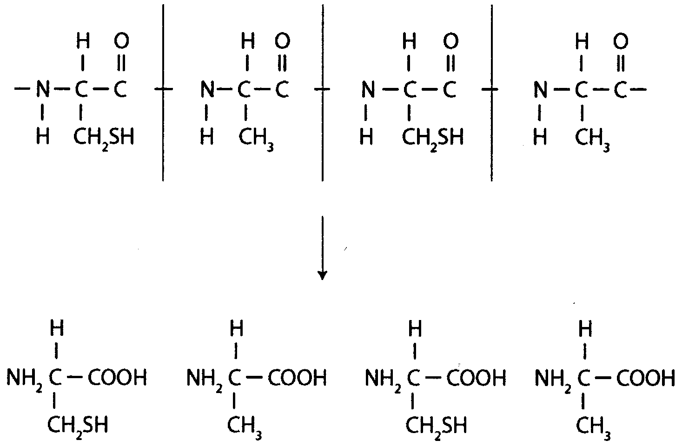

Question 12
Answer is B
    - The steps involved are conversion from atmospheric nitrogen, N₂, to ammonium ions, NH₄⁺, and then conversion of the ammonium ions to nitrate ions, NO₃⁻.
    - The rules for oxidation numbers state that:
- An element has an oxidation number of 0.
- The sum of the oxidation numbers for molecular ions equals the charge on the ion.
- The usual oxidation number for hydrogen is +1.
- The usual oxidation number for oxygen is –2.
    - In the case of N₂: the nitrogen is in its elemental state and has an oxidation number of 0.
    - In the case of NH₄⁺: x + 4 = +1, so x = –3
    - In the case of NO₃⁻: x + 3(–2) = –1, so x = +5

Question 13
Answer is A
    - Nitrogen fixation is the conversion of nitrogen gas to nitrogen compounds.
    - The only step that starts from atmospheric nitrogen in the alternatives provided is alternative A.

Question 14
Answer is B
    - When two glucose molecules condense, hydroxy groups, –OH, on both molecules react to from an ether link,
–C–O–C–, and release a water molecule formed from the –OH and –H groups. See the diagram below.
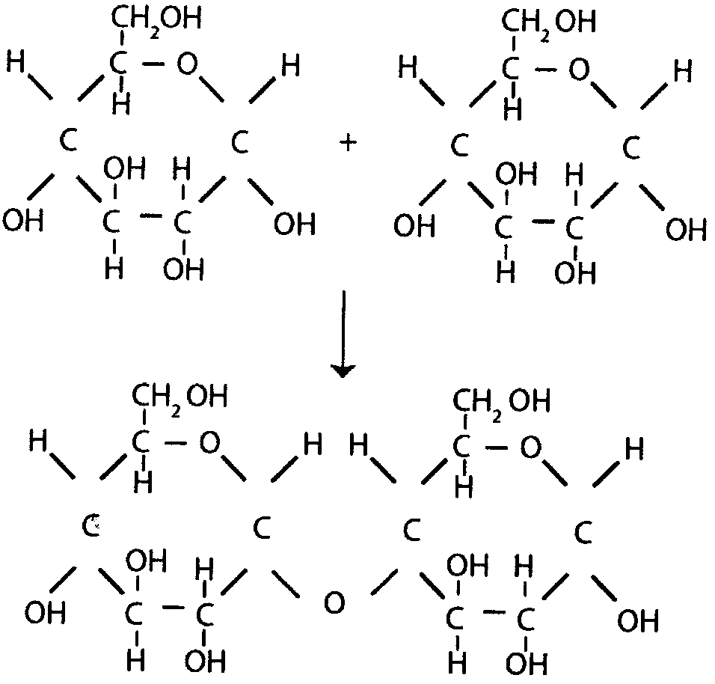

Question 15
Answer is B
    - An α-amino acid is one where the amino, –NH₂, and carboxyl, –COOH, groups are both bonded to the same carbon atom.
    - Hydrolysis means reacting the protein with H₂O, splitting the peptide bonds and producing the amino acids from which the protein was made.

Question 16
Answer is C
    - This question tests your knowledge of food additives.
    - Emulsifiers stabilise a mixture of different liquids, such as water and oil, because their molecules have a hydrophilic and a hydrophobic end.
    - Antioxidants prevent the oxidation of C=C double bonds in unsaturated fats by being preferentially oxidised themselves by oxygen.

Question 17
Answer is B
    - Given the half-cell reaction, you can see that the concentration of hydrogen ions, [H⁺], is decreasing as the reaction proceeds. Therefore the pH must be increasing, because pH = –log₁₀[H⁺]. This eliminates alternatives A and C.
    - The oxidation number of Pb in PbO₂ = is +4: x + 2(–2) = 0, so x = +4.
    - The oxidation number of the Pb²⁺ ion in PbSO₄ is +2. (Remember, oxidation numbers of simple ions such as Pb²⁺ equals the charge on the ion.)
    - Hence the oxidation number has decreased from +4 to +2.

Question 18
Answer is C
    - The main source of energy in the body normally is fat. However, when energy is needed quickly, it is obtained from glycogen.

Question 19
Answer is D
    - When an element’s electrons are in the ground state, they occupy the lowest energy levels possible.
    - For elements in Period 4, the 4s-subshell can hold up to two electrons.
    - After the 4s-subshell, the next energy shell to be filled is the 3d-subshell, which can hold up to 10 electrons.
    - Alternatives B and C have the lower 4s-subshell filled with the maximum number of two electrons, and are therefore in their ground state.
    - D is in an excited state because the 4s-subshell has only one electron – the other electron is in the higher energy 3d-subshell.

Question 20
Answer is C
    - The ionisation energy of an element is the minimum amount of energy required to remove an electron from an atom, or an ion, in the gaseous state. Alternatives A and D involve Br₂ molecules.
    - The first ionisation energy is the energy required to remove the outermost electron. Alternatives B and D are not removing electrons.

SECTION B – Short-answer questions

Note the asterisks. In this section * denotes marks.
Asterisks are located at the end of the point that must be made to gain the mark.

Question 1
- i. E (positive electrode): 2 Cl⁻ (aq) → Cl₂ (g) + 2 e⁻ *
ii. F (negative electrode): 2 H₂O (l) + 2 e⁻ → H₂ (g0 + 2 OH⁻ (aq) *

    - When writing balanced equations, take care to write the correct formulae and use appropriate states of matter.
    - One mark will be deducted, once only from the paper, when incorrect states are used or when states are omitted.
    - One mark is awarded for the correctly balanced equation for each electrode.
    - These equations do not have to be memorised because they are on the Data Sheet. Being told what is produced in the cell allows you to copy the equations from the Data Sheet.
    - It is important that you remember that the Electrochemical Series is for standard conditions (1 M, 1 atmosphere and 25°C) and that the Nelson Cell is using brine as the electrolyte, which is more concentrated than 1 M. hence the table prediction are not necessarily accurate. In this case you are told that Cl₂ (g) is produced.
    - Remember this is an electrolysis reaction, and that although reduction still occurs at the cathode, the cathode is the negative electrode in electrolysis. Ensure that the reaction that consumes electrons is written beside the negative electrode.

- A barrier of asbestos was once used to separate the sites of oxidation and reduction. Asbestos is a health hazard. The semi-permeable membrane that is now used is designed to only allow Na⁺ ions through to the solution around the negative electrode.* The Cl⁻ ions are too large to fit through the membrane. This prevents NaCl contaminating the NaOH produced, which was a problem when asbestos was used.*

    - This is a fact that you are required to learn.

- The cell reaction, established from the half-equations in a., is:
2 Cl⁻ (aq) + 2 H₂O (l) → Cl₂ (g) + H₂ (g) + 2 OH⁻ (aq)
or 2 NaCl (aq) + 2 H₂O (l) → Cl₂ (g) + H₂ (g) + 2 NaOH (aq)
Therefore:
n(NaOH) = 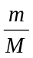 = 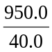= 23.75 mol *
n(Cl₂) = ½ × n(NaOH) = 11.88 mol *
So V(Cl₂) = n × V_{M at STP} = 11.88 × 22.4 = 266 L *

    - In order to know the mole reaction between Cl₂ and NaOH the overall cell equation must be determined. As there are two electrons on each side of the two half-cell equations, the overall cell reaction is found by simply adding these two half-equations.
    - Remember that STP means ‘standard temperature and pressure’. The volume occupied by any gas at these conditions (0°C and 1 atmosphere pressure) is 22.4 L. This is given on the Data Sheet.
    - Three significant figures are required because the molar volume and the molar masses are given to 3 significant figures only (although the mass of sodium hydroxide is given to 4 figures).
    - Keep all the digits in your calculator for the whole question, but round off to the appropriate number of significant figures for each part answer.
    - One mark will be deducted, once only from the paper, when incorrect significant figures are used in calculations.
    - It is worth writing the mole ratio clearly before substituting, because this is often worth one mark. If you substitute incorrectly, it may not be clear that you know the correct mole ratio.

- From the half-equation:
n(electrons) = 2 × n(Cl₂) = 2 × 11.88 = 23.75 mol
Q = n(electrons) × F = 23.75 × 96500 = 2292840 C *
E = VIt = VQ = 4.5 × 2292840 = 10317780 = 10.3 MJ *

    - To calculate the energy (E = VIt = VQ) you need to know Q.
    - Q = It, and also, Q = n(electrons) × F.
    - Generally, you need to use both of these equations. Remember that the two equations Q = It and Q = n(electrons) × F are a way of linking stoichiometry (mass, volume, etc) to charge in a cell via the n(electrons). You can always determine the relationship between n(electrons) and mass or volume by the half-cell equations.

- i. Sodium metal *

    - You should know that the Down’s Cell involves electrolysing molten sodium chloride. Using the Electrochemical Series, when only Na⁺ ions and Cl⁻ are present (without water), Na metal and Cl₂ gas are produced.

ii. Water is present in the Nelson Cell and H₂O is a stronger oxidant than Na+ ions.*

    - Remember, whenever water is present, none of the metals lower in the Electrochemical Series on the left hand side are produced from electrolysis of their metal ions.
2 + 2 + 3 + 2 + 2 = 11 marks

Question 2
- 6 CO₂ (g) + 6 H₂O (l) 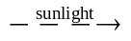 C₆H₁₂O₆ (aq) + 6 O₂ (g) *

    - This is an equation that you should learn.

- C₆H₁₂O₆ (aq) + 6 O₂ (g) → 6 CO₂ (g) + 6 H₂O (l); ΔH = –2813 kJ mol⁻¹ *

    - A thermochemical equation includes the ΔH value as well as a fully balanced equation.
    - Remember, when writing balanced equations, take care to write the correct formulae and use appropriate states of matter.
    - As stated earlier, one mark will be deducted, once only from the paper, when incorrect states are used or when states are omitted.

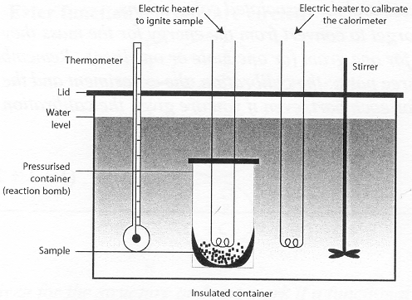
    - 4 × ½ marks are awarded for correctly labelling any four of the major parts being:

stirrer
thermometer
insulated container
electric heater
reaction bomb of the calorimeter

- Using an electric heater, a known amount of thermal energy (E = VIt)* is passed through the calorimeter, which is filled with a measured volume of water. The change in temperature, ΔT,* of the water in the calorimeter is recorded.

    - The calibration constant = 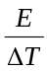 = 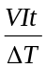 and has the units kJ °C⁻¹.
    - It is important that the volume of water in the calorimeter is measured, because all further experiments in that calorimeter using that calibration constant must use identical conditions, including the same volume of water and the same stirrer, electric heater and thermometer used in the calibration process.

- Use the same volume of water in the calorimeter as for the calibration process.
Weigh a mass of breakfast cereal.*
Measure the temperature of the water in the calorimeter.
Burn the cereal in the calorimeter.
Measure the maximum temperature of the water after the combustion reaction, hence determining ΔT.*
Calculate the energy released by this measured mass using the formula:
E(for measured mass) = calibration constant × ΔT
Convert to energy content in kJ g⁻¹ using the formula:
Energy content = 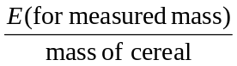 *

    - It is important to read the question carefully. In this response it was necessary to describe the process and the associated calculations.
    - Many students forget to convert from the energy for the mass they used in the experiment to kJ for one gram (or one mole or one litre). Remember, calorimeter questions have three parts: the calibration, the experiment and the conversion. Be sure to account for each part, even if you are given the calibration constant.
1 + 1 + 2 + 2 + 3 = 9 marks

Question 3
- The fat will be a solid at room temperature.*
The C:H ratio indicates it is made from a saturated fatty acid.*
Saturated fats can pack more closely together, resulting in stronger dispersion forces between their molecules, producing a solid state at room temperature.*

    - The double bonds in molecules of polyunsaturated fats do not allow such close packing, resulting in weaker dispersion forces and therefore a liquid state (oil) at room temperature.

- Glycerol
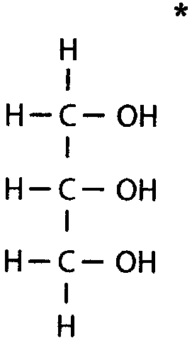
    - This is a structure you are expected to know.

- Ester functional groups are circled.*
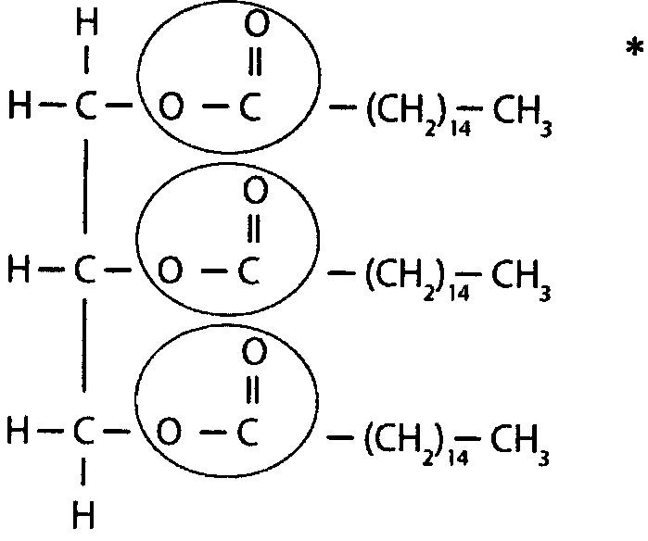
    - One mark is given for the structure and one mark if a functional group is circled and correctly names.
    - Remember that an ester functional group is formed when glycerol (which contains three hydroxy groups), reacts with the carboxyl group on three fatty acid molecules.
    - Draw glycerol and copy the fatty acid from the question so that the –COOH group on each acid is opposite the –OH groups of the glycerol.
3 + 1 + 2 = 6 marks

Question 4
- Cr

    - If this is the electron configuration of a +2 ion, then the neutral atom will have 2 more electrons than given. As there are 22 given, the atom must have 24 electrons. This is chromium.

- 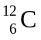

    - This is a nuclear equation and it is balanced by having the sum of atomic numbers and the sum of mass numbers on each side of the arrow equal.
    - When 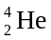 is multiplied by 3, it becomes 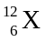. An element with an atomic number of 6 is carbon.

- NH₂CHZCOO⁻

    - A general α-amino acid has the structure NH₂CHZCOOH.
    - It can act as and acid and donate the proton from the –COOH group or it can act as a base and accept a proton onto the –NH₂ group.
    - When it is in a medium that is basic, there is an excess of OH⁻ ions and so it acts as an acid and donates a proton, forming –COO⁻.
    - When it is in a medium that is acidic, there is an excess of H⁺ ions and so it acts as a base and accepts a proton, forming
–NH₃⁺.

- NH₂CONH₂

    - Urea is the chemical that the human body produces to remove excess nitrogen. This is a compound you are expected to know.
4 marks

Question 5
- i. Coal-fired power station:
chemical energy in coal → thermal energy of steam →* mechanical energy of turbine → electrical energy *
Hydrogen fuel cell power station:
chemical energy in hydrogen → electrical energy *

ii. In a coal-fired power station there are large energy losses due to the many energy transformations, in particular the thermal → mechanical step. The losses in energy transformation in a fuel cell are smaller.*

    - The more energy conversions there are, the greater the chances of energy loss. Furthermore, whenever thermal (heat) energy is converted into any other energy form, the efficiency of the process is greatly reduced. It is this step that reduces the coal-fired power station’s efficiency to 30-40% as compared to the efficiency in a hydrogen fuel cell power station of about 80%.

iii. The cost* of generating electricity by this method is currently higher because of the slow reaction rate, and the electrodes are made of expensive catalytic materials.

iv. Anode reaction: H₂ (g) + 2 OH⁻ (aq) → 2 H₂O (l) + 2 e⁻ *
Cathode reaction: O₂ (g) + 2 H₂O (l) + 4 e⁻ → 4 OH⁻ (aq) *

    - Be careful to write equations for the correct electrolyte. The oxidation and reduction equations for both an acidic and an alkaline electrolyte are given in the Electrochemical Series in the Data Sheet. For this reason, there is no need to learn them; just be aware of where they are and be careful to select the appropriate ones for the electrolyte.
    - The second point to make sure of is that you write the half-reaction equation for the correct electrode and that you copy it in the direction you mean it to be. It is a common error to write the half-reactions in the wrong places. Don’t forge that oxidation occurs at the anode. (Remember, they both start with vowels and always occur together.)

- i. 4 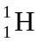 → 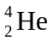 + 2 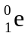 *

    - This is a reaction that you need to learn. Remember that nuclear equations are balanced when the atomic numbers and mass numbers on each side of the arrow are equal.

ii. The splitting of a single large nucleus to give several smaller nuclei.*

    - Such reactions can be either exothermic or endothermic, depending on which nuclei are being split. If the nucleus is larger than iron, it will be exothermic and if smaller than iron, it will be endothermic. Hence there is no need to include a discussion of energy.
7 + 2 = 9 marks

Question 6
- It is a ‘lock and key’ process where the substrate molecule bonds to the active site of the enzyme while the reaction is being catalysed.*
This causes the breaking of bonds within the substrate molecule, producing the products of the reaction when the substrate-enzyme bonds break. The enzyme shape is unchanged after the reaction, so it is able to catalyse the next such reaction.*

    - It may be easier to describe this process using a series of diagrams similar to the one given below. Correctly labelled diagrams provide a large amount of information. It can often be difficult to express your thoughts as clearly and yet as fully.
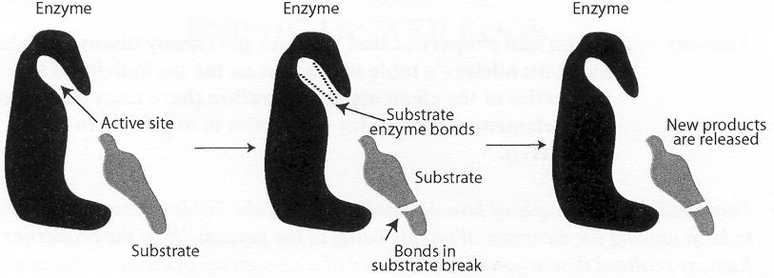
- An enzyme in pineapple catalyses a reaction with the gelatine that stops it from setting. If, however, the pineapple has been heated,* the enzyme is denatured and the reaction does not occur.*

    - This question requires you to apply your knowledge of enzymes. High temperatures (and changes in pH) cause enzymes to change their tertiary structure and prevent them from being able to catalyse further reactions.
2 + 2 = 4 marks

Question 7
- He put the elements in horizontal order on the basis of their atomic masses* and in vertical order on the basis of the periodicity of their chemical properties.*

    - Mendeleev only had information about the properties of the elements, including their masses, which had been discovered before 1869. He had a strong belief in the periodicity of the properties of the elements. He put the elements in a horizontal and vertical order and he left spaces for elements that were still to be discovered. Because of his table, scientists were able to go looking for missing elements.

- Argon had properties that no other previously discovered element had.* Mendeleev’s table was based on the periodicity of the properties of the elements and therefore there must have been other elements with similar properties to argon yet to be discovered.*

    - This was a good example of how Mendeleev’s Periodic Table encouraged scientists to keep looking for elements. With this belief in the periodicity of the properties, Ramsay realised that argon was a member of a new group of elements because its properties were not similar to those of other elements.

- Cobalt consists of a higher abundance of isotopes that have a greater number of neutrons* in them, hence giving cobalt a higher relative atomic mass.

    - Relative atomic mass is calculated from the masses of the naturally occurring isotopes weighted according tot heir abundance. One element may have a smaller number of protons than another but have more neutrons in its isotopes. Therefore the element may then have a larger mass than the other.

- The relative abundance and isotopic mass of each naturally occurring isotope.*

    - You need to know this in order to calculate relative atomic mass.

- i. The 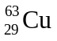 isotope.

    - By looking at the relative atomic mass, you can see that the isotope is closer to the weighted average and must therefore be more abundant.

ii. Relative atomic mass is calculated from the weighted mean of the isotopic masses.* For this reason the weighted average will be closer to the more abundant isotope.*
2 + 2 + 1 + 1 + 3 = 9 marks

