INSIGHT
2005
UNIT 4 CHEMISTRY

SECTION A – Multiple-choice questions

Question 1
Once researchers showed that the plutonium isotope 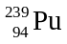 could undergo fission, the plutonium bomb was subsequently developed, and was used in 1945. is one of the most toxic substances known. The number of neutrons in the nucleus of one atom of the isotope is

- 239
- 94
- 145
- 333

Question 2
In a typical ‘D’-size alkaline battery, the cell reaction is:
2 MnO₂ (s) + 2 NH₄⁺ (aq) + Zn (s) → Mn₂O₃ (s) + 2 NH₃ (aq) + H₂O (l) + Zn²⁺ (aq)
The half-cell reaction occurring at the anode is
- NH₄⁺ (aq) → NH₃ (aq) + H⁺ (aq) + e⁻
- 2 MnO₂ (s) + 2 H⁺ (aq) + 2 e⁻ → Mn₂O₃ (s) + H₂O (l)
- MnO₂ (s) + 4 H⁺ (aq) + 2 e⁻ → Mn²⁺ (aq) + 2 H₂O (l)
- Zn (s) → Zn²⁺ (aq) + 2 e⁻

Question 3
Glucose, C₆H₁₂O₆, is an important chemical in the human body because it
- forms proteins by condensation polymerisation
- releases energy when it reacts with O₂, forming CO₂ and H₂O
- releases energy when it is formed in human body cells from CO₂ and H₂O
- forms fats by condensation polymerisation

Question 4
It is interesting to compare transition metals with the Group I and II metals. Which one of the following lists best describes the chemical properties of transition metals when compared to those of the Group I and II metals?
Transition metals
- are more likely to form coloured compounds and complex ions; are weaker reductants; exhibit a range of oxidation states
- are more likely to form coloured compounds and complex ions; are stronger reductants; do not exhibit a range of oxidation states
- are more likely to form white compounds and complex ions; are weaker reductants; exhibit a range of oxidation states
- are more likely to form white compounds and complex ions; are stronger reductants; do not exhibit a range of oxidation states

Question 5
The half-cell reactions for a cell contains Sn²⁺/Sn and Ag⁺/Ag are
- anode: Sn²⁺ (aq) + 2 e⁻ → Sn (s) and cathode: Ag (s) → Ag⁺(aq) + e⁻
- anode: Ag⁺ (aq) + e⁻ → Ag (s) and cathode: Sn (s) → Sn²⁺ (aq) + 2 e⁻
- anode: Sn (s) → Sn²⁺ (aq) + 2 e⁻ and cathode: Ag⁺ (aq) + e⁻ → Ag (s)
- anode: Ag (s) → Ag⁺(aq) + e⁻ and cathode: Sn²⁺ (aq) + 2 e⁻ → Sn (s)

Question 6
When a cell is constructed in the laboratory, the chemicals for the electrodes, the electrolytes and a salt bridge are required. The chemicals needed to set up a cell involving Fe³⁺/Fe²⁺ and Ag⁺/Ag half-cells are
- rods of iron and silver; solutions of KNO₃, Fe(NO₃)₃, Fe(NO₃) and AgNO₃
- rods of graphite and silver; solutions of KNO₃, Fe(NO₃)₃, Fe(NO₃) and AgNO₃
- rods of graphite and silver; solutions of KCl, Fe(NO₃)₃, Fe(NO₃) and AgNO₃
- rods of iron and graphite; solutions of KCl, Fe(NO₃)₃, Fe(NO₃) and AgNO₃

Question 7
The coloured lines in an emission spectrum result from
- energy being absorbed by electrons as they return from an excited state to an energy level closer to the nucleus
- energy being emitted by electrons as they return from an excited state to an energy level closer to the nucleus
- energy being emitted by electrons as they jump to an excited state from an energy level closer to the nucleus
- energy being absorbed by electrons as they jump to an excited state from an energy level closer to the nucleus

Question 8
Moving across Period 3 of the Periodic Table from left to right, the acid-base properties of the oxides change in nature from

- acidic to amphoteric to basic
- basic to amphoteric to acidic
- amphoteric to acidic to basic
- amphoteric to basic to acidic

Question 9
Respiration proceeds CO₂ and H₂O and involves the breakdown of glucose. Respiration is an example of a reaction that is
- endothermic, with oxygen acting as the oxidant
- endothermic, with oxygen acting as the reductant
- exothermic, with oxygen acting as the oxidant
- exothermic, with oxygen acting as the reductant

Question 10
The graph below shows the variation in atomic size of the elements across Period 3.
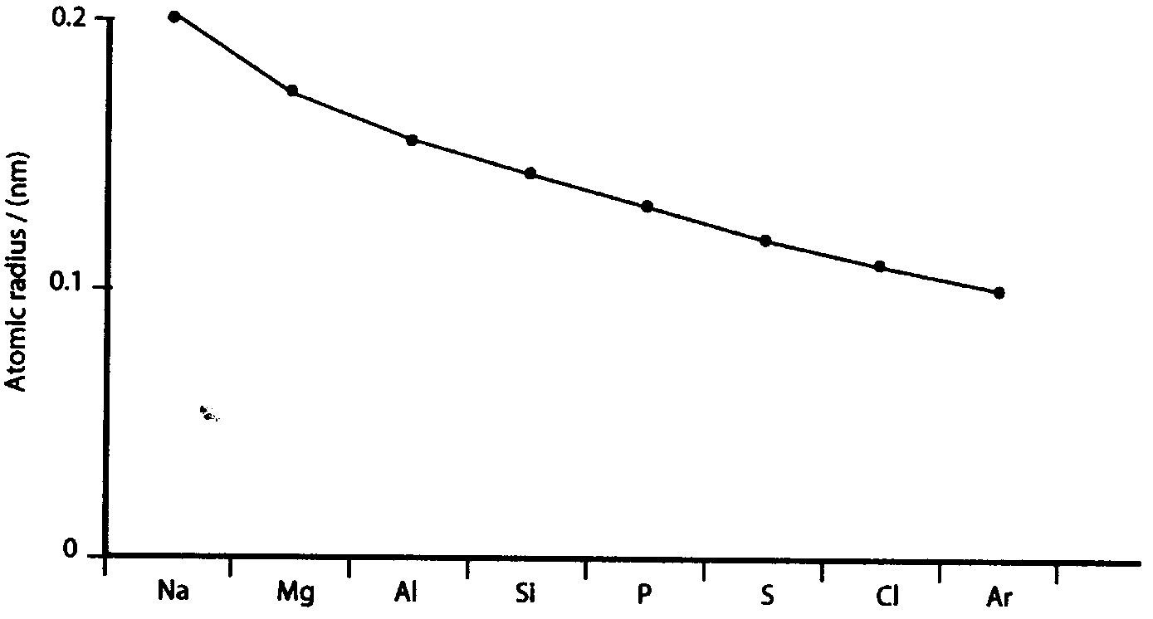
Select the statement that explains this trend correctly.
- As the number of electrons decreases the number of protons increases, and the electrons are more strongly attracted by the increasing core charge of the nucleus.
- As the number of electrons increases the number of protons decreases, and the electrons are more strongly attracted by the decreasing core charge of the nucleus.
- As the number of electrons decreases the number of protons decreases, and the electrons are more strongly attracted by the increasing core charge of the nucleus.
- As the number of electrons increases the number of protons increases, and the electrons are more strongly attracted by the increasing core charge of the nucleus.

Question 11
The following diagram is part of a protein. When this part is broken down in the body which compounds are produced?
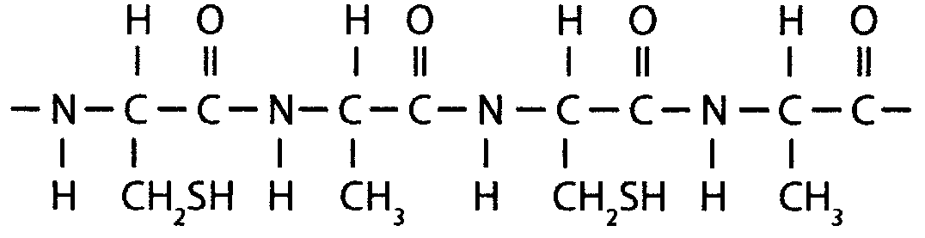
- NH₂CH(CH₂SH)COOH and NH₂CH(CH₃)COOH
- H₂O, NH₂CH(CH₂SH)COOH and NH₂CH(CH₃)COOH
- NH₂CH(CH₂SH)COOH and NHCH(CH₃)COOH
- NH₂CH(CH₂SH)CO, NH₂CH(CH₃)CO and H₂O

The following information is used for Questions 12 and 13.

The steps in the nitrogen cycle are shown in the diagram below.
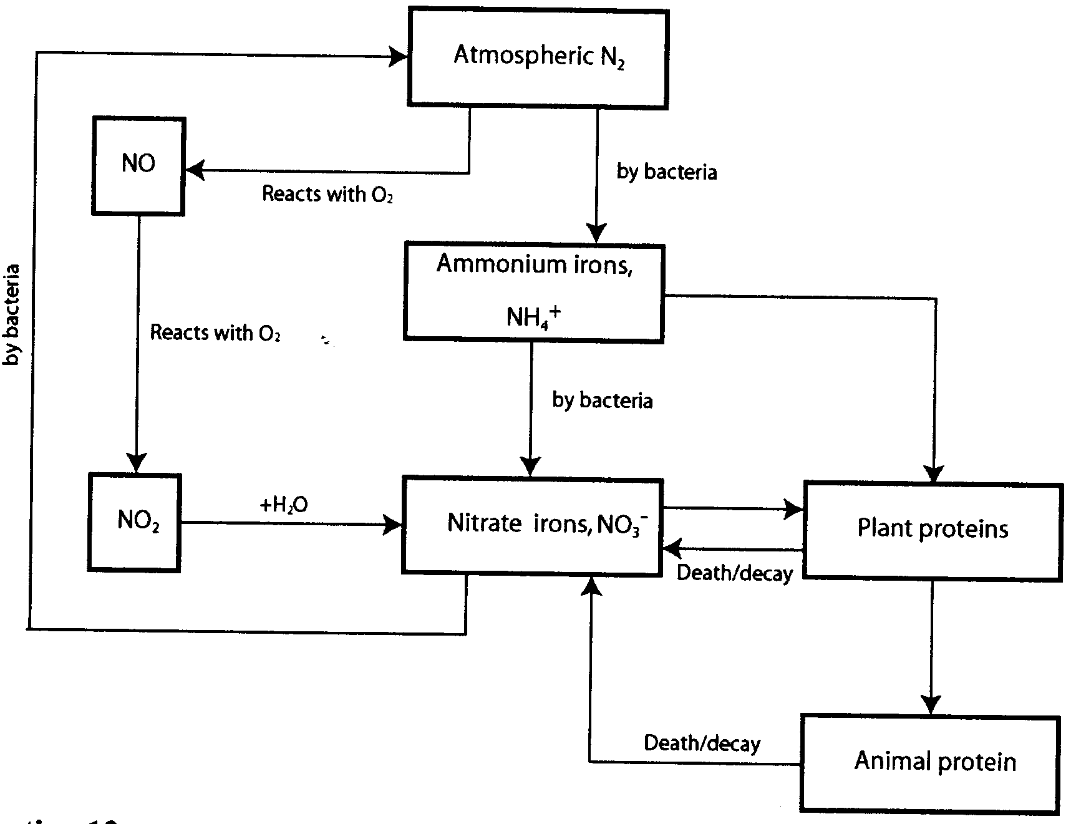

Question 12
As atmospheric nitrogen is converted to nitrate ions by bacteria the following changes in oxidation number occur

- 0 → +3 → +5
- 0 → –3 → +5
- 0 → –4 → +5
- 0 → –3 → +6

Question 13
The step in the nitrogen cycle that is best described as ‘nitrogen fixation’ is

- N₂ → NH₄⁺
- NH₄⁺ → NO₃⁻
- NO → NO₂
- NO₂ → NO₃⁻

Question 14
The functional group that forms when glucose undergoes a condensation reaction to form a polysaccharide is
 | 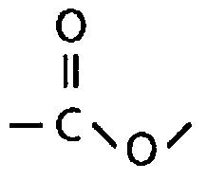 |  | 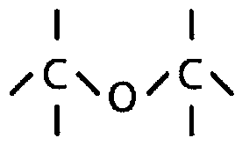 |  | 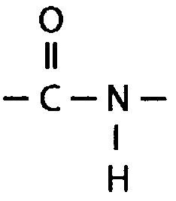 |  | 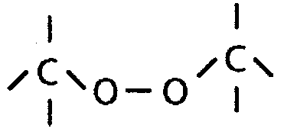

Question 15
Which one of the following is most likely to be an α-amino acid produced as the result of hydrolysing a protein?

- NH₂CH(CH₃)CH₂COOH
- NH₂CH(CH₃)COOH
- NH₂CH₂CH₂COOH
- NH₂C(CH₃)₂CH₂COOH

Question 16
An emulsifier is a substance added in small amounts to a food product to

- prevent the oxidation of unsaturated fats
- prevent the reduction of unsaturated fats
- stabilise a mixture of different liquids
- oxidise one liquid in preference to another

Question 17
The positive electrode of the lead-acid accumulator is made of lead, Pb, and covered in lead(IV) oxide, PbO₂. The half-cell reaction occurring at this electrode is:
PbO₂ (s) + SO₄²⁻ (Aq) + 4 H⁺ (aq) + 2 e⁻ → PbSO₄ (s) + 2 H₂O (l)
Which one of the following statements is true about the reaction?
- The pH of the half-cell is decreasing, while the oxidation number of the lead changes from +4 to +2.
- The pH of the half-cell is increasing, while the oxidation number of the lead changes from +4 to +2.
- The pH of the half-cell is decreasing, while the oxidation number of the lead changes from +2 to +4.
- The pH of the half-cell is increasing, while the oxidation number of the lead changes from +2 to +4.

Question 18
When a sportsperson is engaged in rigorous exercise, such as a short sprint, the body must quickly produce energy. In these circumstances, the main source of energy in the body is

- starch
- fats
- glycogen
- protein

Question 19
Which one of the following electron configurations is of an element that is not in its ground state?

- 1s²2s²2p⁶3s²3p⁴
- 1s²2s²2p⁶3s²3p⁶3d²4s²
- 1s²2s²2p⁶3s²3p⁶3d⁶4s²
- 1s²2s²2p⁶3s²3p⁶3d⁷4s¹

Question 20
The first ionisation energy of bromine is the energy change in the reaction

- Br₂ (g) → 2 Br⁺ (g) + 2 e⁻
- Br (g) + e⁻ → Br⁻ (g)
- Br (g) → Br⁺ (g) + e⁻
- Br₂ (g) + 2 e⁻→ 2 Br⁻ (g)

SECTION B – Short-answer questions

Question 1
The diaphragm or Nelson Cell uses and electrolytic process involving the electrolysis of brine (NaCl solution). It produces three important chemicals: H₂ gas, Cl₂ gas and NaOH solution. The cell usually operates at 4.5 V and 200 A. It is a continuous process which consumes large amounts of energy. A sketch of this cell is shown below.
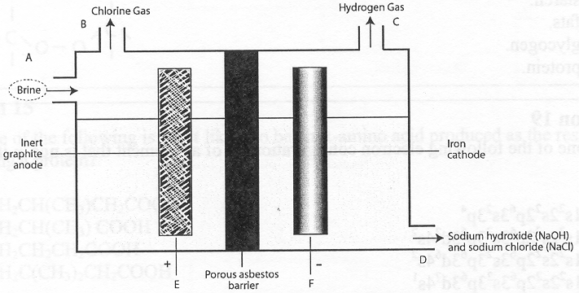
- On the diagram at points A, B, C and D chemicals are added to the cell or collected from the cell. The electrodes are labelled E (positive electrode) and F (negative electrode).
Write equations for the reactions occurring at each electrode.
- E (positive electrode)
__________________________________________________________________________________
- F (negative electrode)
__________________________________________________________________________________
- Modern cells employ a membrane between the two half-cells which has been modified in order to improve the conditions and output of the process. Explain the feature of this membrane that has produced this improvement and the benefit that arises from its use.
_______________________________________________________________________________________
_______________________________________________________________________________________
_______________________________________________________________________________________
_______________________________________________________________________________________
_______________________________________________________________________________________
_______________________________________________________________________________________
- What is the maximum volume of chlorine gas that would be produced at STP when 950.0 g of sodium hydroxide is produced in the cell?
_______________________________________________________________________________________
_______________________________________________________________________________________
_______________________________________________________________________________________
_______________________________________________________________________________________
_______________________________________________________________________________________
_______________________________________________________________________________________
_______________________________________________________________________________________
_______________________________________________________________________________________
_______________________________________________________________________________________
_______________________________________________________________________________________
- Calculate the energy required to produce this volume of chlorine in the cell.
_______________________________________________________________________________________
_______________________________________________________________________________________
_______________________________________________________________________________________
_______________________________________________________________________________________
- In another electrolytic cell, the Down’s Cell, chlorine gas is also produced from electrolysis of sodium chloride.
- What is the other chemical produced in the Down’s Cell?
__________________________________________________________________________________
- Explain why this chemical cannot be produced in the Nelson Cell.
__________________________________________________________________________________
__________________________________________________________________________________
__________________________________________________________________________________
2 + 2 + 3 + 2 + 2 = 11 marks

Question 2
Carbohydrates and fats are important energy sources for the human body. Plants produce glucose as a product of photosynthesis. Glucose is converted into carbohydrates and stored by both plants and animals. Humans oxidise glucose to provide energy for the chemical reactions in our bodies. The oxidation of one mole of glucose produces 2813 kJ of energy.
- Write a balanced overall equation for the process of photosynthesis.
_______________________________________________________________________________________
- Write the thermochemical equation for the oxidation of one mole of glucose.
_______________________________________________________________________________________
- The nutritional guide on a breakfast cereal packet states that each 30 g serving provides 430 kJ of energy. A bomb calorimeter can be used to provide such information. Sketch a bomb calorimeter suitable for measuring the energy content of food. Label at least four major parts of your diagram.

- Describe the process of electrical calibration of the bomb calorimeter.
_______________________________________________________________________________________
_______________________________________________________________________________________
_______________________________________________________________________________________
_______________________________________________________________________________________
_______________________________________________________________________________________
_______________________________________________________________________________________
_______________________________________________________________________________________
_______________________________________________________________________________________
- Describe the steps involved in measuring and calculating the energy content, in kJ g⁻¹, of a breakfast cereal using a bomb calorimeter.
_______________________________________________________________________________________
_______________________________________________________________________________________
_______________________________________________________________________________________
_______________________________________________________________________________________
_______________________________________________________________________________________
_______________________________________________________________________________________
1 + 1 + 2 + 2 + 3 = 9 marks

Question 3
A piece of fat was analysed and found to be made from a fatty acid with the formula CH(CH₂)₁₄COOH.
- Will the fat be an oil or a solid at room temperature? Explain your answer.
_______________________________________________________________________________________
_______________________________________________________________________________________
_______________________________________________________________________________________
_______________________________________________________________________________________
- When one mole of the fat was analysed to produce 3 moles of this fatty acid, one mole of another molecule was formed. Draw the structural formula of this other molecule.

- Draw the structure of a molecule of this fat and circle and name a functional group that is present in the molecule.

3 + 1 + 2 = 6 marks

Question 4
Give a chemical formula or structure for the following:
- the element whose 2+ ion has an electron configuration of 1s²2s²2p⁶3s²3p⁶3d⁴.
_______________________________________________________________________________________
- the atom X in the nuclear equation 3 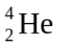 → X.
_______________________________________________________________________________________
- the general α-amino acid in a basic solution.
_______________________________________________________________________________________
- the molecule produced by the human body to remove excess nitrogen.
_______________________________________________________________________________________
4 marks

Question 5
Many people consider hydrogen gas to be an important energy source for the future. Theoretically it could be used in virtually every application where other fuels are presently used.
- Power stations using hydrogen fuel cells may one day provide much of the energy that coal-fired power stations generate today.
- Describe the energy transformations involved in both types of power stations.
__________________________________________________________________________________
__________________________________________________________________________________
__________________________________________________________________________________
__________________________________________________________________________________
__________________________________________________________________________________
- Explain why a hydrogen fuel cell power station is more efficient than a coal-fired power station.
__________________________________________________________________________________
__________________________________________________________________________________
__________________________________________________________________________________
__________________________________________________________________________________
__________________________________________________________________________________
- Name a disadvantage of a hydrogen fuel cell power station when compared to a coal-fired power station.
__________________________________________________________________________________
__________________________________________________________________________________
- Write the half cell reactions that occur in a hydrogen fuel cell when using potassium hydroxide, KOH, as the electrolyte.
Anode reaction: ____________________________________________________________________
Cathode reaction: ___________________________________________________________________
- The fusion of hydrogen nuclei to produce helium nuclei releases enormous amounts of energy and has the potential to provide us with clean, safe and limitless energy.
- Write the nuclear equation for the production of helium nuclei from hydrogen nuclei.
__________________________________________________________________________________
- Another source of energy is from nuclear fission. Briefly explain what is meant by ‘nuclear fission’.
__________________________________________________________________________________
__________________________________________________________________________________
__________________________________________________________________________________
__________________________________________________________________________________
7 + 2 = 9 marks

Question 6
Enzymes are biological catalysts that control the biochemical reactions in the body. The catalytic process occurs on the surface of the enzyme and most enzymes catalyse just one specific reaction.
- Describe the mechanism by which enzymes catalyse chemical reactions in the body.
_______________________________________________________________________________________
_______________________________________________________________________________________
_______________________________________________________________________________________
_______________________________________________________________________________________
- When pineapple is processed and tinned, it is heated in order to preserve the food in the tin. Gelatin powder sets to a jelly when it is dissolved in water, and when tinned pineapple is mixed with the gelatin it makes a refreshing pineapple jelly dessert. If, however, fresh pineapple is used to make this dessert, it never sets. Using your knowledge of enzymes, explain why the tinned pineapple may be acting in a different way to the fresh pineapple.
_______________________________________________________________________________________
_______________________________________________________________________________________
_______________________________________________________________________________________
_______________________________________________________________________________________
2 + 2 = 4 marks

Question 7
- The Periodic Table has provided a means of representing the relationships between different elements. Mendeleev developed an early form of the Periodic Table in 1869. On what two properties of elements did Mendeleev base his version of the table?
_______________________________________________________________________________________
_______________________________________________________________________________________
_______________________________________________________________________________________
- William Ramsay was the first person to isolate argon and investigate its properties. Explain how Ramsay, using Mendeleev’s Periodic Table, was able to conclude that he had isolated an element from a previously unknown group, and that there were other elements to discover in this group.
_______________________________________________________________________________________
_______________________________________________________________________________________
_______________________________________________________________________________________
_______________________________________________________________________________________
- Cobalt is placed before nickel in the Periodic Table because it has one proton less than nickel. However, it has a higher relative atomic mass. Explain why this occurs.
_______________________________________________________________________________________
_______________________________________________________________________________________
_______________________________________________________________________________________
- Mass spectrometers have been used to collect information to allow the determination of relative atomic mass for all elements. What data must be collected for such determinations?
_______________________________________________________________________________________
_______________________________________________________________________________________
- From data collected from a mass spectrometer the relative atomic mass of copper is 63.54. There are two isotopes of copper: 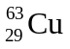 and 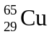.
- Which isotope is the most abundant?
__________________________________________________________________________________
- Give a reason for your answer.
__________________________________________________________________________________
2 + 2 + 1 + 1 + 3 = 9 marks

