Lisachem 2005 | Unit 3 Chemistry | Trial Examination Solutions

Section A – Multiple choice questions

1. | B | As a weak acid, ethanoic acid, CH₃COOH (aq) ionises according to the equilibrium  CH₃COOH (aq) + H₂O (l)  CH₃COO– (aq) + H₃O⁺ (aq)  Because CH₃COOH (aq) ionises only to a small extent, the [H₃O⁺] is significantly less than 0.10 M.  HCl (aq) ionises according to HCl (aq) + H₂O (l) → H₃O⁺ (aq) + Cl– (aq) and because it is a strong acid the [H₃O⁺] is 0.10 M.  So adding a small amount of 0.10 M HCl (aq) to a solution of 0.10 M CH₃COOH (aq) will significantly increase the [H₃O⁺] in the CH₃COOH (aq). Consequently the position of equilibrium shifts to the left, but not enough to compensate for the increase in [H₃O⁺]. At the new equilibrium:  - the equilibrium constant has not changed;  - the [CH₃COO–] has decreased;  - the [CH₃COOH] has increased;  - since the [H₃O⁺] has increased overall the pH has decreased.
2. | A | For the equilibrium CH₄ (g) + H₂O (g)  CO (g) + 3 H₂ (g); ΔH = +206.1 kJ/mol, the concentration of hydrogen in the equilibrium mixture (yield of H₂) will be increased by factors that move the position of the equilibrium to the right.  - An increase in pressure will cause the position of equilibrium to move to the side with fewer particles, in this case to the left. Hence this decreases the yield of H₂.  - An increase in temperature will cause the position of the equilibrium to move in the direction of the endothermic reaction, in this case to the right.  - Removing hydrogen will cause the position of the equilibrium to move to the right to compensate for the loss of hydrogen.  - Increasing the amount of CH₄ in the reaction mixture will cause the position of equilibrium to move to the right to compensate for the increase in [CH₄].
3. | D | n(CO₂) produced = m(CO₂) ÷ M(CO₂)  = 2.93 ÷ 44.0  = 6.66 × 10^{–2} mol  Since all the alternatives, CH₃CH₃, CH₂=CH₂, CH₃CH₂OH and CH₃COOH all have 2 C atoms per molecule, then n(CO₂) produced = 2 × n(compound).  Hence n(compound) = ½ × n(CO₂)  = ½ × 6.66 × 10^{–2} mol  = 3.33 × 10^{–2} mol  Since n = m ÷ M, then nM = m and M = m ÷ n  So M(compound) = m ÷ n  = 2.0 g ÷ 3.33×10^{–2} mol  = 6.01 g mol^{–1}  Ethane; M(CH₃CH₃) = 30 g mol^{–1}  Ethene; M(CH₂=CH₂) = 28 g mol^{–1}  Ethanol; M(CH₃CH₂OH) = 46 g mol^{–1}  Ethanoic acid; M(CH₃COOH) = 60 g mol^{–1}
4. | C | n(NaOH) in 1000 mL = 16.0 g ÷ 40.0 g mol^{–1} = 0.400 mol  n(NaOH) in 20.0 m = 0.400 × (20 ÷ 1000) = 8.00 × 10^{–3} mol  The equation for the reaction between NaOH (aq) and HCl (aq) is  NaOH (aq) + HCl (aq) → NaCl (aq) + H₂O (l)  Hence n(HCl) required = n(NaOH)  = 8.00 × 10^{–3} mol  Since n = cV, then V = n ÷ c  So V(HCl) required = n(HCl) ÷ c(HCl)  = 8.00 × 10^{–3} ÷ 0.450  = 0.0178 L  = 17.8 mL  The fact that a larger volume of HCl was needed to reach the endpoint suggests that either there was more NaOH than expected in the aliquot or the acid in the titration flask was less concentrated than expected.  Alternatives A and B would have caused there to be less NaOH in the titration flask and hence require a smaller volume of HCl to reach the endpoint.  Alternative C, rinsing the burette with NaOH, would have caused the concentration of the HCl in the burette to decrease. Hence a larger volume of HCl (aq) would be needed to reach the endpoint.  Alternative D – correct technique – hence no effect on the V(HCl) required.
5. | B | The only other chemical needed is an indicator to show when the endpoint has been reached. Methyl orange is the only indicator listed.
6. | A | The forward reaction in the equilibrium 2 SO₂ (g) + O₂ (g)  2 SO₃ (g) is exothermic.  Increasing the temperature will have conflicting effects.  - The rate of production of SO₃ will increase, but  - the yield of SO₃ will decrease since the position of equilibrium responds to an increase in temperature by moving in the direction of the endothermic, in this case reverse, reaction.  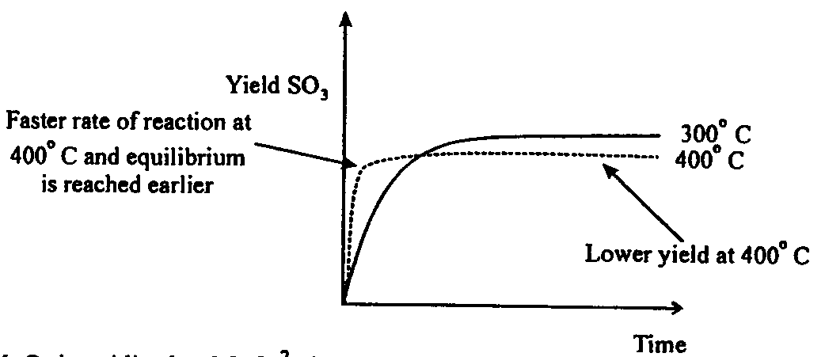
7. | B | MnO₂ is oxidised to MnO₄²⁻, in aqueous solution, according to the half-equation  MnO₂ (s) + 2 H₂O (l) → MnO₄^{2–} (aq) + 4 H⁺ (aq) + 2 e–  So the conversion of 1 mole of MnO₂ to MnO₄^{2–} is accompanied by the loss of 2 mole of electrons (to the oxidant).  N(electrons) = 2 N_{A}  = 2 × 6.0 × 10²³  = 1.2 × 10²⁴
8. | D | N₂ (g) + 3 H₂ (g)  2 NH₃ (g)  K_{c} = 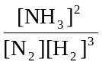  K_{c} × [N₂][H₂]³ = [NH₃]²  [NH₃] = 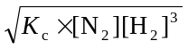
9. | D | The compounds required to produce the ester can be identified by focusing on the ester functional group.  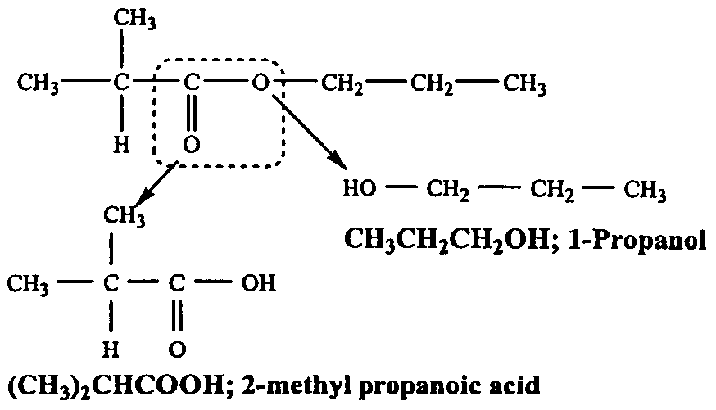
10. | D | Since KMnO₄ (aq) dissociates according to KMnO₄ (aq) → K⁺ (aq) + MnO₄–  n(MnO₄–) = n(KMnO₄)  = c(KMnO₄) × V_{c}(KMnO₄)  = 0.0050 × 25.0 × 10^{–3}  = 1.25 × 10^{–4} mol  5 Fe²⁺ (aq) + MnO₄– (aq) + 8 H⁺ (aq) → 5 Fe²⁺ (aq) + Mn²⁺ (aq) + 4 H₂O (l)  n(Fe²⁺) in water sample = 5 × n(MnO₄–)  = 5 × 1.25 × 10^{–4}  = 6.25 × 10^{–4} mol  c(Fe²⁺) in water sample = n(Fe²⁺) ÷ V(sample)  = 6.25×10^{–4} ÷ 20.0×10^{–3}  = 0.031 M
11. | C | Reaction between Ca(OH)₂ (aq) and HCl (aq) occurs according to the equation  Ca(OH)₂ (aq) + 2 HCl (aq) → CaCl₂ (aq) + 2 HCl (aq)  n(HCl) reacting = c(HCl) × V(HCl)  = 0.0300 × 17.5×10^{–3}  = 5.25 × 10^{–4} mol  n[CaOH)₂] reacting = ½ × 5.25 × 10^{–3} = 2.63 × 10^{–3}  Since Ca)OH)₂ (aq) dissociates according to Ca(OH)₂ (aq) → Ca²⁺ (aq) + 2 OH– (aq)  So n(OH–) present = 2 × n[Ca(OH)₂ (aq)]  = 2 × 2.63×10^{–3} mol  = 5.25 × 10^{–3} mol ##  [OH–] = 5.25 × 10^{–3} mol ÷ 20.0×10^{–3} L = 2.63 × 10^{–2} M  Since [H₃O⁺][OH–] = 10^{–14}  [H₃O⁺] = 10^{–14} ÷ 2.63×10^{–2} = 3.80 × 10^{–13}  pH = –log₁₀[H₃O⁺]  = –log₁₀(3.80×10^{–13})  = 12.4  ## Alternatively having calculated n(HCl) go straight to n(OH–) = n(H⁺) = n(HCl)
12. | A | The formation of a polyester from reaction between the monomers HOCH₂CH₂OH and HOOCC₆H₄COOH may be represented as shown below  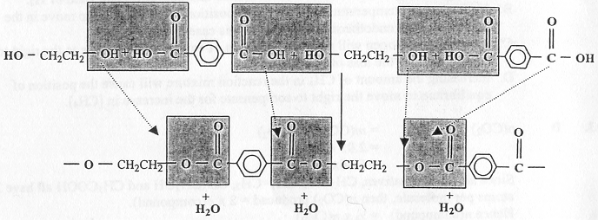  Where the hydroxy, –OH, function group reacts with the carboxy(l), –COOH), functional group, the ester, –COO, functional group is formed and water is released.  Hence the mass of the polymer formed will be less than the total mass of the monomers.  However the mass of carbon in the polymer is the same as the total mass of carbon in the monomers, so the percentage by mass of carbon in the polymer will be greater than in the monomers.
13. | B | Blood pH decreases as the [H₃O⁺] increases. So to counteract acidosis the equilibria  CO₂ (g)  CO₂ (aq) 1.  CO₂ (aq) + H₂O (l)  H₂CO₃ (aq) 2.  H₂CO₃ (aq) + H₂O (l)  HCO₃– + [H₃O⁺] 3.  must move in such a way as to decrease the [H₃O⁺].  The position of equilibrium 3. must move to the left, so the [H₃O⁺] decreases. Since the three equilibria are interlinked the accompanying increase in [H₂CO₃] causes equilibrium 2. to move to the left. This then increases the [CO₂ (aq)], which thus causes equilibrium 1. to move to the left.  Ultimately more CO₂ (g) is released and must be exhaled. This is achieved by increasing the rate of exhalation and inhalation.  Alternative A would result in CO₂ (g) being inhaled with the consequence of all three equilibria moving to the right and the blood becoming more acidic. In alternatives C and D there would be no change in any of the equilibrium concentrations and so the equilibria would not adjust as required.
14. | C | Whilst colorimetry, atomic absorption spectroscopy and UV-Visible spectroscopy may all be used in the quantitative analysis of a solution of metal ions, the technique most commonly associated with the determination of metal ion concentrations is Atomic Absorption Spectroscopy. Because the light sources used in AAS are element specific it can be used to determine the concentration of a wide range of metal ions.
15. | B | 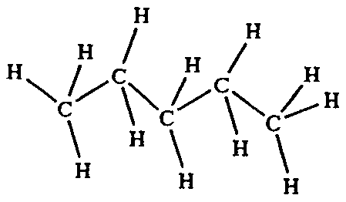 |  |  |  |  |  |  | 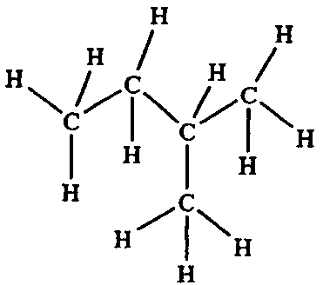
15. | B | CH₃CH₂CH₂CH₂CH₃  C₅H₁₂ – pentane |  |  |  |  |  |  | (CH₃)₂CHCH₃  C₅H₁₂ – 2-methyl butane
 |  | Whilst these compounds are different hydrocarbons, they are also structural isomers because they have the same molecular formula but different structural formulae.
16. | C | 2 H₂ (g) + O₂ (g) → 2 H₂O (g); ΔH = –484 kJ mol^{–1}  The activation energy for the reaction 2 H₂O (g) → 2 H₂ (g) + O₂ (g) is 1852 kJ mol^{–1}.  This information is best represented on an energy profile from which the activation energy for the reaction 2 H₂ (g) + O₂ (g) → 2 H₂O (g) can then be deduced. On the energy profile the energy contents of the reactants is arbitrarily shown as zero.  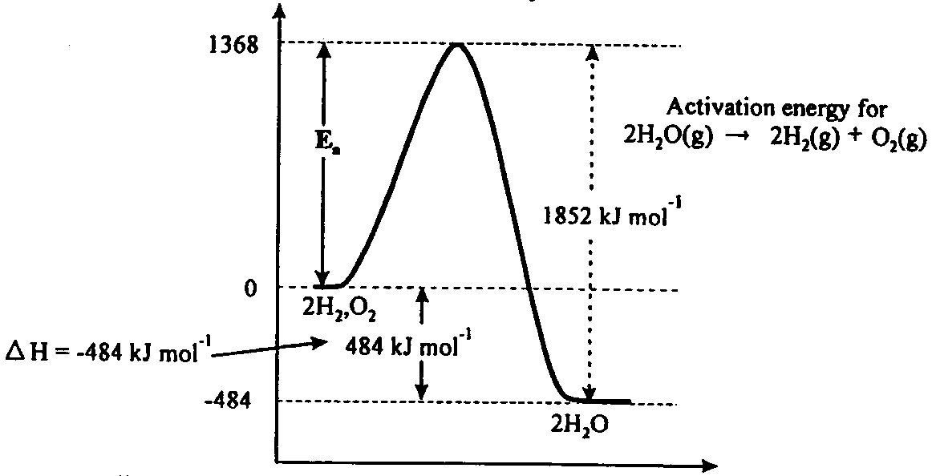  According to the information on the energy profile, the activation energy for the reaction  2 H₂ (g) + O₂ (g) → 2 H₂O (g) is 1852 – 484 = 1368 kJ mol^{–1}.
17. | A | The addition of 50 mL of water to 50 mL of 0.20 M NH₃ (aq) doubles the volume and instantaneously halves the concentrations of NH₃ (aq) NH₄⁺ (aq) and OH– (aq).  This halves the value of the concentration fraction, ie. [NH₄⁺]][OH–] / [NH₃], so the value of the concentration fraction becomes less than K_{c}. To restore equilibrium the concentration fraction must increase so the forward reaction is favoured.  So the addition of water also pushes the equilibrium NH₃ (aq) + H₂O (l)  NH₄⁺ (aq) + OH– (aq) to the right.  Whilst this shift in equilibrium position increases the n(NH₄⁺) and n(OH–) the increase is not enough to fully compensate for the impact of the volume increase on the [NH₄⁺] and [OH–].  The overall effect of the addition of 50 mL of pure water is that the [NH₄⁺] decreases and [OH–] decreases.  The decrease in [OH–] causes an increase in [H⁺] and the pH to decrease.  The changes can also be shown on a simple concentration-time diagram.  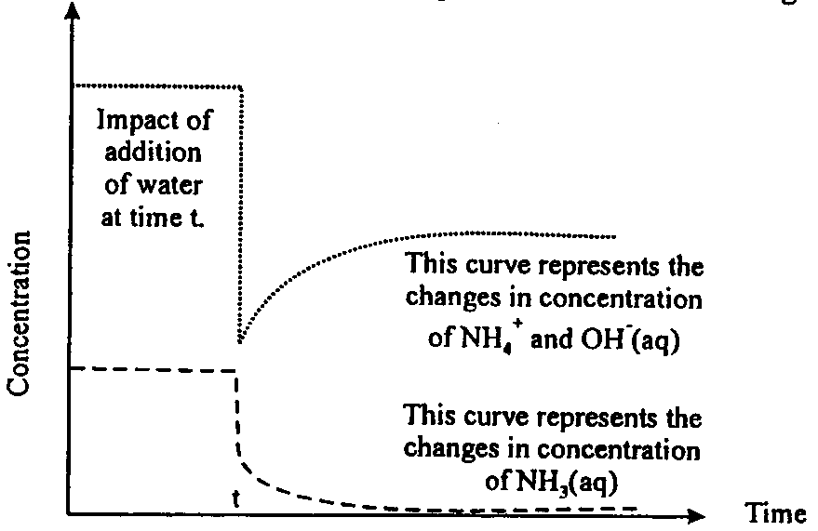  The concentrations of NH₄⁺ and OH– when equilibrium is reached after the addition of water are less than the equilibrium concentrations prior to the addition of water, ever though the amounts of NH₄⁺ and OH– present have increased.
18. | B | The hydrocarbon with the lowest retention time, ie compound A, was least attracted to the stationary phase as the mixture was swept through the column.  The hydrocarbon with the highest retention time, ie compound E, was most attracted to the stationary phase as the mixture was swept through the column.  The peak with the greatest area identifies the most abundant hydrocarbon, ie compound D.  As the retention time increases the number of carbon atoms in the hydrocarbons should increase (unless of course there are isomers present, although the gaps between retention times suggest this is unlikely. So compound C cannot be methane. If methane was present it would have to be compound A.  Since 2,2-dimethyl propane, (CH₃)₄C, has five carbon atoms is could be compound E.
19. | D | The reaction H– (aq) + H₂O (l) → H₂ (g) + OH– (aq) is an acid base reaction with H– acting as a base, ie accepting a proton, and forming H₂, and H₂O acting as an acid, ie donating a proton and forming OH–.  The redox nature of the reaction can be assessed by assigning oxidation numbers.
 |  |  | OXIDATION
 |  |  | increase in oxidation number
 |  |  | –1 |  |  | +1 –2 |  |  |  | +2 –1 |  |  | 0
 |  |  | H– | (aq) |  | H₂O | (l) |  |  | OH– | (aq) |  | H₂ | (g)
 |  |  |  |  |  | decrease in oxidation number
 |  |  |  |  |  | REDUCTION
 |  | Hydrogen is both oxidised, from H– to H₂, and reduced, from H₂O to H₂. so the reaction is a redox reaction as well as an acid-base reaction.
20. | B | The controlling factor in the reaction rate is the proportion of the collisions between the reactant particles which have energy greater than the activation energy. Such collisions are called ‘fruitful’ collisions. An increase in temperature will increase the kinetic energy of the particles. Since the activation energy does not change the increase in particle energy leads to an increase in the number of fruitful collisions and hence a faster rate of reaction.

Section B – Short Answer Questions

Question 1
(a) | In the reaction CaCO₃ (s) + 2 HCl (aq) → CaCl₂ (aq) + H₂O (l) + CO₂ (g), the law of conservation of mass holds because the total of the masses of CaCl₂, H₂O and CO₂ produced, ie the products is equal to the total of the masses of CaCO₃ and HCl reacting, ie the reactants.  However because CO₂ is produced as a gas, if the reaction is carried out in an open flask the CO₂ will escape, ie be ‘lost.  Hence monitoring the decrease in mass of the reaction flask as the reaction proceeds will be equal to the mass of CO₂ produced. 
(b) | Reaction flask and electronic balance (and perhaps some cotton wool to prevent loss of solution from the reaction flask). 
(c) | 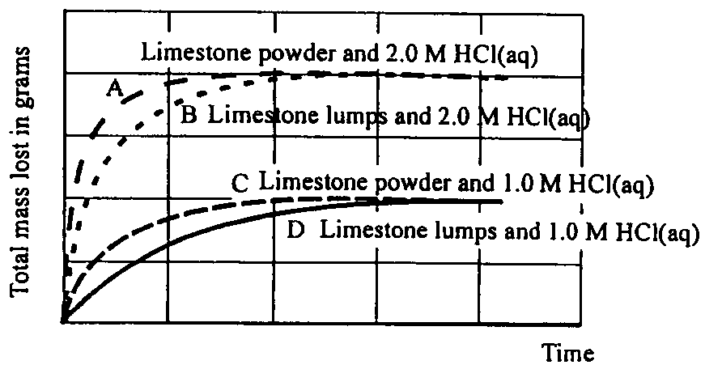  1. B, 2. D, 3. A, 4. C 
(d) | The graphs show that reaction rate increases with reactant concentration.  With 2.0 M HCl (aq) the rate of production of CO₂, as indicated by the gradient of the ‘total mass loss’ ie mass of CO₂ produced, is greater than for 1.0 M HCl. 
(e) | For both concentrations of acid, the powdered limestone will produce the faster reaction rate and so, for a particular c(HCl), the graphs of m(CO₂) produced have a steeper gradient for powdered limestone than for limestone lumps. This occurs because the powdered limestone provides a greater surface area for reaction. 
(f) | Since the CaCO₃ is in excess the m(CO₂ produced depends on the amount of HCl (aq) present,  so 200 mL of 2.0 M HCl (aq) has twice the n(HCl) as 1.0 M HCl (aq) and so should produce approximately twice as much CO₂. 
(g) | Measure the volume of CO₂ produced by collecting it in a gas syringe or  Use a pH meter to monitor the pH of the solution – the pH should increase as the reaction proceeds. 

Question 2
(a) | CH₃COOC₆H₄COOH (aq) + H₂O (l)  CH₃COOC₆H₄COO– (aq) + H₃O⁺ (aq)  K_{a} = 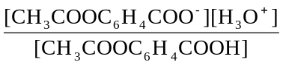 
(b) | n(CH₃COOC₆H₄COOH) = m(CH₃COOC₆H₄COOH) / M(CH₃COOC₆H₄COOH)  = 2 × 300×10^{–3} g / 180 g mo^{–1}  = 3.33 × 10⁻³ mol   [CH₃COOC₆H₄COOH] = n(CH₃COOC₆H₄COOH / V  = 3.33×10^{–3} / 250×10^{–3}  = 1.33 × 10^{–2} mol L^{–1} 
(c) | Since acetylsalicylic acid is a weak acid, we may assume that  [CH₃COOC₆H₄]_{e} = 1.33 × 10^{–2} M  [CH₃COOC₆H₄COO–]_{e} = [H₃O⁺]  So 3.3 × 10^{–4} = 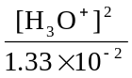   3.3 × 10^{–4} × 1.33 × 10^{–2} = [H₃O⁺]²  So [H₃O⁺] = 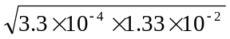  = 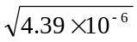  = 2.09 × 10^{–3} M  pH = –log₁₀[H₃O⁺]  = –log₁₀(2.09×10^{–3})  = –(–2.69)  = 2.69 
(d) | ester –COO, carboxy(l) –COOH 

Question 3
(a) | cracking 
(b) | Reaction 1: CH₃CH₂CH₃ 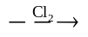 CH₃ CH₂ CH₂Cl; substitution   Reaction 2: CH₂CH=CH₂ 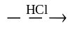 CH₃CH₂ CH₂OH; addition   Reaction 3: CH₃CH₂CH₂Cl 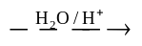 CH₃CH₂ CH₂OH; substitution 
(c) | Propanoic acid; CH₃CH₂COOH 
(d) | Sulfuric acid; acts as a catalyst 
(e) | 1-propyl propanoate;  CH₃CH₂COOCH₂CH₂CH₃   The reaction for the formation of the ester 1-propyl propanoate may be represented as
 |  | 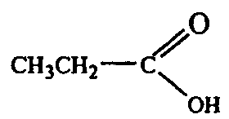 | + | HO–CH₂CH₂CH₃ | 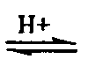 | 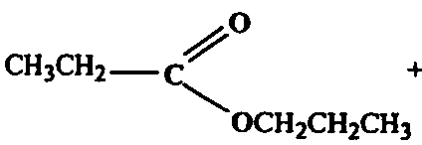 | + | H₂O

Question 4
(a) | A series of standards, solutions of known Ca²⁺ (aq) concentration,  namely 1 ppm, 2 ppm up to 5 ppm, would have been tested using a calcium lamp  which emits wavelengths that will be absorbed by Ca atoms. The measured absorbances of these standard solutions are then used to construct a calibration curve – a plot of absorbance against Ca²⁺ (aq) concentration.
(b) | If the student had used the undiluted mineral water sample the measured absorbance would have been well outside the range of the calibration curve.   The mineral water needed to be diluted so that the concentration of Ca²⁺ in the diluted mineral water was within the range shown on the calibration curve, ie less than 5 ppm. Since the undiluted concentration of Ca²⁺ is 140 mg L^{–1}, dilution by a factor of 100, would give a diluted solution in which the Ca²⁺ concentration would be 1.4 mg L^{–1} (1.4 ppm).  This would be achieved by diluting 10 mL of mineral water with deionised water to produce 1 L of diluted solution (using a 1 L volumetric flask).
(c) | According to the calibration curve:  Absorbance 0.395 → c(Ca²⁺) = 3.00 mg L^{–1}   If the c(Ca²⁺) in he diluted solution was 3.00 mg L^{–1} and the c(Ca²⁺) in the actual mineral water was calculated as 150 mg L^{–1`}, then the actual mineral water was 50 times as concentrated, with respect to Ca²⁺, as the diluted solution. So the 5.0 mL sample of mineral water was diluted by a factor of 50, ie to 250 mL prior to analysis. 
(d) | The lamp used in the atomic absorption spectrometer for the calcium analysis would be a calcium lamp. This lamp emits wavelengths of light that will only be absorbed by calcium atoms and not by the atoms of any other metal.  Hence the presence of Mg²⁺, Na⁺, and K⁺ ions has no effect on the Ca²⁺ analysis.
(e) | (i) | m(Na) in a 1.25 L bottle = 1.25 L × 93 mg L^{–1}  m(Na) consumed in 1 year = 1.25 × 93 × 365 mg  = 4.24 × 10⁴ mg  = 42.4 g 
 | (ii) | n(Na⁺ consumed = m(Na) / M(Na)  = 42.4 g / 23.0 g mol^{–1}  = 1.84 mol  N(Na⁺) consumed = n(Na) × N_{A}  = 1.84 × 6.0×10²³  = 1.1 × 20²⁴ ions 

Question 5
(a) | According to Le Chatelier’s princple the equilibrium N₂ (g) + 3 H₂ (g) 2 NH₃ (g) will respond to increased pressure by moving the position of the equilibrium in the direction of lower pressure, ie to the side with fewer particles. This increases the proportion of NH₃ in the equilibrium mixture. 
(b) | 2 SO₂ (g) + O₂ (g)  2 SO₃ (g) 
(c) | (i) |  | Vanadium pentoxide; V₂O₅. It is arranged on trays to provide the maximum ‘contact’ surface area for the reactants. 
 | (ii) | The equilibria involved in the Haber and Contact processes are both exothermic. This means a rate / yield conflict exists.  A higher temperature increases the rate of production of NH₃ and SO₃ but because the reverse reaction is endothermic in both cases the yields are reduced. Similarly a lower temperature increases the yield of H₃ and SO₂ but the rate of production is decreased.
(d) | According to Le Chatelier’s principle the production of SO₃ in the equilibrium 2 SO₂ (g) + O₂ (g)  2 SO₃ (g) is favoured by high pressures (system moves to side with fewer particles). However the yield is so good at atmospheric pressure that the use of higher pressures is uneconomical. 
(e) | SO₃ (g) + H₂SO₄ (l) → H₂S₂O₇ (l)  H₂S₂O₇ (l) + H₂O (l) → 2 H₂SO₄ (l)   The two stage process is necessary because the direct addition of SO₃ (g) to water results in a highly exothermic reaction which produces an acid mist. 
(f) | 2 NH₃ (aq) + H₂SO₄ (aq) → (NH₄)₂SO₄ (aq) [ or 2 NH₄⁺ (aq) + SO₄^{2–} (aq)]   This is an acid-base reaction because the diprotic acid, H₂SO₄ (aq), donates two protons to the base, NH₃ (aq). 

Question 6
(a) | NaOH (aq) + HCl (aq) → NaCl (aq) + H₂O (l) 
(b) | n(NaOH) in 20.00 mL aliquot = n(HCl) used in titration  = 0.0975 mol L^{–1} × 19.8 × 10^{–3} L  = 1.93 × 10^{–3} mol 
(c) | n(NaOH) reacting with CO₂ = n(NaOH) initially present – n(NaOH) remaining  n(NaOH) initially present = 0.100 mol L^{–1} × 200 × 10^{–3} L  = 2.00 × 10^{–2} mol   n(NaOH) remaining after reaction = n(NaOH) in 20 mL aliquot × (200/20)  = 1.93 × 10^{–2} mol  n(NaOH) reacting with CO₂ = 200 × 10^{–2} – 1.93 × 10^{–2}  = 7.00 × 10^{–4} mol 
(d) | n(CO₂)in gas mixture = ½ × n(NaOH) reacting with CO₂  = ½ × 7.00 × 10⁻⁴ L  = 3.5 × 10⁻⁴ mol   V(CO₂) = n(CO₂) × RR/P  = 3.5 × 10^{–4} × 8.31 × (25 + 273) / 1.00 × 10²   = 8.67 × 10^{–3} L  = 8.67 mL 
(e) | V(O₂) = V(gas) – {V(CO₂) + V(N₂)}  = 100 – (8.67 + 72.5)  = 100 – 81.2  = 18.8 mL   n(O₂) = PV / RT  = 1.00 × 10² × 18.8 × 10^{–3} / (8.31 × 298)  = 7.59 × 10^{–4} mol   m(O₂) = 7.59 × 10^{–4} mol × 32.0 g mol^{–1}  = 2.43 × 10^{–2} g 

