LISACHEM
2005
CHEMISTRY
Unit 3 Exam

Section A – Multiple Choice

Question 1
If a small amount of 0.10 M hydrochloric acid, a strong acid, is added to a 0.10 M solution of ethanoic acid, a weak acid, and the temperature remains constant
- the equilibrium constant for the ionisation of CH₃COOH (aq) increases
- the equilibrium concentration of CH₃COO– (aq) decreases
- the equilibrium concentration of ethanoic acid decreases
- the pH increases

Question 2
Hydrogen may be produced by the reaction between methane and steam. The equation for the reaction is:
CH₄ (g) + H₂O (g)  CO₂ (g) + 3 H₂ (g); ΔH = +206.1 kJ/mol
Which of the following changes would not result in an increase in the concentration of hydrogen in the equilibrium mixture?
- increasing the pressure
- increasing the temperature
- removing the hydrogen produced
- increasing the concentration of methane in the mixture

Question 3
A 2.0 g sample of an organic compound produced 2.93 g CO₂ upon complete combustion. The compound was most likely to be
- ethane
- ethene
- ethanol
- ethanoic acid

Question 4
A 16.0 g sample of sodium hydroxide was dissolved in enough water to make up one litre of solution. A 20.0 mL aliquot of this solution was then titrated with 0.450 M hydrochloric acid. 18.5 mL of the acid was used to reach the endpoint of the reaction.
This data suggests that
- the NaOH had absorbed water before being weighed out
- the piptette used to transfer the dilute NaOH (aq) to the titration flask had been incorrectly rinsed with the acid solution
- the burette had been incorrectly rinsed with the dilute sodium hydroxide solution
- the titration flask had been rinsed with water prior to the aliquot of diluted NaOH (aq) being added

Question 5
Which of the following would most likely be used in a quantitative analysis to determine the concentration of an aqueous solution of hydrochloric acid by reaction with the primary standard sodium carbonate?
- methanol
- methyl orange
- methanoic acid
- methyl ethanoate

Question 6
The key step in the production of sulfuric acid is the reaction between SO₂ and O₂ to produce SO₃. The graph given below shows the yield of SO₃ with time at 300°C and atmospheric pressure.
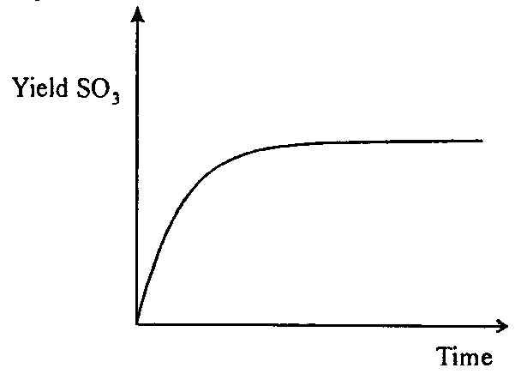
Which of the following graphs below most accurately represents the yield of SO₃ with time at 400°C and atmospheric pressure?
A. | 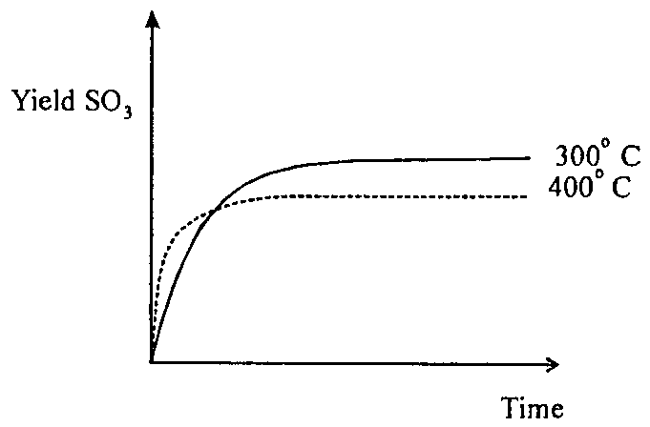 | C. | 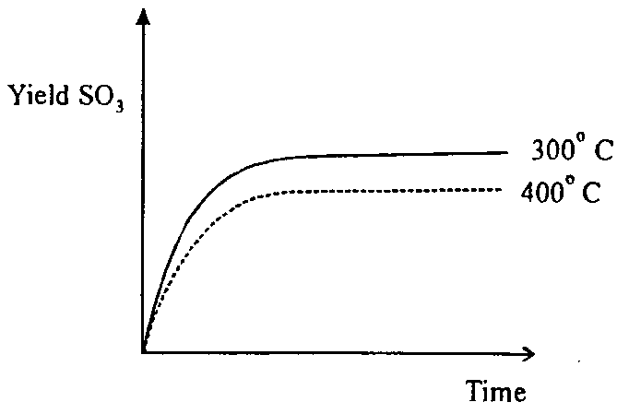
B. | 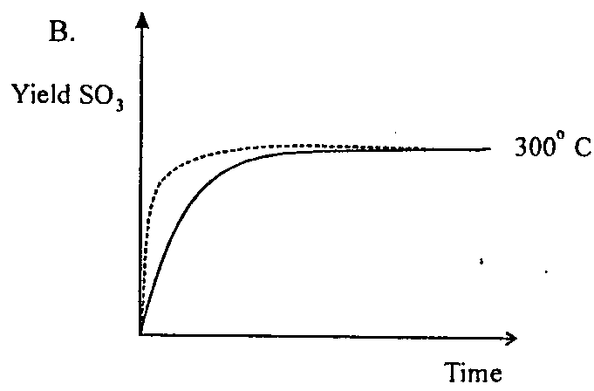 | D. | 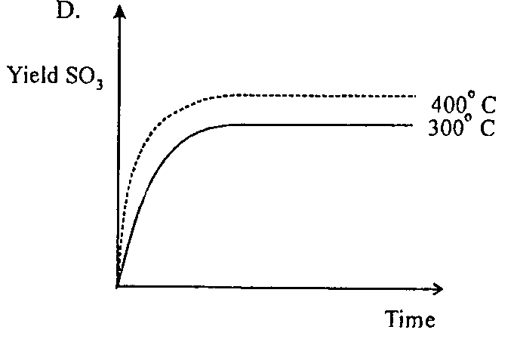

Question 7
The oxidation number of manganese changes as MnO₂ (s) is converted into MnO₄^{2–} (aq). How many electrons are gained or lost when one mole of MnO₂ is completely converted into MnO₄^{2–} (aq)?
- 3
- 1.2 × 10²⁴
- 4
- 1.8 × 10²⁴

Question 8
Consider the equilibrium N₂ (g) + H₂ (g)  2 NH₃ (g) for which the equilibrium constant is represented by K_{c}.
Which of the following expressions represents the concentration of NH₃ at equilibrium?
- 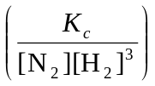
- 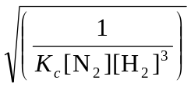
- 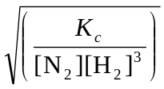
- 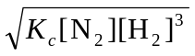

Question 9
What two compounds react together in the presence of sulfuric acid to produce the compound with the structural formula
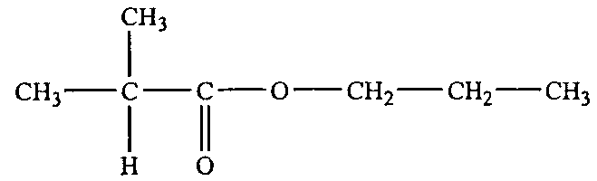
- ethanoic acid and butanol
- 2-propanoic acid and 1-propanol
- butanoic acid and ethanol
- 2-methyl propanoic acid and 1-propanol

Question 10
The iron content of a 20.0 mL sample of water was determined by titration with acidified 0.0050 M KMnO₄ (aq). The reaction occurring may be represented by the equation
5 Fe²⁺ (aq) +MnO₄– (aq) + 8 H⁺ (aq) → 5 Fe³⁺ (aq) + Mn²⁺ (aq) + 4 H₂O (l)
If the water sample required 25.0 mL of 0.0050 M KMnO₄ (aq) for complete conversion of Fe²⁺ (aq) to Fe³⁺ (aq) what was the concentration of Fe²⁺ (aq) in the water?
- 0.0050 M
- 0.0065 M
- 0.014 M
- 0.031 M

Question 11
A 20.0 mL sample of a saturated aqueous solution of calcium hydroxide, Ca(OH)₂ (aq), was titrated with 0.0300 M hydrochloric acid. If 17.5 mL of the acid was required to reach the endpoint of the titration, the pH of the calcium hydroxide solution, at 25°C, was
- 1.52
- 1.58
- 12.4
- 12.5

Question 12
When a polyester forms from reaction between the monomers HOCH₂CH₂OH and HOOCC₆H₄COOH the percentage, by mass, of carbon in the polyester is
- greater than in the monomers
- less than in the monomers
- the same as in the monomers
- dependent on the length of the polymer chain

Question 13
Blood pH is critical to the survival of living organisms. For humans the ideal pH range is 7.35 to 7.45. If blood pH rises too high a condition called alkalosis occurs. If blood pH drops too low the resulting condition is called acidosis.
Blood pH is maintained at desirable levels via the equilibria
CO₂ (g)  CO₂ (aq)
CO₂ (aq) + H₂O (l)  H₂CO₃ (aq)
H₂CO₃ (aq) + H₂O (l)  HCO₃– (aq) + H₃O⁺ (aq)
Should acidosis occur in the blood it may be counteracted by
- breathing into a paper bag
- rapid exhalation of the breath
- injecting the blood with a dilute aqueous solution of potassium chloride
- donating blood

Question 14
Which of the following analytical techniques is most commonly associated with the determination of the concentration of metal ions in diluted solutions?
- Colorimetry
- Gas Chromatography
- Atomic Absorption Spectroscopy
- UV-Visible Spectroscopy

Question 15
Shown below are representations of the molecular structure of two different organic compounds.
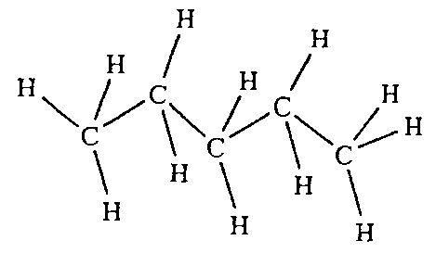 | 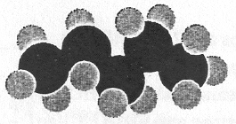
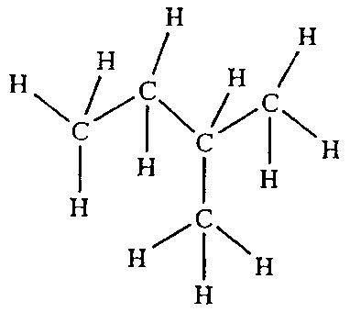 | 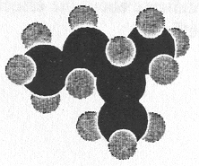
These two compounds are best described as
- allotropes
- isomers
- isotopes
- hydrocarbons

Question 16
Hydrogen and oxygen react to produce water according to the equation
2 H₂ (g) + O₂ (g) → 2 H₂O (g); ΔH = –484 kJ mol^{–1}
The activation energy for the reaction 2 H₂O (g) → 2 H₂ (g) + O₂ (g) is 1852 kJ mol^{–1}.
The activation energy for the reaction 2 H₂ (g) + O₂ (g) → 2 H₂O is
- –1852 kJ mol^{–1}
- 484 kJ mol^{–1}
- 1368 kJ mol^{–1}
- 2336 kJ mol^{–1}

Question 17
Ammonia is a weak base, which ionises in water according to the equation
NH₃ (aq) + H₂O (l)  NH₄⁺ (aq) + OH– (aq)
50 mL of pure water at 25°C is added to 50 mL of 0.20 M NH₃ (aq) at 25°C.
When the diluted solution of ammonia returns to equilibrium at 25°C, the
- pH of the solution has decreased
- [H⁺] has decreased
- [NH₄⁺] has increased
- value of K_{w} has increased

Question 18
A mixture of hydrocarbons is injected into a gas chromatograph and produces the chromatogram given below.
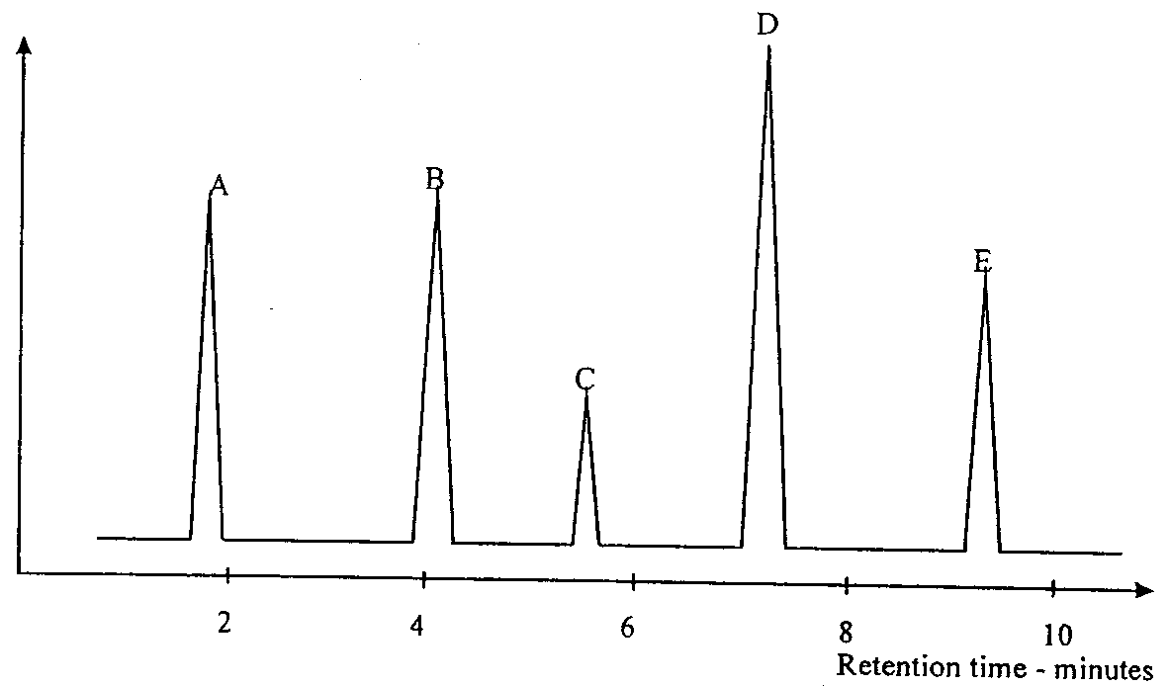
Which of the following statements is not a valid interpretation of the chromatogram?
- compound A was least attracted tot eh column
- compound C was possibly methane
- compound D was the most abundant compound in the hydrocarbon mixture
- compound E could have been 2,2-dimethyl propane
Question 19
Sodium hydride dissolves in water to produce the hydride ion, H– (aq), according to
NaH (s) + aq → Na⁺ (aq) + H– (aq)
The hydride ion then reacts with water according to
H– (aq) + H₂O (l) → H₂ (g) + OH– (aq)
The reaction between H– (aq) and water is most accurately described as being
- a hydrolysis reaction
- an acid-base reaction
- a redox reaction
- both an acid-base and a redox reaction

Question 20
For most chemical reactions, the rate of reaction increases as the temperature increases. The cause of the rate increase is
- the increased kinetic energy of the reactant particles
- the increase in the number of fruitful collisions between reactant particles
- the lowering of the activation energy of the reaction as the temperature increases
- the increase in the surface area of the reactant particles as they expand on heating

Section B – Short Answer Questions

Question 1
The calcium carbonate in limestone reacts with dilute hydrochloric acid according to the equation
CaCO₃ (s) + 2 HCl (aq) → CaCl₂ (aq) + H₂O (l) + CO₂ (g)
In an experiment to investigate the effect of different conditions on the rate of this reaction, a student decides that measuring the mass loss during the reaction will give an indication of how the rate of reaction changes with time.
The student carries out the reaction four times using the following conditions:
- limestone lumps and 200 mL of 2.0 M HCl (aq)
- limestone lumps and 200 mL of 1.0 M HCl (aq)
- powdered limestone and 200 mL of 2.0 M HCl (aq)
- powdered limestone and 200 mL of 1.0 M HCl (aq)
In all cases the limestone was in excess.
Ultimately the student presented a set of graphs for total mass loss against time.
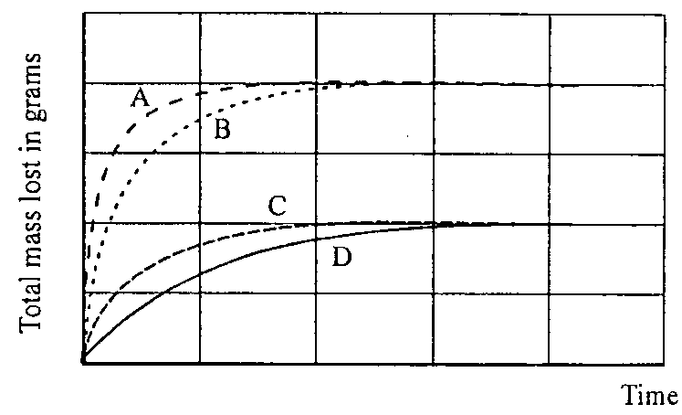
- According to the Law of Conservation of Mass, there is ‘no loss of mass’ during a chemical reaction. Explain then how it would be possible to use ‘mass loss’ to investigate the rate of the reaction between calcium carbonate and hydrochloric acid.

2 marks
- State the key laboratory equipment items that would be needed for this investigation.

1 mark
- Indicate which of the graphs – A, B, C, D – corresponds to each of the four sets of reaction conditions
1. limestone lumps and 2.0 M HCl (aq): __________________
2. limestone lumps and 1.0 M HCl (aq): __________________
3. powdered limestone and 2.0 M HCl (aq): __________________
4. powdered limestone and 1.0 M HCl (aq): __________________
2 marks
- What do the graphs indicate about the effect of concentration on reaction rate? What aspect of the graphs supports this effect?

2 marks
- What effect does using powdered calcium carbonate rather than lumps have on the rate of reaction? Why does this occur?

1 mark
- Why is the total mass loos shown in graphs A and B effectively twice as great as the total mass loss shown in graphs C and D?

2 marks
- Suggest an alternative method of monitoring the rate of reaction between calcium carbonate and hydrochloric acid.

2 marks
Total: 11 marks

Question 2
The active ingredient in aspirin is acetylsalicylic acid, CH₃COOC₆H₄COOH. This is a monoprotic acid with K_{a} = 3.3 × 10^{–4} at 25°C.

- Give the equilibrium law expression for the ionisation of acetyl salicylic acid in aqueous solution.

1 mark
- If two soluble aspirin tablets, each containing 300 mg of acetylsalicylic acid were dissolved in 250 mL of water at 25°C what would be the molar concentration of the solution produced?

2 marks
- Determine the pH of the solution produced in b.

3 marks
- Give the names of the two functional groups present in acetylsalicylic acid molecules.

1 mark
Total: 7 marks
Question 3
The diagram below shows a series of linked organic reactions.

A | CH₃CH₂CH₃ |  | B | CH₃CH=CH₂
 | 1 | 3 |  | 2  Cr₂O₇^{2–} (aq)  H⁺ (aq)
C | CH₃CH₂CH₂Cl |  | D | CH₃CH₂CH₂OH |  |  |  | E | _______________
 |  |  |  |  |  | 5
 |  |  |  |  | F |  | _______________

- Give the name of the process by which compound B would most likely be produced and give a balanced equation for its production.

2 marks
- State the types of reaction occurring at 1, 2, and 3 and in each case give the chemical formula of the other reactant involved.

3 marks
- Give the name and structural formula of compound E.

1 mark
- Give the name and role of the other chemical required for reaction 5.

1 mark
- Give the name and structural formula of compound F.

2 marks
Total: 9 marks

Question 4
As part of a practical assessment a student is required to measure the amount of calcium in a brand of mineral water using atomic absorption spectroscopy.
The atomic absorption spectrometer has already been calibrated for calcium and the calibration curve below produced.
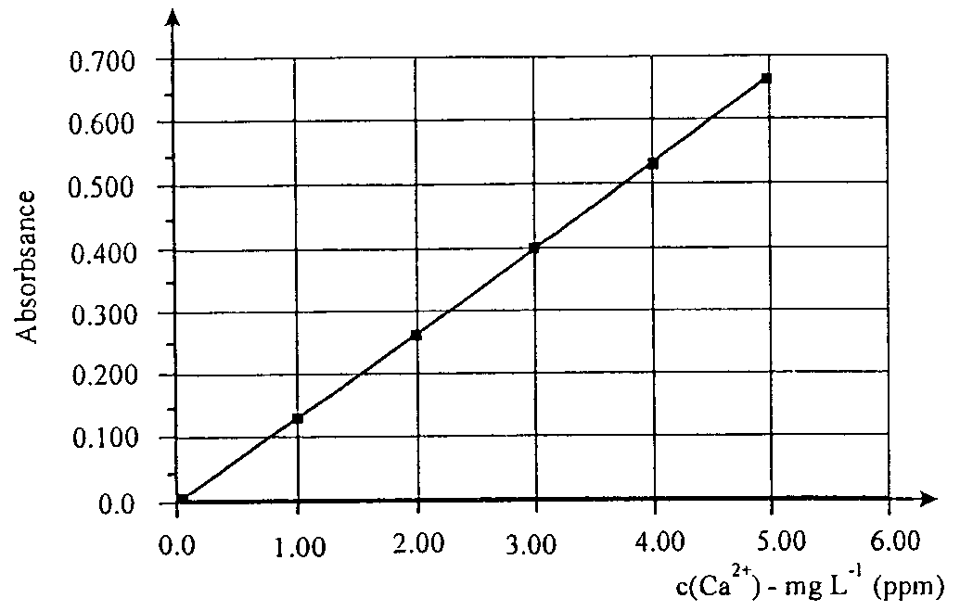

- Explain how the spectrometer would have been calibrated for calcium.

2 marks
- The student is supplied with a bottle of mineral water. The information on the label indicates that the calcium ion concentration is 140 ppm (mg L^{–1}).
The student decides that aspirating the mineral water directly into the flame would not be an appropriate technique and proceeds to dilute the mineral water.
Explain why the student followed this procedure and explain how an appropriate dilution factor might be arrived at.

2 marks
- The student found the calcium concentration in the mineral water to be 150 ppm. This was based on an absorbance reacting of 0.395 for the diluted mineral water. If the student used a 5.0 mL sample of the actual mineral water, to what volume was it diluted prior to analysis?

2 marks
- The mineral water analysed also contained Mg²⁺, Na⁺, and K⁺ ions. Explain why these ions would not be expected to interfere in the analysis for Ca²⁺ using atomic absorption spectroscopy.

1 mark
- The sodium ion content of the mineral water was 93 ppm. If a consumer was to drink one 1.25 L bottle of this mineral water each day for one year, calculate
    - the total mass, in g, of sodium consumed

1 mark
    - the number of Na⁺ ions consumed

1 mark
Total: 9 marks

Question 5
Ammonia is produced in the Haber process, which involves the equilibrium
N₂ (g) + 3 H₂ (g)  2 NH₃ (g); ΔH = –108 kJ mol^{–1}
Modern ammonia production plants operate at approximately 500°C ad 25 MPa pressure. A finely divided iron catalyst is also used.

- Why are high pressures used in the production of ammonia?

1 mark
- Write a balanced equation for the equilibrium stage in the production of sulfuric acid via the Contact process.

1 mark
- Both the Haber and Contact processes use temperatures between 400 and 500°C and a catalyst.
    - What is the catalyst used in the Contact process and why is it arranged on a series of trays in the converter?

1 mark
    - Why are the temperature / catalyst combinations in th eHaber and Contact processes so important?

3 marks
- The pressure used in the Contact process is close to atmospheric pressure. However this is not consistent with Le Chatelier’s principle. Explain the inconsistency.

1 mark
- Sulfuric acid is formed from sulfur(VI) oxide in a 2 stage process. Write balanced equations for the two stages and explain why it is necessary to use this process.

2 marks
- Write a balanced equation for the production of the fertiliser ammonium sulfate from reaction between ammonia and sulfuric acid? Explain why this is classified as an acid-base reaction.

2 marks
Total: 11 marks

Question 6
A gas mixture containing only oxygen, nitrogen and carbon dioxide was analysed as follows:
100 mL of the gas, at 25°C and 1.00 × 10⁵ Pa pressure was passed through 200 mL of 0.100 M NaOH (aq). At this stage the CO₂ was absorbed according to the equation
CO₂ (g) + 2 NaOH (aq) → Na₂CO₃ + H₂O (l)
The remaining gas was then allowed to pass through pyrogallic acid which absorbed the O₂.
The volume of N₂ remaining was 72.5 mL at 25°C and 1.00 × 10⁵ Pa.
Finally a 20.0 mL aliquot of NaOH (aq), remaining after absorbing the CO₂, was titrated with 0.0975 M HCl (aq) using methyl orange indicator. An average titre of 19.8 mL was required to reach the endpoint.

- Write a balanced equation for the titration reaction.

1 mark
- Calculate the n(NaOH) in the 20.0 mL aliquot.

1 mark
- Calculate the n(NaOH) reacting during the absorption of CO₂.

2 marks
- Calculate the volume of CO₂ in the gas mixture.

3 marks
- Calculate the mass of oxygen in the gas mixture.

3 marks
Total: 10 marks

