Lisachem 2005 | Unit 4 Chemistry | Trial Examination Solutions

Section A – Multiple choice questions

1. | D | The key to this question was the direction of movement of the ions in the salt bridge.  Anions – NO₃– - always move towards the anode, which is the site of oxidation, ie Y.  Cations – Na⁺ - always move towards the cathode, which is the site of reduction, ie X.  Hence, reduction is occurring at electrode X, and oxidation is occurring at electrode Y.  In galvanic cells, electrons move spontaneously from the (–) electrode to the (+) electrode.
2. | A | Since the discharge reaction is  PbO₂ (s) + Pb (s) + 4 H⁺ (aq) + 2 SO₄^{2–} (aq) → 2 PbSO₄ (s) + 2 H₂O (l)  Then the recharge reaction is  +2 +4 0  2 PbSO₄ (s) + 2 H₂O (l) → PbO₂ (s) + Pb (s) + 4 H⁺ (aq) + 2 SO₄^{2–} (aq)  The oxidation number of Pb is reduced from +2 to 0 (PbSO₄ → Pb) at the cathode which, in electrolysis, is the (–) electrode.  The oxidation number of Pb is increased from +2 to +4 (PbSO₄ → PbO₂) at the anode which, in electrolysis is the (+) electrode.  Alternative C may have been tempting. However, it is during discharge that the oxidation number of Pb increases as Pb is converted to PbSO₄.
3. | B | As nickel is a transition element the colour change could be due to a change in its oxidation number of the formation of a complex ion.  In NH₃, N is at its lowest oxidation state of –3. Hence it will not oxidise Ni²⁺.  NH₃ is a stonger complexing agent of ligand than H₂O. Therefore, NH₃ will take the place of H₂O as a ligand around Ni²⁺, according to the equilibrium  Ni(H₂O)₆²⁺ (aq) + 6 NH₃ (aq)  Ni(NH₃)₆²⁺ (aq) + 6 H₂O (l)  As this equilibrium moves to the right, the solution colour changes from the green of Ni(H₂O)₆²⁺ (aq) to the blue of Ni(NH₃)₆²⁺ (aq).  A precipitate of Ni(OH)₂ would be expected to be green, the same colour as Ni²⁺ (aq).  The colours of different complex ions of a particular transition metal are associated with electron movement between different orbitals in the d-subshell.
4. | D | The ionisation energy is the minimum amount of energy required to remove the highest energy electron from an atom.  The first five ionisation energies increase gradually but there is a big jump from the fifth to the sixth. As each electron is removed from the outer shell, the core charge is acting on fewer electrons which become progressively harder to remove hence the increase in ionisation energy. There are 5 electrons in the outer shell.  The big jump from the fifth to the sixth ionisation energy indicates that the sixth electron is removed from a shell closer to the nucleus. The increase from the sixth to seventh to eighth ionisation energies indicates there are more than two electrons in that shell.  Both N:2,5 and P: 2,8,5 atoms have 5 outer shell electrons, but the ionisation energy data cannot be that of nitrogen, which has only seven electrons in its atoms.
5. | C | According to H₂ (g) + ½ O₂ (g) → H₂O (g); ΔH = –242 kJ mol^{–1}, for each 1 mol H₂ reacting 242 kJ of energy is released.  The link between H₂ (g) + ½ O₂ (g) → H₂O (g) and H₂ (g) + ½ O₂ (g) → H₂O (l) is H₂O (g) → H₂O (l)  Energy is released when water condenses so for each mole of H₂ (g) reacting in  H₂ (g) + ½ O₂ (g) → H₂O (l) more than 242 kJ of energy is released.
6. | D | When a gaseous sample of an element is injected into a mass spectrometer, the individual atoms assume a positive charge as they pass the electron beam. As the ions pass through the electric field, they are accelerated and then separated in the magnetic field.
7. | C | The fusion of hydrogen to helium in the Sun occurs at temperatures well in excess of 10 million degrees. Such temperatures have proved very difficult to achieve on Earth. The fuels used will be deuterium and tritium, which are isotopes of hydrogen that can be extracted from water.  Fusion does not produce radioactive products.  In terms of generating electricity, a nuclear fusion power station would differ from a coal-fired power station only in the initial reaction – nuclear fusion rather than combustion.  However, the energy released per gram of nuclear fuel would be many magnitudes greater than the energy released per gram of coal.
8. | A | The element with its highest energy electrons in a d-subshell will be in the d-block on the Periodic Table, ie it is a transition element. If the highest energy electrons are in the 5d subshell, the element is in the third transition series, ie the third row in the d-block.  ₈₀Hg – third row, d-block; highest energy electrons in 5d subshell.  ₉₄Pu – second row, f-block; actinide; highest energy electrons in 5f subshell.  ₄₂Mo – second row, d-block; highest energy electrons in 4d subshell.  ₃₈Sr – fifth row, s-block; highest energy electrons in 5s subshell.
9. | D | Using molecular formulae, the equation for the reaction is  C₆H₁₂O₆ (aq) + C₆H₁₂O₆ (aq) → C₁₂H₂₂O₁₁ (aq) [+ H₂O (l)]  Because water is condensed out as the monosaccharides react to produce the disaccharide, the % by mass of carbon will be greater in the disaccharide.  C₆H₁₂O₆: %C = [6 × M(C) / M(C₆H₁₂O₆)] × 100  = [6 × 12.0 / 180] × 100  = 40%  C₁₂H₂₂O₁₁: %C = [12 × M(C) / M(C₁₂H₂₂O₁₁)] × 100  = [12 × 12.0 / 342] × 100  = 42%
10. | B | Consider the steps shown  I N₂ → NH₃; this is reduction as oxidation number of N decrease from 0 to –3  II NH₃ → NH₄⁺; this shown NH₃ acting as a base (accepting H⁺). The oxidation number of N does not change. It is –3 in both NH₃ and NH₄⁺.  III N₂ → NH₄⁺; this is reduction as oxidation number of N decreases from 0 to –3.  IV NH₄⁺ → NO₃–; this is oxidation as oxidation number of N increases from –3 to +5.
11. | B | Trends in properties down a group can all be related to the distance of the outershell electrons from the nucleus. All toms in a group have the same core charge but its effect, and the atoms hold on its outershell electrons, decrease down the group as the outershell electrons are progressively further from the nucleus. Consequently, down a group:  Atomic radius increases as the number of occupied electron shells increases.  Electronegativity – electron attracting ability – decreases.  Ionisation energy – energy needed to remove highest energy electron – decreases.  Reducing strength – ability to give up electrons to other species – increases.  Oxidising strength – ability to force other species to give up electrons – decreases.
12. | B | Yttrium is located under scandium, Sc, on the Periodic Table.  Since the atomic number of yttrium is 39, Yttrium-90 has the isotopic symbol 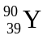.  Each atom contains 39 protons, 39 electrons and 90 – 39 = 51 neutrons.  A Y³⁺ ion contains 39 protons, 36 electrons and 51 neutrons.  With 36 electrons in its nucleus, a Y³⁺ ion has the same electron arrangement as ₃₆Kr, which means its highest electrons are in the 4p subshell.
13. | A | Atoms emit energy when electrons that have been excited to higher energy levels return to lower energy levels. The wavelength of the light emitted depends on the energy difference between the levels between which the electrons move.  When electrons move from the ground state – where all electrons are in the lowest possible energy levels – to an excited state energy is absorbed. This energy is emitted when electrons return to their ground states.  With respect to the 4s and 3d subshells, atoms of the transition elements have electrons of similar energy in both the 4s and 3d subshells. This is why multiple oxidation states are possible for most transition elements.  The movement of electrons between orbitals in a d-subshell is associated with the colours of transition metal complex ions.
14. | A | The mass of Li consumed can be determined form the n(e–) transferred from the anode to the cathode.  The relationships Q = I t and Q = n(e–) × F enable the calculation of the n(e–).  Q = I t = 4.0 × 3 × 60 × 60  = 4.32 × 10⁴ C  n(e–) = Q / F  = 4.32 × 10⁴ C / 96500 C mol^{–1}  = 0.448 mol  Since the anode reaction is Li → Li⁺ + e–  n(Li) = n(e–) = 0.448 mol  m(Li) = n(Li) × M(Li)  = 0.448 × 6.9  = 3.1 g
15. | A | The reaction of CO₂ (g) with OH– (aq) shows that CO₂ is clearly an acidic oxide.  The other three oxides, MgO, SO₃ and Al₂O₃ are all oxides of period 3 elements. Across period 3, the oxides change from basic to acidic.  Na₂O and MgO are basic oxides, meaning they react (i) with water to produce OH– (aq) ions, and (ii) with acidic solutions, ie with H⁺ (aq).  Oxides of P, S and Cl are acidic oxides, meaning they react (i) with water to produce acids, and (ii) with basic solutions, ie with OH– (aq). SO₃ is an acidic oxide.  Al₂O₃ is an amphoteric oxide. It will react with both acidic and basic solutions.  Al₂O₃ (s) + 6 H⁺ (aq) → 2 Al³⁺ (aq) + 3 H₂O (l)  Al₂O₃ (s) + 2 OH– (aq) + 3 H₂O (l) → 2 Al(OH)₄– (aq)  The only oxide listed which does not display acidic properties was MgO.
16. | C | The electron content of an orbital is limited. According to the Pauli principle, an orbital may contain 0, 1 or 2 electrons, but never more than two.  The number of electron shells is the same for all atoms. However chemical properties are based on ‘occupied’ shells, hence the importance of electron arrangements.  The number of orbitals in each subshell follows the pattern s-1, p-3, d-5, f-7.  The number of subshells in a shell is the same as the shell number, eg the third shell has three subshells. The lowest energy subshell in a shell is always an s-subshell.
17. | B | Consider the electroplating of copper as an example.  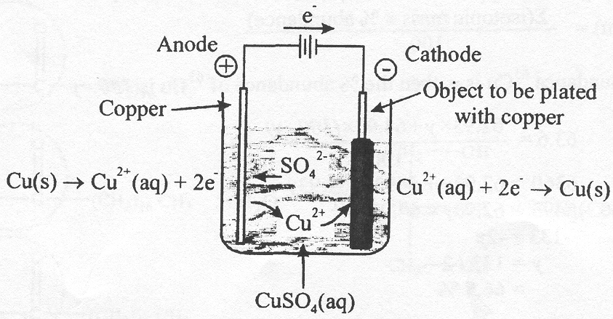  The object to be plated is always at the cathode, where the metal cations are reduced to the plating metal. The anode is a strip or ingot of the plating metal, which is oxidised to the cations. The electrolyte is an aqueous solution of the cations of the plating metal. The complementary oxidation and reduction processes keep the cation concentration constant.
18. | C | Calibration Factor = Energy added during heating / ΔT_{c}  = V I t / ΔT_{c}  = 6.00 × 1.40 × 54.5 / 0.390  = 457.8 / 0.390  = 1174 J °C^{–1}  Energy released by CH₄ = CF × ΔT_{r}  = 1174 × (22.17 – 21.45)  = 1174 J °C^{–1} × 0.72 °C  = 845 J  Energy per mol CH₄ = 845 J / 9.50 × 10^{–4} mol  = 8.90 × 10⁵ J  = 8.90 × 10² kJ  = 890 kJ
19. | D | The half-equations relevant to the electrolysis of concentrated NaCl (aq) are
19. | D | Cl₂ + 2 e– | → | 2 Cl– | 1.36 V
19. | D | O₂ + 4 H⁺ + 4 e– | → | 2 H₂O | 1.23 V
19. | D | 2 H₂O + 2 e– | → | H₂ + 2 OH– | –0.83 V
19. | D | Na⁺ + e– | → | Na | –2.76 V
19. | D | The stronger oxidant, H₂O (l) is reduced at the cathode, which is the (–) electrode in the electrolysis cell. The pH around the cathode increases due to the increasing [OH–].  2 H₂O (l) + 2 e– → H₂ (g) + 2 OH– (aq)  At the anode, whic is the (+) electrode, whilst H₂O is the stronger reductant, in high concentrations of NaCl (aq) 5 to 10 M, Cl– is preferentially oxidised to Cl₂  2 Cl– (aq) → Cl₂ (g) + 2 e–  Cl– (aq) ions move towards the anode – anions move towards the anode.  The semi-permeable membrane allows Na⁺ (aq) ions to migrate to the cathode, where they combine with OH– (aq) to produce NaOH (aq). So that the NaOH produced is not contaminated with NaCl, the membrane does not allow the passage of Cl– (aq) ions.
20. | C | To calculate the percentage abundance of ⁶³Cu you also need the relative atomic mass of Cu which, according to the supplied data table, is 63.6.  Since A_{r}(Cu) = 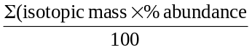  If the % abundance ⁶³Cu is y, then the % abundance of ⁶⁵Cu is 100 – y  So 63.6 = 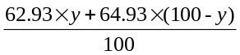  6360 = 62.93y + 6493 – 64.93y  6360 – 6493 = 62.93y – 64.93y  –133 = –2y  y = 133 / 2  = 66.5 %

Section B – Short Answer Questions

Question 1
- i. A monounsaturated fatty acid has only one carbon-carbon double bond, C=C, in each molecule.
A polyunsaturated fatty acid has two or more carbon-carbon double bonds, C=C, in each molecule. 
ii. linolenic acid; CH₃CH₂CH=CHCH₂CH=CHCH₂CH=CH(CH₂)₇COOH – C₁₈H₃₀O₂
linoleic acid; CH₃(CH2)₄CH=CHCH₂CH=CH(CH₂)₇COOH – C₁₈H₃₂O₂
Since each oleic acid has one less C=C double bond, and hence 2 more H atoms, than a linoleic acid molecule, its molecular formula is C₁₈H₃₄O₂ 
iii. Oleic acid molecules have 18 C atoms and one C=C double bond, which begins on the ninth carbon atom in the hydrocarbon chain. The structural formula is
CH₃CH₂CH₂CH₂CH₂CH₂CH₂CH₂CH=CHCH₂CH₂CH₂CH₂CH₂CH₂CH₂COOH
or CH₃(CH₂)₇CH=CH(CH₂)₇COOH. 
- Since stearic acid is saturated its molecules do not contain any C=C double bonds.
The structural formula is CH₃CH₂CH₂CH₂CH₂CH₂CH₂CH₂CH₂CH₂CH₂CH₂CH₂CH₂CH₂CH₂CH₂COOH. 
- i. Glycerol, C₃H₈O₃ 
Glycerol is more commonly recognised by the structural formula
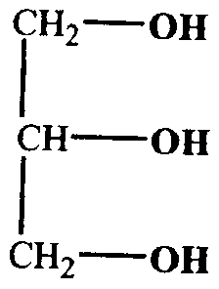
ii. During digestion of fats water acts across the ester functional groups  which are converted into carboxy and hydroxy functional groups. 
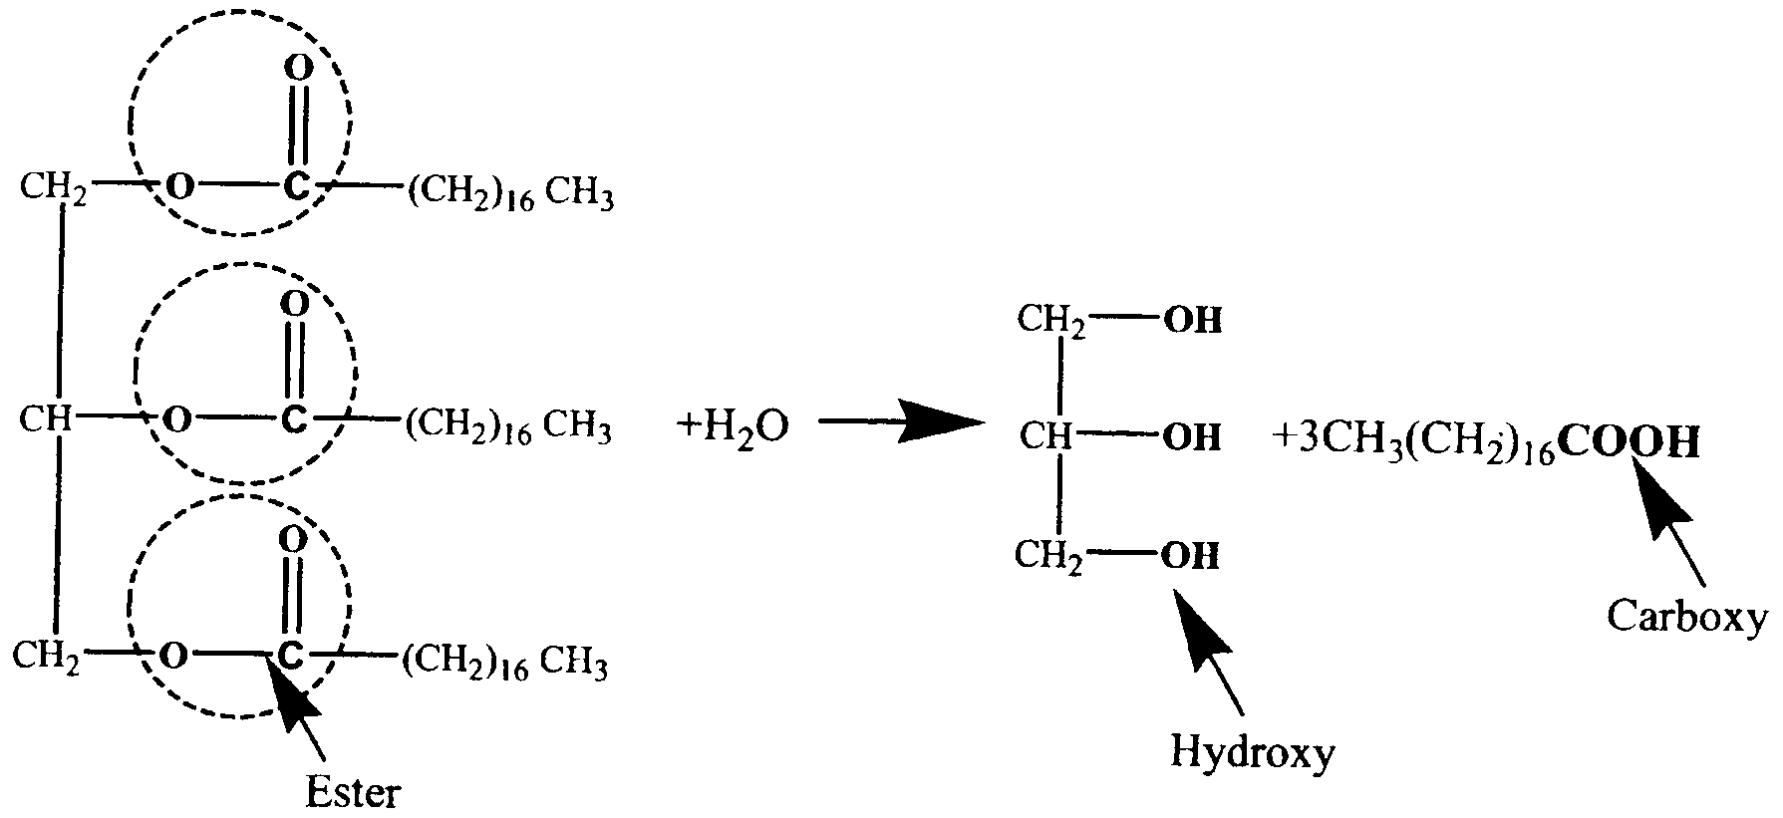
- Energy released by 5 mL olive oil = CF × ΔT
= 5.95 × 10³ × (53.2 – 24.6) 
= 5.95 × 10³ × 28.6
= 1.70 × 10⁵ J 
Energy released by 100 mL olive oil = (1.70 × 10⁵ / 5) × 100
= 3.40 × 10⁶ J
= 3.40 × 10³ kJ 
- Vitamin E protects the C=C double bonds  in the unsaturated fats/oils from reaction with atmospheric oxygen. As an antioxidant it reacts preferentially with atmospheric oxygen.  Antioxidants are good reductants.

Question 2
- According to 2 CH₃OH (l) + 3 O₂ (g) → 2 CO₂ (g) + 4 H₂O (l); ΔH = –1506 kJ mol^{–1}
Combustion of 2 mol CH₃OH releases 1506 kJ of energy
∴ 1 mol CH₃OH → 1506 / 2 = 753 kJ 
Since M(CH₃OH) = 32.0 g mol^{–1}
32 g CH₃OH → 753 kJ
1 g CH₃OH → 753 / 32 = 23.5 kJ 
Heat of combustion of methanol is 23.5 kJ g^{–1}
- (i) Energy added to water = 4.184 J mL^{–1} °C^{–1} × V(H₂O) × ΔT
= 4.184 × 200 × (87.9 – 23.5) 
= 4.184 × 000 × 64.4
= 5.39 × 10⁴ J
= 53.9 kJ 
(ii) m(CH₃OH) used = 125.62 -117.23
(iii) % energy transferred to water = (energy added to water / energy released by CH₃OH) × 100
= (53.9 / 197) × 100
= 27.4 % 
(iv) Most of the energy released from the combustion of CH₃OH escapes to the surrounding atmosphere. The amount transferred to the water could be increased by providing a shield around the burner and/or placing a lid or cover on the can. 
- (i) In a fuel cell chemical energy is converted directly to electrical energy.
(ii) The fuel is oxidised at the negative electrode and oxygen is reduced at the positive electrode. Since the electrolyte is acid, the reduction half-equation is obtained from the electrochemical series by looking for O₂ – the oxidant – in a half-equation with H⁺ (aq).
O₂ (g) + 4 H⁺ (aq) + 4 e– → 2 H₂O (l) 
(iii) CH₃OH oxidised to CO₂.
CH₃OH (l) → CO₂ (g)
CH₃OH (l) + H₂O (l) → CO₂ (g) + 6 H⁺ (aq) + 6 e– 
(iv) Electrodes in a fuel cell must:
- conduct electricity
- not react with the fuel, oxygen or electrolyte
- be porous to allow contact between the oxidant / fuel and the electrolyte
 for two;  for three.
Electrodes may also be impregnated with a catalyst.

Question 3
- (i) 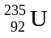 + 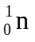 → 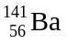 + 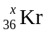 + 3
This is a ‘nuclear fission’ reaction. 
A large nucleus is split into two smaller nuclei by the impact of a neutron.
Nuclear equations are balanced according to atomic numbers and mass numbers.
Left hand side: mass number = 235 + 1 = 236
Right hand side: mass number = 141 + x + 3 × 1
x + 144 = 236 → x = 236 – 144
= 92 
(ii) In nuclear reactions, ‘different’ atoms / elements are produced, whereas in chemical reactions atoms are rearranged but no ‘different’ atoms / elements are produced.
or In nuclear reactions a small amount of mass is converted into energy according to E = mc², whereas in chemical reactions mass is conserved. 
(iii) The main environmental issues associated with nuclear fission are:
  - exposure to harmful radiation, especially gamma-rays
  - storage and disposal of radioactive waste. 
- (i) 4 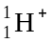 → 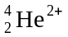 + 2 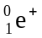 or 4 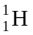 → 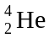 + 2 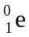
(ii) This is a nuclear fusion reaction.  Small nuclei combine to form larger nuclei.
(iii) During the conversion of hydrogen nuclei to helium nuclei by nuclear fusion there is a decreases in mass consistent with mass to energy conversion in line with Einstein’s E = mc². 
Consequently the total mass of the Sun is decreasing, as is the total number of nuclei present.
- Light energy from the Sun is transformed into electrical energy in photovoltaic cells. This electrical energy is used to ‘recharge’ the batteries and is transformed into chemical energy. 
- 6 CO₂ (g) + 6 H₂O (l) → C₆H₁₂O₆ (aq) + 6 H₂O (l) 

Question 4
- In the electrochemical series fluorine, F₂, is clearly the strongest oxidant. This means it readily causes reductants to give up electrons. 
In the periodic table fluorine is the most electronegative element. This means it has the strongest attraction for electrons. 
So strong is fluorine’s attraction for electrons that it is better than any other element at causing other species to be oxidised.
- During electrolysis electrons are dragged off the (+) electrode and forced onto the (–) electrode. Therefore, oxidation occurs at the (+) electrode and reduction occurs at the (–) electrode.
(+) electrode: 2 F– (l) → F₂ (g) + 2 e– 
(–) electrode: K⁺ (l) + e– → K (l) 
- The oxidants and reductants present in dilute KF (aq) are included in the half equations
F₂ (g) + 2 e– | → | 2 F– (aq) | +2.87 V
O₂ (g) + 4 H⁺ (aq) + 4 e– | → | 2 H₂O (l) | +1.77 V
2 H₂O (l) + 2 e– | → | H₂ (g) + 2 OH– (aq) | –0.83 V
K⁺ (aq) + e– | → | K (s) | –2.93 V
The general principle of reactions in electrochemical series is that reaction occurs between the strongest oxidant and the strongest reductant.
In KF (aq) there are two oxidants – K⁺ (aq) and H₂O (l), and two reductants – F– (Aq) and H₂O (l).
H₂O (l) is the stronger reductant – stronger than F– (aq). Hence H₂O will be oxidised at the anode, rather than
F– (aq). Consequently O₂ will be produced rather than F₂. 
Anode half-equation: 2 H₂O (l) → O₂ (g) + 4 H⁺ (aq) + 4 e– 
H₂O is the stronger oxidant, hence the cathode half-equation will be 2 H₂O (l) + 2 e– → H₂ (g) + 2 OH– (aq) 
- (i) ‘aluminium compound’ is alumina or aluminium oxide
‘lower melting temperature compound’ is cryolite 
(ii) In electrolysis, oxidation occurs at the positive electrode. The oxidation half-equation is
2 O^{2–} (l) → O₂ (g) + 4 e– 
However at the high operating temperature of the Hall Cell, the carbon anodes react with the oxygen according to C (s) + O₂ (g) → CO₂ (g).  The carbon anodes are gradually consumed and are replaced every few weeks.
The changes occurring at the anode may be described by the overall half-equation
C (s) + 2 O^{2–} (l) → CO₂ (g) + 4 e–.
(iii) In an aqueous solution of Al³⁺ there are two oxidants – H₂O (l) and Al³⁺ (aq).
According to the electrochemical series, H₂O (l) is a stronger oxidant than Al³⁺ (aq), so H₂O (l) will be preferentially reduced. 
The half-equation for the reaction occurring at the cathode will be: 2 H₂O (l) + 2 e– → H₂ (g) + 2 OH– (aq)

Question 5
- (i) There are four different amino acids. 
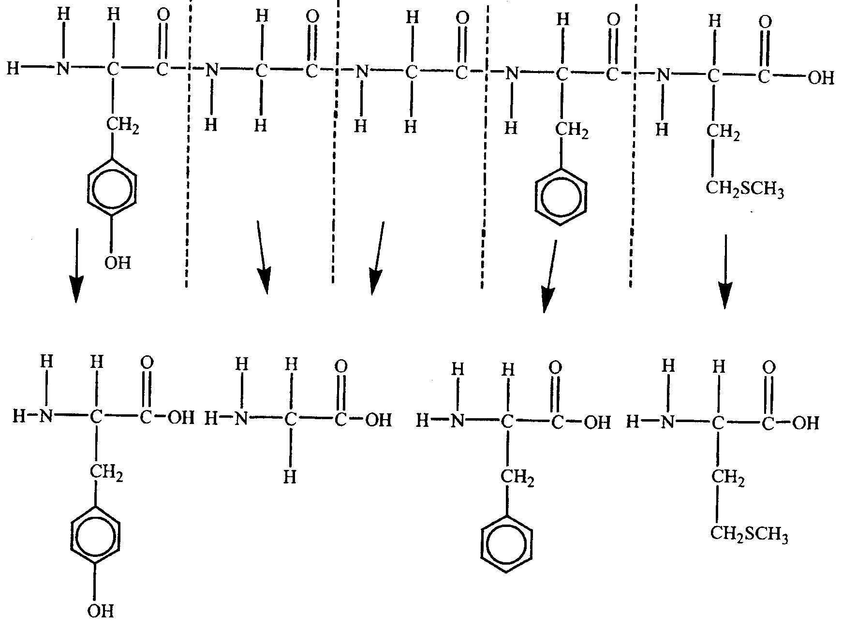
(ii) The peptide group CONH is produced when the carboxy group, –COOH, reacts with the amino group, –NH₂, in a condensation reaction. 
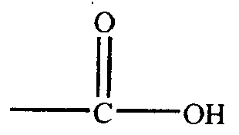 | + | 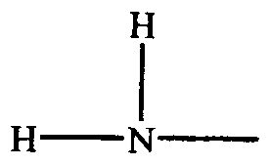 | → | 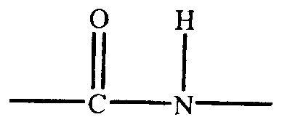 | + | H₂O
(iii) The H atom in a peptide group. 
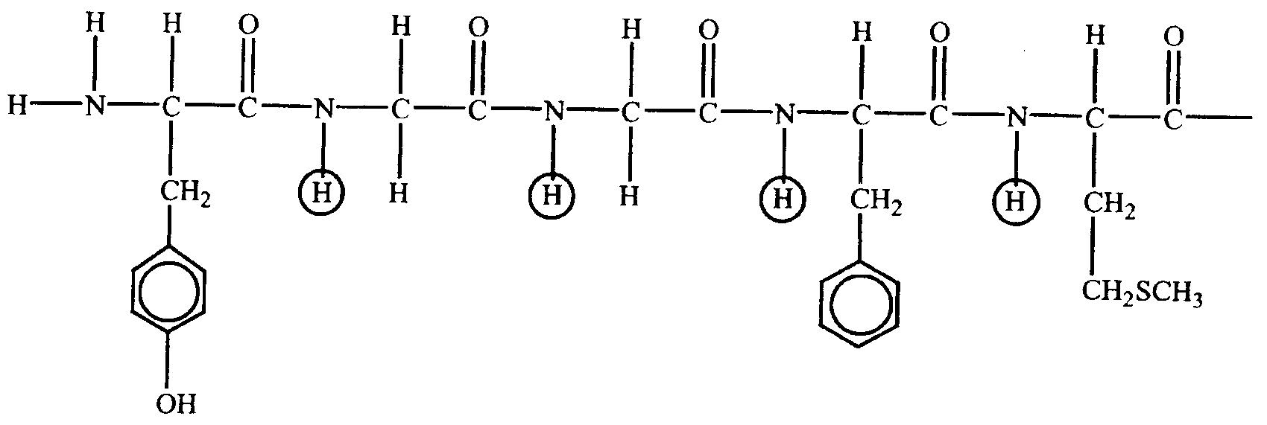
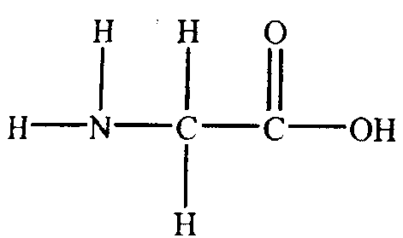
(iv) or NH₂CH₂COOH. 

- (i) Because amino acids have both acidic and basic functional groups their molecular structures are different at pH < 7 and pH > 7.
At pH 2, an amino acid molecule will act as a base and accept a proton, according to
NH₂CHZCOOH (aq) + H₃O⁺ (aq) → ⁺NH₃CHZCOOH (aq) + H₂O (l) 
At pH 12, an amino acid molecule will act as an acid and donate a proton, according to
NH₂CHZCOOH (aq) + OH– (aq) → NH₂CHZCOO– (aq) + H₂O (l) 
Hence the positively charged molecules migrate to the negative electrode at pH 2, whilst at pH 12 the negatively charged molecules migrate to the positive electrode. 
(ii) If the amino acid molecules do not move to either electrode, then the pH of the gel is such that the amino acid is present as its zwitterion, ⁺NH₃CHZCOO–. 
- The digestion of starch beings in the mouth due to the presence of the enzyme amylase in saliva. The starch is hydrolysed to the sweet tasting disaccharide, maltose. Enzymes are proteins. 
There is no sweet taste resulting from cellulose because humans do not produce the enzyme necessary for its digestion. 

