Lisachem
2005
UNIT 4 CHEMISTRY

SECTION A – Multiple-choice questions

Question 1
Consider the galvanic cell represented below.
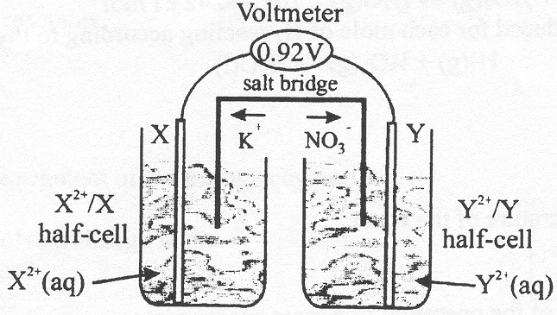
In this cell
- K⁺ ions are moving towards the negative electrode X
- NO₃– ions are moving towards the cathode Y
- oxidation is occurring at electrode X
- oxidation is occurring at electrode Y

Question 2
The 12-volt battery used in motor vehicles consists of six lead-acid cells connected in series. When current is being delivered by the battery, the overall redox reaction is described by the equation
PbO₂ (s) + Pb (s) + 4 H⁺ (aq) + 2 SO₄^{2–} (aq) → 2 PbSO₄ (s) + 2 H₂O (l)
When each cell in this battery is being recharged, the oxidation number of Pb
- increases at the positive electrode
- increases at the negative electrode
- increases as Pb is converted to PbSO₄
- increases as PbSO₄ is converted to Pb

Question 3
An aqueous solution of nickel (II) chloride is green. Ammonia is a weak base, which ionizes in aqueous solution, according to
NH₃ (a) + H₂O (l)  NH₄⁺ (aq) + OH– (aq)
If concentrated ammonia solution is added to an aqueous solution of nickel (II) chloride the solution changes from green to blue. The most likely cause of this colour change would be
- the oxidation of Ni²⁺ (aq) to Ni³⁺ (aq) by ammonia
- the conversion of NI(H₂O)₆²⁺ (aq) ions to Ni(NH₃)₆²⁺ (aq) ions
- the precipitation of nickel (II) hydroxide, Ni(OH)₂
- the movement of an electron from the 4s subshell to the 3d subshell

Question 4
The energies, in kJ mol^{–1}, required to successively remove the first 8 electrons from an atom of an element X are shown below:

Electron | 1 | 2 | 3 | 4 | 5 | 6 | 7 | 8
Energy | 1020 | 1910 | 2920 | 4960 | 6270 | 21300 | 25400 | 29900

The atom is most likely to be
- oxygen
- neon
- nitrogen
- phosphorus
Question 5
Hydrogen reacts with oxygen to form water vapour according to the thermochemical equation
H₂ (g) + ½ O₂ (g) → H₂O (g); ΔH = –242 kJ mol^{–1}
The amount of thermal energy produced for each mole of H₂ reacting according to the equation
H₂ (g) + ½ O₂ (g) → H₂O (l)
will be
- less than 242 kJ
- 242 kJ
- more than 242 kJ
- dependant on the temperature of the water

Question 6
Consider the following description of the operation of a mass spectrometer.

When a gaseous sample of an element is injected into a mass spectrometer, the individual atoms assume a positive charge as they pass the __________. As the ions pass through the __________ they are __________ and then separated in the __________.

Which of the following does not correctly fit one o the gaps in the description?
- electron beam
- accelerated
- magnetic field
- detector

Question 7
On June 28, 2005, an international consortium announced that Cadarache in Southern France would be the site of the world’s first large-scale, sustainable nuclear fusion reactor. Nuclear fusion reactors are not currently a viable energy source because
- the required fuels are very difficult to obtain
- the radioactive products of the process have a long half-life
- it is extremely difficult to generate the required operating temperature
- they are not as efficient as coal-fired power stations

Question 8
Which of the following elements would, in its ground state, have its highest energy electrons in a 5d subshell?
- mercury – ₈₀Hg
- plutonium – ₉₄Pu
- molybdenum – ₄₂Mo
- strontium – ₃₈Sr

Question 9
The formation of a common disaccharide may be represented by the reaction shown below.
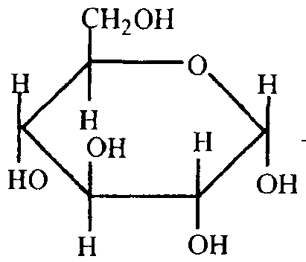 | + | 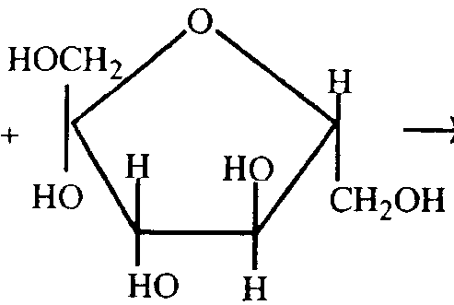 | → | 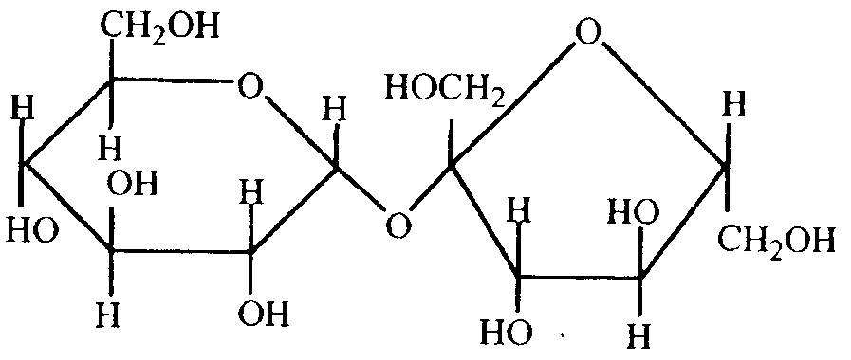
The percentage, by mass, of carbon in the product shown will be approximately
- the same as in the reactants
- less than in the reactants
- 40%
- 42%

Question 10
The diagram below shows a segment of the nitrogen cycle:

 |  |  | atmospheric nitrogen, N₂
 |  | I |  |  |  | III
NH₃ |  |  | II | NH₄⁺ ions in soil
 |  |  | fertilisers
 |  |  |  |  |  | IV
 |  | fertilisers |  | NO₃– ions in soil

Which section does not involve a change in the oxidation number of nitrogen?
- I
- II
- III
- IV

Question 11
Which of the following statements about the trends in properties of elements down a group of the periodic table is correct?
- atomic radius decreases
- oxidising strength decreases
- electronegativity increases
- first ionisation energy increases

Question 12
Yttrium-90 is a radioactive element which may have potential in the radiotherapy treatment of some cancers. It forms Y³⁺ ions which would be expected to each have
- 39 neutrons
- their highest energy electrons in the 4p subshell
- 39 electrons
- 36 protons

Question 13
The emission of visible and ultraviolet radiation from atoms is due to
- the movement of electrons from higher energy levels to lower energy levels
- the movement of electrons from the 4s subshell to the 3d subshell
- the movement of electrons between orbitals in a d subshell
- the movement of electrons from the ground state to an excited state

Question 14
Lithium-ion batteries are excellent power sources for high drain devices such as portable computers and mobile phones. These consist of an anode of lithium metal absorbed into graphite, a solid metal oxide cathode such as CoO₂, and a polymer electrolyte containing a dissolved metal salt. The reactions occurring at the electrodes during the operation of these batteries may be simplified to
Anode: Li → Li⁺ + e–
Cathode: CoO₂ + Li⁺ + e– → LiCoO₂
A lithium-ion battery operating at a voltage of 3.7 volt delivers a current of 4.0 A for 3.0 hours. What mass of Li will be consumed at the anode?
- 3.1 g
- 0.45 g
- 0.051 g
- 11.4 g

Question 15
Which of the following reactions involves an oxide which does not display acidic properties under any circumstances?
- MgO (s) + 2 H⁺ (aq) → Mg²⁺ (aq) + H₂O (l)
- CO₂ (g) + 2 NaOH (aq) → Na₂CO₃ (aq) + H₂O (l)
- SO₃ (s) + 2 OH– (aq) → SO₄^{2–} (aq) + H₂O (l)
- Al₂O₃ (s) + 6 H⁺ (aq) → 2 Al³⁺ (aq) + 3 H₂O (l)

Question 16
The Pauli principle is associated with the limitations on
- the number of electron shells in an atom
- the number of orbitals in a subshell
- the number of electrons in an orbital
- the number of subshells in a shell

Question 17
The diagram below represents the general structure of an electroplating cell.
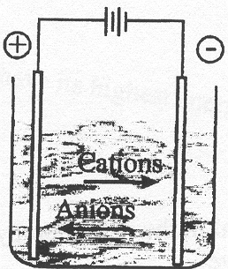
In this cell
- the object to be plated is at the positive electrode
- the object to be plated is at the negative electrode
- the electrolyte contains anions of the plating metal
- oxygen gas is produced as water is oxidised at the anode

Question 18
When a current of 1.40 A was passed through the electric heater of a bomb calorimeter for 54.5 seconds at a potential difference of 6.00 volts, the temperature of the calorimeter rose by 0.390°C.
When 9.50 × 10^{–4} mol of methane gas underwent combustion in the calorimeter, the temperature rose from 21.45°C to 22.17°C.
How much energy, in kJ, was released for each 1 mol of CH₄ reacting?
- 1174
- 845
- 890
- 55.6

Question 19
The membrane cell is used to produce a number of chemicals by electrolysis of a concentrated aqueous solution of sodium chloride, ie NaCl (aq).
Which of the following statements does not apply to the membrane cell?
- Chlorine gas is produced at the anode.
- The pH increases around the cathode.
- Cl– ions move towards the positive electrode.
- The semi-permeable membrane allows the transfer of Cl– ions but not Na⁺ ions.

Question 20
Naturally occurring copper consist of two isotopes: ⁶³Cu and ⁶⁵Cu.
The relative isotopic masses of these isotopes are 62.93 and 64.93 respectively.
The percentage abundance of copper-63 in a naturally occurring sample of copper would be closest to
- 33.5%
- 50.0%
- 66.5%
- 87.5%

SECTION B – Short-answer questions

Question 1
Olive oil is considered to be beneficial to health due to its high content of monounsaturated fatty acids and antioxidants. Studies have shown that olive oil may offer protection against heart disease by controlling LDL – “bad” – cholesterol levels while raising HDL – “good” – cholesterol levels.

- Olive oil usually contains two polyunsaturated fatty acids:
- Linoleic acid which is approximately 9% by mass of the oil and has the structural formula CH₃(CH₂)₄CH=CHCH₂CH=CH(CH₂)₇COOH;
- Linolenic acid which is approximately 1% by mass of the oil and has the structural formula CH₃CH₂CH=CHCH₂CH=CHCH₂CH=CH(CH₂)₇COOH.
Linolenic acid is classified as an omega-3 fatty acid because the first C=C double bond begins on the third carbon from the end of the hydrocarbon chain. On this basis, linoleic acid is classified as an omega-6 fatty acid.
Oleic acid, the main monounsaturated fatty acid in olive oil – making up between 60 and 85% by mass, has the same number of carbon atoms as linoleic acid and linolenic acid and is classified as an omega-9 fatty acid.
(i) How does a polyunsaturated fatty acid differ from a monounsaturated fatty acid?

(ii) Write the molecular formula of oleic acid.

(iii) Give the structural formula of oleic acid.

1 + 1 + 2 = 4 marks
- Some olive oils contain small amounts of saturated fatty acids. Give the structural formula of stearic acid, a fatty acid with molecules containing 18 carbon atoms.

1 mark
- Fatty acids are converted into fats by reaction with a compound characterised by molecules with three carbon atoms and three hydroxy functional groups.
(i) Give the name and molecular formula of this compound.

(ii) Explain how fats are converted into fatty acids during digestion.

1 + 2 = 3 mark s
- When a 5.00 mL sample of ‘Olive Oil’ was completely burnt in a bomb calorimeter with calibration factor 5.95 × 10³ J °C^{–1}, the temperature increased from 24.6°C to 53.2°C.
Calculate the energy content of the ‘Olive Oil’ in kJ per 100 mL.

1 mark
- The main antioxidant present in olive oil is Vitamin E. What structural aspect of the molecules in olive oil does the vitamin protect and how does it provide that necessary protection?

2 marks
Total 13 marks

Question 2
Methanol, CH₃OH, also known as wood alcohol, may be used as a petrol additive to improve combustion and is used as a fuel in its own right in some racing cars.
The combustion of methanol occurs according to the equation:
2 CH₃OH (l) + 3 O₂ (g) → 2 CO₂ (g) + 4 H₂O (l); ΔH = –1506 kJ mol^{–1}

- Determine the heat of combustion of methanol in kJ g^{–1}.

2 marks
- A laboratory experiment is set up to determine the heat of combustion of methanol. Methanol is burned in a ‘spirit burner’ and the heat released is used to heat 200 mL of water. The apparatus was set up as shown below.
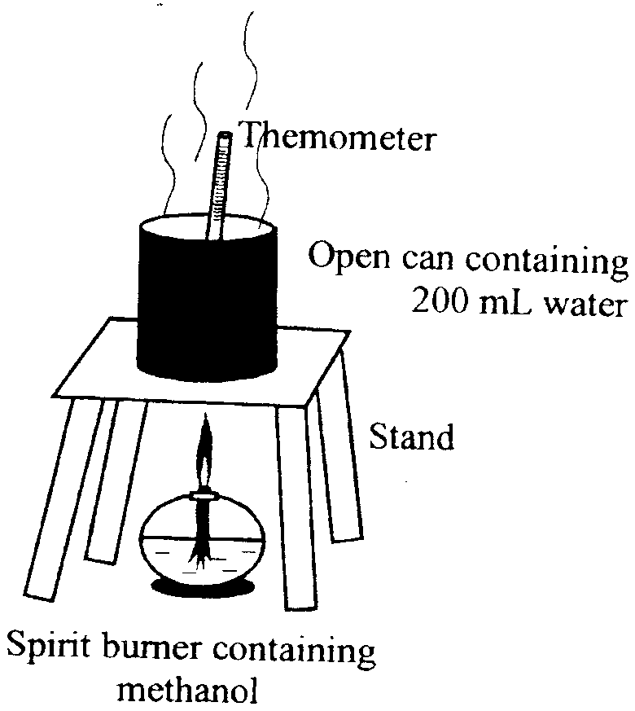 | The following data was recorded:
 | Mass of spirit burner before heating: | 125.62 g
 | Mass of spirit burner after heating: | 117.23 g
 | Temperature of water before heating: | 23.5°C
 | Temperature of water after heating: | 87.9°C
(i) Determine the amount of energy, in kJ, added to the water during heating.

(ii) Determine the amount of energy released by the combustion of the methanol.

(iii) What percentage of the energy released from the methanol was transferred to the water?

(iv) Suggest how the experimental setup could be modified to increase the efficiency of the energy transfer to the water.

2 + 2 + 1 + 1 = 6 marks
- Methanol can also be used as the ‘fuel’ in a fuel cell using hydrochloric acid as an electrolyte.
(i) What is the main energy transformation occurring in a fuel cell?

(ii) Using the electrochemical series, write the half-equation for the reaction occurring at the positive electrode.

(iii) CO₂ is produced at the negative electrode. Write a half-equation describing the production of CO₂ from methanol in the fuel cell.

(iv) State three properties usually associated with the electrodes in a fuel cell.

1 + 1 + 1 + 2 = 5 marks
Total 13 marks

Question 3
Stars may be described as giant ‘nuclear powerhouses’ that are continuously producing atoms.
On Earth nuclear reactors are a significant source of electrical energy.

- A nuclear reactor used in the generation of electricity may be powered by the reaction
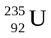 + 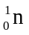 → 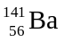 + 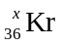 + 3.
(i) State the type of reaction represented by this equation and give the value of ‘x’.

(ii) State one way in which such reactions differ from chemical reactions.

(iii) State one environmental issue associated with such reactions.

2 + 1 + 1 = 4 marks
- (i) Write an equation describing the main reaction occurring in the Sun.

(ii) What type of reaction is represented by this equation?

(iii) Justify the claim that the Sun is becoming less heavy as a result of this reaction.

1 + 1 + 1 = 3 marks
- Solar energy is an important part of the operation of many Remote Area Power Supplies (RAPS). Energy is stored by using photovoltaic cells to charge batteries. What are the energy transformations associated with this ‘storage of solar energy’?

1 mark
- Energy from the Sun is essential for the process of photosynthesis. Write a balanced equation for photosynthesis.

1 mark
Total 9 marks

Question 4
In 1885, the French chemist Moissans wrote about the preparation of fluorine.

“I obtained the fluorine from a fluorine compound that had been added to a mineral having a low melting point and in which the fluorine compound dissolved readily. The use of electricity produce the fluorine at the positive terminal. Difficulty was experienced in getting any material for that terminal that would resist the chemical action of the gas.”

- How is the reactivity of fluorine related to its position in (i) the electrochemical series and (ii) the periodic table?

2 marks
- Write the half-equations for the electrode reactions which occur during the electrolysis of molten potassium fluoride.
(+) electrode:
(–) electrode:
2 marks
- Explain why fluorine, F₂, is not produced during the electrolysis of a dilute aqueous solution of potassium fluoride, and give the half-equations for the reactions occurring at the anode and cathode during this electrolysis.

3 marks
- A description of the production of aluminium by electrolysis may refer to ‘the dissolving of an aluminium compound in a lower melting temperature compound’ and ‘the gradual decrease in size of the positive electrode’.
(i) Give the names of the ‘aluminium compound’ and the ‘lower melting temperature compound’.

(ii) Give the equation(s) for the reaction(s) occurring at the positive electrodes during the production of aluminium and explain why these electrodes decrease in size.

(iii) Explain why aluminium is not produced by the electrolysis of a dilute aqueous solution of Al³⁺ ions.

1 + 2 + 1 = 4 marks
Total 11 marks

Question 5
- The human brain synthesises small polypeptides called enkephalins, part of the endorphin group, which play a role in controlling pain. The structure of one of these enkephalins is given below.
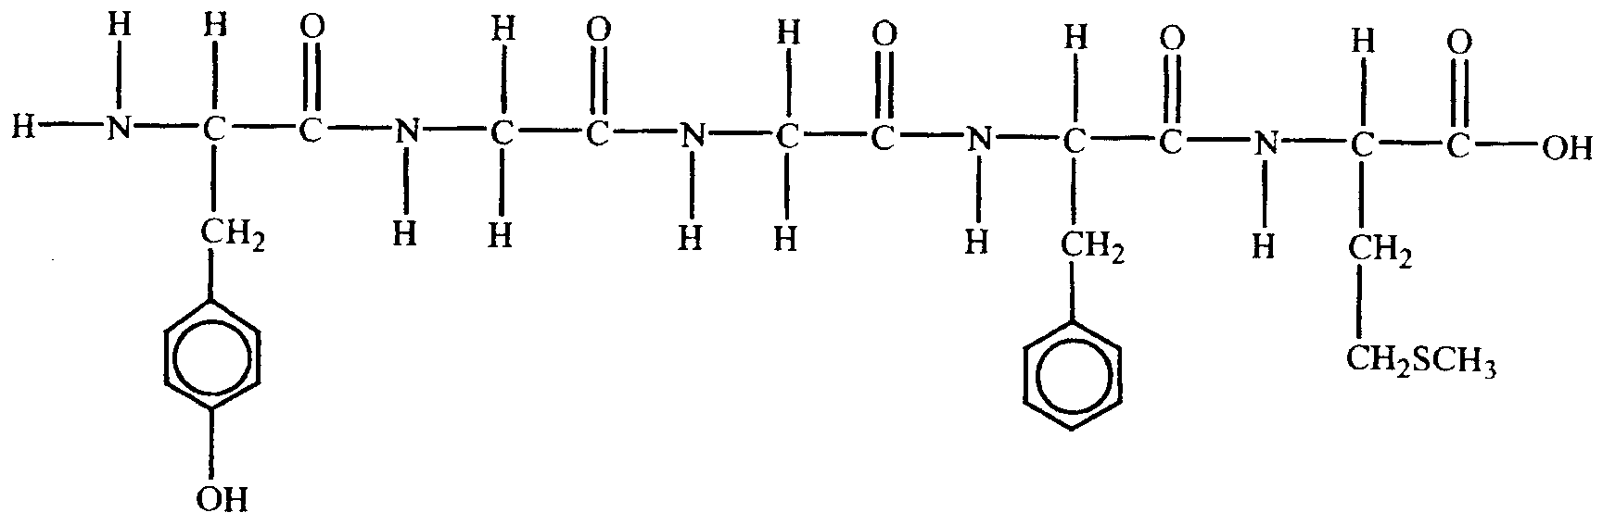
(i) How many different amino acids are present in this polypeptide?

(ii) Describe the functional group changes which occurred as this polypeptide was produced from its amino acids.

(iii) Indicate, on the diagram above, one hydrogen atom that would be involved in hydrogen bonding maintaining the secondary structure of a polypeptide.
(iv) Give the structural formula of the simplest amino acid which would be released during the digestion of this polypeptide.

1 + 1 + 1 + 1 = 4 marks
- Amino acids may be studied using a process known as electrophoresis, which involves passing an electric current through a gel containing the amino acids. An experimental investigation of the electrophoresis of amino acids showed that the direction of movement of the amino acids depends on the pH of the gel. Amino acids moved towards the negative electrode when the pH of the gel was 2 but towards the positive electrode when the pH was 12.
(i) Explain why the direction of movement of amino acids is dependent on the pH of the gel.

(ii) If an amino acid does not move towards either electrode during electrophoresis what does that suggest about its structure?

3 + 1 = 4 marks
- In a simple taste test a student places a small amount of starch on her tongue. After a few minutes she notices a sweet taste. However, when she repeats the exercise with a small amount of cellulose no sweet taste results.
Explain the link between these observations and proteins.

2 marks
Total 10 marks

